The Journal of the Royal Society of Antiquaries of Ireland.

Fifth Series, Vol. 10.  
No. 3 (Sep. 30. 1900). pp. 263-306

EXCURSIONS OF THE ROYAL SOCIETY OF ANTIQUARIES  
OF IRELAND,  
 SUMMER MEETING, 1900.

DESCRIPTION OF THE PLACES VISITED.

[**by** T. J. Westropp, **m.a., m.r.i.a.]**

Ancient Districts of Clare - map  
 History & Topography of Clare - overview

The Journey Through Clare

Diagram of Antiquities in South-Eastern County Clare.  
 Ennistymon

Cairnconnaughtagh

Kilshanny

Caherreagh

Lissdoonvarna

Lissdoonvarna - map

Ballinalacken

Typical details of Castles -diagram

Killilagh

Glasha, Cahermaclancy, Cahermacrusheen

Doonmacfelim

Knockastrollery

Doonagore

Moher

Hags Head

Kilstapheen

Liscannor and the Armada

Kilmacreehy with photo

Lehinch

O Briens of Lehinch

Burren

Chiefs of Corcomroe

Cromlechs and Cahers

Ballyvaughan

Lough Rask - Banshee legend

Drumcreehy and Muckinish

Muckinish and Newtown Castles - photos

Mortyclough Forts

Corcomroe with photo and diagrams

Oughtmama

Ballyvaughan Valley and Rathborney

Killeany and Caher Valley

Cahercloggaun

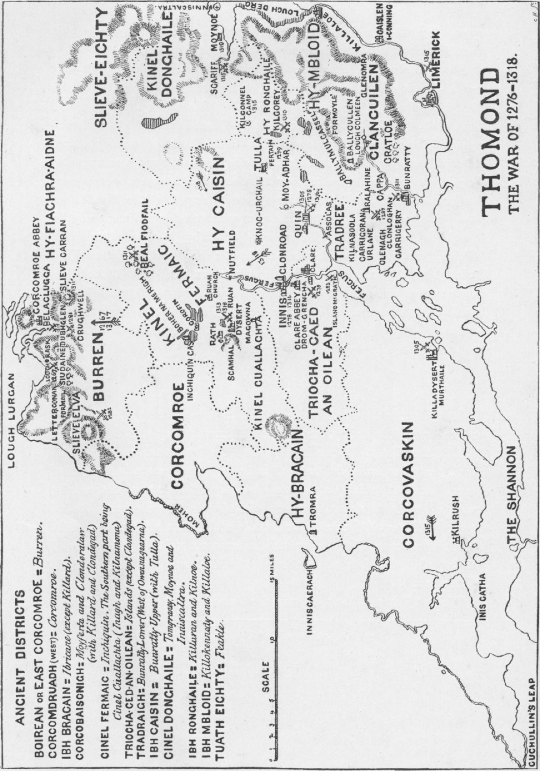

273  
EXCURSIONS OF THE ROYAL SOCIETY OF ANTIQUARIES  
OF IRELAND,  
 SUMMER MEETING, 1900.

DESCRIPTION OF THE PLACES VISITED.1

INTRODUCTORY.

THE Royal Society of Antiquaries of Ireland has already visited districts bordering on county Clare, and has at least on three occasions examined places within its confines. In 1889 it visited Killaloe and Holy Island; in 1890, Bunratty and Quin; in 1895, Corcomroe Abbey; and in 1897, Scattery Island; but it had never, up to the present time, held an actual meeting in the ancient kingdom of Thomond.

This has certainly not arisen from any lack of objects of antiquarian interest; for the county possesses the remains or sites of at least 2300 forts, 130 cromlechs, 190 castles, 150 churches, 3 cathedrals, 8 monasteries, 5 round towers, 10 stone crosses,2 besides cairns and lesser antiquities unnumbered. Before describing the remains on the lines of our intended excursions, it may be well to give a very brief sketch of the topography and history of a region that proudly calls itself “historic Clare.”

It is a curious wedge-shaped district between the Shannon and the sea, and is again split up by the island-studded lake which is regarded as the estuary of the Fergus. The county falls naturally into three divisions—1, the eastern, consisting of the four baronies of Tulla and Bunratty. It may be roughly called the Macnamara’s country, or the old Firbolg state of Magh Adhair. We pass through this between Limerick and Ennis, and see not a few of its remains from the train; 2, the south-western, being the baronies of Clonderlaw, Moyarta, and Ibricane, with which our present tour does not deal; and 3, the northwestern, the baronies of Islands, Inchiquin, Corcomroe, and Burren, the scene of our intended excursion.

Thomond does not hold a very prominent place in ancient Irish heroic legend. It lay, a sort of debatable land (well called “the corner of contention” in later days) on the border of Connaught. As such it was apparently held by the prehistoric tribes of Gann, Genann, and Sengan,

1. Note by T. J. Westropp, m.a., m.r.i.a.
2. Kilfenora, 3; Kilnaboy; Noughaval; Termon; Skeaghavannoe; Dysert; Killaloe

(removed from Kilfenora); Kilvoydane.

274 ROYAL SOCIETY OF ANTIQUARIES OF IRELAND.

whom Ptolemy, in the first century of our era, marked on his map, near the mouth of the Shannon, under the name Ganganoi. Legend then asserts that the great mythic Queen Maeve, the heroine of the cattle foray of Cuailgne, granted the land to an outcast tribe of Firbolgs, the clan or sons of Huamore, whose names are not yet obliterated from the map of Clare,1 for Doon Eerish, on Black Head, possibly commemorates Irgus, who settled on Rinn Boirne; Finvarra (and Kinvarra, just over the present border), the chief Bearra; the river Daelach recalls the name of Dael; and Moyers2 Park, near Quin (Magh Adhair), the plain of Adar. This clan was traditionally reduced to servitude by Cuchullain and other great mythic heroes. The clan of Rory (descendants of Fergus, son of Roi and of Queen Maeve) obtained Burren and Corcomroe; and the race of Cairbre Bhascoin ousted the Martini from Corcovaskin, along the Shannon. Finally (so close to the introduction of Christianity and writing as to be practically history) the Dalcassians, under their prince, Lughad Mean (350), his son, Connall Eachluath of the fleet steeds, and grandson Enna (378-410), reduced Clare from Limerick to the hills of Burren. From them originated the O’Briens, Macnamaras, O’Deas, O’Quins, Mac Mahons, and many a lesser tribe, paying no tribute to the kings of Cashel, and resting content with tribute from Clan Rory who, entrenched behind the great hills of the Burren, preserved all but absolute independence, and became the O’Conors and O’Loughlins of later days. By 440 the chiefs of the Dalcassians had received baptism, and by the end of the century Brecan (480-520), son of King Eochy Bailldearg, had founded the mission churches of Kilbrecan, Doora (which we see from Ennis Station), and Clooney, in the heart of the county; while he and Enda of Arran, followed by a host of saintly men—including Senan, Maccreehy, Luchtighern, and Colman Mac Duach—converted the heathen remnant, till the tribes became known as “the Dalcassians of the Churches.” Then learning and religion all but perished in the Danish wars. From 800 to Brian’s reign (nearly two centuries) the fierce Horseman from Limerick wrought their evil will. The brief sunshine under the hero of Sulloghod and Clontarf ended with his life in 1014. Then followed 150 years of civil war and misery. Donald More was the last king who reigned in Limerick; his son, Donchad Cairbrech, the founder of Ennis friary, gave up the title of king,3 and removed to Clonroad. His successors, from 1248 to 1333, were engaged in a fierce struggle of varying fortune with successive English colonies, especially those under Sir Thomas de Clare, 1276-1287, and his son, Sir Richard, 1310-1318. The

1. See manuscript quoted, “Manners and Customs,” Introduction, p. xxviii; “The seed of the slaves of the sons of Miledh”; “Tuatha Maca nUmoir in Dalcais and Aidne; Tuatha Ua Cathbar in Corca Muichi; Corca Bascainn in Kilmacduach and Corcovaskin; Tuath Ferrudi in Corcmodhruadh, from Corranroe to Roadford (Ath an roide), and Tuath Ferninais in the Eoganacht of Ros Argait and Arainn.”,
2. Moyri, 1584 and 1839, or Moyross, in 1839; Moyars, or Moyers, 1891.
3. Wars of Torlough. The English Government, however, continued to call him and his successors Conor and Turlough, “King” in its State Papers.

PROCEEDINGS. 275

O’Brien princes remained independent of the English, taking tribute from Limerick, to the time of Henry VIII., and, transformed into Earls of Thomond, were little less powerful till the civil war of 1641-1652. The transplantation (1653-55), confiscations (1653-1703), and the war of James II. were less destructive in Clare than in many other places; and many of the older families subsist in all classes of life; while the ancient buildings, beliefs, and traditions have been preserved in unusual vigour to our own time—the threshold of the twentieth century.

It must be understood that the following pages frequently record the chief antiquities along our various routes more fully than time could possibly allow us to visit them; but it is hoped that this may lead our readers, whether after this excursion or when staying in the neighbourhood on other occasions, to examine, at greater leisure, the remains in this part of that beautiful fringe of our Island—

“Whose dwelling is the light of the setting sun.”

**The Journey through Clare.**

Leaving Limerick, we see first, on a rising ground, the high gabled tower of Newcastle, where William III. is said to have resided during the siege of 1690, next, on a rising ground between us and the city, a graveyard is said to mark the site of Singland Church and of the palace of Cairthin Fionn, that early king of the Dalcassians, whom St. Patrick converted and baptized along with his new-born son, Eochy Bailldearg, about 440; while on the low green island we overlook “Cromwell’s Camp.” We cross the Shannon, getting a fine view (l)1 of the picturesque old town, with Thomond Bridge, whose predecessor was built by John, afterwards king of England, and which played so tragic a part in the siege of 1691. Behind rise the bulky towers of the Norman Castle, the turretted belfry of St. Mary’s Cathedral, the graceful spire of St. John’s Cathedral, and, on the other side (r), the many coloured hills of Killaloe and Ara, with Thountinna, where Fintan (the alleged recorder of our legendary history) is said to have slept safely under the waters of the Deluge. Farther on we see the Shannon (l), with the turret-crowned rock of Carrigogunnell,2 a stronghold of the O’Briens, and the long ridge and round dome of Knockfierna (Cnoc firinn), the residence of the puissant fairy king, Donn Firinn. We pass (l) the strong old tower of Cratloe and the turret of Cratloekeale, important seats of the Macnamaras, and reach Cratloe station.

1. L — left, and R = right, facing the engine.
2. An Inquisition, 13th February, 1542, taken at Limerick, states that Mahone O’Bryen, of Carrigogunnell, imposed a tax of 1d. for each barrel of wine, and 2d. for other barrels from the merchants of Limerick. O’Kahane of Keilruish, in the country of Corcovaskin, imposed 6s. 6d. on every ship. Fineen and Teig Mac Namara 2d. on every barrel, cow, or horse, and 6s. 8d. on every man wearing a cap. O’Brien took the same imposts except the cap tax. Donough O’Brien took 20d. on every pack from Limerick to Waterford, and 5d. on a horse load from Waterford to Limerick.

276 ROYAL SOCIETY OF ANTIQUARIES OF IRELAND.

Beneath a steep embankment (l) we note Croaghane church1 and cromlech, and from the opposite window (R) the broken vaults of Ballintlea Castle on the hill-side (Baile an tsliabh, Hilltown). In the distance (l) we see the ivied tower of Rossmanagher, and the large Castle of Bunratty,

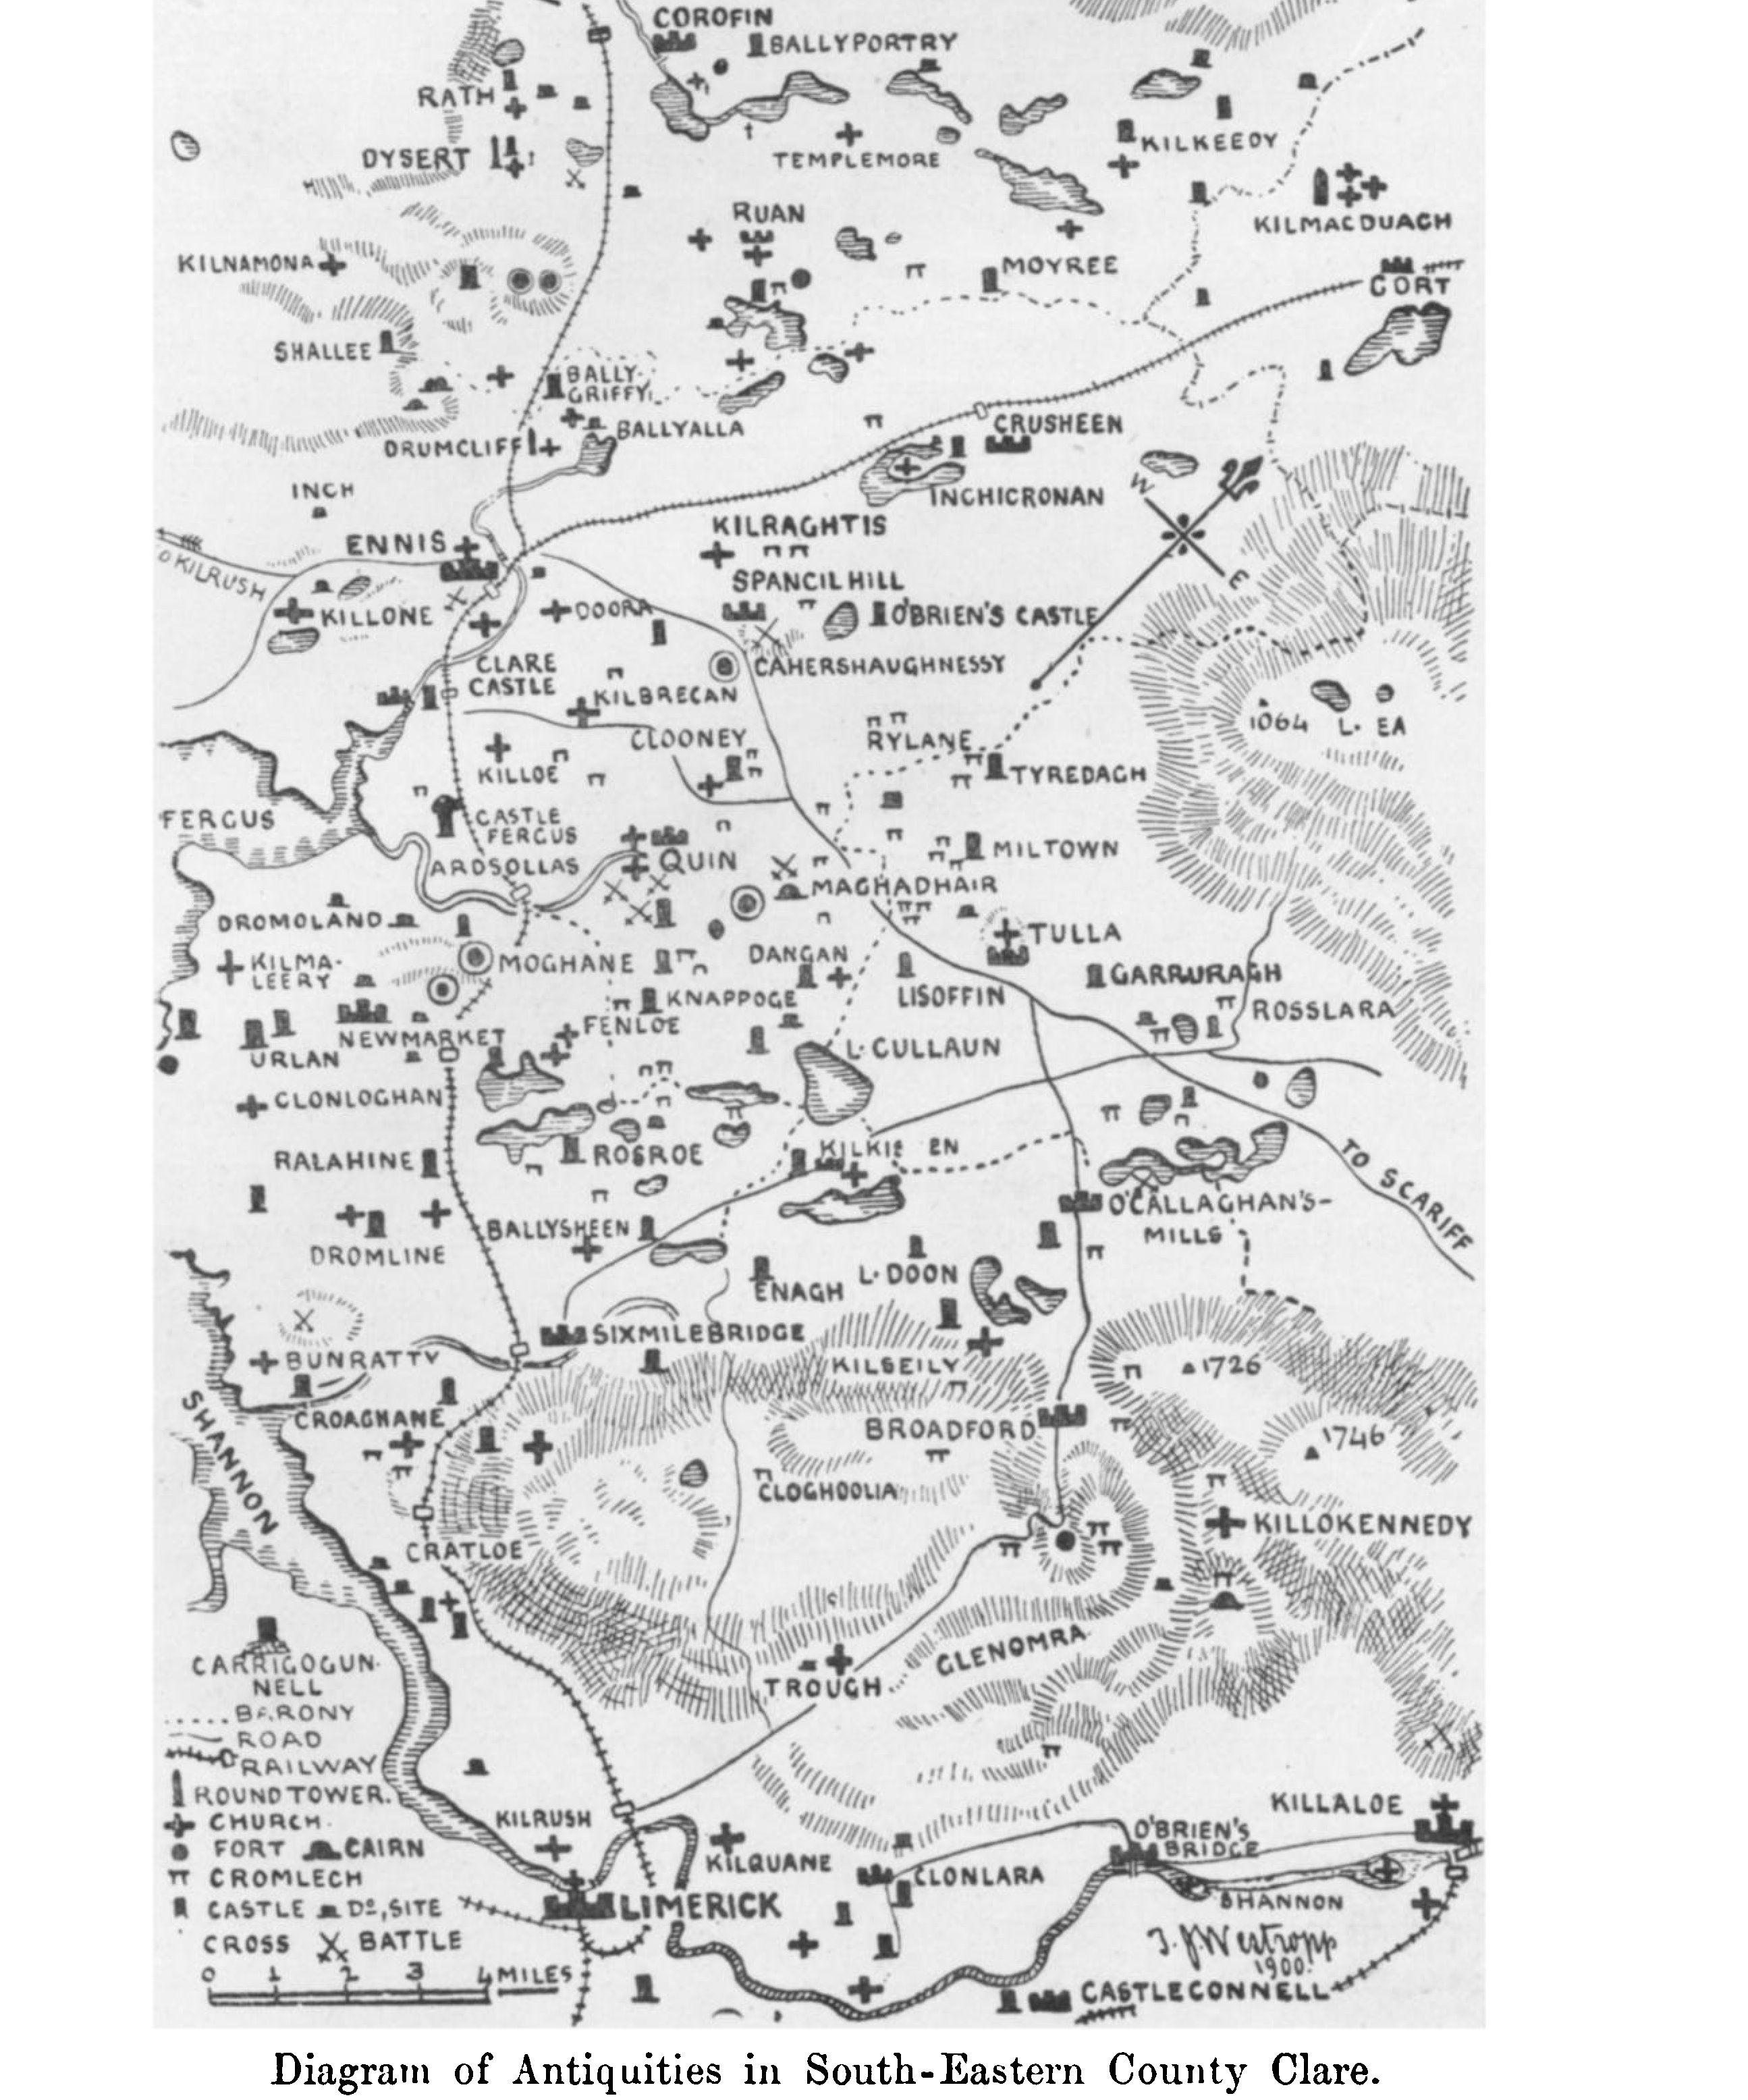

founded by De Musegros 1249, and long held by the De Clares (1276-1318), a seat of the earls of Thomond till 1642. We cross the Owen-na-

1 The inscriptions of several monuments in Croaghane church are published by Colonel Vigors in the “Journal of the Association for the Preservation of the Memorials of the Dead in Ireland,” vol. ii., page 447. The abbreviation P. M. D. will he used here for this Journal.

PROCEEDINGS. 277

Garna stream, and see (R) the prettily situated Sixmilebridge, once famous for cider and oil mills; behind it rise the picturesque hills of Slieve Bernagh.

Between it and Ballycar (l) we pass the ivied church of Fenagh, the distant peel tower of Dromline, and, near the line, among the trees (l), the castle of Ralahine (Rath Laithin), where Prince Dermot O’Brien, in 1317, held his muster before the battle of Corcomroe,1 and where Dyneley stayed in 1680 with the Vandeleurs, and made his sketches of Clare. We are passing through the old De Clare territory of Tradree, called after the Druid Trad, the mensal land of the O’Briens, possibly won before 380. To the other side (R) we see, across the marshes and lakes of Tomfinlough, the woods of Fenloe (Major Hickman’s house). Near it, but not visible, are the churches founded by St. Luchtighern mac Cutrito about 540. To the right of Fenloe is the massive ivied tower of Rosroe.

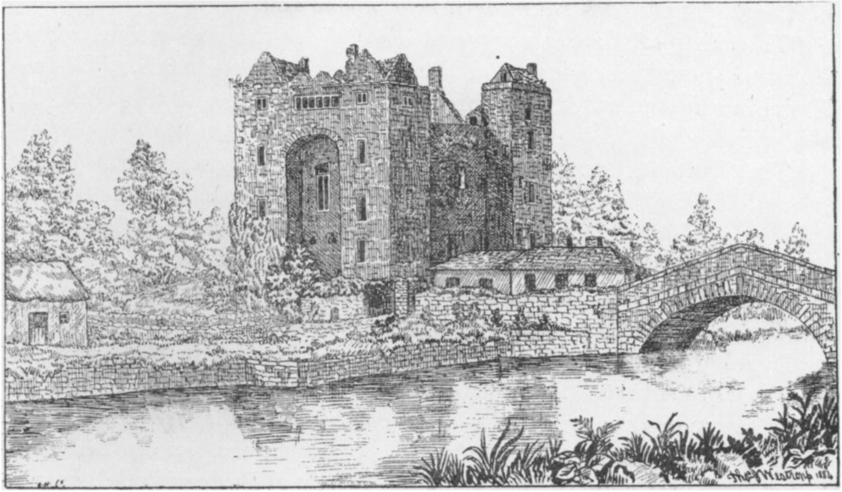

Bunratty Castle.

Leaving Ballycar (Baile Ui Carthaig) station, the old ruined house of the Colpoys family of Ballycar stands (l) near a lake. A little later we get a glimpse (l) of the walls of the huge stone fort of Moghane,2 probably the ancient Cathairkine (1500 ft. by 1100 ft. across), on a wooded hill. The walls, “the labour of an age in piled stones,” are in parts 21 ft. thick, and enclose an area larger than Trinity College, with its park and the adjoining streets. In cutting the railway below it was made “the great Clare gold find” of prehistoric ornaments in a small cist.3 Many of these torques, gorgets, and fibulae were fortunately secured for our museums.

1. A view of Ralahine is given in “The Story of an Irish Sept,” p. 138-139.
2. Plan on page 35. #

3 A similar case occurs in our ancient literature:—“In an adjoining grave was a deep mass of rings and bracelets.”—“Silva Gadelica,” ii., p. 128.

278 ROYAL SOCIETY OF ANTIQUARIES OF IRELAND.

The curious and interesting stone fort of Langough is not visible from the train. We cross the Rine or Gissagh on a high bridge, with a pretty valley and woods, and the towers of Dromoland—the beautiful seat of the Barons of Inchiquin—to (L), and the tower of Quin Friary, seen to (R) and reach Ardsollas station.1

We pass close to Ballyhenon or Castle Fergus tower (l) and get a more distant view of the venerable church of Killoe (r), probably founded by Lugad or Molua of Killaloe in the seventh century. Next we reach Clare Castle, a small town and port with a strong castle embedded in the modern barrack. It was probably built by Robert de Musegros, a Norman knight, about 1250, and was taken by Prince Teige Caoluisge O’Brien in 1270. A view of it in 1681 appears in Dyneley’s “Tour.”-

We cross the Fergus, getting an interesting view (r) of Clare Abbey with the town of Ennis behind it, and in the distance the ivied church of Doora, founded by Bikin or Brecan about 480.

The abbey of Clare is very well seen (r), as the line curves round it so as to show three sides and the interior of the church. We reach Ennis in a few minutes, and change into the carriages of the West Clare Railway.

The line curves round Ennis, crossing the Fergus again. We note near the bridge the modern house of Clonroad, on the site of the O'Briens’ palace, and (r) the nearly levelled but remarkable castle of the O’Briens at Knockanoura. Clonroad was founded in the time of Donchad Cairbrech O’Brien before 1240. Conor Roe (“na Siudaine”) O’Brien and his grandson Torlough enlarged it, the latter having built a tower, of which a sketch by Dyneley in 1680 is alone extant. It was levelled by the Gores early in the last century. After passing the asylum we see the church and round tower of Dromcliff (r), and the castles of Shallee and Magowna on the more distant hills to the left. We cross the shallow old bed of the Fergus and pass close to the very perfect castle of Ballygriffy (r) guarding the old ford. Farther on can be seen (l) the little road-bridge near which commenced the battle of Dysert O’Dea in 1318. The castle of Dysert appears beyond the lake of Ballycullinan (l), but the church and round tower are hidden by the trees. We pass the tall fragment of Cragmoher (Cahermoher) Castle (l) and see to the right beyond the village of Corofin, Ballyportry Castle and the bare rock terraces of Glasgeivnagh and Mullach, the outposts of the Burren.

The journey from Corofin is of comparatively little interest. Some pretty water runnels and wooded scenery occur as we run round the end of Inchiquin Hill (Keentlae). From the brow next the railway sprang Finn’s brave hound Bran with a deer into the Lake of Tirmicbrain; this lake and that of Inchiquin are hidden by rising ground. The rest of the journey is through an uninteresting boggy country, the only objects

1 *R*ecte Ath solais, the “Ford of the Light.”

PROCEEDINGS. Zí\9

of interest being Mount Callan (l) and the shattered castle of Glen1 (R). Tradition says that a wizard flew away from his wife, with half of his castle, to Glen, the other half being at Shallee. Directly after passing its crumbling walls we reach Ennistymon.

279

**Ennistymon.**

Ennistymon (Inisdiomain) only figures in history2 from 1588 as a castle of the O’Briens, of whom the present owner, Henry V. Macnamara, D. L., is a lineal descendant. In 1582 various members of the O’Conor family made over their rights to Turlough O’Brien of Inishdyman. Among the places so granted figure Innistymon, Dough Iconor, Liscannor, and Dunnagoar.3 The purport of this deed is not clear; for we find the O’Briens in full possession at least three years earlier. Donogh O’Brien of Inyshtymon died 1599, holding castles at Innyshtymon and Lyskannor, with the stone fort of Drommore, or Dromfinglas (Cragmoher, Corofin), his son, Sir Terence O’Brien, succeeded. His son, Murrogh, was aged 8 in 1593.4 We will, in a note on Dough, enumerate the various owners of it and Ennistymon during the 17th century. The O’Briens were under the frown of the Government in 1699, “Pursuant to the warrant of Captain Purdon and Captain Stamers for searching the house and castle of Innis-diman for arms, I hereby certify to have found ... 1 fowling piece, 1 brass blunderbuss, all which I engage to deliver to Captain Purdon.”5 In the gable of the present house, on the north side, may be seen the end wall of this castle, with plain, three-light windows, having rectangular hoods and oblong lights, clearly of the Elizabethan period. In the house are a fine set of portraits, many of persons who helped to make history in Clare in the seventeenth century.6

An old featureless church of the reign of George III.7 stands on the hilltop, and has no monuments of general interest. The interest of the place centres in the beautiful wooded glen and picturesque waterfalls

1. Daniel O’Conor, of Glan o Conor, died 1585, holding in that castle “the cellar chamber, middle rooms, and half the porter’s lodging and the lands” (Inquisition taken at Kilfinowrege in 1606).
2. It is mentioned, however, in the mediaeval life of St. Macreehy.
3. “Diocese of Killaloe,” p. 555.
4. Inquisitions, 1588 and 1593.
5. “Diocese of Killaloe,” p. 418.
6. Through the kindness of Mr, H. V. Macnamara I am able to note the principal: — 1. Honora, wife of Donough O’Brien of Dough, 1738; 2. Christopher, her son; 3. Edward, his son; 6. Judge Finucane (by Hamilton); 7. Daniel, third Viscount Clare, 1691; 8. Lord Mountcashel, 1691; 11. Sir Donat O’Brien, Bart., 1691, from original at Dromoland: 12. Sir Edward O’Brien, Bart., 1765 ; 13. Catherine Keightly, mother of the last, granddaughter of Lord Clarendon; 14. Marshal Thomond, sixth Viscount Clare, succeeded as (titular) Earl of Thomond, 1741; 15. Barnabas, sixth Earl of Thomond, dispossessed of Bunratty in 1641; 16. Henry, 7th Earl of Thomond, 1690; 17. Henry, eighth Earl, 1701; 18. Mary, widow of Conor O’Brien, 1641, the notorious “Mhaire Rhuadh ”; 28. Patrick Sarsfield, Earl of Lucan, 1690. I may here note that when using the colloquial name Maureen Rhue I do not forget that the better version is “ Mhaire Ruadh,” but this is less familiar to general readers.
7. Order to change the site of the parish church of Kilmanahan to the town of Ennis tymon, 2 Feb., 1776. Patent Rolls.

280 ROYAL SOCIETY OF ANTIQUARIES OF IRELAND.

falling from ledge to ledge from the bridge in the village to the depth of the glen.

“A mountain stream, which o’er a bed

Of level rock its waters shed

In one broad sheet below.

Careering swift by crag and stone,

Amid its torrent, random thrown,

With eddies deep and belts of foam,

Its bounding waters go.

Till in the distance, far away,

It glides into Liscannor Bay.”

**Cairnconnaughtagh.**

Cairnconnaughtach lies a little over two miles north of Ennistymon: it is a large cairn in a low, swampy tract, near a stream. O’Donovan and O’Curry, on no quoted authority, consider that it was Carn mic Tail, the place whereon the chiefs of the Corcomroes were inaugurated, and the tomb of their tribal ancestor. Legend says it was the tomb of a Connacian army exterminated (except three chiefs) by the men of Corcomroe. The Annals1 mention an invasion of this district by Ruadri O’Conor, king of Connaught, and the loss of three of his chiefs in 1088. If it be really Carn mic Tail we might connect it with the raid of King Aed, of Connaught, in the Life of Maccrehy. Another legend makes the Connaught men pursue, kill, and bury under the cairn a huge serpent. The only certain fact remaining is the great heap of stones said to be 25 feet high, and 100 paces in girth.2

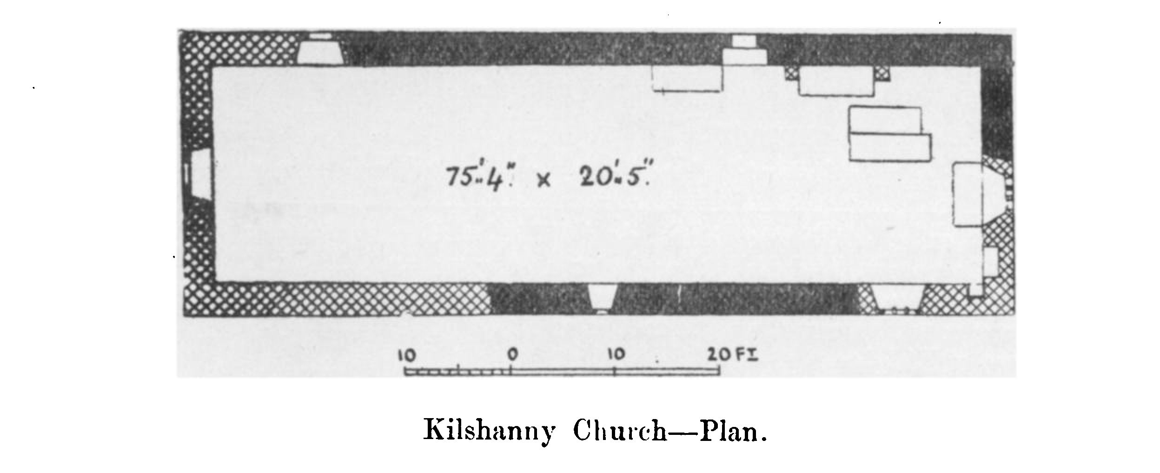

**Kilshanny.**

Kilshanny church is up the stream to the east of the road, not far from the cairn. It is traditionally said to have been founded by St. Cuana, possibly Mochonna of Feakle and Kilquane, and believed to have died about 650. The saint’s bell is at present preserved in the British

1 “Annals of the Four Masters,” 1088.

2 “Ordnance Survey Letters,” R.I.A., Clare, 14 B. 23, page 309. Borlase’s “Dolmens of Ireland,” p. 909, alludes to it.

PROCEEDINGS. **281**

Museum.1 The well has been rededicated to St. Augustine; its name suggests that the founder was Seanach, perhaps St. Senan’s brother.

281

The Monasticons assign its foundation to Donaldmore O’Brien before 1194. It was an abbey in 1273, and its abbot, Florence, was advanced to the see of Kilfenora, but it was used as a parish church in 1302.2 It was held by Torlough O’Brien, of Ballingown (Smithstown), at his death, 1584,3 and by Turlough, son of Teige O’Brien, in 1611. It was eventually granted, with its mill, to Robert Kinsman, April 7th, 1579.4

It is, as usual, oblong and undivided (75 ½ feet by 18 feet 10 inches). The west gable has a pointed door; it is otherwise blank; and the storms from the Atlantic long kept the ivy from covering its nakedness, though elsewhere on the walls the plant was destructively abundant. Remains of the older church are found in portions of both side walls; the northern containing a neatly made doorway, with a semicircular head, and the southern a narrow window of similar design, possibly of the 11th century. The remainder is mostly late 15th century; but the east window seems still later, having two clumsy shafts interlacing, and with semicircular heading pieces. The altar (8 feet 8 inches by 3 feet 3 inches) remains; also a rude tomb recess to the north, and monuments of the Thynnes— 1717 and 1752. The graveyard is full of shafts, portions of window- heads, &c., apparently more numerous than would be needed to complete the windows of the church.

Near Kilshanny dwelt, in the second quarter of the last century, the well-known antiquary, Andrew Mac Curtin. He was descended from a line of annalists (of whom we may note Ceallach Mac Curtin, or Mac Criutin, ollamh of Thomond, who died 1376. Giolladubh Mac Curtin, a famous harper, who died 1404, Seanchan, a historian, poet, and musician, died 1435, and Gennan, ollav elect of Thomond, who was drowned 1436. “There was not in Leth Mogha in his time a better materies of a historian than he.” Andrew was hereditary historian to the O’Briens of Corcomroe, and kept a school where English and Latin were taught, though he hated the former language, and expressed his feelings in a poem, “Sweet is the Irish tongue.” When, as sometimes happened, the school was empty, Mac Curtin used to travel through Clare, especially to the hospitable houses of O’Brien of Ennistymon, and Macdonnell of Kilkee. He has left us a valuable series of copies of ancient manuscripts, the most notable perhaps being “Three shafts of death,” “The wars of Torlough,” and “The Life of St. Senan.”

Caherreagh, Caherkinallia, or Cahercunella, is a much gapped dry stone ring-wall in a marshy hollow, seen to the east of the road near Lough Goller, soon after leaving which we see the houses of Lisdoonvarna under the dark bluff of Slieve Elva.

1. Our Journal, vol. ii.. p. 62. O’Hanlon’s “Lives of the Irish Saints,” ii., p. 285-287, for legend of St. Cuanna and a bell.
2. Papal Taxation.
3. Inquisition, Nos. 8 and 41. MSS. 14. C. 2. R.I.A.

4 MSS. F. 4. 25. T.C.D., not “Hickman,” as in Archdall.

282 ROYAL SOCIETY OF ANTIQUARIES OF IRELAND.

**LlSDOONVARNA.**

Lisdoonvarna (earth fort of the gap) probably takes its name from the green earthen fort of Lissafeeaun, near the old castle site, and the gap (barna) in the slope on which it stands; indeed higher up we find a Caherbarnagh (stone fort of the gap). The curious double name Lis-doon is not an uncommon phenomenon in Clare and elsewhere, as shown by local names, Caher-lis, Caher-doon (Catherton in Scotland, Caermarthen, i.e., Caer-mari-dun in Wales) and Lis-doon. The present village does not stand in the old townland that gave it the name, but in Rathbaun and

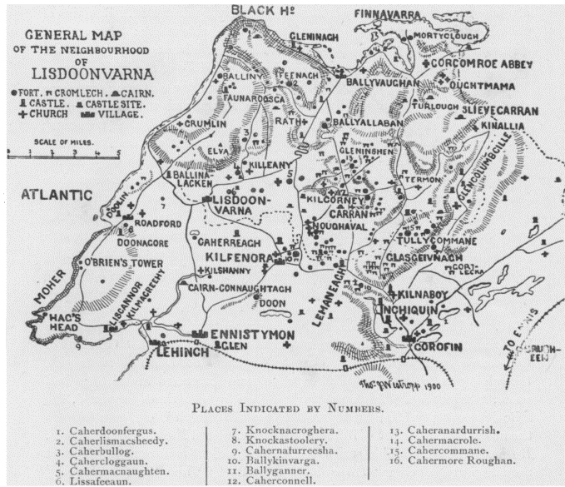

GENERAL MAP of THE NEIGHBOURHOOD OF LISDOONVARNA

Ballyinshen. The ash trees which gave their name to the latter place have long disappeared. South from it lie the low ridges called after the “dog” and the “wolf,” Knockaunawaddra and Knockaunvickteerugh.1 The place has no history. It was confirmed to Boetius Clanchy (not the

1 The name of the wolf appears in not a few place-names in the county, as at Caher mic Tire (Cahermacateer), Breaghva (several townlands), on the border of Clondegad and Kilmaley, near Miltown, near Kilkee, and near Kilmurry Mac Mahon.

PROCEEDINGS. 283

sheriff of 1588) in 1621 its castle, an old residence of the O’Davorens,2 is scarcely named, and till the spa got into repute Lisdoonvarna was not even a village. Only eight hearths paid tax in 1748,3 and evidently most if not all of these were in the house of Mr. Edmond Hogan, from whom the place passed to the Stacpooles. The deep gorges of the streams have curious concretions of clay slate and various minerals so highly suggestive of the hacks of tortoises that we can scarcely blame the author of the “Handbook for Lisdoonvarna”4 for enriching science with the statement (eruditely supported by citations from Buckland in the “Bridgewater Treatise”) that they are “fossils of the class reptilia, order chelonia, or tortoise; of those seen some are broken, . . . and the yellow fat and green flesh are plainly indicated.” The sulphur and iron springs are easily found; lithium has been found in the one and manganese in the other. The only modern building of note is the curious “Spectacle Bridge” with a circular ope above its arch, a most picturesque object, especially as seen from the pretty glen at the late Dr. Westropp’s garden.

283

1. Patent Roll, 19 Jas. I., pars 3f.
2. The name of O’Davoren appears in the weir Coradh mic Dabhoirenn, north of Corofin, in “The Wars of Torlough,” 1317, and in the “Annals of the Four Masters” from 1364, when Giolla na naemh O’Davoren, chief Brehon of Corcomroe, died.
3. Handbook to Lisdoonvarnn,” p. 30.

4 Ibid., page 32.

ROYAL SOCIETY OF ANTIQUARIES OF IRELAND.

SECTION I.

284

*FIRST EXCURSION.*

**Ballinalacken.**

The district between Ballinalacken and the cliffs of Moher formed the ancient district of Tuath Glae, and was chiefly held by the Clancies or Mac Flanchada, the hereditary brehons of Thomond.1 As we leave Lisdoonvarna, the most remarkable natural features are the deep glens cut in the shale; the road loops round a green hill, and a beautiful view opens before us. Beyond lies the open sea, and to the north and west the low Isles of Aran and “the distant mountains that uprear their giant bastions to the skies” in Connemara. The great limestone plateau of the Burren falls in abrupt terraces to the north, near the graveyard, and church fragment of Oughtdarra; and in the centre, rising from the valley, is a table-like rock, at one angle of which is a dark old peel tower. Ballinalacken Castle is a fifteenth-century building, to which period the great majority of the towers owe their origin; and it is a very perfect and typical example of the class.2

These peel towers are nearly always oblong buildings, built in two sections, that next the door being narrower than the main wing, and as a rule not built in one piece with it, but bonded into the latter. The “door-section” has usually got a spiral staircase to the left hand side,3 the steps are very well cut and laid, having often a circular newel forming a hand “rail,” and lit by small slit windows which were unglazed, and often have little drains in the sill to let out any rain that might blow through. At the opposite side of the door was a small guard room, or rather porter’s lodge, and the door was defended by a “murder hole” over the passage, a corbelled gallery at the battlements, and sometimes a loop hole in the door jamb. The remainder of the “door section ” consists of several stories of small bedrooms with one or more vaulted floors, and it sometimes, as at Ballinalacken, Ballyportrea, &c., rises a story higher than the main wing, though sometimes only the part above the staircase rises into a corner turret. In the main section we usually find a gloomy vaulted

1. We also find them building the castles at Urlan, near Bunratty, about 1460.— “Castle Founders’ List.”
2. In the appended illustration the reference numbers indicate—1 and 2. Windows, Newtown, Clonlara. 3. Window, Moghane. 4. Finial, Cleenagh. 5. Arrow-slit, Coolistiegue. 6. Ditto, Ballyportrea. 7. Corbel, Lemeneagh. 8. Fireplace, Ballinalacken. 9. Ditto, Moyree. 10. Ditto, Lemeneagh. 11. Doorway, Moghane. 12. Fireplace, Tierovannan. 13. Ditto, Ballyportrea. (The block is kindly lent by the Royal Irish Academy.)
3. The staircase is to the right hand of the door in Ballinalacken.

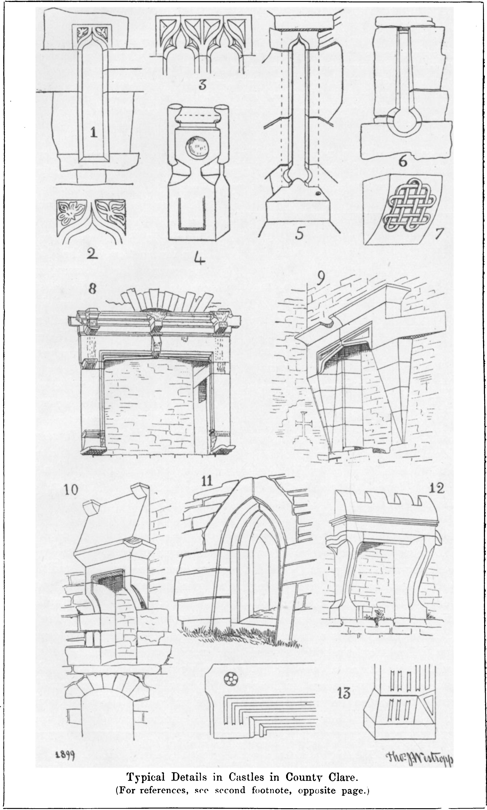

286 ROYAL SOCIETY OF ANTIQUARIES OF IRELAND.

“store” or kitchen on the ground floor, and then three or four stories each consisting of a single large room; the top room was usually roofed with shingles or thatch and rests on a vaulting over the other stories. The vaults usually retain marks of the wicker hurdles over which they were turned, and the fireplaces, as a rule, are much later than the castles, as in the present tower, where we find a well-cut example with the date 1642; nor do we see any fireplace in Clare with an earlier date than 1576, as at Castlefergus.

The top of the rock at Ballinalacken formed a bawn, and was defended by a wall, pierced by a late pointed arch under a machicolation. The castle was held, with others, by Teige M‘Murrough O’Brien in

1584,1 and at the earnest petition of Daniel O’Brien of Dough in 1654 was spared from destruction by the Commissioners for dismantling castles: — “A little castle which is already demolished by the Irish, by name Ballenalacken, which hath no bawne or barbican that stands as yet.” “But, however, your petitioner is afeard that the said masons out of malice or gain will fall doune {sic) the said stearcase of Dough or the ruinous Castle of Ballinalacken.” It seems evident from his petition that the “demolition” was only of its timber-work, though I find no evidence of its repair or subsequent habitation by the said Daniel O’Brien.2 The lands were confirmed to Captain W. Hamilton under the Act of Settlement in 1667.3

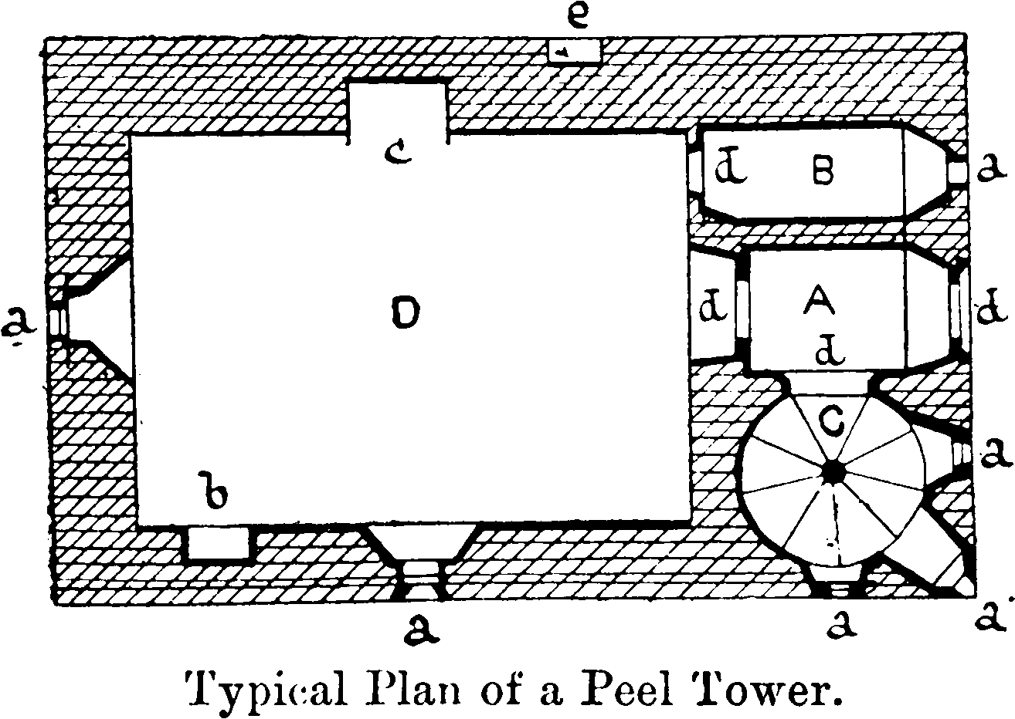

a. Porch, b. Porter’s Room (often opens into a). c. Staircase, n. Store, **a.** Windows, **b.** Ambry. **r.** Fireplace, **d.** Doors, **e.** Garderobe.

**Killilagh.**

Driving southward we pass few remains of much interest. To the east, up a cross-road, is a mound, called Knockaunacroghera, where, tradition says, “Boeothius Mac Clanchy hanged the Spanish grandee.” The legend refers to the merciless sheriff of Clare in 1588. We reserve further notice of him to our account of Liscannor. It lies near the entrance to St. Catherine’s, and is a heap of earth and stones, covered with coarse grass. Tradition says it is a “Spaniards’ grave,” where a number of the dead from the Armada were buried, and among them the scion of a noble Castilian house, which sent in later years emissaries on the vain errand of striving to recover the youth’s bones for burial in Spain. We pass Knockfinn cross roads, where Clanchy’s manor is commemorated.4 Between

1. MSS. T.C.D. (Castle List), “Diocese of Killaloe,” p. 570.
2. “Diocese of Killaloe,” p. 219.
3. Roll 19. and 20. Car. II., pt. 5.

See Inquisitions of Hugh Clancy of Tomolyn, 1579 (taken 1588). His son, Boetius or Boetagh Clancy, died 1580, and was succeeded by his nephew, Boetius, son of Hugh (MSS. 14. C. 2. R.I.A., No. 9). A short account of Boethius Clancy, 1588, appears in our Journal for 1890, p. 70.

PROCEEDINGS.

the road and the sea are several defaced forts. Glasha, Cahermaclancy (evidently the early residence of this family of brehons) and others, and the fallen cromlech of Cahermacrusheen. “S. F.,” for some unknown reason, identifies Doolin1 with the site of the battle of Corcomroe in 1317, i. e. only some fifteen miles astray. Killilagh Church, a long, late 15th century ruin, lies to the right. It is oblong in plan (57 feet 6 inches by 19 feet); the west gable had a square-oped belfry and window; the south door is broken, but had a pointed arch. There are a flat-headed window and an arch in the south wall, beautifully chisel- dressed; the latter leads into a small chapel, 17 feet by 22 feet, with three ogee-headed opes. The east window of the church has a neat splay, and a tall round-headed light.

287

Toomullin Church lies to the left of the road, near a stream which falls over a low shelf of rock near the ruin. It was a parish church in 1302; but the present building belongs to the same period as Killilagh. It is oblong, 33 feet 4 inches by 17 feet 6 inches. The west gable has a ruined belfry, once square-topped; a defaced door remains in each side wall, and a later addition, or priest’s room, 10 feet long, was built outside the old west gable, and communicates with the church by a pointed door. There is a round-headed south window and a trefoilheaded east window slit, with triquetras in the spandrels of the outer face under a hood-moulding.

Doonmacfelim Castle is a mere fragment, quite defaced, and with a vaulted lower room.

Knockastoolery fort contains a stone on which Sir Samuel Ferguson states that he found a defaced ogam inscription, which, however, only appears to be weathering. On the beach opposite these remains “P. D.”2 states that cocoa-nuts and other tropical fruits have often been found.

Doonagore Castle stands on the hillside above Bealaghaline Bay at the northern end of the mighty cliffs of Moher. It is a very perfect specimen of the round turret, and derives its name from a dry stone fort lying eastward, and quite levelled since before 1839. The name is understood to mean “fort of the goats” ; but the Gore family, its owners, claim it as bearing their own name. In fact the place was called Doonagore in the reign of Elizabeth, while the Gores came to Clare about 1653. Probably the use of the name long preceded “the spacious times of great Elizabeth,” when it was held by Sir Turlough O’Brien in 1584.3 The castle belongs to a class represented in Clare

1 Dublin University Magazine, vol. xli.,p. 89. Perhaps mistaking it for Dubhglen, i.e. Deelin and Glennamanagh, past which the army marched.

2  “Handbook to Lisdoonvarna,” p. 83.  
 3  Perrot’s Deed with the Clare Gentry.

288 ROYAL SOCIETY OF ANTIQUARIES OF IRELAND.

only by Newtown, Faunaroosca, and itself; the lower story has a vaulted dome, and a staircase leads round the thickness of the wall to an upper room. The present doorway is on the ground; but some have supposed that an upper ope represents the older door: this is oblong, 15 feet up, 3 feet high, and 6 feet wide. It has to each side a stone holdfast, possibly to let down a cover from above. Immediately over its lintel is another ope of equal length, but only 1 foot high.1 The tower is about 24 feet through and 50 feet high, and has the remains of a surrounding enclosure, or bawn, now in a very fragmentary condition, and built, like the turret, of thin flagstones.

**Moher.**

The cliffs of Moher have been frequently described and illustrated, from 1778, not only in tourist’s guides, but in works by our French neighbours, Mme. de Bovet and M. Martel,2 which admirably describe “les falaises de Moher ” and “ Le cap de la Sorciére.” They also appear in our ballad poetry in “The Monks of Kilcrea”:—

“Oh, Moher’s cliffs are steep and bare,

The wild gull builds her rude nest there,

The green sea foams below,

And rising sternly o’er the wave

Its rude assault they meet and brave,

As warriors front a foe.

While breaking surge and sheeted foam   
Roar round some shattered craglet lone.”

We need, in an antiquarian guide, only note that the most prominent points are Slievenageeragh, 668 feet high, Ailnasharragh, “the foals cliff,” down which a break-neck path leads to a talus of fallen rocks and the sea-shore, 603 feet below, O’Brien’s Tower (named from a modern tea-house, 587 feet high, and “Hag’s Head,” called “Kan Kalye” (Ceann Cailliach) in the 1560 map of Munster, 407 feet high. From these heights we enjoy a glorious view of sheer and dark ramparts, and foam-girt pinnacles, and an extensive coast-line.3 Connemara, with its peaks; Aran, the middle isle crowned by the walls of Dun Conor, distinctly visible; Liscannor Bay, the spire of Miltown Malbay behind Spanish Point, Caherrush, Mutton Island, the bold head of Baltard, Loop Head, and, if the day be clear, the vast mountains of Corcaguiney beyond the Shannon. Inland we note Burren, Elva, Callan, and the distant peak of the Telegraph Hill (1746 feet high) at the farther end of

1. Dublin University Magazine, vol. xli., p. 89.
2. “Trois mois en Irlande,” p. 280 ; “ Irlande et les Cavernes Anglaises,” pages 125, 126.
3. The “Battle of Magh Leana,” p. 99, classes together “a fight with a shadow, a cast of a spear against a cliff, an eye measurement of the ocean, or an idea of eternity.”

PROCEEDINGS.

Clare. There are remains of a fort on the edge of the cliff not far south from O’Brien’s Tower.

289

Hag’s Head is the only spot of any actual archaeological interest on these cliffs. One legend says the “Hag” was named “ Mal,” and pursued Cuchullin to Loop Head, springing after him to Dermot and Grania’s rock, and being dashed to pieces in attempting to spring back again. Her blood reddened the sea to Moher, and gave Malbay its name. Her shape formed by a natural arch the slope of the cliff, and a great pinnacle, resembling a grotesque head, can be traced to this day. On the headland stood the ancient fort called Mothair ui ruis, which gave its name to these precipices. It was a cliff fort, of the type so common round our coast, in Cornwall, and even in the Vosges and Switzerland, consisting of a dry stone wall across a neck of land, and was entirely demolished to build the telegraph tower early in the present century. John Lloyd, in 1778,1 thus describes this “famous old fort”:—“This Moher is on the summit of a very stupendous cliff, surrounded by a stone wall, part of which is up; inside of it is a green plain . . . This wonderful promontory, almost encompassed by devouring seas, and the opposite wild coast, affords a horrible, tremendous aspect, vastly more to be dreaded than accounted for.” The bridge near Hag's Head is called Cahermoher, probably from the fort. On the lower terrace the flagstones are often found marked by curious tracks of worms and annelids, and ought to be examined by geologists. In other parts fossil plants and true coal are found.

**“Kilstapheen,”** or “ **Kilstephen.”**

Tradition says that a submerged reef off Moher, at the mouth of Liscannor Bay, marks the site of the lost city and church of Kilstapheen, the key of which lies buried with the hero, Conan, under his ogam scribed slab on the side of Mount Callan. In Hall’s “Ireland”2 this city is said to lie at the mouth of the Shannon; and although one tale may have been transferred to a second place, I am inclined to think both legends are genuine folk lore, the belief in submerged cities and islands being very common; and indeed the inroads of the sea in historic times, and even in human memory, go far to justify it. The peasantry believe, or believed, at Moher, that whoever saw the domes and pinnacles of the lost town—over the waves, or dimly visible under the heaving waters— was doomed to die within a week.

“And point where high the billows roll

Above lost Kilsafeen.

Its palaces and towers of pride

All buried in the rushing tide,

And deep sea-waters green.”

We drive down the long slopes, and passing the fort of Cahernafurreesha, 1 “

1 “Impartial Tour in Clare.”

2 Vol. ii., p. 436.

290 ROYAL SOCIETY OF ANTIQUARIES OF IRELAND.

a horse-shoe on the cliff edge, reach Liscannor, noting the house of Birchfield, where resided the locally famous “Corny” O’Brien, “who built everything in the place except the cliffs and Liscannor Castle.” The holy well of St. Brigid and the O’Brien’s burial place, though a tourist resort, are of no antiquarian interest.

**Liscannor and the Armada.**

Liscannor is a little fishing village, with a tiny harbour on the site of an ancient fort. The castle is a gloomy old tower, 32 feet by 13 feet 8 inches, and 65 feet high, with a residence to the west, 30 feet 7 inches by 28 feet. It is all built of thin flagstones, and fairly perfect, though a long patch of wall has fallen. It stands on a bold, though low cliff, deeply undercut by the sea. It was held by Sir Turlough O’Brien in 1588, and here a great levy of the natives lay encamped to prevent any landing from the ships of the Armada.

Boetius Clancby, of Knockfin, was then sheriff of Clare, and seems to have been an energetic and merciless man, but, in any case, the lust for plunder so prevailed along the coast that little encouragement was needed to secure a bad reception for the ill- fated fleet. At last, on September 5th, 1588, at the close of a dark and stormy day, the watchers on the towering cliffs of Moher fancied that sails were visible beyond Aran, and next day a huge galliass, the “Sumiga,” lay in the bay before Liscannor. The crew sent out a boat, but the boiling sea prevented it landing, and only some wreckage and an oil jar lay on the beach. Next the patrone and purser came in a second boat to beg for water, but their piteous request was refused and they were driven off, and the purser arrested, and next day the Spanish ship was gone. Two ships, one being possibly the “Sumiga,” drifted down the coast. The one at high water passed between Mutton Island and the mainland and was wrecked and the crew of 2000 men massacred at Dunbeg. The second ship struck on a reef near Tromroe Castle, and met the same fearful fate. O’Brien, Clanchy, and Nicholas Cahane, the coroner, took care not to encumber the county with prisoners. The government only secured a few guns, and the rest of the plunder was so eagerly sought for that Cahane had no little difficulty in persuading a boy to leave the wrecks and take a letter to the Mayor of Limerick, for there were then no English settlers or soldiers in Western Clare.1

**Kilmacreehy.**

Kilmacreehy church2 lies east of Liscannor, near the shore. It is a melancholy little place, a long storm-lashed ruin of thin flagstones, the mortar washed out of their crevices. It consists of a nave (39 feet 7 inches by 22 feet 5 inches) and a chancel (35 feet by 17 feet), with a southern porch. There was a bell chamber on the western gable, as is usual in this district, and, indeed, as far as I know, over all Clare; for true bell towers are almost unknown in its churches.3 The chancel arch is pointed, and 13 feet 9 inches wide, and a plain stoup projects from the southern

1. See our Journal, 1889, pp. 131, 132.
2. There is a short description under the name “ Kilcready ” in our Journal, vol. ii., 4th Series, 1872-1873, p. 13. Mr. Frost also notices it, “History,” p. 107.
3. One occurs at Kildysert and one at St. Finghin’s, Quin.

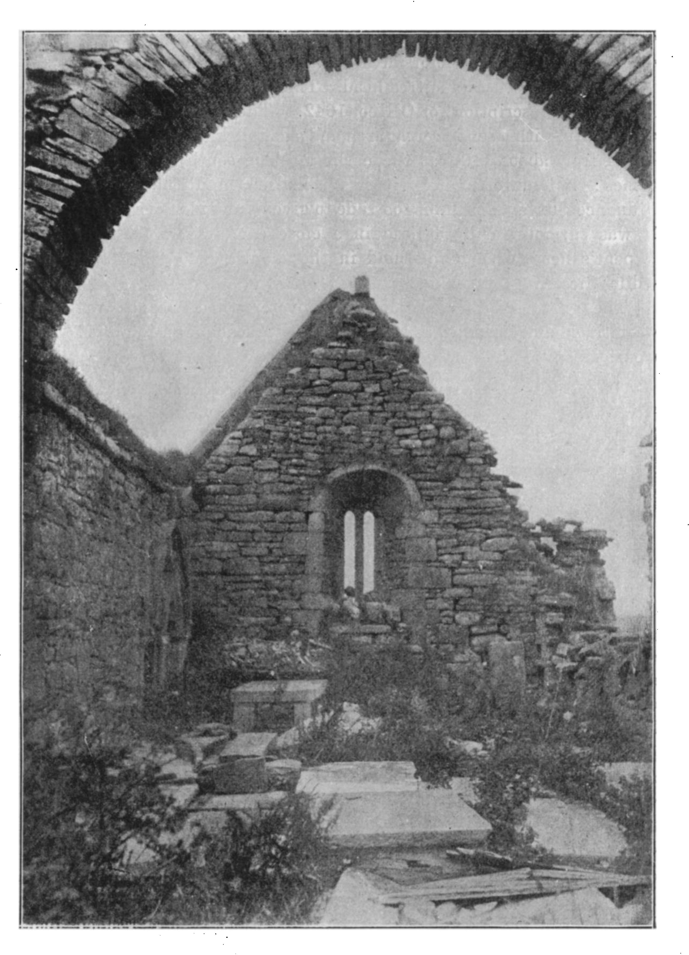

**Kilmacreehy, Co. Clare.**

(From a Photograph by RicharJ J. Stacpoole, d.l.)

292 ROYAL SOCIETY OF ANTIQUARIES OF IRELAND.

wall. The interest centres in the chancel. A sedile or tomb recess lay on each side; that to the north is entire, and is of very late and clumsy decorated gothic, two cinquefoil arches, with a quatrefoil overhead, and a heavy hood capped by a mitred head. There is a tombstone near it (bearing a Latin inscription) of O’Heo, 1642. The east window has a neatly made splay, with a semicircular arch and a double light with pointed heads, dating from about 1490 at the earliest. The south sedile had also two arches; but unfortunately it has collapsed, and the sketch in the Ordnance Survey Letters is too rude to give us any idea of its appearance. It was surmounted by a head in a close cap, which (with a curious serpent’s head, with a roll held in the mouth, belonging to the same sedile) lies in the window.

The graveyard is overgrown and overcrowded, heaped with large wormtracked and rippled flagstones. The Macdonough tomb (1745) has a curious epitaph :— .

“Here resteth Nick, whose fame no age can blot,

The chief Macdonagh of old Heber’s lot,

Who, while on earth, revived the ancient fame

Of his own line, and yt of all his name.

His fixt religion was his actions guide,

And as he lived beloved, lamented died.”

The place is called Kilmaccrik in 1302,1 but little trace of the older church remains. St. Maccreiche, or Maccreehy, is stated in a late mediaeval “Life” to have been a friend of St. Ailbe, of Emly, with whom he was living (circa 540) when Aed, son of Eochy Tirmcharna, king of Connaught, plundered Corcomroe. The natives accordingly sent to Emly to ask the saint’s advice and help. Ailbe advised him to hold a meeting at Cairn mic Tail, the place of inauguration of the chiefs of Corcomroe, and, escorted by his favourite disciple Mainchin, Maccreehy came to Tomfinlough, and persuaded St. Luchtighern mac Cutrito and another monk to join him and go as envoys to King Aed at Rathcroghan. Aed at first refused to see him; but suffering from fever and thirst the same night, which he attributed to the saint’s prayer, he got alarmed, and restored the spoil, swearing that he would never again plunder Corcomroe. The saint (it is said in his 80th year) built Kilmacreehy and two other churches at Inagh (circa 560-580); one of the latter, “Teampul na glas aigne,” left some trace to the present century. He also (probably aiding Mainchin) founded Kilmanaheen, near the dun, where resided Baoth Bronach, king of Corcomroe, who had given the site to the church. Maccreehy left a bell, which he had brought from Rome, to his own church, where for ages it was preserved and venerated.2

1. Papal Taxation Exchequer Rolls—“Calendar of State Papers, Ireland.”
2. Vita Sancti Maccrecii, quoted in notes to new edition of Archdall’s “Monasticon” (1873), p. 83. The “Annals of the Four Masters” date the death of King Aed in 574, which seems to throw doubt on the relations of Maccreehy and Ailbe, as the latter died thirty years earlier.

PROCEEDINGS.

His “ bed’’ lies far out on the strand, to the south of the church, and there can be no doubt but that the sea has made great inroads on this stormy coast. Beside the legend of Kilstapheen, we have the record of the great tidal wave that split Mutton Island into three parts in 902, and swept away 2000 people. The same story lies with the submerged bogs and tree stems at Killard, and with the bare little rock of Mattle (Inismatail) which was worth granting to the Archbishop of Cashel in 1215:-

293

“No legend needs to tell,

For story’s pen must fail to write What ruin paints so well.”

For many acres of land and many miles of coast must the “white toothed waves” have swallowed, even since the dawn of history, as the centuries passed by.

**Lehinch.**

We pass two bridges over the Daelach river, which preserves the name of one of the many brothers of the builder of Dun Aenghus, and note the lofty side wall of Dough1 (Dumhach or sandhill) castle, pierced with plain windows. Much of this tower fell in one piece about sixteen years ago, and lies in masses on the shore. It belonged to Daniel O’Brien, whom we noted at Ballinalacken, and who so hospitably and humanely sheltered many English settlers in 1641, for which even the Cromwellians spared his “strand hasse ” when he “feared the masons would fall down the staircase.” It stands among the sandhills, long the reputed haunt of the fairy king, Donn of the sandhills, one of which, “Crughaneer,” is still supposed to be haunted, which does not prevent the tract from being one of the best golf links in the kingdom. The rising bathing place of Lehinch has a good hotel on the railway. We may note of the name that the ancient form, Leathinnsi, ‘ half island,’ was used even in 1809 as Lehinsi, but most unfortunately, during the latter half of this century, the tourists, the railway, and the golfers are setting up the crude form “Lahinch,”2 which every conscientious antiquary and student of Irish ought to avoid and discourage, “ abhor, renounce, and abjure.”

1. Dough. As we meet not a few of the O’Briens of this castle and Ennistymon, we may note their origin at this place:—1. Daniel, brother of Donough, second Earl of Thomond, died 1579; 2. Sir Turlagh, died 1585; 3. Donal; 4. Teige; 5. Donogh, also resided at Inistymon, married Honora, daughter of Conor O’Brien of Lemeneagh; 6. Christopher; 7. Edward; 8. Christopher; 9. Edward, his brother Christopher is said to have survived to 1856. Edward’s daughter Anne married Hon. M. Finucane, Justice of Common Pleas, and their daughter and co-heiress Susanna married Wm. Nugent M‘Namara, of Doolin, 1798, bringing the estates to her descendant, the present owner.
2. It probably owes its diffusion, if not its origin, to that fertile field of strange spelling, Lewis’ “Topographical Dictionary,” which gives “ Lahinch or Lahenzy.”

294 ROYAL SOCIETY OF ANTIQUARIES OF IRELAND.

SECTION II.

SECOND EXCURSION.

Burren.

Burren Barony, with “the ancient hills and the deep that coucheth beneath,” forms one of the most weirdly fascinating and curious districts of our western coast. It has, it is true, none of the richly-coloured mountain domes which glorify the scenery of Kerry and Connaught; its coast is not walled in by shere precipices like Moher and Kilkee, nor has it the loveliness of lake and forest scenery, but its beauties grow upon the mind and ever freshen and increase as we explore its valleys and lonely uplands.

“Upon the left was Coreomroe and, next, nor far away

Was Kilfenora’s holy shrine and towers of Lemaneagh,

While full in front spread bleak and wild

Grey Burren’s rocks all shattered-piled,

Rugged and rough and drear and lone   
A weary waste of barren stone.”1

The terraced and white hills shining with strange lights, relieved by blue or violet shadows at high noon, glowing red and orange in the sunset, or turning grey and corpse-like as the dusk settles on the rocky yet grassy fields and barren crags awful with a sense of age-long loneliness and desolation. Barren crags they seem to the distant view, but we find them sheeted with ivy, with the dryad mountain aven, and, as the season changes, with wild violets and snowy drifts of anemones, with the deep blue gentian and the cranesbill, and many varieties of the fern. The rock slopes with filagree of waterfalls and runnels, the rock domes capped with the crumbling walls of some caher, the cromlech shining on the hillside—white at noon and red at sunset— and round two sides the “ever complaining sea,” beyond which, as the ancient dwellers in these hills fabled, lay isles of wonder; all these are felt with a freshness and fascination unfelt in more favoured places, and “we who labour by the cromlech on the shore, by the grey cairn on the hill, where the day sinks drowned in dew,” might wander long in the more picturesque tourist routes and find less of interest han we can glean in a few days from the rich harvest of Burren.2

1. “Monks of Kilcrea.”
2. Chiefs of Corcomroe. [presented below as single lists]

Chiefs of Corcomroe.—704. Celechar. 711. Ailechdai mcThalamnaic (i.). 737. Flan Fearna. 756. Torptha (i.). 760. Rechtabhra (i.). 840. Dubhriop, son of last. 871. Flaherty, son of last. 892. Celsus, son of last. 899. Bruaiteach. 902. Flan. 916. Ceat, son of Flaherty. 926. Amrothan (Anrudain), son of Malgorm. Argar. Maolechlain; his son, and chief elect, Lochlan, slain 965, in Brian Boru’s army in Connaught, and his son, Conor, was mortally wounded 985 (i.). 983. Lochlan (whence O’Loughlin). The Corcomroes divided as at present. 1002. Conor, son of Maolechlain; he died 1010 (i.) (whence O’Conor). 1026. Maolechlain O’Conor. 1105. Conor. 1113. Lochlain. 1135. Aed. 1158. —O’Conor slain. 1277. Donall Mantagh (w. t.). 1283. Donall, or Donchad. 1317 till after 1350. Felim the Hospitable. 1422. Rory, slain at Dough. 1431. Mortough slain. 1471. Conor, son of Brian oge O’Conor, slain at Leithinnsi (Lehinch). 1490. Conor, son of Donall.

Chiefs of Burren.—1028. Congalach O’Loughlin (i.). 1060. Annadh. 1105.

(?)Donnall. 1150. —O’Loughlin drowned. 1168. Conor Leathdearg O’Loughlin slain. 1200. Congalach. 1267. Conor Carrach (w. t.). 1281. Congalach (w. t.).

1396. Irial slain. 1389. Maolechlain. 1448. — O’Loughlin died. 1503. Conor, son of Rory.

(i.) Older Annals of Inisfallen,

(w. t.) Wars of Turlough.

PROCEEDINGS. 295

**Cromlechs and Cahers.**

295

As the districts, which we purpose to examine, are noteworthy for the great number of their forts and cromlechs, a few general notes on these structures may prove useful to some of our readers. Neither term is satisfactory, for the “forts” are not so much fortresses as courtyards, and the word cromlech simply meant a sloping natural rock, and is applied to leaning pillar stones and even stone circles; but as in this country it has an unequivocal meaning, and is more familiar than dolmen (which can also mean a holed stone) we prefer to use it. The natives call cromlechs “Lobha yermudh’ augus Granya’ ” (Dermot and Grania’s beds) or simply “lobbas” or “granny’s beds,” in allusion to the legend which made them the couches or shelters of those famous fugitives, and they tell how Dermot put seaweed on the top slab of one, when Finn bit his prophetic thumb; and, finding the seaweed was over the lovers, believed they were drowned, and gave up the pursuit. The wider spread tradition regards them as graves, and in the few instances where they are called “altars,” it is in the Christian sense with legends of the Mass having been celebrated on them in penal times. The Clare ones are as a rule boxes of five stone slabs, the breadth tapering, and the top sloping eastward; the tops of the sides frequently have been hammer-dressed to the required slope; they have usually been covered by mounds or cairns, and some contained human skeletons; while I only know of one find (of a gold fibula) near the cist on Knockalappa. Though cists are mentioned in Irish Literature, there is no case, so far as I know, recorded of the erection of an actual cromlech.1

The forts in plan, construction, and even in name (“dun” in Ireland, “duna” in Bohemia, “ dounon” in the Greek geographers) are identical with others of a series extending across Europe from Bosnia, Bohemia, Thessaly, and Esthonia to Scandinavia, and our islands. Had our antiquaries taken this broader view, we would have been saved from such narrow theories as attributed our cahers to the sons of Huamore (who dwelt in nine raths before coming to Clare, and were nearly exterminated soon afterwards) to sea rovers (who would never have built them on inaccessible cliffs several miles from a bay, or on inland crags), to the Danes or the monks; these theories were made by persons who only thought of a few of the finest, and therefore most exceptional, out of hundreds of our forts. These enclosures probably date over a space of two thousand years from the Bronze Period to the eleventh century of our era, and show traces of rebuilding and repair. Macgrath shows that they were passing out of use in 1317—1318.2 Our oldest records bristle with statements as to their founders and features, and treat as commonplace present day facts the walls built in sections, the stone gate-posts, the chipping of the blocks, scaffolds, souterrains, and excluded water supply, stone huts, triple ramparts, and pillar stones near the wall.3

1. Proc. R.I.A., 1897, vol. iv., Ser. iii., p. 542.
2. “Ruan of the grass-grown hollow cahers.” “Even a man in a cahers ‘cave.’ ” —“Wars of Turlough.”
3. Pillar near fort, “Book of Fenagh” and “Tain bo Cuailgne.” Triple fort (Todd Lecture Series, R.I.A., vol. iii., No. 830), “Book of Lecan”; “Poem of Seanchan.” Chipping blocks: scaffolds used in the building of Grianan Aileach, “Leabar Breac.” Walls built by separate gangs, “Seanchas Mor,” vol. iv., p. 123. Souterrains (“Battle of Magh Leana,” p. 7). Wells near forts, Adamnan’s “Life of St. Columba ” ; “Colloquy of the Ancients ” (“Silva Gadelica,” p. 195).

296 ROYAL, SOCIETY OF ANTIQUARIES OF IRELAND.

Though none of the Clare cahers1 equal Dun Aenghus, Dun Conor, or Dunbeg in grandeur, we must remember that those fine structures have been so much rebuilt and tampered with as to be of little evidential value to antiquaries, while the Clare cahers are untouched by the restorer. The vast majority of the seven hundred forts of Burren and the adjoining baronies are simple ring walls about 100 feet across, often without terraces or steps. The walls have two faces and loose filling, they are 6 to 10 feet thick, and about the same height. The gateways usually face the south or east, and are about 4 feet wide, and 4 to 6 feet high, with long stone lintels, and sometimes side posts; while in the larger forts walls from 17 to 21 feet thick, sometimes in two or three layers are not unknown; owing to the supply of timber being abundant, traces of stone huts are rare, and I do not know a perfect example in any Clare fort. The largest cahers in Clare are the triple walled forts of Moghane, 1500 by 1100, Langough, Cahercalla, near Quin, and Cahercommane on the Glasgeivnagh plateau; the double-walled Cahershaughnessy and Glenquin, and the caher of Ballykinvarga, with its chevaux-de-frise.2

**Ballyvaughan.**

We drive up the plateau to the north of Lisdoonvarna, and getting distant glimpses of the sea and the churches of Kilmoon and Killeany, drive down the winding road at the Corkscrew Hill, with a fine view of a long valley reaching to Galway Bay. We note the O’Loughlin Castles at Gragan and Newtown (the latter a round turret), and the church of Rathborney, an interesting late building.

We soon reach Ballyvaughan village, a quiet little place with hotels, and occasional steamboat service to Galway, making it a very good centre for botanists and geologists. Three small forts and the much levelled ring of a great caher lie near the quay. It takes its name from the family of O’Beachain, and passed into possession of the O’Briens about 1540, in consequence of a small act of lawlessness told at some length in an ancient deed. “The son of the Madra dun” (dun dog) stole a cow and brought her to Laois O’Lochlain, and the townland became forfeited and subject to a fine of fourteen cows. The successors of O’Lochlain endeavoured to alienate the “town” to the O’Briens, a number of whom came to witness the giving of possession. As might be expected in those rough times and hostile clans, great lawlessness ensued. The wife and servants of a certain Mahon Ballagh got killed, other people wounded, and the value of five suits of clothes plundered by the followers of Teige O’Brien. The aggrieved survivors “set up three crosses of interdiction” at Bally- vaughan, and got heavy fines of cows, sheep, goats, eighteen litters of swine, a woman’s gown, a shirt and barread, and three groats for “a

1. In drawing this distinction we must, however, remember that the Aran Isles

belonged to “Clare” in early times.—“Book of Rights.” .

1. Moghan and Langough (Journal R.S.A.I., 1893, p. 281); Cahercalla (*I*bid., 1896, p. 150); Cahershaughnessy (Ibid., 1893,p. 287); Cahercommane (Ibid., 1896, p. 154); Glenquin (Ibid., p. 365) ; Ballykinvarga (Ibid, 1897, p. 121).

PROCEEDINGS. 297

milch cow carried off by Teige O’Brien and left dead on the way.” But it would appear all the same that the O’Briens kept the townland.

297

**Lough Rask.**

The little lake of Lough Rask (Rasga) lies on our right after leaving the village. It is only noteworthy as being the scene of a most circumstantial banshee story, written in the lifetime of many contemporaries.1 It is curious to find in a history authenticated even in minute details by other records such wild tales as Macgrath tells about the “Genius of Erin.” “The Sorrowful Badbh of Burren,” and “The Washer at the Ford,” but, as we pointed out on a former visit, the Banshee is still very real to many in Clare, and we know, and have known, several persons who assert the reality of such apparitions on their personal knowledge, and have heard many more such tales at second hand. Macgrath2 revels in a group of some ninety adjectives and epithets in his endeavour to depict the loathsome and hideous “apish fool,” with every attribute of malignity and unblessed old age. The loathsome creature was “thatched with elf locks, foxy grey and rough as heather, long as sea weed, closely matted,” a bossy, wrinkled forehead, every hair of her eyebrows like a strong fish hook. As for the other details they scarcely bear translation. We can almost see her crouching on the bank of Rasga, with “cairns” of bloodstained heads, limbs and weapons, washing them till the lake was stained with blood, and brains, and hair, as she foretold to Prince Donchad O’Brien, before the dawn of an August morning in 1317, his impending doom and that of his army. “I am Bronach and all your heads are in this slaughter heap.” Then the angry soldiers tried to seize and throw her into the lake, but she rose on the wind and flew away. “Heed her not, she is a friendly ‘badbh’ to Clan Turlough, and wishes to save them,” said the ill-fated prince, and he marched on to Corcomroe to rest under the abbey pavement ere another day had dawned.

**Dromcreehy and Muckinish.**

With better auspices we follow the route of the army round the foot of the hills and pass Dromcreehy church, a heavily ivied and

1. “The Wars of Torlough,” by John, son of Rory Mac Craith (Magrath). It can scarcely be too often impressed on our readers that O’Curry’s statement that this work was written in the fifteenth century is absolutely wrong. It only rests on a statement of Andrew Mac Curtin, in the late (1721) manuscript in Trinity College, Dublin, which very probably refers to the old manuscript from which he made his copy. John Mac Grath expressly states that Mortough O’Brien was dead, and Dermot O’Brien was reigning in prosperity, and that Felimy O’Conor, of Corcomroe, still lived. Now Dermot was deposed in 1360. Felim O’Conor died 1365; of his repute in Thomond, it is stated that it “has had no ebb, but he daily and widely increases it.” The “Story of an Irish Sept,” p. 143, alleges that Magrath died in 1425, “a prosperous and wealthy man,” but if we verify this, we find that it refers to the son of Flann Magrath, not John, son of Rory. So we see that the work is by a contemporary, and dates between 1343 and 1360.
2. “Wars of Torlough,” 1317.

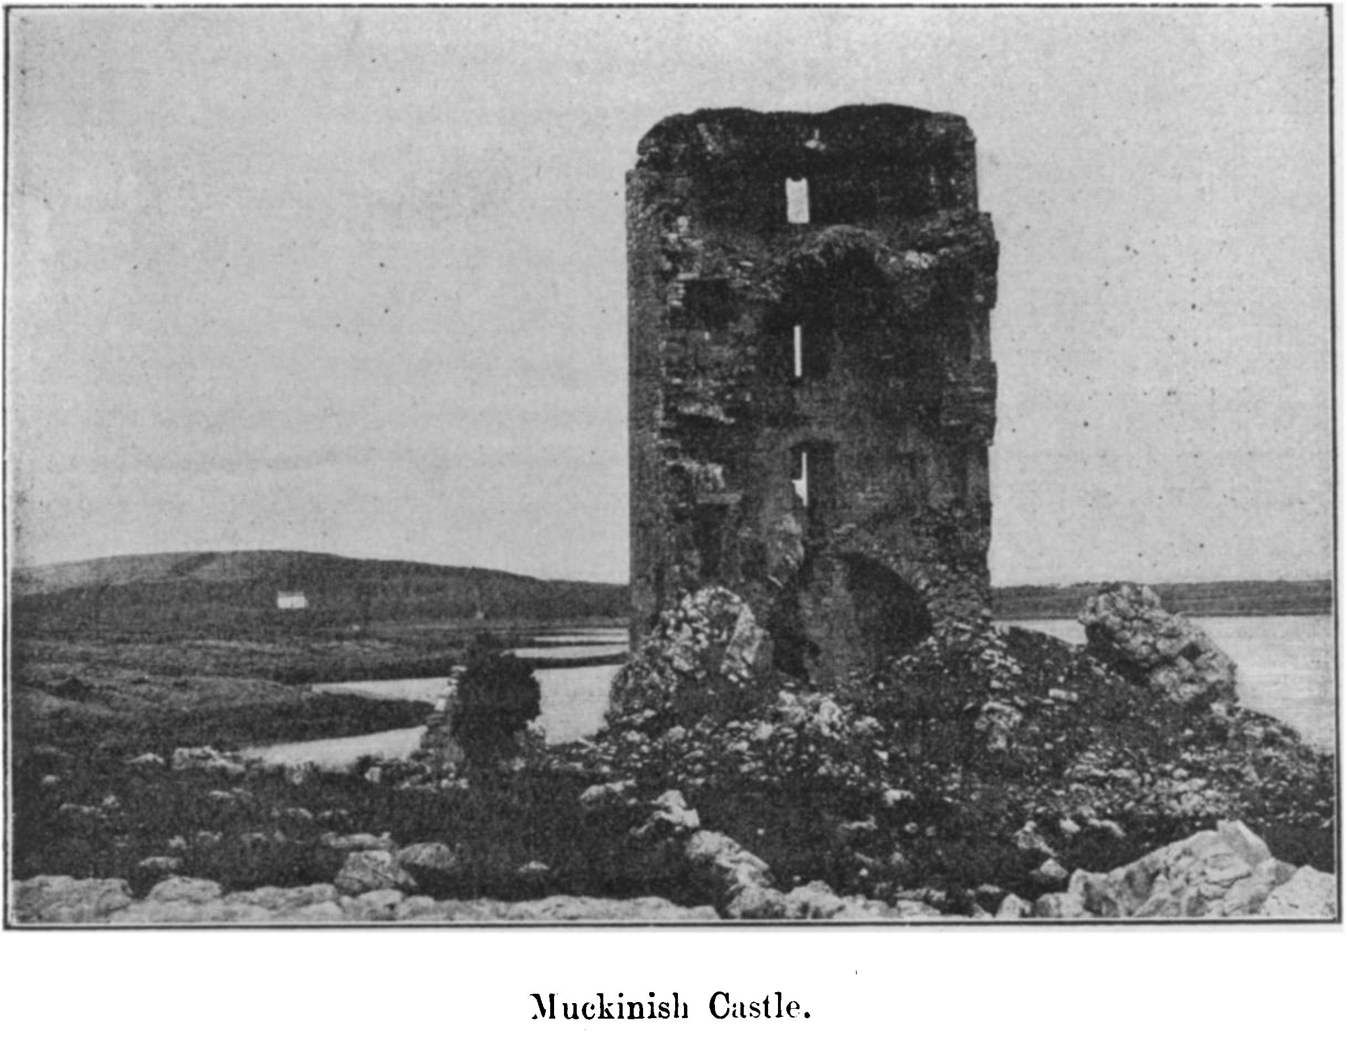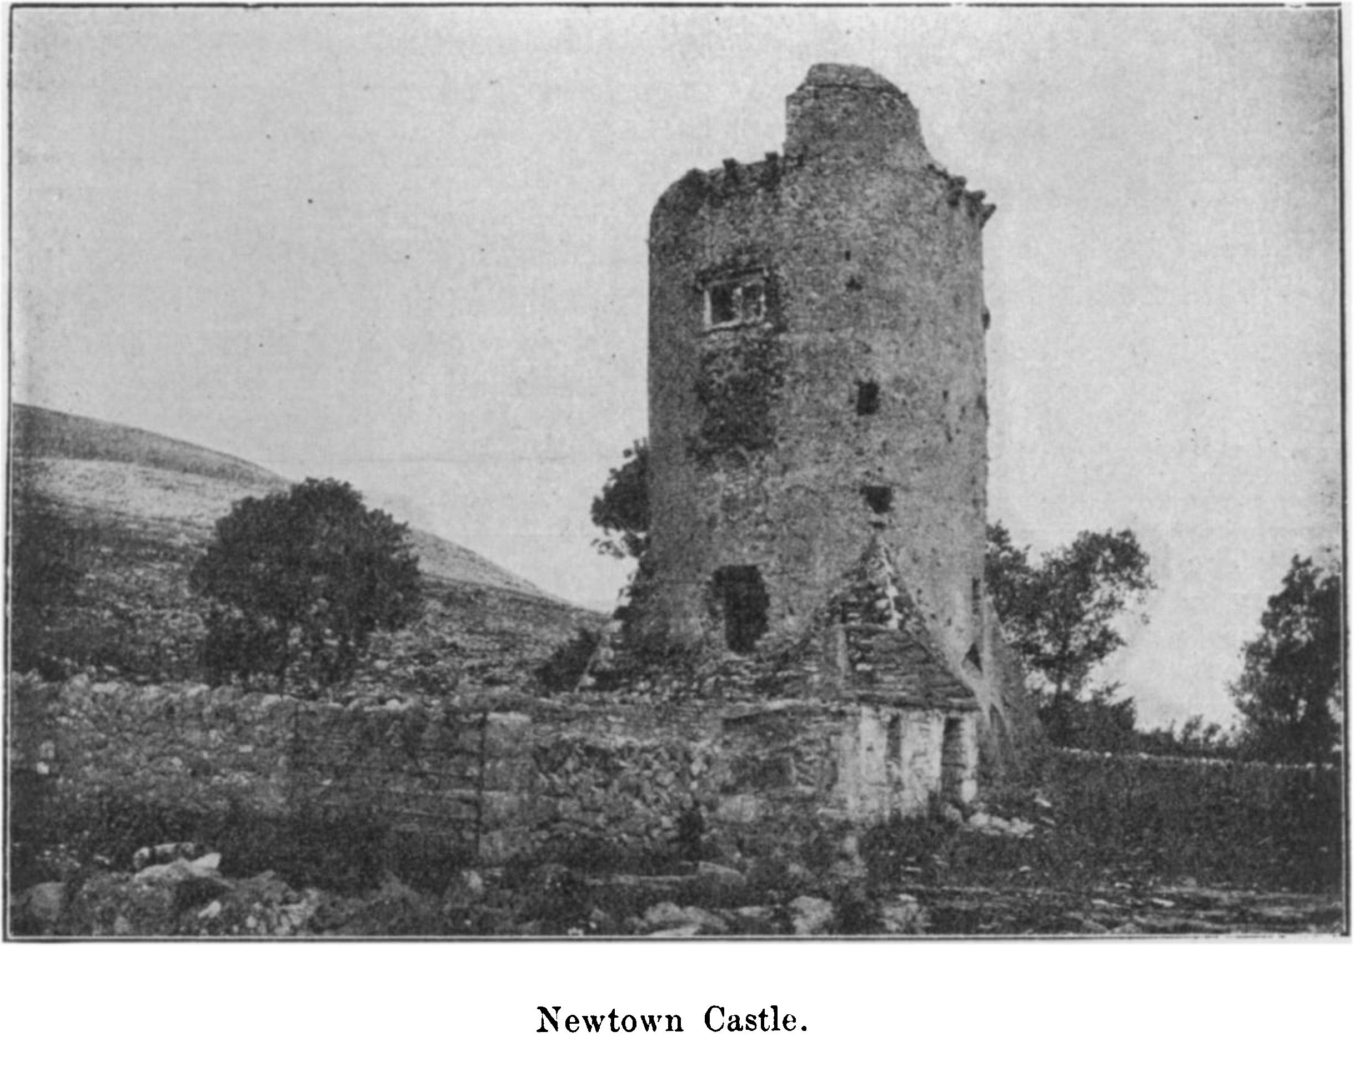

PROCEEDINGS. **XVV**

half -fallen ruin. It has a neat eleventh-century south window, and a late north door, similar to the west doorways of Quin Friary and Abbeydorney. The building had a nave 45 feet by 21 feet, and a chancel 36 feet by 18 feet. The name, I know not on what ancient authority, is rendered ridge of Criothmhaille or Crughwill, but the townland of that name lies far to the south, and the 1302 Taxation calls the parish Drumcruth. We pass the village of Caherloughlin; its great fort is now overthrown and partly levelled, being divided into fields. The plain old tower of Shanmuckinish stands on the neck of the peninsula of Muckinish (Pig Island).1 The tower is said to have been named in jest as being three years older than the second Castle of Muckinish, but it seems later than its neighbour. Uaithne More O’Loughlin lived there till 1740. It measures 28 feet 6 inches by 25 feet 6 inches, and is about 74 feet high, with good limestone chimney- pieces. The half next the creek slipped down unexpectedly about sixteen years ago. From the road above it we get a pleasing view of the tower, seeming to be almost perfect, with the wooded hill of Finnevarra for a background, and the sea and Pouldoody to either side, for it overlooks the latter famous oyster bed. About half of the second castle remains, a picturesque and very characteristic ruin. We soon see the little turret of Corcomroe Abbey across the creek, and pass round by the village called Bealaclugga, “the ford of the skulls,” from some forgotten combat.

299

**Mortyclough Forts.**

Parkmore rath lies down the creek on the eastern side. It is a double ringed fort 214 feet in diameter, with a most curious double souterrain 26 feet long. At the inner end you creep through an ope in the roof into an upper chamber, whence you descend into a sloping passage which leads into a lower gallery 14 feet long, and at right angles to the first passage. Mortyclough has a rath and ruined caher, each with a souterrain.2 The name has been supposed to be derived from the grave of Mortough Garbh O’Brien, 1317, who fell, however, on the ridge to the west of the monastery, and was buried in the chancel, so probably O’Curry was right in preferring to derive it from “Mothair tighe cloice,” the enclosure of the stone house, which well describes the fort.

**Corcomroe Abbey.**

“The Abbey of St. Mary of the Fertile Rock” (de petrá fertili) or “of the green rock” (de viridi saxo) has been fully described in our Journal and Guide for 1895, so we need only study the salient points of its history and architecture. It was founded about 1182 by Donald More O’Brien, King of Munster, and was a daughter of Suir Abbey. In

1. The views of Muckinish and Newtown were kindly lent by the Royal Irish

Academy. "

1. Journal of the Society, vol. i., 1849-51, p. 294.

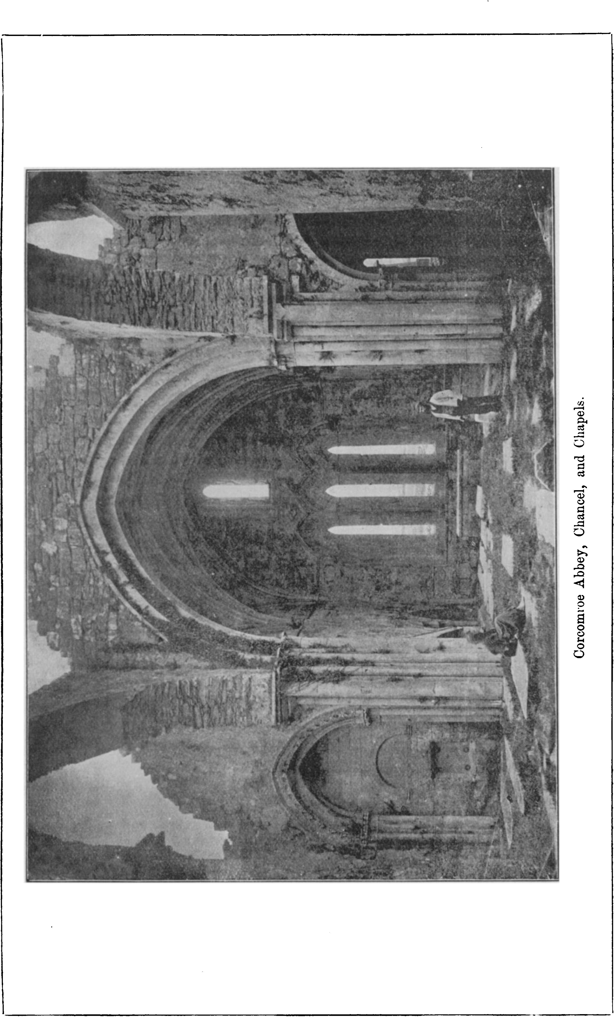

PROCEEDINGS. 301

1249, however, it was placed under the rule of Furness Abbey, in Lancashire, and probably received monks from that place. Conor na Siudaine O’Brien, grandson of Donald, seems to have been a benefactor, and passed for the founder in one local legend, while a second version said that it was built over the spot where he fell at the camp of Siudaine in 1267 or 1268. Although there seems no evidence to locate Siudaine near Newtown Castle, as in the Ordnance Survey maps, it must have lain some distance from the abbey towards Drumcreehy. However, the dead prince was brought back to the monastery and laid in the place of honour at the north side of the chancel, “ honorably” interred, and “over his place of rest” the monks “set up his tomb.”1

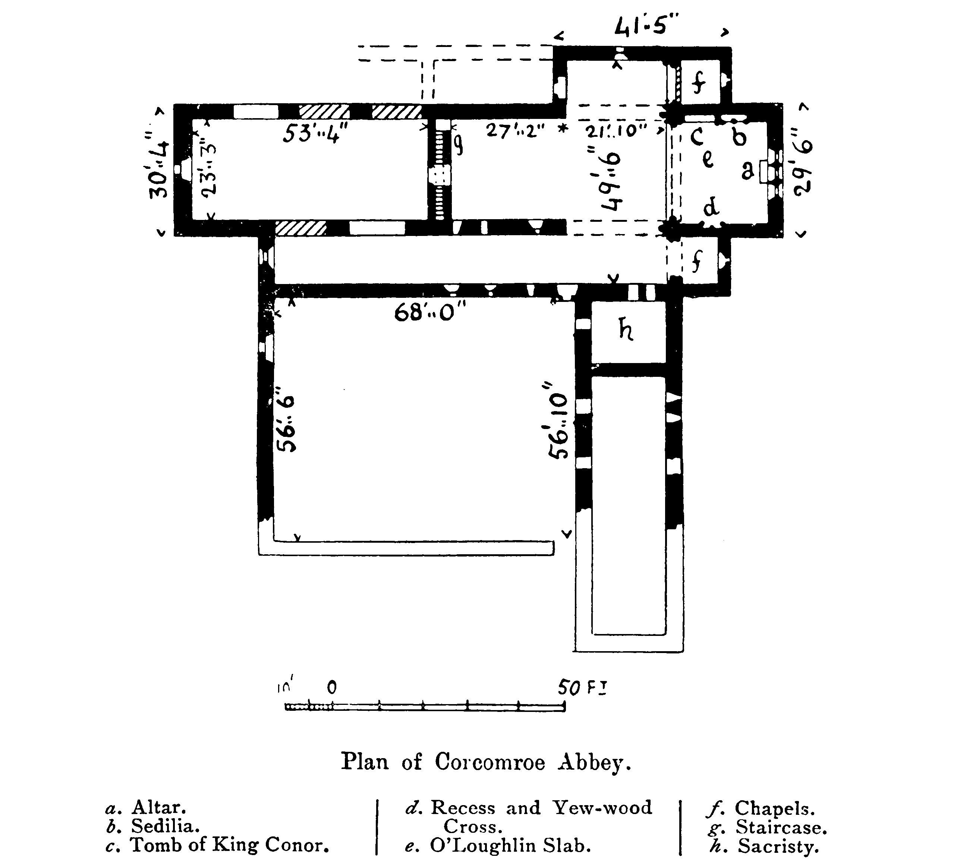

The abbey was used as a barrack by Dermot O’Brien and his forces, in August, 1317, the night before the fierce battle of Drom Lurgan or Corcomroe was fought on the ridge to the west of the monastery. We read of the “arable land,” “stone enclosure, polished stones, whitewashed walls, and smooth grave-flagged sanctuary,” and in its aisles next evening were buried heaps of the slain, each clan in its grave,

1 “Wars of Turlough.”

302 ROYAL SOCIETY OF ANTIQUARIES OF IRELAND.

while the chiefs of the defeated faction, Prince Donchad and his kinsmen, Mortough Garbh and Brien Bearra O’Brien, were laid under stones cut with distinctive marks, but now “their memorial has perished with them.”1 A learned poet, Teige, son of Donough O’Daly, was buried here in 1514. At the dissolution it was granted to Murrogh, Earl of Thomond, 1544, and twenty years later to Donnell O’Brien, the last native prince, as a bribe to forego the chieftainry. Donough, brother of Dermot, Baron Inchiquin, obtained it, 1584, and a certain Richard Harding in 1611. Yet the monks subsisted in 1628, when Friar John O’Dea, an Irish monk of Salamanca, was appointed abbot. It now belongs to William Molony, Esq., of Kiltanon.2

The ruins consist of a church and small cloister, with ranges of defaced domestic buildings to the east, two detached houses to the south, and an enclosed park with a gate tower to the west, of which the upper part has fallen since 1839. A well named Tobersheela gushes out of the crag in the enclosure to the south-east. The church is cruciform, and consists of a very plain nave, with pointed arcades and doorway, the west window and clerestory lights having semicircular heads, as is so common in our religious edifices of that date. Much of the arcade is now closed. The arches are spaced unevenly, and at a point 52 feet from the west a plain massive wall with a low pointed doorway and a plain bell turret has been built to enlarge the ritual choir by 49 feet, including the space between the great round arches leading into the transepts. Up to this point all is of the plainest work, but the chancel and chapels are of rich and deeply interesting Norman transition. The older chancel is nearly square and richly groined, one rib with a fishbone pattern. There were traces of fresco painting in the groining, red, black, drab, and perhaps green, when I first saw it in 1878. The altar is complete, and stands before a triple light Gothic window with a single light overhead. The plain tomb recess in the north wall is occupied by the effigy of Conor na Siudaine, a most interesting monument, and, with the O’Conor tomb in Roscommon, one of the only figures of an Irish chief. Conor is cleanshaven, with long hair falling in elaborate locks. The features have been described by a well-known antiquary as “noble and full of repose,” but are crudely conventional. The crown is greatly defaced, but was decorated either with fleur de lys or trefoils. The left hand holds a sceptre of similar design, the right some object, probably a reliquary, suspended round the neck of the figure. The robe falls in long pleats to below the knee, and the figure seems to lie upon a cloak. The feet are shod with pointed shoes open on the instep (not, as so often stated, in “pampooties,”

1 They lay across the church from north to south in this order:—1. Prince Donough. 2. Brian Bearra. 3. Mortough Garbh. 4. Teige Luimneach. 5. Torlough mac Teige (“Wars of Torlough,” Mr, S. H. O’Grady’s translation, p. 107).

2  Journal 1895, pp. 280-283 ; “ Triumphalia Chronica S. Crucis,” pages 95, 101, 143, 145, &c. Frost, “History and Topography of Clare,” p. 22.

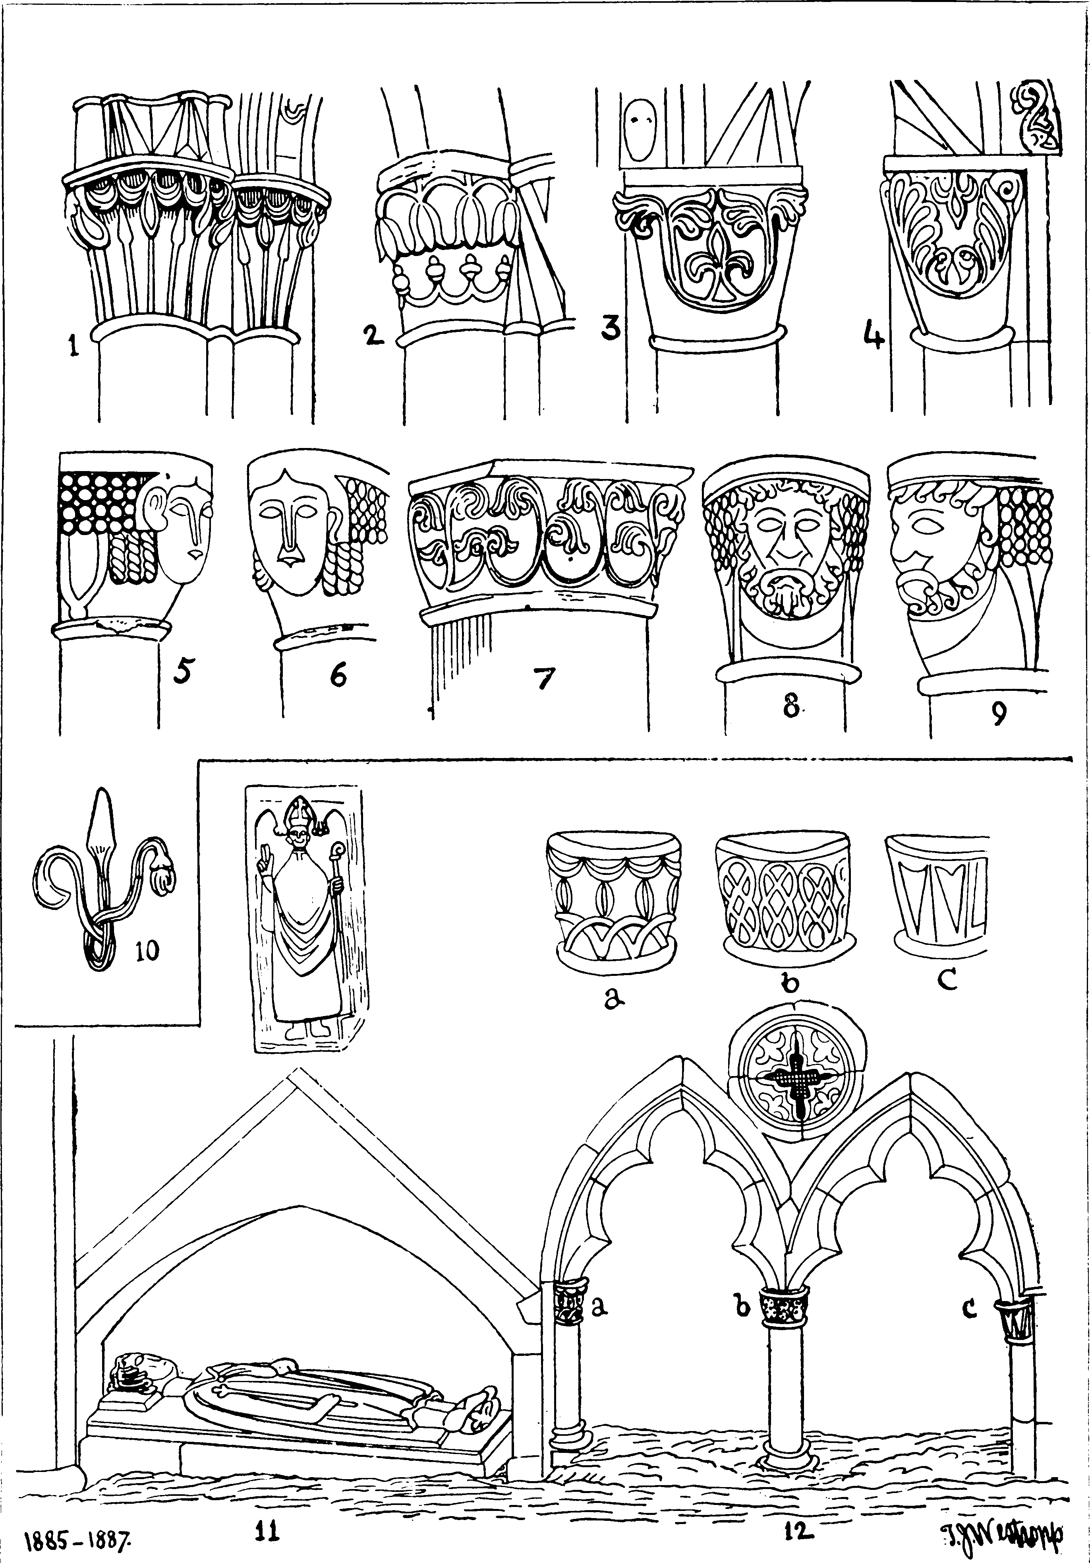

**Details in Corcomroe Abbey.**

1-9. Capitals of Chancel and Side Chapels. 3, 4, 10. South Sedile. 11. Tombs of King  
Conor O’Brien, 1268, and a Bishop. 12. North Sedilia.

304 ROYAL SOCIETY OF ANTIQUARIES OF IRELAND.

such as the islanders still wear) and rest upon what appears to he an elaborate cushion, covered with fleurs-de-lys, which some assert to be a dog.1

The capitals of the chapels and chancel are elaborately carved with floral and other designs, except two in the south chapel, which are decorated with most archaic and curious human faces.

Over Conor’s tomb a somewhat crude figure of a very smiling bishop is set in the wall, and there is a double sedile; in the opposite wall is a recess of good transitional work. A slab or wooden coffin lid with a raised cross is laid in this recess and is said to be of yew wood.2 Some late tombs with Calvary crosses and the later slab of “O’Louglin, King of Burren,” lie in the chancel.

East of the Abbey the “corker road,” the ancient Carcair na gCleireach (clerics’ prison), over which Hugh O’Donnell twice retired after his successful raids into Thomond in 1599 and 1600, runs over the ridge.

Oughtmama.

Up the hillside to the south-east of the abbey are the three very ancient churches of Oughtmáma, which, having been described by Brash, Dunraven, and in our previous guide,3 need only be noted as being (1) a large early church with a nave and chancel, a choir arch with a semicircular head, a west door with inclined jambs, and a curious font, carved with two struggling animals.4 (2) Close to the east end is a small oblong oratory with an arched door, little later than the first church; (3) while to the N.E. remain the foundations and east gable of another oratory. The well is dedicated to Colman, an unknown saint, perhaps MacDuagh or one of the three Colmans of this place in our martyrologies. The name Oughtmáma means “breast of the pass,” and the site is utterly lonely and deserted, though once occupied by a considerable village.

**Ballyvaughan Valley.**

We return from Corcomroe Abbey by the same road through Ballyvaughan, and then, keeping along the valley, pass the round castle of Ballynua or Newtown, where the O’Loughlin, “King of Burren,” resided till the beginning of this century.5 It differs from Doonagore and Faunaroosca in being later, and more elaborate, with spiral stairs and a square base. Rathborney Church lies to our right, an interesting

1. “Journal P. M. D.,” vol. ii., pp. 274-278, gives a careful description of King Conor’s tomb by Lord Walter Fitz Gerald. See also Gentleman s Magazine, 1864, Part i., “Notes on the Architecture of Ireland,” pp. 283, 284.
2. Bishop Pococke, in his “Tour,” p. 107 (edition 1891), notes of Corcomroe, that “On the graves are laid tombs of wood, many of them being of yew, with some remains of inscriptions on it.”
3. Journal, 1895, p. 283. Frost, “History of Clare,” p. 25.
4. The head of the east window, scooped out of a solid block, lies near the west door, and is reputed to cure headache, if the patient lies down and places his head in the opening.
5. Edward, the present “King,” resides nearer to Ballyvaughan.

PROCEEDINGS. 305

church (56 feet 6 inches by 21 feet), with door and windows of about the year 1500. A double oped holy water stoup1 occurs in the door jamb. The rath, which gives it its name, remains in the graveyard.

305

In the valley behind it occur a cromlech, the ruined cahers of Lismacteige and Feenagh, and the fine half-moon rampart of massive masonry on the edge of a low cliff and called Caherlismacsheedy, of which I hope soon to give plans and descriptions in our pages.

At the end of the valley, among thick trees, is Gragan Castle, the chief seat of the O’Loughlin’s in late mediaeval times. It consists of a low oblong tower with three vaulted rooms below. A straight staircase leads up to a large room with a grey marble chimney piece. A baun surrounds the tower. There is a nearly levelled caher with two concentric rings near which the Corkscrew Hill is ascended by a boldly-designed road, from the summit of which we see the whole valley to the sea, with both ranges of terraced hills, and return again to the uplands near Lisdoonvarna.

**Killeany and the Caher Valley.**

If time allows, the ancient church of Killeany and the forts of Cahercloggaun and Cahermoyle ought to be visited. Killeany is dedicated to and was probably founded by the evangeliser of Aran, St. Enda or Eany, living in the late 5th century. It mainly dates from the earlier 15th century, but the east gable is probably four centuries older, and possesses a well-built round-headed window adorned with a snake knot on the outside. The chancel arch is pointed, and the west end was walled off, probably for a priest’s residence. The church consists of a chancel 35 feet by 20 feet, and a nave 19 feet long and 19 feet 9 inches wide. The only tombstones of note are those of Honora Neylan, 1725, and Father Moriargh Flanagan, priest of the parish, 1772.2 There is an altar in the graveyard, with numerous round stones laid upon it.

Cahercloggaun was till recently a fine fort on a knoll to the west of the church. Its wall abounds in unbroken joints. The grass-grown masonry of the O’Loughlin’s Castle is heaped to the west end, but even some years ago it and the fort were being destroyed to mend the roads, and no one was willing to take steps to stop this disgrace (so wanton an injury in a land of far too abundant stones), so another object of interest may probably be lost to Lisdoonvarna by the apathy of its inhabitants.

The steep bluff of Slieve Elva rises boldly above its strip of trees, at this point; if we pass round it we go down through a desolate region of crags and brushwood into the Caher valley, which is traversed by a stream, and attains considerable grandeur and rugged beauty at the so-called “Khyber Pass.”

1. Similar stoups occur at Kiltinanlea, Canon’s Island, Clonlea, Carran, and Kilfarboy, in this county.
2. “Journal P. M. D.,” vol. iii., p. 228. Frost, “History and Topography of Clare,” p. 31. O’Hanlon’s “Lives of the Saints,” iii., p. 915.

306 ROYAL SOCIETY OF ANTIQUARIES OF IRELAND.

Near the bluff of Slieve Elya we find a remarkable pit in the limestone which leads to an underground river, a mysterious place like that in the poet’s dream:—

“Where Alph, the sacred river, ran

Through caverns, measureless to man,

Down to a sunless sea.”

The late Dr. William Stacpoole Westropp and several friends once explored these extensive caverns with no little risk and difficulty. The stream falls over a high shelf of rock into a pearly natural dome, whence runs a long low passage, which eventually communicates with a lateral gallery, up which exists a still finer but similar dome, a waterfall bursting through a cranny high up its flank. The caverns down stream lead towards Killeany church.

The defaced forts of Cahermoyle, built of huge blocks, and Lisheeneagh, the two ring walls called Caherbullog, the cromlech of Cooleamore, and many other lesser forts remain near the southern end of the valley. Slieve Elva was the traditional scene of seven battles fought in the third century by the great king, Cormac Mac Airt.

A short distance to the west of Cahercloggaun we notice the very old side wall and crowded tombstones of Kilmoon. The ruin is of little interest save for a mitred head on a corbel. A lofty pillar stone called “the Cross” stands at some distance to the east. The founder of the church has been asserted to be St. Muadan, but as the place was Kilmugoun in 1302 and the well was dedicated to Mogua, it was probably founded by the patron of Noughaval.1

There is, or was, a “cursing stone” at Kilmoon; whoever wished to invoke misfortune on an enemy fasted and “did” certain turns “against the (course of the) sun,” and turning the rounded stone with appropriate curses you twisted awry the mouth of your victim. Not many years since a certain farmer appeared at Petty Sessions accused of beating a beggar woman, and he urged in his defence that “she had threatened to go and turn the stones of Kilmoon against him.” 2 After passing Kilmoon we very soon reach Lisdoonvarna.

(To be continued.)

1. The name Mogua could, however, scarcely evolve into “Moon” by any system of corruption.
2. Rounded stones lie on the altars of Kinallia, Killone, and Temple na neave, near Ross, but I have never heard of anyone having “turned the maledictive stones” at these places.