THE JOURNAL

OF  
THE ROYAL SOCIETY OF ANTIQUARIES  
OF IRELAND

FOR THE YEAR1916  
VOL. XLVI, PART II  
(VOL. VI. SIXTH SERIES—VOL. XLVI CONSEC. SERIES)

**NOTES ON CERTAIN PRIMITIVE REMAINS (FORTS AND  
DOLMENS) IN INAGH AND KILLEIMER, CO. CLARE**

Introduction

Islands barony

Inagh District

Teampull dubh na hAighne

Legend of Skaghvicencrowe

Mount Callan

Carncreagh

Kiltumper

Leckaun

Clochaun an Airgid

Drumanure

Ballyhea South

Clonderlaw

Kilrush

Carrowdotia

Cahernagat

Liss

Other Forts

Addenda (Part xvi)

Introduction

Ballyalla Lake Crannogs

Claueen Crannog

Killone Group

Kilquane

Ballymacaula

Kilmorane

Barloughra

Newhall

Feeagh

Ballybeg

Bunratty Upper

Rathclooney

Kylebay

Cauher

Lisnagleeragh

Dromoland

Ballysallagh

Pillars

Bunratty_Lower

Thady's Hill Fort, Kilconry

Lisconor

Ballynoosky

Caherforia

Caherscooby

Bunratty

Mote

Caher

Rosroe

Langough

THE JOURNAL

OF

THE ROYAL SOCIETY OF ANTIQUARIES

OF IRELAND

FOR THE YEAR1916  
VOL. XLVI, PART II  
(VOL. VI. SIXTH SERIES—VOL. XLVI CONSEC. SERIES)

NOTES ON CERTAIN PRIMITIVE REMAINS (FORTS AND  
DOLMENS) IN INAGH AND KILLEIMER, CO. CLARE

PartXIV

(Continued from vol. xlv, 'page 274)*

By Thomas Johnson W**estropp,** President  
[Read 28 September,1915]

When the notes on the early forts and dolmens of the three richest divisions of Co. Clare had virtually come to an end, and it became necessary to methodize and arrange their table of contents, a deficiency became apparent, which I must remedy in this paper. A broad band intervened between the districts more fully described. One barony, Islands, was practically unrepresented; and a few dolmens had recently been found in the parish of Inagh. The case of Clonderalaw was different. It was not altogether neglected and many forts in its ancient tribal extent were described. In fact (omitting the sea coast and the Cahermurphy group) there was little save the commonplace ring forts to describe, and they were more than sufficiently represented in the general survey.

This present paper, accordingly, is intended merely to describe some scattered remains in the Brentir, or great bogland, from Mount Callan inland to Kilmaley. To these I add a few in Corcavaskin,

[*Previous parts of this paper have been published in book forrm as The Archaeology of the Burren, Clasp Press,1999. They are available on the Clare Library website]

98 ROYAL SOCIETY OF ANTIQUARIES OF IRELAND

especially in Killeimer parish. I also give a group of forts in the parish of Killone to illustrate those of Islands Barony. The paper (if less consecutive than my other papers of this Survey) may be accepted as a supplement, binding together the districts of north-west Clare, the seaboard and the eastern baronies, so exceptionally rich in early remains, and adding some notes of interest on other antiquities in the county.

A little (and but little) need be said in the preface. No earthwork of any size or exceptional nature occurs in our study of this- region.

In Islands barony the names exceed the forts in interest. These following are in Kilmaley parish :—Lisconor, Lisgortnageeragh, Lisbiggeen, Lisnagower, Lispuckaun, Lisreeha, Lisborneen, Lissylenagappagh, Lisroe, Lisheenanlish, Liscreeha and Lisknocknacreeha,, Fairyhill Sheeaun (Sidhean, fairy hill), Rathcrony, Rathgower, Cahermore, Caherea, Kyleatunna (of the Sonnach or palisade) and Knockatunna. The animal names, two fairy forts and two of the rarer sonnach names stand out. In Killone, only one fort, Lismulbreeda, has a name; in Clare Abbey parish, only one, Lissaun. In Dromcliff, are Cahercalla, Cahernakirka (both levelled), Rathcraggaun, Rathkerry, Lissanard, and Tullylassa, or Tullassa. The preponderance of Liss-names in Kilmaley is noteworthy.

In early tradition I only find one fort mentioned as on Mount Callan or Sliabh Leitreach at Cluain-Alestair. The names may be partly represented by “Lettermoylan,” on the south-east slope of Callan (where the only fort on the hill is traceable) and Cloonanaha. It lies above the side road from “The Hand” to Colonel Tottenham’s house and beautiful gardens on the east flank of the mountain. In history, only one other fort is named in the district of this paper, but that of outstanding importance, the “rath of beauteous circles,” “the princely palace of earth,” made by King Donnchadh Cairbreach Ua Briain (died 1242) and his successor, Conchobhar Ruadh, at Cluain ramh fhoda (or Clonroad, near Ennis) in the parish of Dromcliff; unfortunately not the slightest trace of this notable late royal rath remains.1 In Clondegad parish we find the names of Caherea, a nearly levelled ring wall, the two conjoined forts of Lismorris, Lisduff, Lishee; and Liscasey. There was a Norman settlement in this parish, evidently intended for the germ of a manor of Corkenebaskny (or Corcavaskin) as Clondegad was then part of east Corca Bhaiscinn. In 1260 enquiry was made if David Laundry (the

1 Even of the later buildings a slab with the O Brien arms and supporters at Dromoland and two with the Gore arms at Derrymore are the only relics. Dyneley’s view shows the Castle in 1680.

NOTES ON CERTAIN PRIMITIVE REMAINS 99

Londoner) or his father William held in lordship 4 carueates of land in Clondegad which William, son of Walter Maunsell, holds.1 The settlement was swept out of existence with those at Clare Castle (Clar atha dha coradh) and Bunratty by Tadhg Caoiluisge Ua Briain a few years later, when he cleared his father’s (King Conchobhar’s) kingdom of the intrusive colonies. The fictitious manor of Islands continued to reappear in Norman legal rolls, but there is no other evidence for its existence in the elaborate records of the wars of the second Norman colony. Matthew, Bishop of Killaloe, and Peter, son of David Laundry, claimed the church of Clondegad (which William fitz Walter Maunsell holds) after the death of King Conchobhar in 1268 and down to 1309 we read of the farm of John son of Geffry for the cantred “de Insula in Tothmon.” 2

Of some 180 forts in this barony and district nearly all are low, featureless earthworks, 100 to 120 feet across, with, as a rule, a fosse and inner and outer rings. Lismulbreeda has curious slabs, like gravestones, in its garth; I cannot ascertain their nature. Near it lies the well known cave of Lismoylebreedy, its soft sandstone scribed with scores, crosses and initials, of no great age, and a reputed hiding place of Diarmuid and Grainne. A large rock on top of the cliff (Mr Thomas Kinnane heard) was brought thither by Grainne in her apron.

Loughvella fort, a broken ring wall, close to the road from Claureen Bridge to Fountain Cross, has the foundation of a circular hut inside it. The low drift hill of Temple Harighan lies to the north of Dromcliff ridge, with its church and shattered round tower. It also had a church, encircled by two entrenchments of earth: the inner ring and church are entirely effaced since 1839; the outer is faintly traceable, being over 400 feet across, east and west, and about 300 feet over all, north and south, a long oval earthwork. There are several curious sites around Ballyalla Lake; two apparent crannogs and a circle of stones on the north peninsula, another crannog near a stream on the north-west, and a mound on the west shore. In the site near the stream Miss Diana Parkinson found the chert head and other remains described in these pages in 1905.3 Just beyond the Fergus, which forms the east boundary of the parish, in Ballycoree (“Ballycorey” on the maps Ordnance Survey 33), are two forts, the eastern, a dismantled cathair, near Loch Girroga and the railway, the other a large, nameless stone fort, it consists either of two rings or a large oval ring, 300 feet across, east and west, with a cairn inside. The little group round Killone Lake includes several

1 Plea Roll, xlv, Hen. Ill, and liii, m 8 f.   
2 Pipe Roll, i, Ed. II, no. 36.

3 Vol. xxxv, p. 391.

100 ROYAL SOCIETY OF ANTIQUARIES OF IRELAND

stone forts and earth forts, one with a souterrain, a burial cist and hut sites, near these are the notable caves of Edenvale, Newhall, and Ballybeg, excavated by the late Mr Richard Ussher, in 1902-4.1 Besides the hitherto unrecorded dolmens in Kilmaley and Inagh I must, for completeness, describe the remains on Mount Callan; their literature is scattered in several books and the proceedings of more than one society, so a condensed account may be welcome.

**Inagh District**

As Moyarta, Burren and Corcomroe recall at many places legends of the Red Branch Sagas, so Inchiquin and the Inagh district eminently recall the later cycle of legends of Finn and Diarmuid. The latter and his lover, Grainne, are remembered on Mount Callan and their legend is told more fully and with characteristic local features at Drumanure, near Bohneill, and Lismulbreeda. The overflow of the abundant legends of Glasgeivnagh 2 and Inchiquin Hill flows down to Callan; the old legend of the Feis tighe Chonain is located on Keentlae summit and tells of Finn’s hunting over the Brentir; he had two hounds at Inchiquin and two at “Formaoil of the Fiana”,3 the Formoyles being not far from Inagh, where “the Darragh’s” well is shown on the maps. The watershed between Scool and Maurice’s Mills overlooks the great hunting ground northward to the ridge, where Finn’s famous sword was made. This wild romance is valueless for local topography; it names a cairn, a dun (with a gate, a sonnach and a bruighin) on Ceann Sleibhe, Keentlae or Inchiquin Hill). The editor imagines the house to be a cave, but I see nothing to indicate this. It has an equivalent to the local legend of Roc mac Diocain, the one-legged giant who hops round Ireland to Beann Edair to the fort of his son Oisin, on to the legendary grave of Conan Maol, to the scene of Finn’s mad festivities with Conan.4

In historic times Inagh makes little figure; it does not appear among the parishes of Co. Clare in 1302, which is the more remarkable because it boasted two churches of the locally famous St Mac Creiche. Its very name (Eidnach or Eidneach) appears in the Annals of the Four Masters only in 1573 and 1599, and, even in 1655, it was merged in the adjoining parishes of Rath and Dysert. In non- ecclesiastical record it corresponds to the “foul land of the ODeas,”

1. Trans. R. I. Acad., vol. xxxiii, p. 1.
2. Glasgeivnagh Hill and Slievnaglasha ; Lon’s forge was at Mohernagartan Fort, see Journal, vol. xxvi, p. 227.

3 Ossianic Society Trans., vol. iv (1851), p. 51.

4 Feis tighe Chonain Chinn Sliebhe (Ossianic Society, 1855), ed. Kearney, p. 140.

NOTES ON CERTAIN PRIMITIVE REMAINS 101

Brentir Fearmacaigh, and how wild and lonely it was, even about the year 1300, nearly every allusion to it by the Cathreim Thoirdhealbhaigh attests. It was a tangle of bogs and oak forests. In 1278 King Donnchadh, son of Brian Ruadh, in his opening raids against his rival, King Toirdhealbhach, ravaged Ui Cormaic (the parishes of Kilmaley and Clondegad), but his opponent was on the alert and skilled in all the culture of the merciless wars of the time. Toirdhealbhach hid in the woods at Forbhair, or Furroor, probably a far larger tract than the little stream bed where the name survives and a little river falls over ledges of coal shale rich in the fossil stems of the great equiseta of the earliest forests of the west. He probably lay near where the little fragment of the later Castle of Inch stands, where he was reinforced by his ever faithful friends, the Clan Cuilean, or Mac Namaras, along with the Ceneal Fearmaic, or O Deas, and the Uaithne tribes, from north-eastern Co. Limerick. His chief lieutenant, his brother, the reckless, brave, but cruel Domhnall, was with him and all was ready without arousing a suspicion among his enemies. He lay on Dromgrencha, the Eden vale and Rockmount ridges, “green oaked, spreading boughed, clear streamed Dromgrencha,” watching through its great oaks every movement on the plain for four days. At last Mathgamhan Ua Briain and the Ceneal Donnghaile, or O Gradys,1 marched past the monastery of St Peter and Paul on the Fergus and (under a cloud of embroidered banners) Toirdhealbhach’s army charged across the fields below the ridge. The surprise was complete, Mathgamhan, his household and the survivors of the O Grady’s troops fled, and the assailants turned from the pursuit and slew the enemy’s fair-haired women, little boys, servants, kern, horseboys and herdsmen at the Abbey. Domhnall, carrying the pick of the prisoners with him, plunged back into the woods, none too soon, for the Normans and the rival O Briens were coming up in force. He was overtaken in the bog of Moin na sead, massacred his captives and fled into “the shady and in-sweet birds-abounding woods of Brentir.” 2 His enemies knew better than to follow him into the maze, they sent two forces ravaging the O Dea’s lands and lying in wait, but Domhnall and his troops “knew by heart each path in the darkness of the strath,” and passed over the high ridge of Scamhal, escaping between Dysert and Rath. It is

1. Perhaps some of the colony of that family settled by Thomas De Clare in his demesnes round Kilnasoola.
2. The place names of the district suggest oak groves (like Derry, Darraghs, Derryharriv); the alder (like Gortbofarna garden of the alder booth), the hawthorn (Skaghvickencrowe, and perhaps the yew (Garvoghil and Dromanure). The name» also recall the wild pigs (Turkenagh, Muckinish) Sedgy moors (Muingnaboolyduff) and the summer pastures and milking places (Boolyduff, Boolinrudda, Boolyna- miscaun, Boulavaun, and Boulynagreina). Port names are almost absent.

102 ROYAL SOCIETY OF ANTIQUARIES OF IRELAND

by this path that we still reach Inagh from Corofin, over the great ridge, down, past Moyhiil (Maethail), to the stream valley of Maurice’s Mills.1 The ridge commands a most noble view, even from the road; we see the grey crags of Burren; the terraced pyramid of Mullachmore; the Lakes of Inchiquin and Scool; the white villages of Corofin and Ruan; Scamhal, with its cairn crowned bluff, and, far across the pleasantly-wooded hills and plain, the blue ridges of Aughty and Slieve Bernagh and the domes of Thountinna and Kimalta, away, beyond the hidden Shannon, in Co. Tipperary. I have counted no less than thirty-three lakes from the brow of Scamhal alone. Behind, ridge behind featureless ridge, a rather vague and sad landscape, lies the interminable Brentir, “bare to the sun,” where the oak forests once hid the light from the wild boar and wolf, and, in the middle, the great flat-topped natural mote of Callan.

A maze of little roads, known to few but the people of Brentir, leads us through heathy fields, green, rich meadows and marshes, full of bog myrtle and iris, silvered with bog cotton—

“ A bright shaft has been shot into the land so that the water flag is gold beneath it.

“ The heath spreads out its long hair—the weak fair bog- down grows.” 2

Up a high pass we reach Bohneill Castle; like all the antiquities of mediaeval times in this region it has nearly disappeared; I remember it a large oblong platform reveted by a wall and with the fragments and debris of a fallen peel tower inside, now all is gone. Of Moyhiil Castle no trace remains, save a stone of some late addition, with the date 1637, at a neighbouring house.

At Inagh, hardly a trace of the “Teampull dubh na hAighne” (sic) or its companion church remain. “Perierunt etiam ruinae”— not one stone of the foundation, but, strange to say, we can reconstruct the larger church with some certainty, as fragments of what are usually all the architectural features of such a church remain. It had a double-lighted east window, with trefoil heads and iron

1 “Maurice’s Mills” was named after a Maurice, either Maurice son of Geffry O Connell, of Ballycarbery, near Valencia, and brother of Daniel, ancestor of the Derrynane line, or his son of the same name. The elder Maurice was transplanted to Breantry after 1652, his two sons were Maurice, in the King’s Guards, slain at Aughrim, 1691 (as is still traditionally remembered round Inagh), and John, a Lieutenant in the King’s Regiment, killed at the siege of Londonderry, 1689. The last of the Breantry family, Richard, died in 1749. The Inagh people say of the vault: “Dan O’Connell’s great grandfather, who fought at Aughrim, is buried here.”

2  Early poem on May (Ériu, vol. i, p. 186, and Ossianic Soc., vol. iv, p. 303, ed. John O Daly).

NOTES ON CERTAIN PRIMITIVE REMAINS 103

frames for the glass, dating about 1460-1480; there was also a plain chamfered doorway, probably in the south wall, and an altar tomb, of about 1630 to 1640 (with the Crucifixion, St John and the Blessed Virgin in high relief in the style of the O Flanagan tomb at Kilnaboy) and now set in the O Connell vault.1 No remains of an older building are recognisable, nor of the second church, though old people, about 1870, said they remembered remains of these buildings as still standing. There are slight traces of another church, reputed to be (like the others) of St Mac Creiche, on a spur beside a stream, above Mount Callan House; an oblong foundation (about 31 feet by 15 feet inside, the walls 2 feet 8 inches thick) of small flagstone masonry, the wall rarely over a foot high, and the whole sheeted with wild hyacinth. There are some interesting legends and folk lore. For example, at Skaghvicencrowe, which (as its name Sceach mhic Enchro, implies “ Mac Enchro’s hawthorn ”) was a settlement of the Mac Conchroes, Mac Enchros or Crowes, there is the variant of a wide spread tale.2 Flann Mac Donough (Mac Enchro) dreamed he would gain a lot of money at Balls Bridge (Droichet maol, Bald Bridge) in Limerick. Loitering there aimlessly a cobbler asked and was told his object; the questioner laughed and said he too had often dreamed of treasure under a thorn at a place called Skaghvickencrowe, but did not believe there was such a place. Flann hastened home and dug at the bush finding a slab with an untranslatable inscription. Long afterwards a travelling scholar read “one side is luckier than the other,” and Flann, next night, found a large treasure and became a rich and influential man. “The warlike Mac Concroes” fought for Prince Diarmuid at the battle of Corcomroe Abbey, in 1317, with the O Lees, O Dowalls, O Galvans and O Hehirs.3 In 1645 at least a dozen appear as living on Skeaghuickenchroe townland.4 Old people say there was a dolmen in it, but the inhabitants deny this.

Mount Callan (Ordnance Survey 31)

The district was unnoted by antiquaries save at one spot, and that was where the modern study of Ogham and the noting of field antiquities in Co. Clare may be said to have commenced in the

1. This was the burial place of the Liberator’s family while in Co. Clare.

2 Published by Dr G. U. Macnamara, Limerick Field Clu**b**, vol. i, Part iv, p. 42. Several branches of the Crowes bear the hawthorn bush in their armorial bearings and the motto “Skeagh mac en chroe ” (sic), others, with less happy taste, used canting arms or crest of crows and crowing cocks; one took the motto “Deus pascit corvos.” [See the elaborate study of the Story of the Pedlar of Swaffham, in Gomme’s Folklore as an Historical Science, chap. i.—Ed.]

1. Cathreim Thoirdhealbhaigh.

4 Book of Distribution and Survey**,** vol. ii, p. 535.

104 ROYAL SOCIETY OF ANTIQUARIES OF IRELAND

latter half of the 18th century. Ancient literature has little to say of Callan. It may be the Sliabh Cailghe or Calgain where the Mairtinigh of Corca Bhaiscinn fought the mythical King Oenghus Olmucaidh in a.m. 3790.1 The Dindsenchas,2 in its legend of Nas, tells of “Sliabh Collain, now Sliabh Leitreach: it is called Cluain Alestair and is in Sengann’s heritage.” Alestar, from whom the place was called, was one of the leading rath builders of Eriu. He Was summoned by King Eochaidh Garbh to cut down the wood of Cuan (clearings were important when Ireland was a sheet of forest), the clearing was in honour of the royal consort Tailtiu. Nas, Ronc, and Alestar stayed away and the queen, resenting the slight, condemned the three rath makers to death. Better counsels prevailed, and she commuted the sentence by bidding each to build a fort in her honour, whence originated the forts of Naas, Rath-ruinc and Cluain Alestair. The name Leitreach probably survived on Callan at “Littermoylane” held by the Bishop of Killaloe in 1656. Lettermoylan lay from the present Mount Callan House to the dolmen, along the stream-varied wet slope, or Leitir. There, about 1650 onward, lived a numerous branch of the MacBrodins, the well known bardic historians. To them (as Dr George Macnamara suggests) the Ogham inscription may be attributed, rather as a scholastic exercise than as a forgery. In Littermoylane, in 1656,3 resided Bryan, Boethius and Conor Mac Dary Brodie (p. 533); in the Formoyle townlands were—Conor mac Moylin Mac Brodie, of Gortintenill, Daniel Mac Daniel, of Letterahaffe and Cloonekiddle, Conor Mac Dary, of Derrynakilly, John mac Barnard, of Tirranskagh, Luke, of Knockluachra, James Oge, of Lairheagh, and Daniel Mac Teige, of Beanormullach, all Mac Brodys. The Bishop of Killaloe held Littermoylane, probably because the oratory of St Mac Creiche marked it as church land.

The modern history of Callan begins in 1748 with Michael Comyn’s novel of The Three Sons of Thorailbh mac Stairn. Comyn was evidently saturated in the topography and folk tales of Clare, so his legends, though probably varnished, cannot be set aside in every case as mere inventions. He brings the “Three Sons” to Callan after killing a peist, for it was the custom every third year to hold a sacrifice to the sun, ”upon an altar which was made of ice-plate-like grey flags.” Knowing Comyn’s methods and that a

1. Annals Four Masters,
2. Revue Celtique, vol. xv, p. 20.
3. Book of Distribution *and* Survey, vol. ii, pp. 533-534.

4 It is most remarkable in a literature that rarely fails to give lights on field archaeology (and in which pillars, holed stones, tumuli and earthen and stone forts with all their features constantly appear) that no distinct reference to a dolmen (save stone boxes or graves) appears. Even in later literature, like the Agallamh, I recall only Oilill Olum’s tomb on the hill at Dun gClaire and “ the tulach’s top where Leaba Dhiarmata is” (Silva Gadelica, vol. ii, pp. 129, 138). The last is the actual grave of Diarmuid.

NOTES ON CERTAIN PRIMITIVE REMAINS 105

dolmen (at which flowers were offered and sports held, down, at least , to 1844) existed at Callan, we may conclude that he would also have alluded to the Ogham slab had he been aware of its existence, still more had he been the forger.1 There is no reason, so far as I can see, to suspect Comyn, John Lloyd, or Theophilus O Flanagan of the act of forgery, even though we cannot accept Canon Dwyer’s singular attempt to prove Michael Comyn’s good faith (in 1749) by citing a record of an unknown Nicholas Comyn, a generation before (1721), having accused a neighbour of substruction of tithes in the Diocesan Court of Killaloe!2 Surely small evidence of a nice sense of honour, were it even the same person who did it. If Michael Comyn cut the inscription he certainly made no use of it; he left it to be announced to the outer world in 1778, by a schoolmaster, John Lloyd, author of a little pamphlet on Co. Clare,3 and Theophilus O Flanagan, who, in 1785, communicated an account of it to the new-born Royal Irish Academy,4 and wrote about it to the omniscient General Vallancey.

Lloyd briefly described it, without boasting or emphasis, reading it— “Beneath this stone lies Conan, the swift and long footed” (cos fada not cos obata); he adds quaintly, “this gentleman was a very uncouth officer and voracious eater.” This simple note did not suffice for those who, in the nadir of Irish archaeology, basked in the light of such pundits as Vallancey. We know how such men turned the name “E Conic 1739 ”5 upside down and read it Beli Dinose (“to Baal Dionysus”); or took an Elizabethan tablet at Turlough in Co. Mayo6 as proving that the adjoining round tower was built at the close of the first century, or derived Lough Derg from the Hindoo Dwerga and Lough Ree from the goddess Rhea, or how with the scores of puerilities and false deductions in Collectanea they “established” the linguistic identities of Gaelic with Hebrew, Chaldean, Carthaginian, Arabic, Chinese, and Japanese, and discoursed on Irish Nanic

1. There was a strange tradition that one Dr O Gorman dreamed of it and found it after a six days’ search. He attempted to remove it, but in vain ” (Proc. R. I. Acad., vol. i, ser. ii, p. 319).
2. Diocese of Killaloe, pp. 363, 505.
3. An Impartial Tour in Co. Clare, 1778. O Flanagan claims to have found

it about 1779.

1. Trans. R. I. Acad., vol. i, p. 3, sqq.
2. On Tory Hill, Wexford, see Journal, vol. i, p. 300.
3. Statistical Survey of Co. Mayo, pp. 128, 129. The author (J. Mac Parlan) never seems to have been staggered at the first century Irish being (according to his theory) accustomed to use Latin and to date by the common era, and to add “Lector ora pro eius anima.”

106 ROYAL SOCIETY OF ANTIQUARIES OF IRELAND

temples, mithraic caves, and Bobeloth inscriptions. Theophilus O Flanagan, whose bona fides I see no cause to question, stepped in and fed their morbid appetite with a perverted ingenuity beyond the fictions of Sir Walter Scott or Dickens. He had no knowledge of Ogham, he says, but he fathered the transliteration. He read it forward and backward, upside down and right side up, and altered the values of two letters, split it into fragments, took the nearest Irish words and translated it, “out of honesty into English,” in five readings:—“ (1) Beneath this stone lies Conan (Conaf) the fierce and swift footed; (2) obscure not the remains of Conaf the fierce and swift footed; (3) Long may he lie at his ease on the brink of this lake that never saw his faithful clan depressed; (4) Long let him lie at rest beneath this hieroglyphic} darling of the sacred; (5) Hail with reverential sorrow the drooping heath around his lamentable tomb.” In addition, he quoted (Lloyd possibly knew of it) an interpolation in certain copies of The Battle of Gabhra, telling how Conan went to worship the sun at Callan, was murdered and buried 1 under an Ogham slab and so could not fight at Gabhra. This is said to appear in manuscripts of the early part of the century (1720),2 but, if so, we may suspect the Mac Brodies as responsible. In any case the engraver of the Ogham line was a very clumsy “forger” to fail to spell correctly even the name of the hero Conan, which goes far to clear all of any connivance between the carver and the scribe. O Flanagan read the stone “Fan li da fica conaf Colgac cos obmda.” Vallancey in Archaeologia read it “Fan licsi ta conan * colgac cos fada.” Mrs Knott gives it as “ Fan li da fica conan colgac cos obmda.” John Kennedy sent to John Windele a sketch reading Fol lita feca terulgac cos obmda.” Sir Samuel Ferguson publishes it as “Fan lia do lica cosas colgac cos obad,” and my recent careful rubbing gives “ Fan lia do lica Conaf Colgac cos obata.” The scaling slaty rock and (as I first sketched it in 1887) the moss and heather debris leaves my early copy somewhat doubtful, not that the reading is of any great value, save for its curious history, as a low water mark of Irish archaeology and the beginning of the collection and study of Ogham inscriptions. It is on a slab (not as some have said broken into two, or the remains of a dolmen) about 8 feet 5 inches long, but slightly irregular. A gun and spear are cut near the beginning of the epigraph and careless late initials here and there. O Flanagan’s sketch is bad and too regular. The thin scribed stem lines and others, faintly marked below, forming a frame, contrast

1. Kearney suggests that Conan of Ceann tsleibhe (and not Conan Maol) was buried on Callan (Feis tighe Chonain, p. 116).
2. See Paper by (Sir) Samuel Ferguson, Proc. R. I. Acad.**,** vol. i (Antt.), ser. ii, p. 269a.

NOTES ON CERTAIN PRIMITIVE REMAINS 107

with the broad shallow “slots” so unlike all genuine Ogham epitaphs.1

Turning to its published descriptions we get some interesting side lights. O Flanagan (1785) calls it “a square rock on the Leitermoylan—that is, the south-east side of the mountain.” He says that in the previous autumn (1785) he went to conduct Edward William Burton, of Clifden, Co. Clare, to see the stone “which I had the good fortune to discover five or six years before” (1779-80). He had “no knowledge of Ogham ” (p. 4). He first went to “a large druid’s altar” and asking if there were any other such stone he was told of one at the side of a small lake, about a mile north-east of the altar.” The peasantry it seems had buried it since his last visit (a favourite low trick often practised, as at Fahan, to get money from tourists), but he located and showed it to Burton, copying it for Vallancey. He thought that John Lloyd had not heard of his (O Flanagan’s) account. The additions in Gough’s Camden, 1789, ,say it was “a very curious tombstone discovered by Mr O Flanagan on Callan Mountain, in Irish Altoir na greine ... on which is the following inscription:— ‘Fan lid (lia) a fica Conan Colgach cos obmda ’ ” on a slab 7 to 8 feet long.2 Hely Dutton (1808) calls it “the celebrated tomb of Conan . . . erected in a.d. 259,” and also mentions the cromlech of Altoir na greine, but does not seem to have visited them.3 John Windele is utterly confused writing of the cromleachs and remains of a “stone rath,” as at Lough na minna, “the lake of the inscription,” (a place far from Callan). “Near or in, the rath are the remains of a stone way still visible.” 4 He -evidently never saw them, but appears to have seen the existing dolmen. He inserts a letter of 1 August 1814, from John Kennedy, of Limerick, to his friend Denis Flynn, of Cork. It describes a “pilgrimage” to Conan’s stone on July 14, and on the sketch map marks: “C. Back here of this summit is the altar of sacrifice and Buaile na Greine.” Lewis’ Topographical Dictionary, under “Kilfarboy,” mentions, in 1838, the altar, two lesser cromlechs and a stone fort with the remains of a passage. Professor Brian o Looney wrote a most interesting letter to (Sir) Samuel Ferguson.

1. See Archaeologia, vol. vii, p. 282 ; Trans. R. I. Acad., vol. i, p. 3 ; Proc. R. I. Acad. (Antt.), vol. i, ser. ii, p. 269; Windele's MSS. R. I. Acad. Supplement, vol. i and vol. ii, p. 335; Two Months at Kilkee (Mrs Knott, 1836), p. 159, citing Dublin Philosophical and Scientific Review, 1826, p. 142; Gough’s Camden (1789); Limerick Field Club Journal, vol. ii, p. 252 ; Post Chaise Companion, Dublin, 1786, col. 176.
2. Dr G. U. Macnamara suggests that this epigraph was the work of one of the Brodins (historians and genealogists) who about 1650 onward lived on the flank of Mount Callan, about two miles from the stone.
3. Statistical Survey, Co. Clare, pp. 317, 318.
4. MS. R. I. Acad. Supplement, vol. iii, p. 335 ; published Proc. R. I. Acad. (Antt.) vol. i, ser. ii, p. 270.

108 ROYAL SOCIETY OF ANTIQUARIES OF IRELAND

He states that an oenach was held at Boulynagreana on Easter, St Patrick’s day, and the first Sunday in August, Domnach Chruim Dhuibh. He was told that Crom was a god of sacrifice (dua) and, himself, laid flowers on the altar, and mound on Garland Sunday, 1844, when a boy and with other boys.1 The altar stood on high ground to the south-west of Conan’s tomb, overlooking the lake to Crag na Sean ean} and was (as we shall note later) entirely destroyed in 1855.

The name Altoir na greine (very wrongly attached by the new Ordnance Survey maps to the Leaba near the main road to Milltown Malbay, near “the Hand” cross-road) properly applied to the monument to the north-west of the lake, and was really Alt na Greine, “the eminence of the sun,” like Gualanagreina and Booleynagreana, “the shoulder, and milking ground, of the sun.” So the theories of sun worship at Callan are based on stupidity and mistaken names. The other “altar” in Co. Clare, Altoir Ulltach, was so called from Christian rites, an Ulster priest having been accustomed to celebrate the Mass in penal times. The existing dolmen was never called “Altoir na greine ” till very recent years. In 1839, and on my visit in 1887, it was Leaba Diarmada agus Grainne, like most of its congeners, so I suppose some ignorant person confused Grania and Greine and imposed the false name on the Ordnance Surveyors. It ought to be removed from the maps, which (for want of efficient revision) have too often stereotyped similar errors.

The most important contribution to the subject is by Sir Samuel Ferguson in two papers, in 1872;2 one, on the monument and one on the literary forgery. The Leaba was illustrated and described by Borlase in Dolmens of Ireland.3

Had not a miserable old man wantonly destroyed the other “altar” (though stones were so plentiful) the Altoir na greine might have been standing, an object of the deepest interest, to our day. The vandal smashed it with a crowbar to fence his cabbage garden in 1859—one reads with grim satisfaction that O Looney attended his funeral soon afterwards 4—and the stones have been removed, the broken slabs having been taken for road metal on the laneway to Mount Callan House. The inefficient antiquaries, who lost themselves in fogs of sun worship and pseudo-ogmic erudition, had never planned or sketched it. O Looney, who knew it well, has left us the only description.5 At the time of its destruction it was a rude bin

1. Proc. R. I. Acad. (Antt.), vol. i, ser. i, p. 267.
2. Proc. R. I. Acad. (Antt.), vol. i, ser. ii, p. 269, p. 315.
3. Borlase, loc. cit., p. 79.
4. Proc. R. I. Acad., vol. i, ser. ii, p. 2.

5 Ibid., p. 267.

Plate XI]

To face page 108

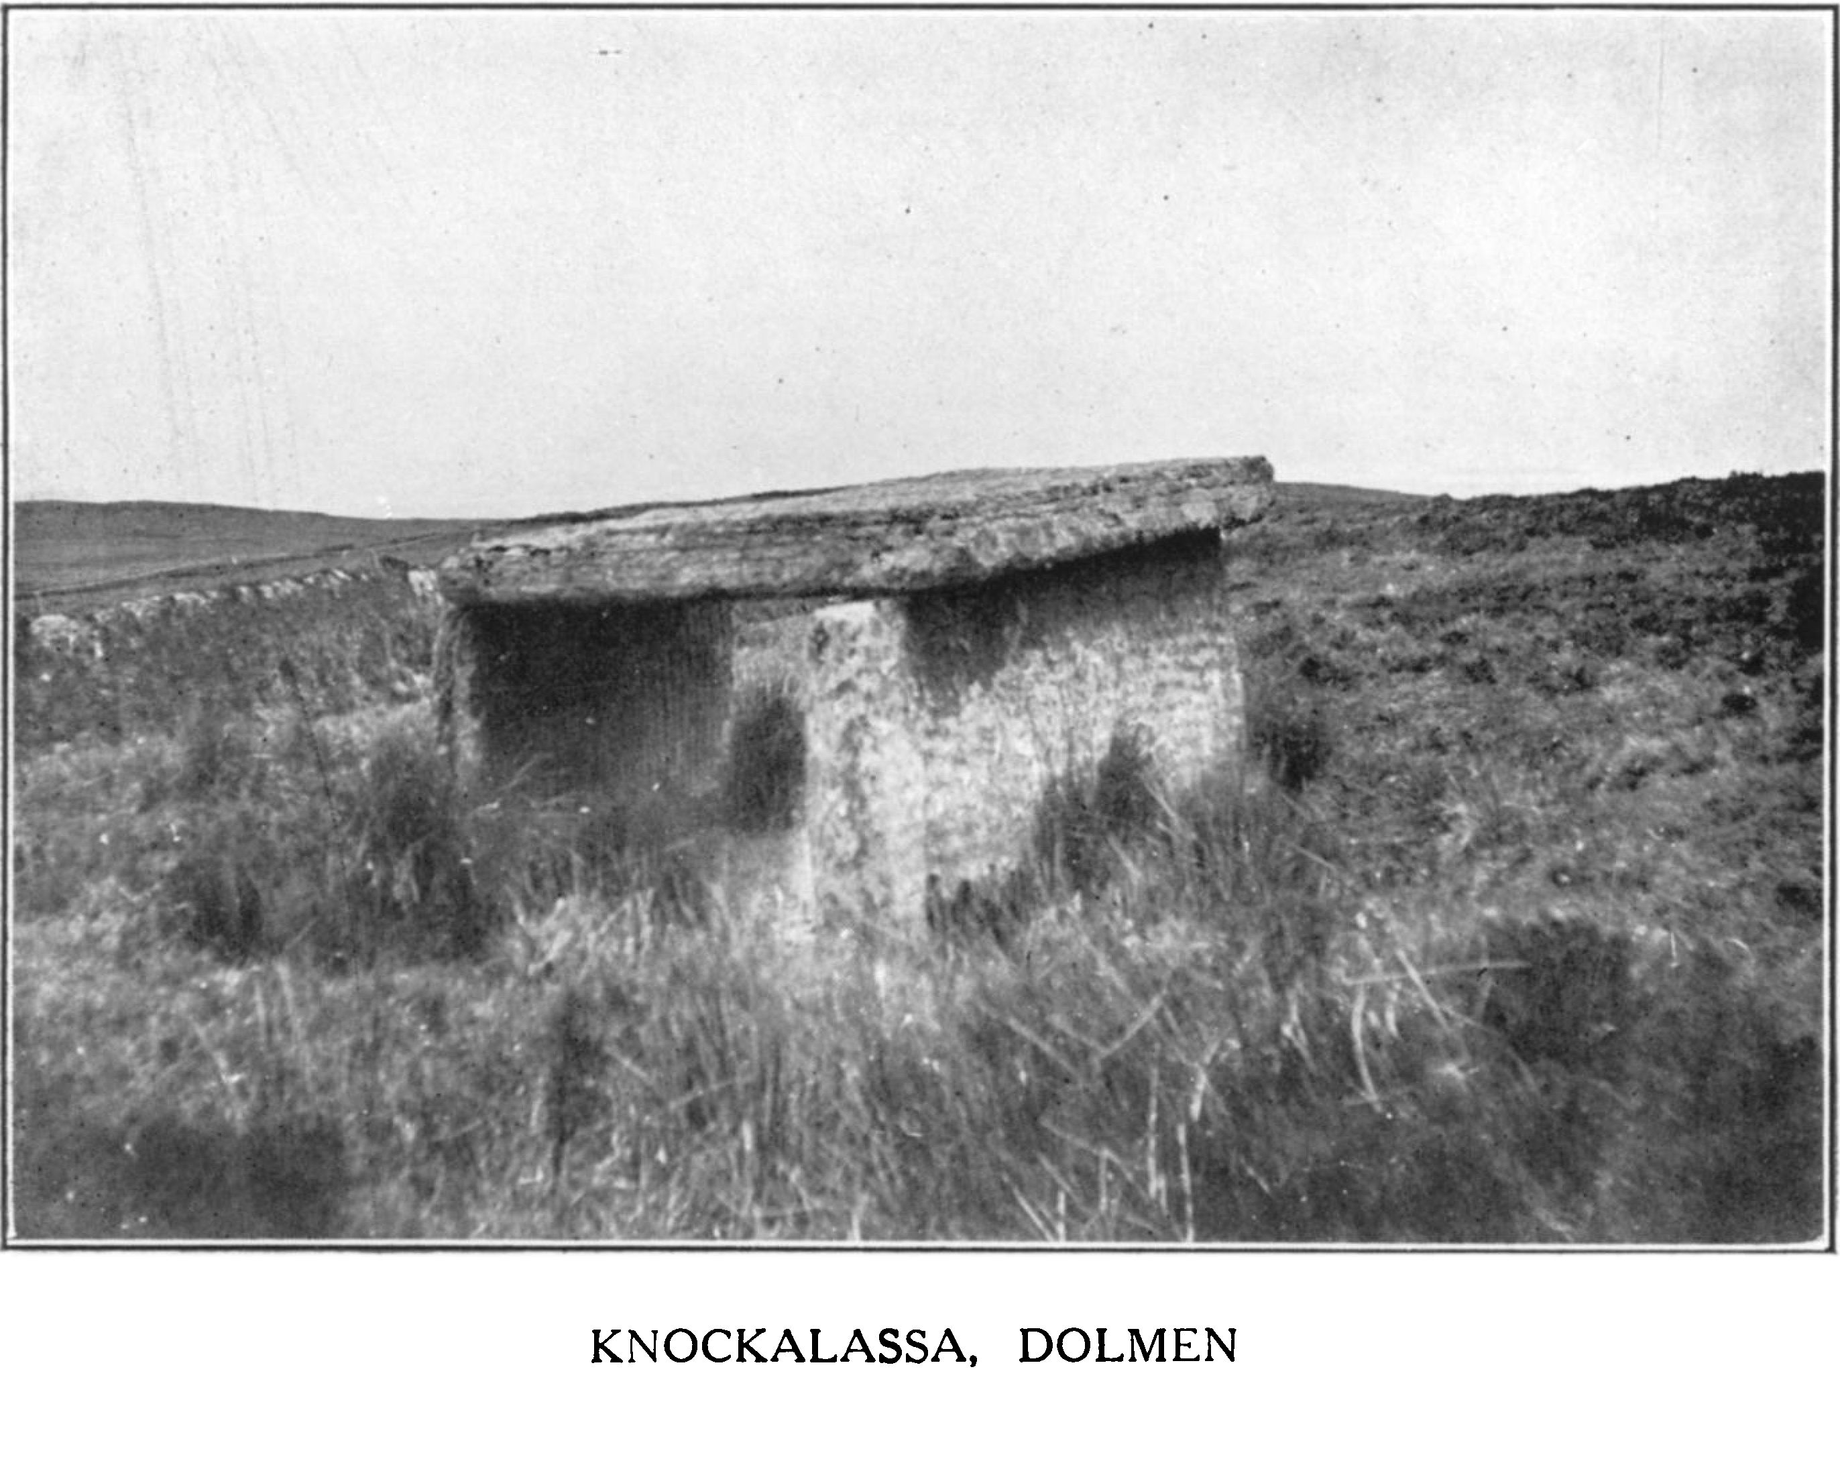

NOTES ON CERTAIN PRIMITIVE REMAINS 109

or chest “of six grey slabs with a heavy cover. The four side blocks stood upright, fixed in the ground, with another to each end, the sides about 4 feet apart, and a great flag resting on them. Two upright flags were fixed behind, at the west end, rising 18 inches and 2 feet above the table stone. There were other stones of various shapes and sizes around it at the back and ends and an elevation, or mound, of clay and small stones. It lay south-west from Leaba Chonain, and looked south-west across the lake to Crag na Sean Ean. The description suggests a monument like the central compartment of the pillared dolmen of Ballyganner, a cist with taller pillars at the ends; one pillar, too, stands at the east end of the north side of Cooleamore dolmen, while the flooded cist (miscalled a well) of Tobergrania, at Ballycroum, near Feakle, has a stone at each east and west end of its sides, low, but like the antae of the large single slabs in other dolmens. Several of such monuments in Co. Clare have a mound adjoining, so we can form a fairly good idea of the Altoir na greine—a cist, with two slabs to each side, one to each end, and pillars to the west, with possibly, a fence, or peristyle, of lesser stones and partly embedded in a mound clearly indicating its sepulchral character.

Borlase connects the townland name, Knockalassa, with the legendary Glasgeivnagh (the wonderful green-grey cow of the smith Lon mac Liomtha)1 He is evidently wrong, for the name means “Hill of the Liss,” and the ruined fort, or liss, is there still. Of course Vallancey’s views of the sun worship rested, like an inverted pyramid, on the wrong name and the forged passage in the “Battle of Gavra.” Less reputable rites seem to have attached to it, for Windele’s notes give the pregnant words about the cist—“fruitfulness of progeny.”2 When We remember the indecent rites and belief connected with the Ballyganner dolmens, in 1808, to which a girl (on that account) refused to guide Hely Dutton,3 and another case in very recent years, which I could tell of my own knowledge (if it could bear repetition), we can understand the attempts of the priests and others to wean the people even from the otherwise harmless rites at the oenachs. Perhaps some such feeling may have led to the apparently needless destruction of the Altoir in 1859. Even so late as 1895 Borlase heard at Milltown Malbay that young people used to dance on the existing Leaba on midsummer day, although the priests were trying to stop the custom. Whether the sense of

1. Dolmens of Ireland, vo! i, p. 79; see Journal, vol. xxv, p. 227; Folk Lore,

vol. xxiv, p. 100.

2 MS. R. I. Acad. Supplement, vol. i, p. 292. The date of this note seems uncertain, as Windele was chaotic in his note keeping.

3 Statistical Survey of County Clare, p. 318.

110 ROYAL SOCIETY OF ANTIQUARIES OF IRELAND

indecency was helped by the coarse local tales of Diarmuid and Grania or whether it was part of a wider belief, noted even on the Continent of Europe,1 this is not the place to decide, but it is one of the ideas to be reckoned with in treating of Irish dolmens.

The remaining Leaba stands at the head of the pass, just above and to the north of the road from “the Hand” westward. It is in a shallow peat moss pool, and is said to have been dug out by

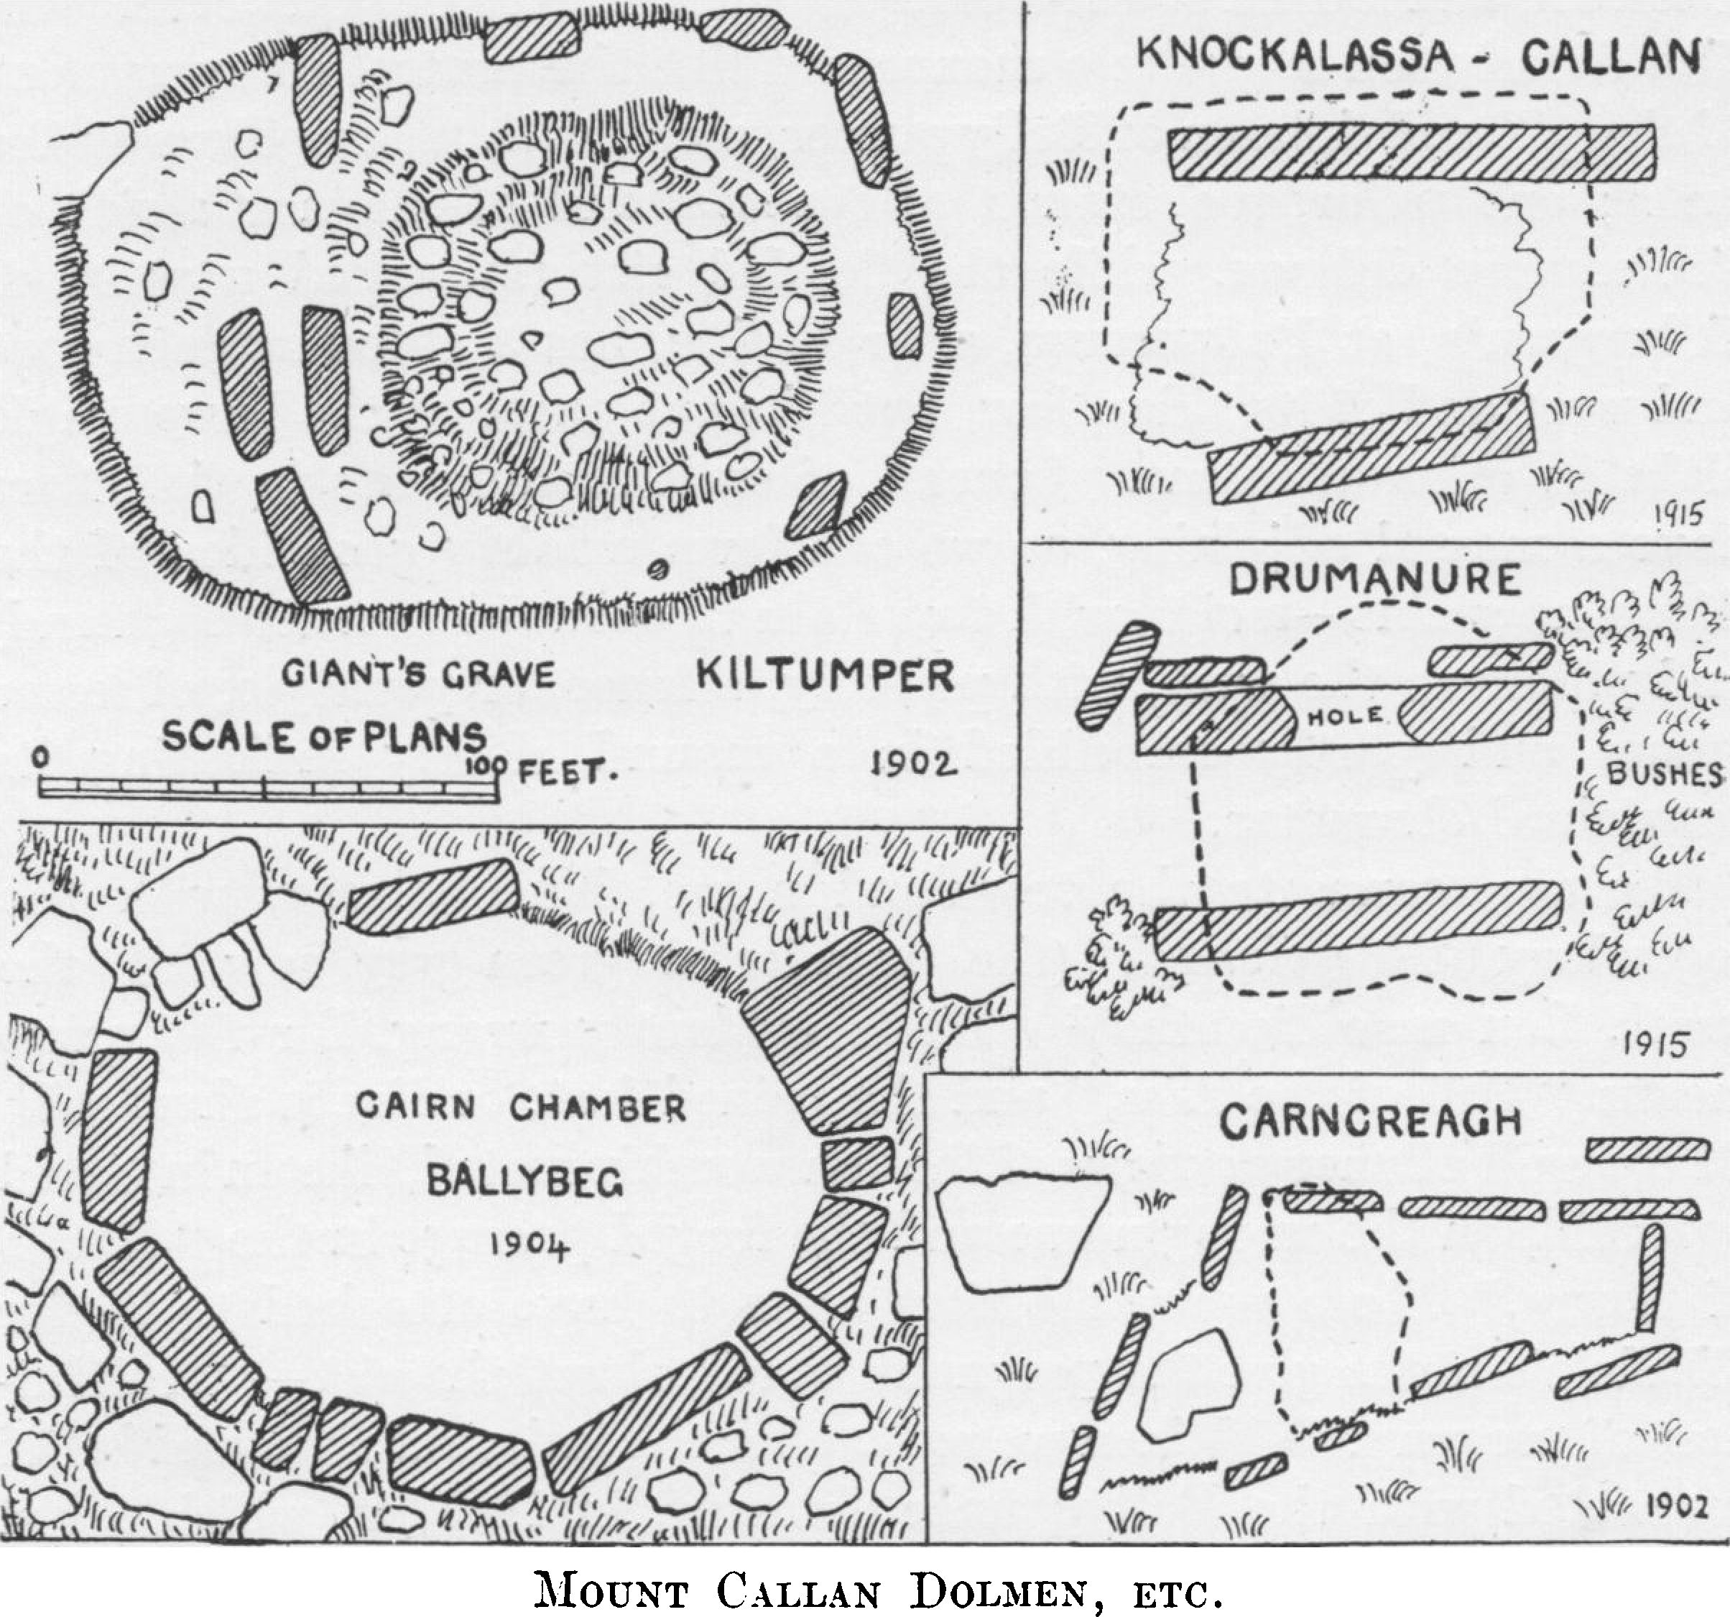

treasure seekers. It commands a weird view of the dreary, featureless hinterland, southward; the brown hillside and, westward, an interminable extent of the Atlantic, with the dark cliffs of Beltard and the islands of Iniscaerach and and Illanmatail, set in their foam frames of frosted silver, towards the sunset.2

The cist is formed of smooth beautifully regular slabs; the two sides stand, the northern is 10 feet long, 3 feet 3 inches high and 11 inches thick; and the southern, 6 feet 9 inches by 3 feet 3 inches, while the great cover resting on them is 9 feet 9 inches along its north side, 5 feet 5 inches to the west and 7 feet 4 inches across north and

1. Borlase, Dolmens of Ireland, vol. iii, pp. 846, 565, 554.
2. These appear faintly to the right of the dolmen on plate XI.

NOTES ON CERTAIN PRIMITIVE REMAINS 111

south. The sides are 5 feet 8 inches apart at the west, and 5 feet at the east end, the cover is level, unlike most of the Clare dolmens, which slope and taper eastward. The cist faces east-south-east. The slabs vary from 9 to 12 inches in thickness. I was told in 1887 that it was called “the Hand” and the cross road was called after it, but this has been denied by all to whom I repeated it.

Carncreagh (Ordnance Survey 39)

Just within the west border of Kilmaley Parish, in the barony of Islands, near the east end of Doolough, is the dolmen of Carncreagh. It lies in a rushy moor, where the new road bends northward, not very far from the cave whence the Faracat (a formidable black monster with a white crescent on its head) sprang upon the spears of the Three Sons of Thorailbh. The Lake, it may be remembered, is the prison of the more formidable Cata subdued and chained by St Senan of Iniscatha.1

The monument is a long dolmen (not an allee couverte) of slabs of thin gritstone, five to the north, three to the south, being 17 feet 2 inches long over all east and west. The chamber is 13 feet long and tapers from 6 feet 5 inches to 2 feet 9 inches; one cover remains and traces of a parallel row of slabs are found along the northern face.2

Kiltumper (Ordnance Survey 48)

The monument of Kiltumper, in the parish of Kilmihil, and barony of Clonderalaw, lies about a mile and a quarter eastward from the fine stone fort of Cathair Murchadha or Cahermurphy.3 It is conspicuously marked on all the maps, which impressed Borlase and others with a sense of its importance, quite undeserved. It was called Tumper’s Grave (“Tuam fhir” or probably “Fhir mor”) from a “great ma ” or giant, “Thoompa,” a Danish chief, who was chased by the Dalcassians from Cahermurphy to this spot and killed and buried.1 It Was only a small kerbed cairn; the upper part is now entirely removed.3 The kerb slabs never exceed 3 feet 6 inches long; nine remain; most of the southern ones are removed. The enclosure only measures 15 feet east and west by 11 feet north and south. The place is so remote from the lines of main roads

1. Life of St Senan, Colgan’s Acta SS. Hib.,March 8. Vita S. Senani, Colganr Acta SS. Hib., March 8th; Folk Lore, vol. xxi, p. 477 vol. xxiv, p. 206.
2. Limerick Field Club Journal**,** vol. ii, p. 254.
3. Ordnance Survey Letters MSS. (R.I.Acad.), Co. Clare,vol. ii;MSS. R. I. A., 14 B 24,pp. 45, 46.

112 ROYAL SOCIETY OF ANTIQUARIES OF IRELAND

that no one described or noted it, even in the Ordnance Survey Letters1 on this account and not from any interest in the monument itself I record it here.

Leckaun (Ordnance Survey 32)

A dolmen, marked on the new maps only, lies in Leckaun (in the parish of Kilnamona, Inchiquin), not far from Rushaun Lake. I have to thank the Rev P. O’Halloran, of Inagh, not only for much kindness when I re-examined the Callan remains, but for visiting and noting this dolmen for me. It is nearly rectangular and like the Knockalassa Leaba; the eastern slab has fallen inward and the west end is removed. The cover is 9 feet by 7 feet and about 8 inches thick, resting on the ground at the east end; it has a piece broken out of its north-west corner. It is 5 feet high at the west end, and is called Lubby’iermidd’ aus’Graine. About 200 yards to the north-east is an ordinary earthen fort.

**Cloch an Airgid** (Ordnance Survey 24).

Just over the boundary at Bohneill Castle2 (in Derry, in Rath parish, Inchiquin) is a curiously scribed rock, often said to be an Ogham, it lies in Carrovere, just over the edge of the townland. It is called Cloughanarrigid (Clock an airgid, the Rock of the Silver), but I heard no legend when I visited the place in 1895. It is a natural outcrop with many idle scribings, among them h.n., a.b., x, a.t., H.ONEirr {sic), a.d.xiv, 1614, 14,1614. It is evident that some member of the family from which Bohneill is named, one H. O Neill, executed these, and perhaps the many other meaningless scorings, in the reign of James I. Bohneill (as I said) has been entirely removed for building and road material, but extensive remains of featureless walls existed in 1895.

Drumanure (Ordnance Survey 24)

Going southward from the Castle we find, just on the edge of the townland of Drumanure (locally Drymanure!), a perfect dolmen, first recorded on the modem maps. The adjoining Gortbofarna is thought to be named from the Gort, or garden, of the both, or hut, of the alder, which was also the “Neill’s Hut ” of Bohneill. The

1. Proc. R. I. Acad., vol. xxvi, p. 466; North Munster Archaeol. Soc., vol. ii, p. 255.
2. The will of Murrogh O Brien, last recognised King and first Earl of Thomond, in 1551, first names “Castellum de Banneill, with it are given Ne Marteri (Martry), Dreyny and Dirrah (Darragh). It is Boneill in 1584 in Perrot’s Composition, with the Clare gentry and in the Castle List.

NOTES ON CERTAIN PRIMITIVE REMAINS 113

dolmen, densely overgrown with brambles, stands in a rich wet meadow, near the well and farmhouses, south from the road. Mrs Shannon (who is said to be 95 years old, though still active and clear-minded) told us, without questioning, that it was called Leaba ’iermuid, and that “Graunia, Finn’s wife, ran away with ‘Iermuid and they built the “Labby” for a bed. ‘Iermuid brought the big stone from over the hill of Aile, to the west there, on his head and Graunia carried the other stones in her apron.1 ” “It has a very bad name, no one likes to go near it in the dark”; even “when the hens lay eggs in it no one will go and fetch them out.”

The monument is of gritstone; I succeeded in making a plan only with much pain and difficulty. The north side is 8 feet 9 inches, the southern 9 feet 5 inches long. The west end is open, 3 feet 8 inches between the ends. Two stones 3 feet 3 inches and 3 feet 6 inches long are set against the north-west corner, one may have been the end slab. Another stone, 2 feet 6 inches long is set against the north slab at its west end, just beside it a hole has been chipped through the north slab. The east end is so bedded in brambles, both inside and out, that I could not see if the end slab exists. The sides project about a foot west of the cover, like antae. The slabs are 10 to 12 inches thick. The cover is 7 feet 6 inches long and 8 feet 8 inches wide, overhanging the sides about 18 inches, but very irregular ; the sides rise barely 3 feet above the soil.

Ballyhea South (Ordnance Survey 24)

The dolmen in Ballyhea South was first recorded on the new Ordnance Survey. Dr MacNamara and I had difficulty in locating its site at some small broken stones near a little stream: no certain trace remains. We subsequently heard from Mr Molony, the schoolmaster, who lives near the site, that even about 27 years ago in 1888), when he first came to the place, only one slab remained. The rest had been destroyed by a returned emigrant from the United States, who dreamed of a treasure being hidden in it, but found nothing, after spending much money in digging and blasting there; one is glad to hear of his failure, as it discourages other dreamers. “There was a crock of gold in the Lobba,” all said, but “no one ever heard of any gold being found in Inagh” parish nor even of “weapons or old things.”

Not far away in a bog, in Drumleesh, a place called Turkenagh recalls “the wild boar out of the woods,” as mentioned in the hunts of Finn mac Cumhail in the district. In it is a well marked green

1. Mr Thomas Kinnane, of Ennis, heard a similar legend of a rock near Lismul- breeda Cave.

114 ROYAL SOCIETY OF ANTIQUARIES OF IRELAND

spot, where tradition says two priests were buried after being chased thither from Dysert O Dea and slain by Cromwell’s men. Tradition also recalls that “there were monks at Roosca;” this is interesting, for we learn from an obscure document that, in December 1666, Mortough O Gripha, of Roosca in Bantry (Brentry), in the parish of Dishart, Co. Clare, was a Franciscan Friar of Ennis and, when Morrice 0 Connell gave them the site of their house at Roosca, Flan Broody the Guardian, O Gripha and others lived and officiated there for three years.1

CLONDERALAW

**Antiquities near Kilrush** (Ordnance Survey 57, 68)

In order to record the important forts of Carrowdotia and to give some account of the general antiquities of that class in the tribal district of East Corcovaskin2 I here take up my survey to the east of Moyasta Creek, which bounds the Irrus, already surveyed. The chief strip in which the forts abound runs from about six miles south from Kilmacduan and Kilmihil, already studied, along the Shannon and up the Fergus estuary to the barony of Islands. The wilderness from Callan and Doolough round Lough Naminna is a mass of boggy moors and little lakes devoid of antiquarian interest.

The vast majority of the forts may be set aside as of very little interest. The names also are less instructive than those of the north-west and east parts of the county. There are about 150 in Clonderalaw, nearly all featureless earthworks, once stone faced, about 5 or 6 feet high, sometimes with a fosse. Two known to me have souterrains, but probably many others might be found; certainly several are believed to exist. The churches and castles, also,, are neither beautiful, ancient nor important, save on the Fergus Islands. The vast majority of the castles are heaps of debris. Killeimer, the most interesting of the churches, is horribly defaced by the removal of its plain 10th century east window to Kilrush before 1839.3

The names are not given in early documents, save that of Cahercon, Cathair dha chonn, in the 1390 Rental. The other names, including a few from the records, are: In Kilmacduan— Caherfeenick, Caheraghcullin, Danganella, Lissaghaun, Lisnahoanshee and Lissatouk ; Kilrush—Lissarinka, Knocknahooan,

1. Historical Memoirs of the O Briens(0 Donovan), p. 502.Hist, of Co. Clare**,** J. Frost, p. 554.
2. The Corca Bhascoinn chiefs claimed descent from Cairbre Baschaoin, son of King Conaire More, who died circa a.d.166. They merged into the Ui DomhnailL
3. Ordnance Survey Letters**,** vol. ii, Killimer.

NOTES ON CERTAIN PRIMITIVE REMAINS 115

Rathoran, Lissaculia, Listeernagall, Carrownalongfort (in Kilcarroll, 1615) and Caherholey (1641);1 Killeimer—Cahernagat, Clooneylissaun, Dunneill, Dunnagrogue, Caherlassa, Doonies (1676), Lisnalarabauna, Lissanard, Lissrawer, Caherstrassko (at Dunneill 1675 survey), Ballinagreenaun (near last 1624); Kilmihil—Cahermurchada or Cahermurphy, Cahermore, Lisbaun, Sheeaun (Sidhéan or Fairyfort), Cahercanavan, Lisnaleagaun, Reanlassa, Lissatuan, Lissycrereen, Lissenegen, Ballyduneen, Lissanair; Kilmurry- macmahon—Reanlassa, Lisnalanna, Caherbane (1675 now Carrowbane), Lissathonrun, Lisheendeen (Lisneodine 1675); Kilfiddan— Effernan crannog ; Killoffin—Lisnamorna ; Killadysert—Lisnafaha, Lisbekan or St Bekan’s fort, Lissyurriheen and Cahercon.

The district was once evidently greatly covered with oak forests Knockerra (Cnoc doire), Derrylough, Derrybrick, Knockaderreen, Durha, Derrynageeha, Derrynalecka, Derriniddawn, Derryshaan. Derrygeeha, Crossderry and other wood names, like Rusheen and a, wolf name Breaghva or Breffy, all marking its desertion in early days.

History, as distinct from the Life and Monastery of St Senan (died 540) and the Mac Mahon chiefs2 there is none. A vague legend dated by the “chronologers” in the fabulous past of a.m. 3790 tells of a battle where King Oenghus Ollmuchaidh defeated the Martinigh (a tribe subsequently found at Emly down to the Danish wars) at “Clar in Corca Baiscinnd,” or Cooraclare,3 or as the Four Masters say on Sliabh Cailge.4 Senan’s “Life “ is very ancient, and gives an interesting picture of the Corca Bhaiscind about 480, the chief entertaining strangers, or attacked by enemies in his dun or earthen fort, the lesser gentry with their residences and farms far apart (Gerchinn, father of Senan, had a farm at Molougha, far to the east of Kilrush, and one to the west of Poulnasherry), their sons, spear in hand, driving great herds of cattle across the tidal creeks, and the men of the district commandeered to carry fire and sword against the Corca Modhruadh far to the north.

Carrowdotia (Ordnance Survey 68).—Passing round the beautiful woods of the Kilrush demesne we reach a ridge, beyond which (up a long valley, on the opposite ridge, below the modern village and chapel of Killeimer) we see a huge heap of stones, the only large cathair in the district. It is called Cahernagat on the new maps,

1. Deposition of Moseley, T. C. D. Library.
2. The Mac Mahons were a branch of the O Briens sprung from Mathgamhan fourth in descent from King Brian Boroimhe. For their pedigrees, see History of Co. Clare (James Frost), p. 74.
3. Book of Lecan, p. 579.
4. Mr Frost identifies it with Moveen; it is far more likely some high ground at or near Callan if it be not at Cooraclare.

116 ROYAL SOCIETY OF ANTIQUARIES OF IRELAND

which are most probably right; it is nameless on the old ones, which give the name to the one in Ballymacrinan, which is not a cathair, nor has it a “cave” for cats. The name, however, cannot be very ancient, as it clearly implies that the cathair had been long deserted and became a haunt of cats and probably of other doleful creatures— Cahernagat, the stone fort of the cats, or (as the peasantry occasionally say) of the Cata, the monster subdued by St Senan and commemorated in the name Iniscatha or Scattery. It reminds one of the King Cat of the cave (souterrain) of Cruachan Fort and the three formidable cats of that place; of the Faracat, springing from its cave near Doolough, on the “Three Sons”; of the monsters which Finn banished from the raths1; and of the “Wild Cat of the Carns.” Few are the features (even in prehistoric forts and local legends) on which early Irish literature does not shed light.

In Ballymacrinan,2 the first fort in the top of the north ridge beside the old road calls for very little notice; it is a perfect ring mound, 5 to over 6 feet high, with a ring of hawthorns. It measures about 100 feet across. A little further west, beyond the adjoining farmhouse, we cross the ridge and (from the head of an old deep double cattle track down to the little stream below the hill) we get a striking view of the two forts in Carrowdotia north. Near us on the hillside is a curious slight hollow, suggestive (save for being on so steep a slope) of the hollows which, elsewhere, mark the site of levelled raths.

Cahernagat.—This lies on a subsidiary ridge, or terrace, south of Killeimer village and, though it is shut in by the valley (every part of which it overlooks) on three sides, it has a beautiful view westward of the mouth of the Shannon; Hog Island; Scattery (the Sacred Isle of St Senan), with its tall round tower; Kilcredaun point and lighthouse, with the bold hill of Rehy; 3 and (across the wide estuary) glimpses of the Kerry coast and Beal sandhills, with the blue summits of the huge mountains of Corcaguiny rising over the nearer but lower ridges.

The fort is a vast heap of tumbled grey sandstone blocks, white with weather beating and lichen, the majority, small flat slabs, but not infrequently large blocks occur (2 feet 6 inches by 3 feet 6 inches and a foot thick, or a little more or less). It is from 7 to 11 feet high to the west, but is rarely over 5 feet high to the south and north-east,

1. See Bricriu’s Feast (ed. Henderson, Ir**.** Texts Soc.), p. 73, and Introduction to Feis tighe Chonain (ed. Kearney), pp. 35, 36, for Cruachan cats; Revue Celtique, vol. xxxiii, p. 71, for the “ cat of the carns.”
2. The Baile mhic Droighnean of the 1390 Rental (Hardiman Deeds, Trans. R. I. Acad., vol. x.) and in a deed of 1611.

8 This is the view so recognizable in Dyneley’s sketches of Scattery and Dunagrogue in 1680.

NOTES ON CERTAIN PRIMITIVE REMAINS 117

being nearly levelled to the east. It is from 20 feet to 30 feet wide, being much spread. The actual rampart can rarely be disentangled from the debris, but is about 12 feet to 16 feet thick; breaches of the facing show that it was excellently built with a batter of 1 in 9. The masonry is unusual, the large blocks are separated by nearly equivalent spaces of thin slabs, like a heap of bricks, the whole of fair execution. Unfortunately it was too convenient a quarry, and the neighbouring village, Roman Catholic church, and farm houses were largely built out of its stonework. It measures about 165 feet, over all, as spread. The garth is 118 feet to 120 feet across. The actual outer diameter is impossible to fix anywhere, but is about

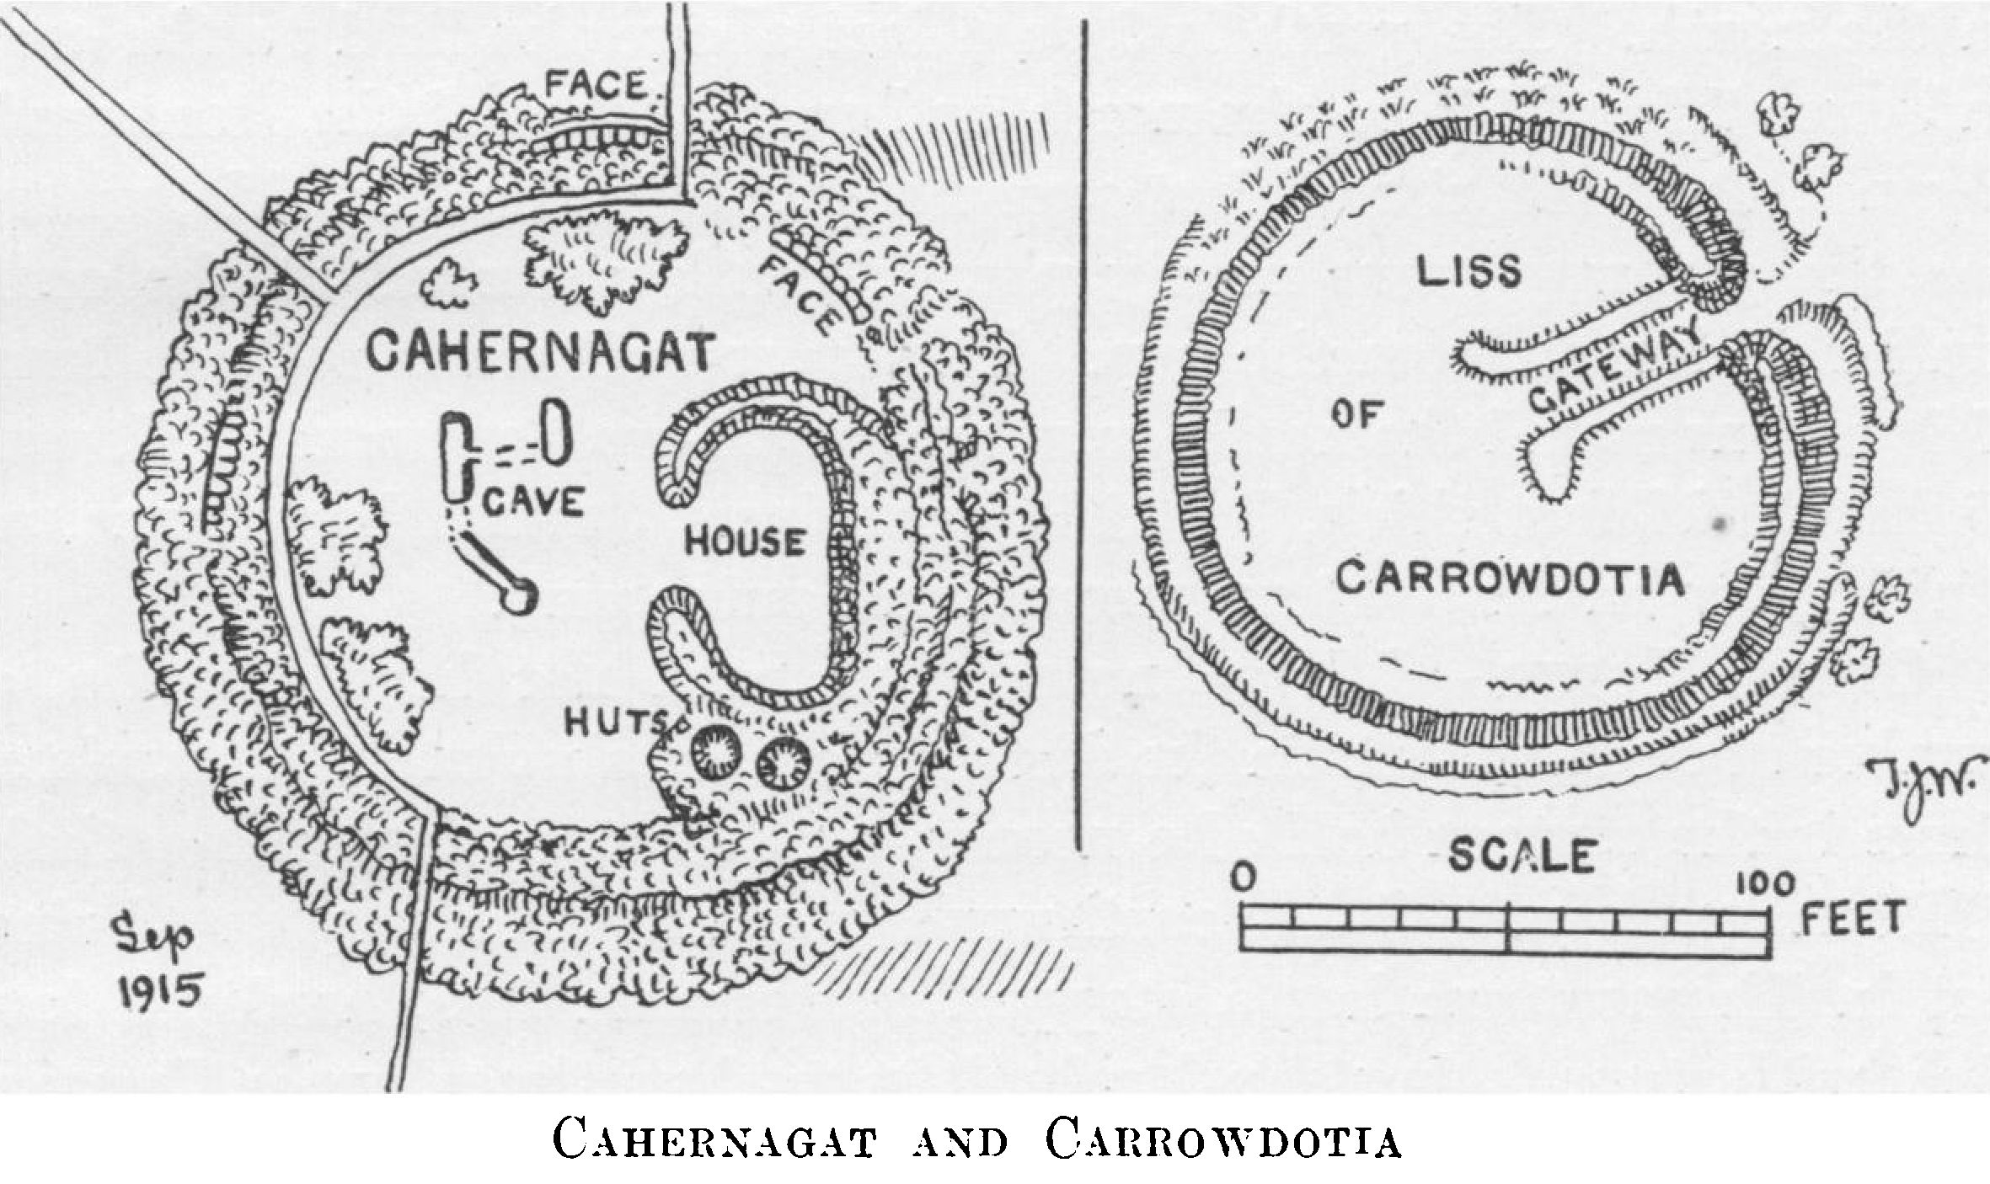

150 feet across. The interior is about 2 feet over the ridge to the east, but 7 to 10 feet above the outer ground to the other points.

There is a house ring at the east side, the walls 9 feet thick. 51 feet north and south, 21 feet east and west; at its south end are two circular cells, 6 feet and 9 feet inside, 24 feet over all—they have now collapsed. At 21 feet from the doorway of the large enclosure is an oval pit, another collapsed cell of a souterrain, 41 feet from the north segment, and 8 feet by 6 feet across. It is probably connected by a passage 12 feet long (the farther opening hardly 2 feet square, with thin flag roofing) to a larger fallen cell, 13 feet long by 6 feet wide, whence another passage, 5 feet to 6 feet wide, runs to the south-east to a cell, the whole 18 feet long and fallen in. There is nothing else in the garth save some small groups of bramble and willows. There is no discoverable trace of a gateway, but from the lie of the ground it was probably beside the hut circle and to the north of it. It is interesting to find so large and important a stone fort

118 ROYAL SOCIETY OF ANTIQUARIES OF IRELAND

In a land of earthworks. O Donovan inclined to identify it with the Aenach mBearrain of the Book of Rights, ante a.d. 802, but, even if the latter be Burrane (which is absolutely doubtful), that place is two miles away, and the cathair cannot be intended. The bulk of the fort names in this document are hardly possible to identify with existing forts with any absolute certainty.

**Liss.**—This lies down the slope to the south-west of the cathair, between them, 66 feet from the latter, is a spring and runnel. The Liss is of earth, faced with good though rarely large stonework, both inside and outside. It had an outer ring only 3 feet thick and high, a wet ditch fed by the spring, 3 to 4 feet deep and 9 feet wide, runs round three sides, but is only marked by the even curve of rushes on the north. The garth is 3 to 4 feet above the field to the east and over 7 feet high to the north and east. Most of the stonework is gone; the bank rises 5 feet over the garth to the east side, where was the gateway; two nearly parallel walls recurved at the ends run for 40 feet in from the gap. The outer wall seems to have been of dry stone round the north, west and south-west segments. It was 15 feet to 18 feet thick, but little remains. Several hawthorns, as usual, grow on the eastern mound and outer ring.

Other Forts.—I have noted, but need not here describe, a number of earthen forts in the district; all are absolutely featureless. There is the eastern half of a nearly levelled stone fort, the cathair of Doonagurroge.1 Small earthworks remain. A fine planted ring fort in Thomastown has a stopped souterrain: two, hardly 5 feet high, with stone facing, much rebuilt in modern times, are in Carrowfree, beside the road to the West of Knockerra; the western has been embodied in a farmyard, the eastern half of the lesser has been rebuilt. Beyond these are the quarries in a high ridge, with a fine wide view far inland over Kilmihil and Cahermurphy to Slieve Callan and down the Shannon to the sea. On the eastern slope, near Tarmon Lough, is a high earth ring, a thicket of hawthorn (scarlet with fruit when I saw it), called Lisnarinka, “fort of dancing,” whether of fairies or mortals I know not. Lisnalannav, in Tullycreen, has a killeen graveyard for children. Small low forts, of which I have seen many but made notes of only a few, abound near Kilrush—3 in Dysert, 4 in Ballymacronan, 1 in Cloonylissaun, 8 in the Carrowdotias, 3 in Poulnadarree, 6 in Doonagurroge, 2 in Moylougha, including a large earthwork called Listeernagall, oval, 300 feet by 220 feet, with a small mound in the centre. The one south

1 Dun na gCorrog in above cited mortgage, 1611. It was a residence of the Hickmans and is named Doonogoroge in their settlement of 1715. Dyneley gives a view of its castle, 1680.

NOTES ON CERTAIN PRIMITIVE REMAINS 119

of the boithrín, 470 yards west of Moylacha churches, might have a claim to be Gerrchinn’s residence, where his saintly son, Senan, was born,1 were the probabilities not rather in favour of the churches being on the site; 5 forts lie in Leadmore and Carrowncalla, including the small Lissacoolia and larger ones at Leadmore House (about 150 feet across) and Fort House in Cappagh (about 200 feet in diameter over all), but much defaced. In Killeimur, a fort, Cahirlassa (alias Carroo, alias the two Donies, alias Derilogha, alias Teernane), is named by the 1675 Survey now at Eden vale. It evidently lay in Derrylough.2 A small cairn of grey stones lies beyond Knockerra Lough. Going back below the quarries to Moylougha, or Molougha, the ancient Maglacha,4 St Senan’s birthplace, we saw two forts without apparent fosses on low ridges. One is in Dunneill and probably gave its name to the townland. No fort remains at the birthplace, to claim its honours, unless the raised graveyard on its green ridge above another long lake may conceal its traces; one church has disappeared and the two remaining ones are nearly levelled.3 The ancient Killeimer is further south, the burial place of the Colleen Bawn. Other featureless forts lie between the Kilrush demesne and at rare intervals along the roads round Clonderalaw Bay and on to Kiiladysert and Cragbrien northward, but none seemed to me worthy of any detailed description. The large tumbled ring wall round Canons Island Abbey has been noted in these pages, with a plan; it is the only remarkable fort seen by me on the west side and islands in the Fergus estuary.

I will only add a few notes on the other forts of Clonderalaw, Lisrawer, in Burrane Upper, is more probably the Eanach m Bearrain of the Book of Rights than is Cahernagat. It is an earthwork, with a fosse and inner and outer rings, 235 feet over ail and 150 feet

1. Vita S. Senani, March viii; Colgan, Acta SS. Hib.y p. 612.
2. Derrylogh or Toorynane was another of these endless alias names in the settlement of Poole Hickman of Kilmore on his marriage with Mary, daughter of Mounteford Westropp of Attyflln, Aug. 31 and Sep. 1st, 1715 (Dublin Reg. of Deeds, vol. xv,, p. ]28), held in fee-farm from the Earl of Thomond.
3. They measure, Teampull Senain, the south-west church, 18 feet 9 inches by 39 feet 2 inches, the north-east, 9 feet by 11 feet 2 inches, including in each case walls 30 inches thick. Of the first the west gable and a reach of the south wall 13 feet long are standing; the east gable, with its slit window, remained in 1839. The other church is only 4 feet high; it has a west door and an east window. The little stations called Senán’s Altar and Lacht Senáin in Cloon Senáin field near the lake are extant. In 1843 three churches remained, but the “Senans Chapel” beside the largest church has been embodied in or replaced by a vault. The Ordnance Survey Letters, Co. Clare, vol. ii (MSS., R.I.A., 14 b 24 p. 2), describes them the largest church as 32 feet 3 inches by 13 feet (sic); the Seipeal beg Shenain is unchanged; the third measured 30 feet 3 inches by 16 feet 6 inches, 3 paces from the large church it was even then completely destroyed. A deed of 1611 fixes the mears of Molougha (Ordnance Survey Letters, Co. CHre vol. ii, 14 b 24, p. 9).

120 ROYAL SOCIETY OF ANTIQUARIES OF IRELAND

inside. Lissanard is in the same townland, a small fort, about 100 feet across; also a little house ring 70 feet across and Lisnalarabaunia, a defaced fort, 110 feet over all. The cathair at Doonagrogue is partly levelled and defaced by a quarry and a late wall. It measures 120 feet east and west by 100 north and south; the overturned south segment remains. In the Kilkerin peninsula, abutting on the Shannon bank, at Redgap, is a large D-shaped fort, 200 feet east and west, 210 feet north and south inside, and 280 feet over all. A rectangular fort, 135 feet by 120 feet, remains in Colmanstown, and small house rings, 60 to 70 feet over all, in Kilkerin and Knockphutteen. Besides the crannog, in Effernan Lake is a sort of promontory fort, about 180 feet each way, with deep cuts, partly artificial, leaving a neck only 30 feet across. The Thomastown fort with the souterrain is a good earthen liss, its garth 80 to 85 feet inside, 130 feet over the ring, and about 200 feet over all. Lissatouk is only noteworthy, like Lisnalannav, for containing a killeen graveyard for children. The name “Dunawalla,” in Moanmore, near Moyasta, like that of “Greenaun,” has no trace of a fort. Besides those named at Knockerra there is another finer fort, south of the quarries, 120 feet inside, with a fosse, and 210 feet over all. Lisnarinka is 110 feet inside and 170 feet over the fosse. Lisnafaha, near Effernan, is defaced and about 150 feet across. There is a good fort in Cahercon, with a fosse 170 feet over all and 110 feet inside, the rings planted; two lesser forts lie near it. Finally (not to multiply these dry notes), there are many little forts, 70 feet and under, like those in Gower, Gowerhass, Moyadda Beg and Parknamoney. One point of interest in local history may be noted. The Cathreim Thoirdhedlbhaigh tells how (about 1287) Turlough og, son of Brian Ruadh, invaded Corcavaskin and attacked Rory Buidh Mac Mahon and Tadgh Mac Mahon, surrounding them “in the lightsome fort”; both were killed in the assault “at Disert Murthaile (Killadysert) of the even shore.” There is a good liss, planted, in Killadysert glebe, close to the shore and creek, with Liscormick and Ballinacragga forts not far from it.

THE JOURNAL

OF

THE ROYAL SOCIETY OF ANTIQUARIES

OF IRELAND

FOR THE YEAR 1917

VOL. XLVII, PART I

(VOL. VII. SIXTH SERIES VOL, XLVII CONSEC. SERIES)

NOTES ON THE PRIMITIVE REMAINS (FORTS AND  
DOLMENS) IN CENTRAL CO CLARE

ADDENDA  
Part XVI

(Continued from vol. **xlvi** page 120)

By Thomas Johnson WestroppM.A,. M.R.I.A. President  
[Submitted 12 December 1916]

In a survey made under so many limitations as my attempted one of the “Prehistoric Remains” in Co. Clare, new matter constantly comes to hand. From the first I was under no illusions as to the incompleteness of my work. The difficulty of working this rich but previously unexplored district must be my excuse, but must equally excuse my anxiety to give what I can to render the series less imperfect.

As this is my last opportunity of including within the index of this long series of papers my notes on the forts of Clare, I add some undescribed antiquities in the central portion of this county, though in some sense more fittingly an appendix to my papers in the Proceedings of the Royal Irish Academy. All lie in the more central part of Co. Clare, and, though I have since examined and re-examined many other forts, I find little else worthy of special addition to my

ROYAL SOCIETY OF ANTIQUARIES OF IRELAND

older papers save in the case of the very remarkable Langough, and the undescribed and problematical remains in Rathclooney.

**Ballyalla Lake Crannogs** (Ordnance Survey 25, 33)

This lake (in Templemaley parish, Upper Bunratty) was dominated by a peel tower (of which the foundations are barely traceable), where Mrs Cuffe held out against two blockades of the Confederate Catholics in 1642. Her journal of the first siege, and the “lethren goon,” which “gave a great report” and “let fly backward,” is curious reading in these days of giant artillery, “mighty for the pulling down of strongholds.” There were, however, defensive residences long before the peel tower was built. The lake level is now greatly lowered by the drainage works of 1846-7, which so altered the course of the Fergus, bringing above water-level several crannogs. Towards the north a promontory runs into the lake, having, at its end, a stone built crannog known as The Island. It is still isolated for more than half the year, and forms one of a group of three lake dwellings. At a slightly higher level, opposite to these, and like them, marked on the new maps, is another crannog, on the Dromcliff shore of the loch and only surrounded at exceptionally high floods. It is about 170 feet across and was girt by a ring of boulders, some of which, now resting on a shoal of white marl, have slipped, breaking the circle. Within these boulders, small stones were heaped, and earth laid on and with them; they were carefully laid and packed with spalls, without any trace of piles. Traces of fire and charcoal lie about a foot under the surface, but no laid hearths were found. The only object of great age found in the crannog by Miss Parkinson1 was a chert arrowhead; bronze pins and iron nails abounded; among the “finds” were a bronze pincers, an ornament with silver interlacing, a bronze spoon, a pin with a ring, a bead of deer's horn and others of dark and light green glass, and the usual coin of George II, 1736. Coins of this King and of his successor have the occult power of getting frequently into older finds at some depth under the surface. Of stone objects there were whetstones, a spindle whorl, fragments of flint, grooved sandstones, a hammer stone, part of a black chert ring, and the chert arrow-head. Whether these were brought as amulets among their uncongenial later surroundings, or represent the disturbance of the stratum of an older settlement, is hard to say.

Claureen Crannog (Ordnance Survey 33).—The crannog lies in a dried-up lake bed and consists, like the last, of a ring of boulders

1 Journal, vol. xxxv, p. 391.

NOTES ON CERTAIN PRIMITIVE REMAINS

in blue clay, and a heap of small stones. It seems older; the bones in it are more decayed and fragmentary than at Ballyalla. They lie in masses of charcoal. The finds include bronze clasps and buttons, an amber bead, bone pins, a slate spindle whorl, a fragment of jet, a broken chert spear head, bronze clasps and buttons, and rusted iron objects. Two fossil shells were found; as I have pointed out this is not unprecedented in Ireland or France. A polished fossil coral was found by me in a midden in Dunmore promontory fort near Loop Head; a sepulchral urn in a burial mound at Castle Hyde had an encrinite with it; a burial in Topping Mound, a carn in Antrim, yielded an echinoderm1; another was found in France in an early “find,” and an ammonite in the fort of Carnoles in France. It is not unusual to find a skeleton in a ring of fossil sea urchins.

3

Not far from the crannogs, in the river-cutting opposite to the ancient church of Templemaley, a fine souterrain was cut into when the new channel of the Fergus was dug. It is 25 feet long, with large unscribed limestone slabs for its roof, and the sides of comparatively small stones. It has a side passage 10 feet long. The church is of pre-Norman date, but on my last visit was entirely hidden by ivy and bushes.2

Killone Group (Ordnance Survey, 33, 41)

This term I use to cover a number of lesser antiquities in Newhall (Killone), Barntick, Barloughra, Ballybeg, Eden vale, Cahercalla, and adjoining townlands. They centre round the lake and beautifully picturesque Augustinian Convent of Killone, founded before 1194, (probably nearer to 1170) by the last King of Munster, Donald mor, O Brien.3 As I pointed out at the beginning of this paper, Eden vale and Rockmount were the ridge of Dromgrencha, a wilderness in 1278, “green-oaked, spreading-boughed, clear-streamed Dromgrencha, on the verdured bank of the gently flowing Fergus.”4 The Rockmount road, evidently the line of some old pass, leads across the ridge, while a cross road, grass-grown and disused, runs down into Ballybeg and on to Killone Convent and Feeagh. The latter part is known as the Pilgrims’ way, leading to the Holy Well of St John, near the

1. Journal, vol. i, ser. ii (consec.), p. 351, Topping Mound; Cork Hist and Arch Journal, vol. xi, p. 187, Castle Hyde.
2. The hopeless ignorance of the local authorities and their carelessness about ancient ruins keep them from putting in force their own powers and clearing ivy off these venerable churches. Tomfinlough, Kiltinanlea and Killilagh were wrecked by this carelessness; Kilmacreehy and Clonlea are ready to follow. Interesting early churches, like Rath, are concealed, and getting hopelessly effaced by this cause for want of an enlightened public feeling.
3. Described, supra, vol. xxx, pp. 126 sqq.
4. Cathreim Thoirdhealbhaigh***.***

4 ROYAL SOCIETY OF ANTIQUARIES OF IRELAND

convent, once the centre of one of tne largest *patterns* in western Ireland. Folk tradition is not abundant; a great, broken, ice-borne limestone boulder, about 10 feet high, rests on the summit of the ridge, and is said to have been thrown by a giant “Hughey ” from near Mount Callan at another giant; and the stream under Newhall House to the Lake of Killone was the haunt of a mermaid, who used to come up it and steal wine in the O Brien’s cellars. She was stabbed by a butler and the stream ran red with her blood.1 When the lake, at long intervals (usually after a dry summer), gets red from iron scum, it is supposed to be from her blood, and to foretell misfortune or a change of owners to Killone. There are two small, nearly levelled, house rings east of the stream below the Edenvale kennels in Cahercallabeg. One was a stone ring Wall, 60 feet across; neither calls for description. The Edenvale Caves have been carefully excavated by Mr Ussher, with those of Killone and Barntick. They yielded remains of a very early human settlement, contemporary with the great “elk,” bear, and Arctic lemming. The inhabitants dressed skins with flint scrapers, made bone implements, used fire and were cannibals. Of later settlers, an early bronze wire bracelet, a plain golden one, part of a bronze clasp inlaid with silver interlacing, late skeins and other objects were unearthed.2

Kilquane (Ordnance Survey 33).—On tne green shale hills northwest from the Inch river, near Woodstock, is the trace of a killeen graveyard, on a rising ground above a marsh. In it is a basin stone of coarse conglomerate, 19 inches high and 2 feet 6 inches long, with an unusually large basin or bullán, 2 feet wide. The enclosure is a low mound with a few blocks set in it.

Ballymacaula (Ordnance Survey 33).—On the opposite side of the Inch river is a conspicuous ring wall called Lissanard, not far from Beechpark House. It was so extensively rebuilt for the late Mr Marcus Keane that it is hard to distinguish the old from the new work. Parts of the old wall, nearly 5 feet high, are recognizable. It measures 120 feet over all. No features remain, nor any foundations in the garth.

Another cathair, named Cahernakirka, has been entirely levelled since 1839. I found no trace of any stone fort in the townland of Cahercalla; some, without warrant, suppose that it took its name from Lissanard. There are several greatly defaced forts of earth

1. For the variants of this story, see *Folk* Lore, vol. xxi, p. 341.
2. Trans. R. I. Acad., vol. xxxiii, p. 66.

NOTES ON CERTAIN PRIMITIVE REMAINS 5

and stone in Kilquane, Bushy Park, and Gortnore, along the old road from Inch to Shallee Castle. The conspicuous cairn which gives its name to Carran, or Corran Hill, on the bounds of Ballyneillan and Bushy Park yielded human and other bones, but no cist. I have elsewhere noted the sepulchral chamber in the carn of Ballyneillan, in which two human skeletons were found.1

5

Kilmorane (Ordnance Survey 41).—There is in this townland one of the so-called “thunder holes” (others occur near Ballycarr and Corbally in eastern Clare and the Poulashantona near Ruan in West Clare), where, as a rule, an underground river has caused the ground to fall in. The fort has a fosse with inner and outer mounds, all 15 feet wide, the mounds rising 5 feet over the field and the fosse nearly 15 feet deep to the west, where it is still wet. The garth is 126 feet across and commands a fine view from the Burren and Corran Hill to Aughty and Knockfirina.

At the fork of the main road to Kilrush, with the branch to Ballynecally, is a nearly levelled earthen fort, in this townland, its platform only a few feet high and its western edge cut off by the road.

Barloughra (Ordnance Survey 41).—Opposite to the lodge and gate at Newhall and the back avenue of Edenvale, on a fairly steep slope, is a small rath with a deep fosse and a garth terraced up on the slope with inner and outer rings set with hawthorns. It measures about 85 feet across the garth, 102 feet over the ring, and about 130 feet over all.

Another terraced up fort, about 400 yards to the south-west, in the same ridge, was probably walled with stone; it rises about 7 feet over the slope, but is nearly level with the top of the ridge; we often find this arrangement near Tulla and Bodyke in East Clare. The surrounding fence is 6 feet thick and 3 feet high, much gapped. The fort has no fosse and is somewhat D-shaped in plan. It measures 123 feet (north and south) by 144 feet (east and west). There are several similar house rings, calling for no special mention, in the adjoining fields, in the townland of Newhall.

Newhall (Ordnance Survey 41).—Several forts here call for no notice. There is a trace of a levelled ring wall in a grove, near the picturesque old garden, with its ponds, rows of araucarias and bold outcrop of rock, with shrubs and walks. The only forts worthy of mention are near the cross roads to the south-west of the house. There is a fine earthwork, slightly oval, with a broad fosse. The garth has two souterrains, now filled in. The whole measures over

1 Proc. R. I. Acad., vol. xxvi, p. 467 ; Journal, vol. xliii, p. 244.

6 ROYAL SOCIETY OF ANTIQUARIES OF IRELAND

the inner ring 143 feet north and south by 132 feet east and west and 175 feet over all. It is believed to be haunted by fairies, who take the form of rabbits.1

Feeagh (Ordnance Survey 41).—At the south end of Killone Lough, in Feeagh, is a small house ring, about 70 feet across, in a thicket of thorns. On the edge of the town land next Barntick, near the shore of the lake, is a boulder with a bullan basin ground into it. It is not near any old graveyard.

The map marks two reaches (not in line) of a thick straight earthwork. Neither Miss Stacpoole nor I noticed anything but an old causeway on any of our walks in the townland. The large straight earthwork south of Bunratty on the new large scale maps is a modern fence, and the Feeagh bank may be such, if it be not the causeway. The ring wall opposite to Killone Abbey on the craggy plateau to the north-east of the lake is a fairly old, coarsely built bawn, featureless and 4 to 5 feet high; no hut sites apparent at it. None of the forts on the Rocky Road (one a cathair and hut site) or between Killone Lake and the Fergus are worthy of description and those southward to Bealacorick Bridge are small typical raths

Ballybeg (Ordnance Survey 41).—Several forts lie between the EdenvaJe crags and Ballybeg Lake, to the north of Killone, along a winding old laneway to the east of the Pilgrims’ Road.

The first cathair was once a fine ring wall. Much of the rampart to the south is still standing; it is 8 feet 3 inches thick, of large good blocks, the inner face unusually well built, in courses about 8 inches high, with large filling. The next, near the boithrin, is 105 feet across, north and south; the upper part of the wall has been rebuilt: it is 10 feet thick, and the old part 4 to 5 feet high, with a slight batter and small filling. The cathair, south of the house, is nearly levelled; it is circular, 60 feet across, with no foundations in the garth. A low green artificial mound not far to the west of the last, is girt with modern walls, making it a pen. A large boulder is embedded in it.

Of the group along the edge of the lake, and south from the last, there remain the following:—The most northern cathair, near the house is 72 feet across and 8 feet to 10 feet thick. The facing is good, with a slight batter, but the stonework is small. There are faint traces of a circular hut to the west side of the garth and of the fort gateway facing the east. At about 100 yards from it, to the east-south-east, along the foundation of a wall from the fort, is what

1 Folklore, vol. xxxi, p. 483. A fairy hare haunts Knockfirina, Co. Limerick.

NOTES ON CERTAIN PRIMITIVE REMAINS 7

seems the base of a levelled tumulus; in it is the foundation of a somewhat oval chamber, 14 feet 4 inches north and south, 10 to 12 feet east and west. It consists of 11 slabs firmly set in the ground; two others have been removed. Several are from 3 to 4 feet 2 inches long. To the south of the last is another cathair with two looped hut enclosures in the garth, against the north-western segment. It is 93 feet north and south, with a rampart 8 feet thick; the facing is nearly all removed. To the north-west the wall is only 6 feet thick and well preserved. Another oval cathair lies to the east of the houses on the Pilgrims’ Road. It is oval, 111 feet across north and south by 87 feet east and west, the wall is partly standing, 8 feet to 10 feet thick and 4 feet to 5 feet high, with rude facing and very large filling. It has looped foundations in the south segment and across the garth.

7

Two other ring walls lie up the slope towards Eden vale, but have no outlook. The southern is 93 feet across, with a massive wall, 12 to 13 feet thick and a side enclosure. An old bawn of very large blocks lies in a horseshoe-shaped hollow, south from these. South from this, in the rock ledge of a craggy knoll, are two of the caves excavated by Mr Ussher.

The summit of the ridge falls in an abrupt precipice within the bounds of Eden vale. It has a beautiful view down the wide estuary and islands of the Fergus, and far off to the Galtees and Ballyhoura on the borders of Cork and Tipperary. The great grey ramparts of the Bronze Age hill-town of Moghane show well above the trees of Lord Inchiquin’s beautiful demesne, the church of St Mochulla and the village of Tulla, Clare Castle and Abbey, Ennis Abbey, and the castles of Cleenagh and Urlan down the river are visible. To the other side is the long deep-wooded glen, with the lake and house of Edenvale and the fine old garden, with its cedar and Judas trees, its brick walled terraces and grey flights of steps mirrored in the lake, and, behind, another vast outlook of wooded ridges, out to Mount Callan and the Burren, where, on a clear day, the grey speck of Cahermore, in Glenquin, and the cairns of Slievenaglasha can be seen.

**BUNRATTY UPPER**

Rathclooney (Ordnance Survey 26)

This group lies north of Cahershaughnessy and west from Knocksallagh forts, already described.1 They extend to “OBrien’s Big

1 Journal, vol. xxiii, p. 287. Proc. R. *I*. Acad., vol. xxxiv, p. 74.

8 ROYAL SOCIETY OF ANTIQUARIES OF IRELAND

Loch,” and are near the five Knocknafearbrioga Pillars of Classagh, traditionally the seven petrified robbers who maltreated St Mochulla’s bull. Passing the Ballyvergin ridge and the tall chimney, ruined houses, and dangerous shafts of the deserted lead works (that some 50 years ago gave employment to 100 men) we see on the opposite hill to the west a deceptively conspicuous fort called Kilbay on the maps, but locally Kylebay.

Kylebay.—Here is a killeen or children’s burial ground, only one old man of 87 years having been buried in it during the Great Famine (1846-7). A slight depression may mark a filled fosse, but otherwise it is a ring mound 9 to 12 feet thick and usually 5 feet high, set with old hawthorns. The graves are oblong patches of small stones and the garth is only 75 feet across, though shown as large on the 1839 maps.

Cauher.—Mr Michael Daffy, of Rathclooney (a bright, hearty old man, full of information on all local matters), brought us to a monument, barely marked on the new survey, but of much interest, to the north-east of Kylebay Hill, in a pleasant green valley. He did not know what “Cauher” meant, but the “old people thought it was something older than the forts, for ‘rath’ is a fort, and people used to live in the forts, even if their houses were only wood, but this was older and for some kind of religion, whatever it was, for there was an altar in the middle.” When he was young his grandfather moved a lot of the stones. At that time, old people said, “a large slab with a hole in it lay on the altar.” This and many of the other blocks remain set in the wall beside it. The slab is a foot thick, 4 feet high and 3 feet wide, with an oval hole towards one side, about 8 inches by 5 inches and partly artificial. The “Cauher” is a nearly circular earthen mound, about 4 feet high, made round a low outcrop of broken crag. It was girt by a wall in which, round the edge, were set large rude limestone blocks, rarely less than 3 feet each way. Two slightly larger ones at the north suggest a gateway. There are about seven others at irregular intervals round the west and south-west segments, those to the north having been set in the field walls near that side of the ring. Between are remains of a well built wall of thinner stones, 9 to 10 feet thick, and best preserved to the north and north-west. I cannot decide whether this was an original feature or built in between the blocks of an older circle. In the centre, on the rock platform, rest three large shapeless crag blocks, the largest 6 feet by 4 feet by 2 feet 3 inches, and near them lay an irregular rounded drift block of drab sandstone, with a basin; this Mr Daffy removed to his garden at his picturesque old house farther to the north-east. The stone is 3 feet 4 inches long, with a

NOTES ON CERTAIN PRIMITIVE REMAINS 9

shapely oval bullaun, 16 inches by 13 inches and 7 inches deep. It was famous for curing warts, and Mr Daffy attested cures of his own knowledge. There are other wart stones in Co. Clare—one in an old enclosure called Doughnambraher, not many miles westward; one in the socket of Kilvoydan cross near Corofin—but basin stones are very common. One figures in the Life of St Mochulla, “a polished stone with a basin like a water vessel,” dug up when levelling a site for his church at Tulla, in about a.d. 620. Others remain near that place, two at Knockaclochaun, others near the dolmens of Newgrove and Kiltanon, one near the killeen and pillar stone of Tyredagh, one on the Killeen of Fomerla, two in the conglomerate block beside the mound, earn, and pillar of Magh Adhair, one in Caherscooby stone fort near Dromoland, one at Crossagh near Ralahine, one at Tomfinlough church, one in a granite block in Clare Abbey, others in Ballyvergin and in a killeen at Kilvoydan, near Ratbclooney, not to mention others about the farther districts of Co. Clare. “There was some unnatural quality in the place” (Cauher), “for when the grandfather attempted to build the wall across it, after removing the stones, one of his pigs went mad and a sheep sickened and did not recover till the work was stopped;” other portents also occurred.

9

Immediately behind the fort, to the north-east and not far distant, was a place called a “Cartabrannach,” or “Danes’ (recte Briton’s) forge.” A low wide mound, barely rises above the field level. Mr Daffy once dug into it, finding “burnt coals and stones with the show of fire” on them; a layer of bones lay about 2 feet under the sward, he was not sure that they were human. No “fear” attached to the site, but legend told of a battle near the Cauher. We shall note similar hearths and a layer of bones near Caheraforia.

Behind the pretty garden of Rathclooney (the house is said to be the oldest building in the district after the castles) an earthwork lies on a gently rising ground. It is claimed to be the “real rath” of Rathclooney, but the maps assign the honour to another similar rath near O Brien’s Big Loch. There was a deep fosse, now filled up, but remembered by the older folk. The ring is 104 feet over all, from 8 to 12 feet thick and rarely 5 feet high. The platform being, as so often, on a gentle slope, was levelled up to the south; most of the bank was thrown into the fosse, save to the north-east, where it rises nearly 5 feet over the garth and gives a pleasing view of the lakes towards Durra. There is a trace, very suggestive of a souterrain, in the centre of the garth. Perhaps from a subconscious recollection of some tale of it in childhood my informant once dreamed of treasure hidden under stones in a hole there. His mother

10 ROYAL SOCIETY OF ANTIQUARIES OF IRELAND

stopped him from digging, as she recalled how, long before, “something bad” had happened to a man who was let cut bushes in the fort—what it was she did not tell.

The other forts are featureless and of little interest. About half the ring of a long oval earthwork, about 300 feet across north and south, is on a furzy tract near the lakes, with an earthen lios, of the usual type, named Cloonalough. Several levelled forts in Durra and Kilvoydan. A larger and once important cathair, called Cahereiny, near Kilvoydan church and dolmens: it is a large, very defaced and overgrown fort, once of good masonry, with strong walls and a closed souterrain in the overgrown garth. It is on the edge of a low crag ridge, overhanging a cultivated field, in which rises a smaller low rock-platform, perhaps once walled, as it has heaps of stone blocks upon it. Save the Giant’s grave, a long dolmen, and a perfect little cist in a carn in Ballymaconna, near Kilraghtis church, the killeen, graveyard and basin stone of Kilvoydan and the dolmen on Kilvoydan Hill, none of these call for any further notice, as I described the cists elsewhere.1

Other Forts.—Of some other forts I may briefly note the following:—Lisnagleeragh in Kiltanon (Ordnance Survey 27). It is a high, stone-faced, oval earthen ring, 5 feet high and 15 feet thick, 146 feet to 155 feet over all, enclosing a garth 105 feet across and planted with beech trees. The gateway was to the east.

Dromoland (Ordnance Survey 42), on the “Cottage Hill” just above the beautiful vista showing Dromoland Castle across the lake, is a fine rath. There are slight (if any) traces of a fosse. A ring, evidently once stone-faced, 7 to 11 feet high and 9 to 12 feet thick; the garth is 80 feet across. It commanded a fine view of the Fergus estuary and the hills even to Aghaglinny and Elva over the top of the Glasgeivnagh, through the fine trees among which it stands. There is a low tumulus of uncertain age, but I think old, beside the avenue north of the house. It is 5 to 7 feet high, 27 feet across on top and 54 feet over all, with no fosse. The traces of unmarked early remains in Tradree are endless. Many fields are covered with house rings and old enclosures. I recently found in the field to the north-east of the cross-road, between Kilnasoola church and Ing, in Ballysallagh West, the foundation of a large cathair: a small house-ring of stone, 22 feet across inside, and the base of a carn 30 feet in diameter, surrounded with a fosse 12 feet wide and an outer ring wall 15 feet thick—an unusual structure in this district. The thick population of this parish has much affected the remains.

1 Proc. R. I. Acad., vol. xxix, p. 72.

NOTES ON CERTAIN PRIMITIVE REMAINS 11

There is a line of blocks of doubtful purpose and age in the same field, and a ruined dolmen not far to the east.

Pillars.—In Newgrove or Ballyslattery, just inside the demesne wall between it and Kiltanon on a ridge, is a remarkable boundary stone. It seems to have been raised from the bed of the stream at the east foot of the ridge, and is set north and south. It is 6 ½ to 7 feet high, 6 to 8 feet wide and one foot thick. It probably marked the termon of the monastery of St Mochulla on Tulla Hill. A fine dolmen and bullán stone remain not far away near the avenue.

Of other pillar stones near Tulla I will briefly note the dimensions. Tyredagh pillar is a very thin slab of limestone, 9 feet high, 2 feet wide and 5 inches thick; near it is a killeen graveyard, and a sandstone boulder with a bullán-basin ground in it lies at the other side of the road towards the castle. Two dolmens, a possible trace of a third, and a small earthen ring, possibly sepulchral, remain in the townland.1

The “Farbreaga of Knocknafearbrioga (so locally pronounced) measure—the southern, 4 feet 10 inches high by 3 feet 8 inches by 1 foot 2 inches; the second, 4 feet 5 inches by 11 inches by 17 inches; the fourth is broken; the fifth leans to the north-west and is 6 feet 1 inches by 2 feet 3 inches by 10 inches. There are said to have been others.2

Magh Adhair, the place of inauguration of the Dalcassian Kings from at least a.d. 877 to 1570, has a limestone pillar 6 feet 3 inches high by 2 feet 6 inches by 10 inches, and a stump of a second pillar. Near them is a conglomerate boulder with two bulláns. The pillar is in Corbally the others and the mound and carn across the brook in Toonagh (Tuana Moyre 1584 and Tuana Moree 1655).

Derrymore, south-east from Tulla towards Dangan, has a limestone pillar 6 feet 3 inches high, 23 inches wide, 10 inches thick, beside a pool choked with sallows and water plants.

I may add Cloghlea, on the bounds of the glebe field and termon of Tomgraney monastery. It is of two contiguous slabs of limestone beside the road, and is 6 feet 7 inches high and 4 feet 2 inches thick, each layer 10 inches to 11 inches thick.

**Bunratty Lower**

Little need be added to the account of this district save a note chiefly on some hearths recently found by Mr William Halpin, of

1. Described Proc. R. Acad,, vol. xxiv, p. 110.
2. For the legend, see ibid,, p. 97.

12 ROYAL SOCIETY OF ANTIQUARIES OF IRELAND

Knocknagun, the owner of Caherforia fort, already described, to whose information and that of his son, Brendan, I owe the bulk of this note.

Thady’s Hill Fort, Kilconry (Ordnance Survey 61).—On the south slope of a low green hill (near the 15th century church dedicated to St Cannara) is a fine nameless fort, overlooking the Shannon from Limerick to Foynes. The outer ring is 4 feet over the field, it is 15 feet thick below, 6 feet on top; the fosse is 12 feet wide below, 30 above and 7 to 8 feet below the ring. Owing to the slope of the ground and possibly to the mounds having been stone faced and capped by a wall, the inner ring is slightly lower; it is 4 feet to 5 feet higher than the garth, which is 78 feet across (102 feet over all) and has a late oblong house site to the south-west. The gateway was to the south, where also is a gangway 25 feet long over the fosse. The inner ring is 15 feet thick, stone faced in parts, and 13 to 15 feet above the fosse to the south-east. The outer ring has been levelled into the fosse along that segment, but elsewhere is well preserved. The set back for a stone revetment is well marked to the north. It measures about 170 feet over all.1 The church is nearly featureless, and only the side walls and west end remain in part; it has a pointed, plainly chamfered south door.

Lisconor (Ordnance Survey 51).—The fort is on a low ridge with pleasant outlooks to the river. It was mainly of stone with an earthen core 9 feet thick and 8 to 9 feet high to the south, The garth measures 98 feet north and south, 84 feet east and west; about 102 feet to 116 feet over all. The entrance was to the east. There are two opes of a souterrain running south-west and north-east, an old hut foundation at the south-west ope, a late house site and enclosures lie in the garth. An annexe adjoins to the south-west. In the corner of a field to the south-west under a slight mound, locally a “mote,” was another ope into a deep souterrain. Some calves having been killed in the opes these are filled with stones over timber balks. It was about 4 feet high and wide; the sides of small stones. North from the fort, 70 yards away, is a curious oblong terrace, and enclosure 93 feet long, 51 feet wide; the walls 9 to 12 feet thick. It has two divisions 24 and 42 feet long inside. The terrace, to the east, is about 15 feet wide.

On the opposite hillside in Clonloghan is a large irregular fort, 250 feet long, 200 feet wide, with earth banks 5 feet to 7 feet high. Across the ridge lie seven small forts in Cahertiege, the north-east one a defaced ring wall, the north-west segment fairly preserved.

1 Misprinted “300” in mention of Thady’s Hill, Proc. R. I. A., vol. xxvii, p. 231.

NOTES ON CERTAIN PRIMITIVE REMAINS 13

**Ballynooskny** (Ordnance Survey 51).—At the south-east corner of this large townland, in a marshy field, is a low house platform, about 50 feet across, thickly planted, and a few feet over the marsh. A well has been dug in it. Another Liss has been partly destroyed by the yards of Crow Hill.

**Caherforia** has been already described.1 Near it to the northwest were two shallow lakes, one drained only in recent years by Mr W. Halpin. Round the shores of these Lakes were three “hearths” like those surrounding Coolasluasta Lake. About 270 feet from the extreme north point of the fort, in line with Urlanmore Castle, in a craggy patch, is a low heap of cinders and burned limestone 15 to 21 feet across and about a yard high; in it was found (I was told) a “diamond shaped” bit of bright yellow metal about half an inch each way. The mound had a circle of stones and marks of a fierce fire in the middle. About 23 yards from it is a spring in the rock, which probably supplied the fort, and the rock cutting which drained the eastern lake. In the same field is a second hearth, 18 to 21 feet across. Both were on the skirts of the marsh. An old man living not long ago, remembered a stag being saved in the lake when he was a boy. A third hearth was disclosed at the enclosing ditch of the tilled field on the former west lake. It has less charcoal and more slag and lime than the last hearths. Another hearth (I hear) was cut through by the new road in Rinanna, in the angle of the Fergus and Shannon. A mass of bones (chiefly “long shin bones ”) was laid bare near the western hearth of Ballinooskny; no skulls were found, but the remains were supposed to be of animals. The townland name implies some “conflict” in the remote past. There is a late belief that another fight took place near Ballycar, and many human bones have since been found in a gravel pit near the railway station to the south of the road at that place.

I need not do more than notice that besides the great fort of Knockadoon2, and the house ring beside it in Cleenagh, there are eleven small forts, two barely segments, in the same townland behind Kilmaleery holy well. Here a picturesque well house has been recently built, with the wrong name “Tober Mo Laoghaire” on its arch. The name in 1302 was Kellmalitrie and no saint Laoghaire, or “Mo Laoghaire” is recorded in the county. It is a pity such guess work is put in permanent form, to start false history and derivations on no better basis than the supposed Irish form of the modern place name.

1 Proc. R.I.A., vol. xxvii, p. 230.   
2 Ibid, vol. xxxii, p. 65.

14 ROYAL SOCIETY OF ANTIQUARIES OF IRELAND

Caherscooby.—I re-examined the forts of Caherscooby; the cathair bearing the name being on the townland bounds projecting into Caherkine is probably the Cathernachyne 1 of the Inquisition of 1287 on the death of Thomas de Clare. The western fort, just above the lower road, though (like Caherscooby) levelled to its foundation, was once a massive structure of large blocks, the wall 10 feet thick. The garth, 146 feet across, has (besides some cuttings and heaps of large stones) a tumbled house ring 36 feet over all. It was once evidently a fort of considerable importance. Caherscooby is entirely defaced, but a mass of its large facing stones, some 3 feet by 4 feet, lies close to it in Caherkine. The souterrrain is now torn up and partly filled. It is 32 feet long. Near it is a small bullán in a block of sandstone.

**Bunratty** (Ordnance Survey 61).—I have described elsewhere the very remarkable earthworks defending the old Norman town of Bunratty.2 I repeat my description and plan here, as they will be inaccessible to many. Briefly as bearing on these (and omitting all other history of the place, though important and interesting) I must record a few dry facts. In the guerilla warfare of Prince Brian, afterwards the great monarch Brian Broimhe the Danes were so harassed in Tradree that they were obliged to raise “a fortifying bank” round it. That no trace of such a work was found anywhere on the bounds of Tradree was a mystery, and some (who should have known better) identified with it the great Bronze Age hill-town of Moghane. It evidently fortified only the patch of firm land in the marshes (as yet perhaps unnamed) of Bun raite, the mouth of the channel of the Owenogarna River. This 10th century work was restored or emulated by Sir Thomas de Clare. In 1275 he threw up “a broad-based, high crested rampart, with a ditch running from the stream to the sea” or estuary, but the enemy used to climb over. Now evidently the entrenchment which the Danes meant to make “one garrison of Tradraighe” we find in the remains of the great trench round Bunratty.

The hillock on which the late castle, the mote, and the church stand is still isolated at high tides and always surrounded by marshes to the south, west, and north. The fosse is filled in for much of the north and west segments, but it is marked by an even band of iris and rushes. The north side was defended by works so late as 1642. To the south-west we find a great fosse 2,000 feet long and well preserved for 900 feet. It is from 20 to 30 feet wide, 9 to 11 feet below the revetted bank, with a rampart 5 to 8 feet

1. Ibid., vol. xxvi, p. 226.
2. Journal North Munster Archaeological Society, vol. iii, p. 314 sqq., along with Dr G. U. MacNamara’s monograph on the place, p. 220.

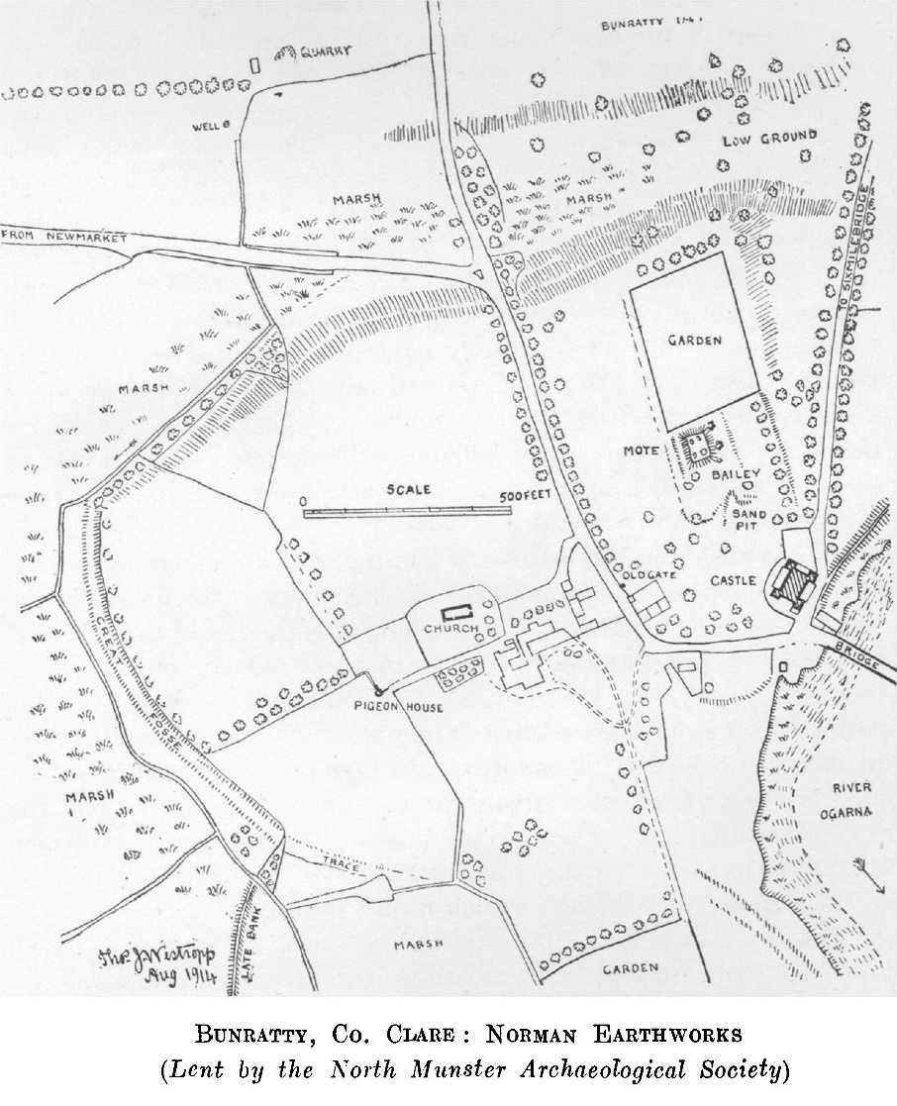[To face page 14

Plate I]

NOTES ON CERTAIN PRIMITIVE REMAINS 15

high. Where the ditch ends was evidently a deep marsh round to the river. It is cut into the foot of the natural slope of the Island and leaves a band like an outer bank all round feet 36 feet to 48 wide.

Mote.—On the summit of the Island to the north-west of the present castle is a raised oblong platform with traces of two other enclosures. It is very possibly the mote castle of Robert de Musegros about 1249-51. It is from 10 to 12 feet high, 70 feet long and 46 feet wide. A fosse 18 feet wide and trace of an outer mound 10 feet thick are seen to the west and very slight trace of a fosse to the south. There was evidently a bailey of two levels 140 feet and (the lower) 110 feet wide and about 250 feet long: the lower ends in a terraced- up bank 5 or 6 feet high and now planted with large trees. The south end has been so dug up for gravel that the length is very doubtful, the more so that the garden of the Studderts of Bunratty lies close to the end of the mote and may have also trenched upon the surrounding bailey. Indeed the west fosse may be a slight parallel-sided depression along the west wall of the garden.

The present over-all dimension of the “bailey” is nearly 250 feet square so near as Dr George J. Fogerty, R.N., and I were able to trace it.

In 1289 the English made about 140 yards of fosse round the castle with a palisade and a mill fosse. There was a large stone tower and chamber near the river, a wooden tower beyond the gate (perhaps on the mote) and houses within the castle (yard).1

In 1321 the fortress had a large tower unroofed, a good stone chamber, a cellar filled with stones, another chamber, a platea covered with boards, a stone kitchen with a cistern and an oven. The other houses below the precinct of the castle were in ruins.2

Caher (Ordnance Survey 51).—A cathair near the “Thunder - hole,” between Newmarket and the railway. The wall to northwest is fairly complete, 12 feet 6 inches thick, 3 feet higher than the garth, and 5 feet over the crag. It is 75 feet across the garth inside and abuts, like Langough, on a low crag ledge over a bushy glen Two earth forts on the old road, called Bohernabrow, are quite featureless.

Rosroe (Ordnance Survey 43).—I had occasion to mention the very curious traces of a settlement to the east of Rosroe Castle. Others occur between Hazelwood (Ballyhickey) and Corbally and at Castlefergus.3

1. Pipe Roll, xxi, Edw. I.
2. Inquisition xvi, Ed. II, no. 37.
3. Proc. R. I***.*** Acad., *vol. xxiv, p. 90 ;* Kilvoydan and Ballymaconna Dolmens *p.91; Ballyogan.*

16 ROYAL SOCIETY OF ANTIQUARIES OF IRELAND

Langough (Ordnance Survey 42).

There is a fitness in my closing this survey with one of the three remarkable forts which I described in the first independent section of it, in 1893.1 This is the more needful that it becomes more difficult to describe and study a fort in proportion to its complexity, the appearance of alterations, its dilapidation and overgrowth, in all of which qualities Langough, unfortunately, excels the other forts of the county. The chance that has brought me to Newmarket each autumn for several years gave me abundant opportunities for study on various lines and enable me to give at last a minute account of the ruin and a suggested explanation of its phenomena. Every scholar knows how fascinating it is, but how very difficult, to decipher the original text from under later obliteration and writing in a palimpsest. Just such a task meets us at Langough, but there we are trying to read and reconstruct a language of which we have scarcely mastered the rudiments.

When I first examined the site in 1892-3 I was only beginning'a scientific study of primitive forts, and the fort was lost in a dense thicket, subsequently cleared away outside the inner works. I had however, the admirable map of the 1839 Ordnance Survey to help me and my admiration grows for the intelligent insight shown in the plans of Langough and Moghane on it, seizing, as they do, nearly all the main features of both structures and omitting the accidental ones. I may be forgiven for failing to elucidate at first the remarkable remains before me and may venture to give the results and (so far as I can suggest) a theory, modified till it falls in with all the traces on the ground.

The fort was probably an early walled village, a sort of suburb of the great hill-town of Moghane; the latter, judging from the gold ornaments of the Great Clare Find, may have perished in an unrecorded raid from about 500 to 700 years before our era. While, however, Moghane was never rebuilt (save that certain later ring forts were built upon and out of the debris of its overturned ramparts), Langough was extensively modified on at least two, if not three, or more, occasions. In some instances, where we find one wall overlying another, we can fix with all assurance the succession of the works. In others, where they abut, the issue rests rather on general considerations; 2 in yet other instances I do not venture to assert the additions as belonging to either of the main periods of the fort.3

1. Plan, Proc. *R.* I. Acad., vol. xxxiv., p. 67 and plate,
2. For instance, the bastion and built gate at the end of the hollow way, 66 feet outside the rock gate and line of the main wall of the older annexe, are possibly later than the older annexe and earlier than the modification of the latter.
3. Journal, xxiii, p. 284; Proc. R. I. Acad., vol. v, ser. iii, p. 440 ; vol. xxiii, p. 225.

NOTES ON CERTAIN PRIMITIVE REMAINS 17

There is one problem, the apparent exclusion of the commanding north-west knoll, which can be solved only on a study in the debris on its slope. The old fort builders were careless in choosing what we should consider salient points for their works,1 and it is strange that the bold crag knoll a little distance from the outworks of Langough was not at least defended by a detached ring fort. The builders preferred to fortify a platform of little natural strength, placing their citadel on its level, with no other advantage than being on the edge of a low ledge of stratified limestone.

As we stand at the upper end of the road called the ”Sweep,” or “Loop, of Langough” (Loon-ga, or Lon-ga, as pronounced), we see a long craggy slope, flanked by a tangle of thickets of hazel, hawthorn, and pegwood, down to an old lake bed, a cut away bog and meadows rich in purple gentian and parnassus grass. Little can be seen of the fort; a low knoll, covered with debris down its flank, lines of grey stones and reaches, chiefly of late looking field walls, among the bushes. When, however, we get on to the plateau we see the long foundations and large blocks and the lower part of the massive walls of the inner works.

The remains consist of a massive ring-fort, usually of fine masonry, with the unusual batter of 1 in 2 ½ in parts: it varies very much in character and has evidently been patched and repaired on several occasions. Parts are hammer-dressed to fit irregular stone work together, parts of good large oblong blocks, parts of rather small stonework and the joints packed with spalls; the wall is 6 ½ feet to 8 feet thick at the rock, but in other parts near the gateway and elsewhere, about 10 feet thick and rarely over 4 feet high. At the south end, near the cliff, the piers of a gate, 4 feet 6 inches wide, remain, but no lintel. The finest and probably an original part of the first fort forms a revetment cleverly bonded into the irregular cliff ledges. The garth is 97 feet north and south by 111 feet east and west; in the centre is a house ring of large blocks 3 to nearly 5 feet long, 27 feet across and nearly equi-distant (30 to 33 feet) from the main wall. It is quite overthrown by treasure-seekers, and contains a rock cut souterrain,12 feet long and 4 feet wide, with parallel sides, its roof slabs all removed and heaped together. It was overgrown and concealed down to 1914. To the central fort in early times was added a large and singular annexe. It abuts against the ring fort, so is at any rate later than it, be the interval long or short, and its traverse at the west gate and the north end are overlaid by the later annexe, when the fort space was rebuilt and reduced, probably in

1 Of the stone forts of East Clare only two (Moghane and Caherscooby) occupy really commanding sites. The great forts of Langough, Cahercalla and Caher- -shaughnessy are on low ground, the last in the bottom of a hollow overhung by hills.

18 ROYAL SOCIETY OF ANTIQUARIES OF IRELAND

the later conditions, known best to us in tradition and history, when the walled village had ceased to be made. It was at first an irregular pear-shaped enclosure covering most of the plateau; a road (curved to the south-west and 9 feet wide) ran between two walls from the

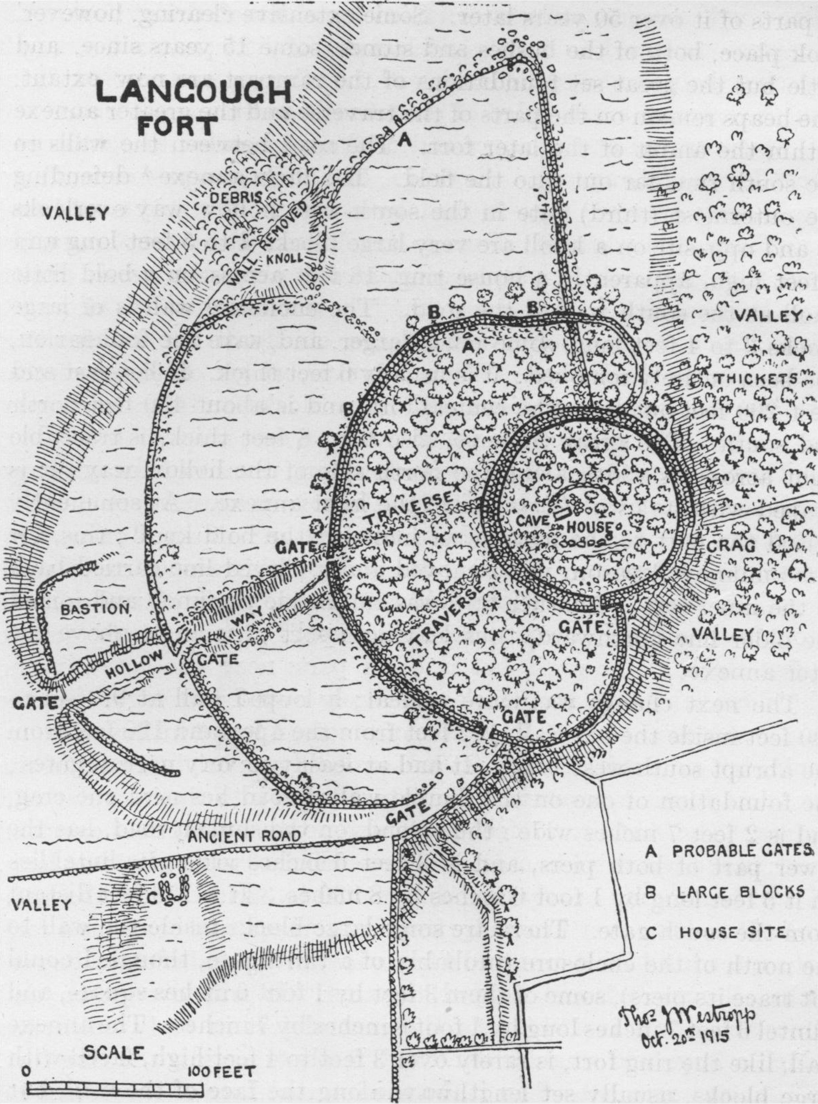

gate and along the crag ledge and southern curve. Another straight road, 12 feet wide, with traverses to each side of a natural channel,, ran towards the south-south-west across the garth to a rock-cut gate, the natural hollow running on to the edge of the platform. It is over 244 feet long; the side walls are much removed, but remain in

NOTES ON CERTAIN PRIMITIVE REMAINS 19

parts along it. About 66 feet from the rock gate another built gate of large blocks is found where the plateau ends at the shallow valley; a looped wall curves back on either side to the main wall. It is evident from the map that, in 1839, the whole extent of the main wall was marked by continuous heaps of stones; indeed this was true of parts of it over 50 years later. Some extensive clearing, however, took place, both of the bushes and stones, some 15 years since, and little but the great set foundations of the rampart are now extant. The heaps remain on the parts of the traverse and the greater annexe within the ambit of the later fort. The road between the walls to the south runs far out into the field. The little annexe1 defending the outermost (third) gate in the south-west hollow way overlooks it, and opposite on a knoll are very large blocks 4 to 5 feet long and 3 feet high, apparently a house ring, 18 feet across, on a bold little knoll at the south wall of the road. The enclosure wall is of large blocks 3 to 4 feet long, some much larger, and, save the foundation,, has been entirely removed; it is usually 6 feet thick. It lies east and west 200 feet out from the central fort, and is about 430 feet north and south. The great traverse, also 6 to 8 feet thick, is traceable right across its width along the north side of the hollow way; it is heaped with its own debris inside the later annexe. At some early period the part to the north-west included the bold knoll; this, for some unknown reason, was removed and a curved line carried back to the inner fort. Another wall was run inside the knoll and joined the older line northward, thus leaving a sort of triangle above the later annexe.

The next change was more radical; a looped wall at 95 feet to 100 feet inside the old wall, 142 feet from the apex and 120 feet from the abrupt south-west bend. It had at least two very narrow gates; the foundation of one on the double walled road lies next the crag, and is 2 feet 7 inches wide: the second, on the sunken road, has the lower part of both piers, and is 3 feet 6 inches wide; its lintel lies on it 5 feet long by 1 foot 6 inches by 8 inches. It is 159 feet distant from the south gate. There are some large blocks inside the wall to the north of the enclosure (probably of a third gate, though I could not trace its piers), some of them 3 feet by 1 foot 6 inches square, and a lintel 6 feet 7 inches long by 1 foot 8 inches by 7 inches. The annexe wall, like the ring fort, is rarely over 3 feet to 4 feet high, faced with large blocks, usually set lengthways along the face of the wall, but sometimes as headers, like bond stones, 3 feet long. The wall is 6 feet to 8 feet thick, with no trace of a batter. The rudely crescent garth

1 These are rare in Ireland, but not so uncommon elsewhere—*e.g.,* at Hartland (Victoria Histories, Devon, 1906, p. 576).

20 ROYAL SOCIETY OF ANTIQUARIES OF IRELAND

is 51 feet wide to the north, 85 feet to the west and 81 feet (gate to gate) at the south. As so often noted, the wall is built over the walls of the larger annexe and that of the sunken way. The whole circuit of the old wall is about 770 feet, that of the later annexe 530 feet, the ring wall 420 feet and, if we include an enclosure running southward in the little glen and seeming to be fairly old (120 feet by 57 feet), about 300 feet, the whole wall extent, without the traverses and curved road wall, is about 2,300 feet. There are no late house foundations in the ambit, or indeed near the fort.

Across the glen to the east is a cathair, a circular ring of tumbled stones and quite featureless. It has a wall about 7 feet thick and is 65 to about 70 feet across the interior, which was tilled in 1892. At the foot of the slope is the curious fairy mound, much feared by the superstitious old of the district. It is about 5 feet high and 54 feet to 63 feet across the top, 90 feet over all, with a slight ditch around it 6 feet wide, and traces of stonework. I have described the other forts of this most interesting district in the Proceedings of the Royal Irish Academy.

For this section of the paper I have to thank (as so often) Dr George MacNamara and the Rev. John Bolton Greer. Besides these, the Rev. Patrick O’Halloran of Inagh, Mrs Murdock of Ballyvergin, Miss G. C. Stacpoole, and Lord Inchiquin who gave me valued information and help for the present section in various matters. If I have in these papers produced an approximately complete survey I have to thank the kindness which I met in all the 25 years of my work of so many kind and sympathetic friends.

This content downloaded from 109.76.164.22 on Tue, 24 May 2016 09:26:26 UTC  
All use subject to <http://about.jstor.org/terms>