North Munster Antiquarian Journal Vol 2(4) 1913

**KILKEE (CO. CLARE) AND ITS NEIGHBOURHOOD.**

By THOMAS JOHNSON WESTROPP, M.A., M.R.I.A.

Part_1

Kilkee to Cross, Introduction  
 History of the district

Medieval period

Burton, Westby, Mc Donnell, Westropp

Village of Kilkee

Kilkee fishponds

Amphitheatre & Duggerna

Mirages

The Intrinsic

Doonaunroe

Bishop's Island

Part 2

Kilkee to Cross (continued)

Bishop's Island (continued)

Illaunadoon

Doonlicka

Goleen, charms for rats

Tullig Cliffs

Dundoillroe

Cloghaunsavaun

Part 3

Dunbeg and Dunmore

Hickman, Stacpoole, Westropp

Dunbeg castle and bridge

Dunmore

Killard Church, graveyard and Holy well

Legend of the Soul Cages

Part 4

Dunbeg to Kilkee (continued)

Doonegal Promomotory Fort

Farighy, St Brendan’s Holy Well

Kiltinnaun (Bansha)

Lisnaleagaun

Georges Head

Conclusion

Kilkee Fishpond

Kilfieragh graveyard

Moyarta Forts - Lissagreenaun

Corrections and additions

Cahermurphy and Mac Gormans

Milltown Malbay, Dough & Rinbaun

MuttonIsland or Iniscaeragh

Lislard and the mote, Craggicorridan

Ballyganner

Cross, The Kilballyowen font  
St. Senan's bell shrine

North Munster Antiquarian Journal Vol 2(4) 1913

KILKEE (CO. CLARE) AND ITS NEIGHBOURHOOD.

PART I.

KILKEE TO CROSS.

By THOMAS JOHNSON WESTROPP, M.A., M.R.I.A.

Kilkee, the best known and most favorite resort on the coast of Co. Clare, must now be examined in order to complete my long series of papers on the pleasure places of the county. Though, as a rule, the district most favoured by the antiquary lies far off the tourist track, I think these papers have been justified from the standpoint of an Archaeological Society by the interesting remains noted. I also have found that these accounts were welcome to pleasure seekers, and gave them a new interest in these beautiful spots along the hem of the Atlantic. Clare is, indeed, fortunate in its three seaside towns (Lisdoonvarna being too far inland). In other centres we rarely stand “on the edge of the Old World face to face with the glory and terror of the ocean of the sunset.” None of the others have such noble ranges of cliffs to either side and many are far less accessible. Even such charming spots as Dingle, Valentia, Waterville, and Glengariiff, shrink back into shelter, but Kilkee and Ballybunnian stand out boldly—like the old headland forts—

“Out on the edge of the land,

Alone on the cliff I stand,

While the fierce sea roars at my feet.”

Few more impressive hours can be spent than above the Diamond Rocks in the full glory of the gale, especially on a moonlight night,when the glare of the surf, the roar of the hungry waves, and the dull boom of the caverns add weirdness and awe to the dimly-seen outlines of the black headlands and islands. Though lacking the rich rock tints of Kerry, the colouring of sea and sky, and the clear light and water give to the Clare coast gorgeous colour effects beyond the power of painter to reproduce.

213

A place gains much by the avenue through which we approach. In older days, before the railway extended past Miltown Malbay, which it only reached in 1887, the only approach was by the Shannon from Limerick or Foynes. How delightful it was to steam from the quays of the city (better furnished with shipping then than now) leaving the clustered houses and the dark battlemented tower of St. Mary’s Cathedral. Thinking, perhaps, of the beautiful legend of its bells and their founder, the aged Italian, who sought for the plundered bells vainly till one glorious evening, as he approached the town(1) by water, he heard and recognised their chimes, and was found dead with a smile on his face. Every turn brought a new memory of history or legend. Carrigogunnell, with its tale ot the witch, the death-dealing candle and its story of the O’Briens “Lords of the Rock,” rose over the woods of Tervoe. We saw Bunratty, with its memories of de Musegros and de Clare; of the hapless King, Brian the Red, torn from his host’s banquet to be “dragged to death by a stern steed”; of the sieges by King Torlough O’Brien, by his son, King Murchad, who won it from the Normans at last in 1334 ; and that of the Confederate Catholics, when the Legate Rinuccini, so admired the building and its fine parks, and the Parliamentary garrison was expelled. The tall tower of Canons’ Island recalls Donaldmore, the last King of Munster, his fierce cruelty, his craft and his remorse that gave us Holycross and St. Mary’s Cathedral Corcomroe, and many another abbey and church before 1194. The fragments of the lofty seated church of Knockpatrick, behind Foynes, have their memory of our Patron Saint blessing the people in Corcovaskin, who swarmed across the stream to meet him. He blessed their ships and foretold the birth of their Saint, Senan, the pure and austere father, and his monastery “in yonder green island at the mouth of the sea”(2). Soon we round Kilkerrin Point and Tarbert, and see the island with its lofty, slender round tower.

1. Lameriq is one of the few inland towns marked on the early Italian Portolano Maps from 1339 onward.
2. “Tripartite Life of St. Patrick” (ed. W. Stokes, Rolls Series I., p. 207 and Life of St. Senan, in Whitley Stokes “Lives of the Saints,” from the Book of Lismore.

214

With the railway, fewer and fewer, enjoy this prelude. Well might   
its remembrance inspire Sir AubreyDe Vere’s ode :—

“River of chieftains, whose baronial halls

Like veteran warders guard each time-worn steep,  
Carrig’s stern rock, Bunratty’s regal walls,

Portumna’s towers, the Geraldins grey keep.”

Still the more prosaic approach, though far less enjoyable, save in bad weather, is far from lacking interest. The view of the old city and the many coloured hills as we cross the Shannon, the wide view of the river valley, as we pass above the cromlech and ivied church of Croaghane, over the shoulder of Cratloe hill, and see Bunratty and the towers of Drumline and Rosmanagher, is rich and pleasant.

“On its grassy rock well founded,

With its ivy mantle round it,

By a belt of dark trees bounded,

Frowns Rosmanagher’s castle tall.”

Under the wooded ridge of Moghane, in the cutting near the lake to the south of Moghane bridge, was found some 65 years ago the wonderful mass of gold ornaments(3), probably dating from 500 to 700 years before our era. If (as is most probable) they were plundered from the huge triple-walled fort or hill town, on the ridge, then it may date over 2500 years back. We get glimpses of the Abbeys of Quin, Clare and Ennis, of the peel towers of Ralahine, Mountcashel, Rosroe(4), of the great battlefield at the end of the lake near Dysert, where, in May, 1318, Richard de Clare and his chivalry fell. Then we pass Corofin, seeing the strangely-terraced grey hills of the Burren, and ivied Tirmicbrain and the wooded ridge of Ceanntsliabh the site of the legend of the Feis tighe chonain. On through the bogland of Inagh, past the bay and sandhills of Lehinch, with the tall castles of Dough and Liscannor and memory of the Armada, and finally through the drearier country below Dunbeg, we run past the green mote of Lisnaleagaun into Kilkee. In a few minutes we see the beautiful bay, with its golden crescent of sand, and the dark cliff of George’s Head, carved by sea and storm into a grim human face, like some ancient colossus, and enter on our heritage of the untold wonder of the Atlantic and “the rampart of the Old World to the west.”

1. Proc. R. I. Acad., vol. xxvii (c) p. 220
2. Also of Clarecaslie, Ballyhannon (Castlefergus) and Ballygriffy.

215

The history of even the district is obscure; I must recall to my readers the leading facts. Ptolemy, after a.d. 144, places the Ganganoi in the angle north of the Shannon, they are the Irish tribes of Gann, Gennan, and Sengan, and the latter subsisted long enough to be connected with what was then the southern part of Connacht on the Shannon (or at least at Mount Callan) when our traditions got recorded. A dim legend of the Martinigh, a Firbolgic race, tells how they held the same district and were defeated by the High King, Aenghus Olmuchaidh, in a.m. 3790, on Sliabh Cailge. The latter place was also very possibly Callan, but local historians (forgetting that Corcovaskin in early times met Corcomroe, probably at the Daelach river and estuary near Lehinch) sought for some southern hill, and fancied they found it in the ridge of Moveen near Kilkee. Then the historic period opens and shows as no new settlers the Corca Bhaischoinn (or Corcavaskin) tribes, descendants in one legend of Queen Medb and her lover, Fergus, son of Roigh, and in another tale, of Cairbre Bhaiscoin, brother of Cairbre Musc and the hero of a cycle of crudely pagan legends, often very repellent (no less to the early clerics than to modern feelings), which generations of scribes confused and made contradictory in vain attempts to expurgate objectionable features(5). Conaire, High King of Ireland, at about the time of Ptolemy’s great work, a.d. 165, had three sons, Cairbre Musc, ancester of the Muscraighe (whence the existing name Muskerry), Cairbre Riada, ancestor of the Dalriada in the north-east of Ulster and in Scotland, and Cairbre Bhaiscinn, of Corcavaskin, in S. W. Thomond, but Thomond was not then known by the name till Lughaid Meann added eastern Co. Clare to the real Thomond in Co. Limerick, about a.d. 370. Not to go into the details, some said that the youngest Cairbre had a son, Duben, or according to others, a daughter or sister of the name. The latter was ancestress by him of the Corca-Duibne, whose territory was then far larger than the present barony of Corcaguiny. What is probably the earliest version made Duben not the sister, but the mother of Cairbre. When the battle of Cenn Febhrat, in Co. Limerick, was fought between Lughaidh MacCon and Eoghan Mór, son of Oilioll Olum, the three Cairbres, of the race of Ith, son of Breogan, slew

5 For these tales see “Silva Gadelica.” (S. H. O’Grady). Vol. II. p. 535, and Borlase’s “Dolmens of Ireland.’'

2 I 6

their father in their mother’s arms. From Cairbre Bhaiscinn and Duben sprang the Corca Duibhne, and how ancient the name is can be shown by the Ogham inscriptions “maqi mucoi dovinnias” in the Dingle peninsula and by one to “the name of Duben,” “Anm dovinnias,”(6) on the hill, within the fortified promontory of Dunmore, overlooking the Blasket Sound, amid some of the most lovely scenery in Co. Kerry. Early, but unscientific Philologists derived the brothers epithets Musc as “mo aisge,” inordinate desire; riadha, “rigfhada,” long forearm, and baschain from “bas caein,” euthanasia “pleasant death” for “he died on his pillow,” but if “pleasant” it was a reproach in those fierce days so to die, as it was to the Norse and Danes in later times —

“A leech death, a bed death, a straw death, a cow’s death—

Such death suits not me.

Me, happier, the Valkyrs shall waft from the war deck,

Shall hail from the hoimgang of helmet strewn moorland,

And sword strokes my shrift be, with heroes hot corpses High heaped for my pillow.”

Angus was Cairbre Musc’s real name, Eocho was Cairbre Riata’s, and Oilill was Cairbre Bhascinn’s. The whole confusion shows how early the legend must have been, and how much it was disliked, but too well rooted to be eliminated by more civilized genealogists. It is also said that when the ill-conceived son was born all nature revolted and was blighted. It was only when a druid charmed the more than original sin from the child into the wonderful cow “Bui,” and the latter swam away and became one of the rocks (“Bui,” on the early Italian maps still called “the Bull and Cow”), off the south coast of Kerry, that the blight ended. At every side, in morals, thought and beliefs the stories stand, confessedly pagan and primitive.

Of the Corcovaskin, near Kilkee, definite history only begins after the year 700. Little were to be gained by giving the names of the chieftains and whether they fell in battle or not, or how the tribal group, once tyrannized even over central Clare, or how their importance died out after the weakening of the first forty years of the Norse wars, by 850(7). In fact the only name of any real interest, and it overlaid by uncertainty and myth, is that of Senan of Iniscatha, before 550. We hear of a daughter of Niall, son of Mechar, of Corca Bhaiscinn, of

1. Journal Roy. Soc. Ant. Ir., Vol. XL., p. 265.
2. See Supra, Vol. I., p. 219 ; Vol. II. p. 30.

217

the race of Conaire, of Leim Conchulainn (Loop Head), who, by her husband, Sinell, was mother of St. Mobaoi of the Ui Muiredagh(8). The O’Domhnaills were chiefs in the 11th and 12th centuries and were equally undistinguished, and the ruling house of the Dal-gCais slipped into the district first as the O’Briens of Tromra, and then another branch as the chiefs of the MacMathgamhains or MacMahons of Corcavaskin. The first befriend King Thordheabhagh Mór (Torlough) when, in 1276 (at the alarm of his deposed uncle with his Norman allies Thomas de Clare and his followers, having taken his rath palace at Clonroad) fled up the coast to Corcomroe(9). The last were probably the people plundered by King Murchad O’Brien in 1315. The Bruce’s expedition had reached to Limerick—

“Which is the southmost town, perfay !

That in Ireland may founden be”(10)

as Barbour sings. Murchad had thrown in his lot with the English who flattered him by saying that they must win for they had the King of Erin with them(11), his rivals supported the Scottish King of Ireland, Edward Bruce. The great war ran its course little effected by the English skulking at Lodden till the Bruces went away(12), or by a small skirmish of the MacNamaras with the Scotch at Castleconnell(13). It had, however, a bearing on this remoter district, King Donchad O’Brien had made a tactical mistake, for his friends and allies, Richard de Clare and the Norman Colony in Tralee, could not now support an open ally of “the King’s Scottish felons.” Murchad, as soon as possible, set on his rival and drove him back into the wedge-like district ending in Loop Head called “Western Irros.” He then wasted it from Knockalough to Cuchullin’s Leap and left no stronghold unburned(14). Kilkee, however (to my knowledge), only appears about the close of the 14th century, in about 1390, where it is called Cil Caeidhe. There is still a holy well called Tubberkee, Tobar Caeidhe, on the cliffs near Foohagh, but no church site is known at or near Kilkee unless it be the

8 “Martyrology of Donegal.” The name Mechar is interesting as bearing on the Macharius of Dun Mechair (named in the “Life of St. Senan”) in this district.

1. Cathreim Thoirdheabhaigh.
2. Barbour’s poem on Bruce; written 1375, Book XVI., line 264.
3. Cathreim Thoirdhealbhaigh.
4. Annals of Clynn. Plea Rolls Edw. II., &c.
5. Cathreim Thoirdhealbhaigh.
6. Ibid.

2 1 8

old “Killeen” Graveyard, near the fallen dolmen, in the field behind Moore’s Hotel. The MacSweenys held Cil Caeidhe under the MacMahons(15) and built the castle, probably late in the 15th century, when numbers of such structures were being built in Co. Clare—1460 to 1500. A grant of the family alludes to it in 1550 when Edmond Roe MacSweeny, son of Gilladuff, held it; the next recorded owner of Cil Caoidhe is Collo MacSweeny, who died in 1575, his son and successor Aedh MacSweeny (or Hugh, as the English called him) owned it, but a certain Owen MacSweeny claimed it under a mortgage of Morrogh, Collo’s brother. Torlough MacMahon, as overchief, is named as its owner in 1585, but of course it was in MacSweeny’s actual occupation. When the prudent MacMahon was succeeded by his son Teige Caech, “the shortsighted,” as he well deserved to be nicknamed, a change in the overlords occurred leaving the occupants unscathed. He saw fit to defy the not too patient government and to rouse the emnity of the all powerful O’Briens, although the weakest of the Clare chiefs. He plundered an English Merchant ship and captured the brother of the Earl of Thomond, one Daniel O’Brien, and, almost before the English could act, the Earl flung him out of Clare. The imprisoned Daniel was more than repaid by the grant of his captor’s ample lands. MacMahon fell accidentally by the hand of his only son, at Dunboy, and the innocent parricide carried his remorse to Spain and gave no more trouble. Under O’Brien, as under MacMahon, Hugh MacSweeny still sat in his dark old flagstone tower looking over the bay and the crescent strand, and far towards the sunset. He, or a namesake was there in 1651; the castle is marked as Quilqui in one of the few surviving maps of Co. Clare in the Down Survey, and was maintained, with Carrigaholt, as barracks for the Cromwellian garrisons. At Kilquiee the supply of oats, contributed by the inhabitants of the Barony of Moyarta, was stored in 1652. The influence of Daniel O’Brien’s family (augmented by the court favour of his grandson and the title the latter had procured for his house—the Barony of Clare) was again predominant after the Restoration. Little is told of the castle and district, and that little is bare mention between 1660 and 1691, but in the interim Lord Clare

1. For what follows see Inquisitions, list of Clare Gentry holding Castles, 1585 (MS. T.C.D.). Down Survey map of Moyarta (No. 61).

2 I 9

had staked all on the cause of James II, and lost, so the whole district was confiscated in 1688. William, forgetting that he held the throne on entirely different lines from his predecessors, granted the huge estates of Lord Clare to Keppel, Earl of Albemarle, and the act of favouritism raised a storm of envy and justifiable anger in England. The grantee was quick to see his own precarious tenure, and speedily and silently sold all his grant to a syndicate of local gentry, Francis Burton, W. Westby, and Charles MacDonnell, the last a prominent member of an Antrim family of Scotch descent. The patent to First Earl of Albermarl was dated 16th February, 1698, and his sale to the Syndicate, March 9th, 1695, for £2,500. They got the estates confirmed under the Commissioners of the Confiscated Estates in 1703, and divided the land among them, A portion(16) was bought by the Amory family from Cambridge, but they never lived in Clare and sold their estates there to the Westropps and others later in the century.

The MacDonnells lived at Kilkee castle and have the credit of protecting the last of the old local bards, the Curtins, whom, especially Andrew, they hospitably entertained on occasion at “Cil Caeidhe of the Jewels” as he termed it in his poems. When the family succeeded to large estates about Ennis from Christopher O’Brien they settled at Killone, now Newhall, and Kilkee was left to a widowed mother as a dower house. Daughter of the O’Briens, and widow of Charles MacDonnell, she lived there to a great age, dying at the centenary of the great confiscation in 1788. Ten years earlier John Lloyd described it in his “Impartial Tour in Co. Clare” as “a spacious old-modelled house with many outoffices;” after the death of its occupant the family left it to decay. Standing on the storm-beaten plateau, behind the angle of the “West End,” it soon fell to ruin, and in 1816 Mason found its remains were “imperceptible.” I have been told that its “vaults were standing some 40 years since,” but (as I often played in the field where it stood before that period and even then had an interest in abbeys and castles, and I have no recollection of any old building other than Dunlecky on my visit of 1868) I believe my informants mistook imagination for fact in a way common, at least to sea side haunts.

1. Moveens, Kilcashin, Drumellihy, and perhaps other lands.

220

People, such I remember, describing Beltard signal tower as an “old castle,” and the well house at the village as “an old church,” were probably responsible for the tale; so much for the castle; the only trace of old work near its site is a low defaced ring fort, perhaps the homestead of the MacSweeny’s before the Peel tower was raised.

The village, however, now demands our attention, for, by the close of the reign of William IV , it had risen to some importance. When, in 1778, Lloyd described it as “Kilkee, the most western seat on the coast is a spacious and regular old modelled house with many out offices situated on the brink of a delightful bay and a pleasant beach decorated with sandhills and sheltered from the N.W. wind by a commanding eminence”—there was evidently not even a hamlet. He does not tell of it as he does of Liscannor Bay that people frequented it in summer for the bathing.

At the beginning of the late Queen’s reign a number of lodges had been built with a schoolhouse and a new Roman Catholic Church. The old Parish Church of Kilfieragh had been let go to ruin. Kilkee had 153 houses in 1831, which had greatly increased six years later. Hot baths were established by a Mr. Jonas Studdert, and a police barrack, a coastguard station, “a penny post to Kilrush,” and a courthouse (replacing the old irregularly held manor court for small debts) had sprung up. Protestant service was still celebrated in the schoolhouse, but subscriptions were then being collected for a new church(17). The Kilkee fishery was worked by 25 canoes, twice the number being employed at Farighy; before leaving the subject, I may cite John Lloyd in 1778, for though the popular idea that only one copy of his little work survived in the National Library of Dublin, is quite unfounded) his little shilling handbook is now rare. “There is an artificial curiosity made use of by certain individuals in the upper part of this dangerous coast. It is a kind of canoe or currach, composed of wattles covered with raw hydes. With this Indian-like construction they fish successfully in the proper season, and paddle some leagues out in calm weather In the month of August there is often a large squadron of them together in the Bay of Liscannor, and in this posture they appear

1. This was intended to be built in the Square before Moore’s Hotel, but was fortunately established at the head of the bay in open fields.

221

like so many porpoises on the surface. Each man carries his wicker boat or canoe on his back occasionally to and from the shore.” The large wheat trade with Limerick, Tralee and Ennis existing at that time seems to have died out by 1837, but large supplies of turf were shipped from Poulnishery to Limerick. A second old manorial court was occasionally held by the Seneschal at Lisdeen. There is little in the history of Kilkee to detain us farther; the not very thrilling round of pleasure, bathing and boating in the summer months, stagnation in the winter, a wreck at long intervals, a sea monster or apparition of Hy Brazil, are its main annals The steamboat made it very accessible from Limerick, and though possibly less “fashionable" than when I first remember it in “the sixties” it is more popular and crowded, while the new light railway, the motor and the golf links, have all played their part in adding to its prosperity.

Let us first explore the coast southward from Kilkee. In the field behind Moore’s Hotel, as I noted, is an unfenced killeen for unbaptized children, near it lie two slabs of flagstone, and I think a third under the others, to all appearance the ruin of a dolmen. The cover measures 6 feet 7 inches by 5 feet 3 inches, and is about a foot thick, the under slab, 3 feet 6 inches by 5 feet 9 inches. It probably was a burial cist of the usual type, the small end slabs were first removed, then the weight of the cover heeled it over north-ward, for, as usual, the sides were only slightly set in the surface of the field, and were probably as dependent on each others support as a house of cards unless (as so often) they were embedded in a small mound up to the level of the cover slab. Mrs. Tufnell Oakes first called my attention to it. I know of no other cist or dolmen south of Carncreagh at Doolough, though especially in places like Ross, thick, loose slabs abound of the very dimensions most suitable for a cist. These are long enough to leave space for a recumbent human body with the knees bent in the attitude of sleep so common a posture for the laying out of the pre historic dead, so the absence of slab cists is the more remarkable.

The Edmond Rocks derive their name from a ship which was wrecked one night (Nov. 12th, 1850) in that apparently improbable place. It is said that had the “Edmond ” not been turned in towards

222

the lights of the houses it would have stranded safely and probably without loss of life. It probably attempted to anchor on seeing the lights near it, and so was swung on to the rocks.

As I noted there was a rath, a low ring mound, and a peel tower of the MacSweenys (which with the additions of the MacDonnells has not left a trace) on the hill in the angle of the West End. At the foot of the western slope, near Duggerna, there is, however, an interesting relic of the castle, its embanked fish pond, which untold hosts of visitors pass without notice. It is a great oblong hollow about 450 feet long and 150 feet wide, with banks 5 to 6 feet high, fed by a little stream which now runs through it undammed in a forest of yellow iris where the cliff road ends.

Beyond are the well-known fields (now Golf Links) along the cliffs fringed by the best known lesser cliff scenery at Kilkee, the Diamond Rocks and the curved “Amphitheatre.” Near the lowest edge of the latter a beautiful little cave, with a natural wonderfully regular bath, enamelled with pink coralline, may be visited to the left at low water and beyond are the ridges of Duggerna. The latter great wave breaker—Docharna, “the obstacle,” partly keeps the heavier waves from the southern side of the bay. It is full of endless rock pools, gardens of weeds (pink, green, brown, purple and old gold); starred with sea anemonies (crimson, amber and green) some full of fish and strange creatures(18), others black-purple with sea urchins. The latter recall a quaint story told by the first historian of Kilkee, Mrs. Knott(19). She commenced her “Two Months at Kilkee” by arriving delicate, hungry, tired out by the long journey from Limerick, and then having to wait for the slow cart that brought her luggage and provisions from Kilrush. A knock came—heaven gives relief—the provisions had arrived, the invalid thought, but a peasant girl entered with the query “do you want any dillisk or porcupines,” and the visitor had only to laugh off her hungry disappointment at the quaint wares. Let explorers of Duggerna, however, be very careful to watch the tide as the deep hollows near the

1. The beautiful violet “Portuguese Man of War” is sometimes found on these coasts. Mrs. Knott mentions the violet shells of the Janthina “Two Months at Kilkee,” p. 86.
2. “Two Months at Kilkee,” 1835, p. 34 for “Duggana and the Rock Pools,”* see p. 69.

223

land fill between the pools long before the tide reaches the rocks at the outer end, and they may be cut off from the shore, though few such accidents have occurred. Westward lies the curious rock like an elephant’s head called variantly “The Pulpit,” “The Lion,” and “The Ruined Tower.” Farther on are the Diamond Rocks, breasting the full force of the magnificent waves, and with a glorious view of the gloomy Intrinsic Bay with its three islets, Illaunawhilla, “Bird Island,” Illaunpoultoohy, or “Lamb Island.” and the outer, the wrecked headland of Bishop’s Island, with a glimpse of the cliffs at Loop Head, through the gap and northward, cape beyond cape, George’s Head (once called Cream Point(20) now named from the huge human face on it which was supposed to resemble George III.) Lackglass, Farighy, Doonegall, and, far beyond, Hags Head and the Aran Isles with occasionally (and an ominous weather sign) the huge pyramids of Connemara.

“Viewed from the vantage of those giant rocks   
That vast in air lift their primeval blocks   
Screening the sandy cove of lone Kilkee.

I scan the dread abyss till the depth mocks   
My straining eyeballs and the eternal shocks   
Of billows rolling from infinity.

Here man alone is naught, Nature supreme   
Where all is simply great that meets the eye,

The prescipice, the ocean and the sky.”(21)

From the Diamond Rocks I saw more than once between 1868 and 1872 the phantom island(22) to which from the influence of the mediaeval maps from 1325 downward the name of Brazil (now Hy Brasail) attached. It appeared immediately after sunset like a dark island far out to sea but not on the horizon. On the last occasion, I made a rough-coloured sketch next day which shows the appearance as having two mountains, one wooded in the low central tract between rose buildings, towers and curls of smoke, rising against the golden sky westward. I have on several occasions since then seen mirages of islands, but never anything so matter of fact as the former “vision of the lost Atlantis.

1. “Two Months at Kilkee,” pp 57-83; it is nameless on the map of 1839. Lackglass Bay was in 1836 most appropriately named the “The Great Horseshoe,” behindit “The High Cliff of Corballe,” 220 feet high. I cannot find when the name “George’s Head” originated, 1836-1866.
2. Aubrey De Vere.
3. Proc. R. I. Acad. xxx. (c), P257.

2 24

We ascend the “Look-out Hill” getting a widespread view inland to Mount Callan and up the Shannon to Tarbert and the hills of Luachair, on the borders of Kerry and Limerick, besides the coast and the illimitable ocean. The cruel looking wedge-shaped bay below recalls by its name one of the saddest wrecks of the coast—the intrinsic, on January 30th, 1836(23). The great ship got embayed in a blinding storm, her cables held and the cliffs were crowded with people unable to help. There was no rocket apparatus then, and the question often strikes one whether the “economy” (or rather moneysaving spirit) that has abolished so many of the coastguard stations was a safe one. Through the spray the horrified watchers saw the signals of the crew, who at last, in hopeless despair went below. A frightened woman ventured to look out of the cabin door and kneel on the deck; they saw two men washed over board, and strange to say, washed back again; and they saw those who proved to be a young officer and his bride again look out to see if any hope remained. At last the struggle ended: the ship, struck by two huge waves in quick succession, sank at its fearful anchorage, and as it disappeared a seabird swooped on the waves, soared and dropped a lady’s glove among the people on the cliff I heard, as a boy, grim traditions among the fishermen, who remembered that terrible day, and what the divers saw when they examined the wreck later on. The officer and his wife were in the cabin, and the crew huddled together in death, swarmed over and preyed on by fishes and gigantic eels: it was said that the men refused to descend again. Mrs. Knott preserves a pathetic poem on the incident of the glove—

“Of the cherished of many a heart and home there’s but this relic, tossed,

Fragile and light on the wild sea foam, a type of the loved and lost.”

1. “Dublin University Magazine”(1841) vol xvii., p. 364 ; Lady Chatterton’s “Rambles in the South of Ireland” vol. ii., p. 226; and “Two Months at Kilkee,” p. 205. The intrinsic had arrived at Liverpool from Calcutta, and after fourteen days started again for New Orleans to meet her doom. She sailed round the north of Ireland, and was blown out of her course. The wreckage was washed up the coast even to Miltownmalbay.

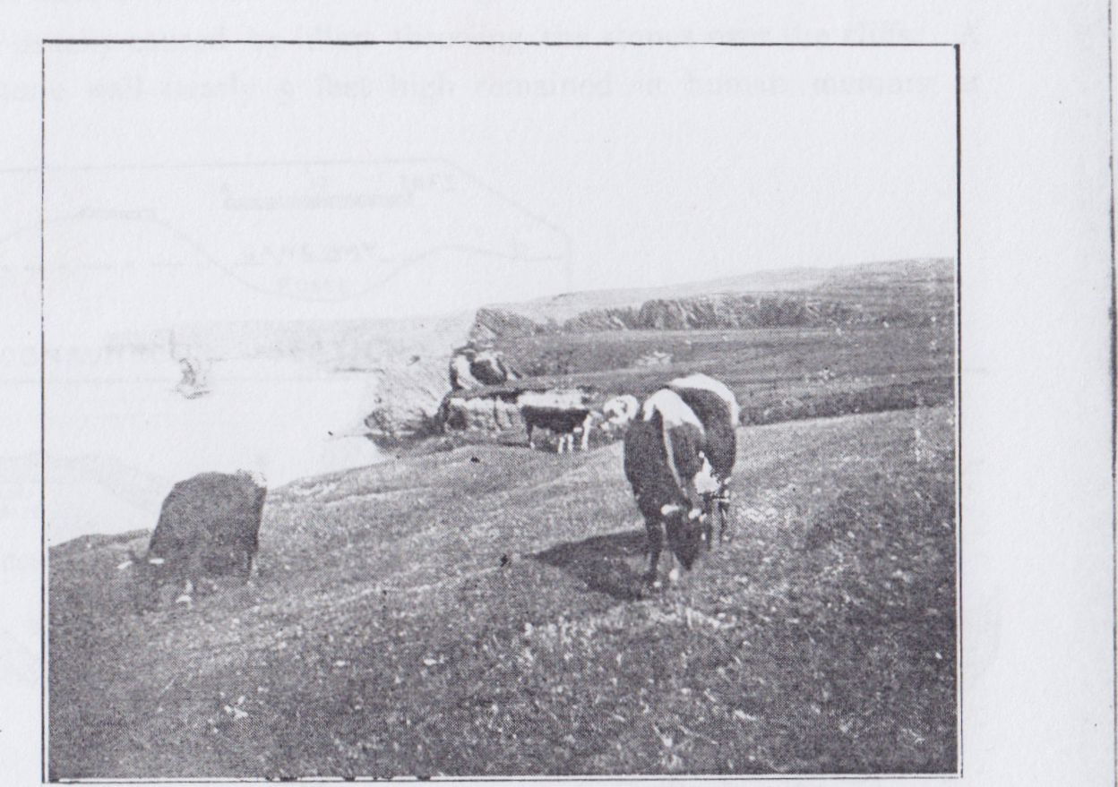

Cliffs near Foohagh, Co. Clare

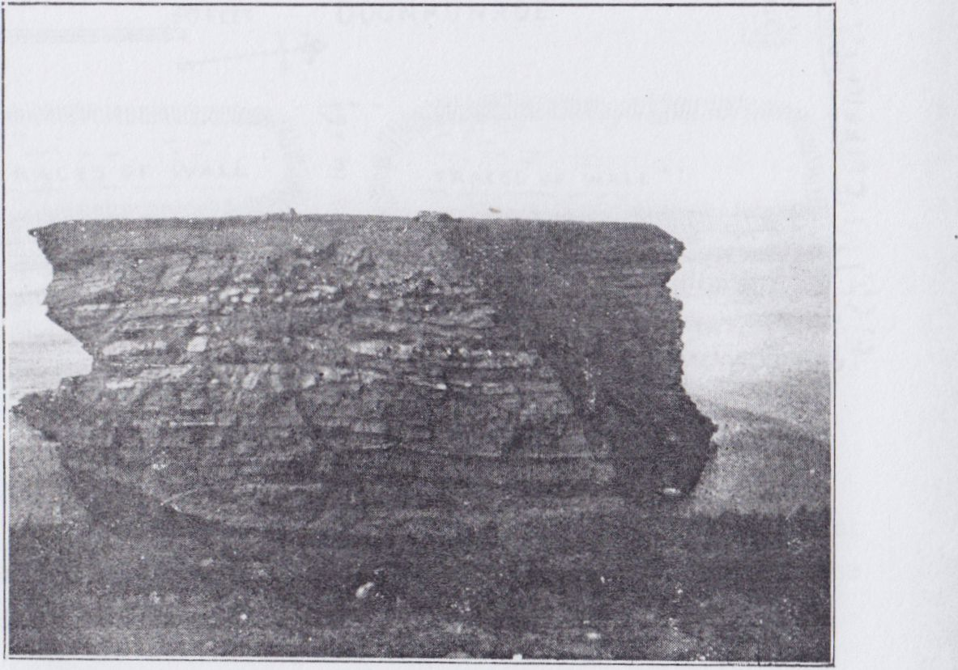

Bishop’s Island, Near Kilkee.

225

I heard that for long afterwards the shadowy masts could be seen under the water on bright days.

From this on to Loop Head is one of the loveliest reaches of the Irish coast. Probably its culminating point is at Foohagh, and there we find the first of the fortified headlands south from Kilkee called Doonaunroe. From its earthworks we overlook Bishop’s Island, and the great pillar to the south far out in the sea called on the maps “Grian Rock,” by the fishermen “Bodawogga.” The small dark spike of Dunlecky Castle, the once fortified headland of Illaunadoon, and the long ranges of precipices on to Tullig are all in view southward, the coast to Aran northward.

DOONAUNROE(24). On the bold promontory of Foohagh Point 185 high, when I sketched it with a camera in 1875, remained a strong drystone wall, still about 5 feet high, of thin flagstones. This rested on an earthwork 25 feet thick at the base and 15 feet above, rising 9 feet over the fosse, and 5 feet over the field. The fosse is much filled up by the levelling of the outer mound, but it was 10 feet wide, and is still 3 or 4 feet deep in parts. The entrance is by a gangway and gap; inside, clearly traceable, though hardly rising over the smooth sward, are the foundations of several huts, and later houses, a range of the latter with four rooms or houses near the southern edge of the cliff has been undermined and has partly fallen away. Beyond it is the site of an early hut, also partly fallen. Then there is a circular foundation and a group of similar cells partly fallen near the N.VV. angle of the head. Another oblong hut, probably very late, stood beside the rampart. It is interesting to note (as so frequently in headland forts, not only in Ireland, but in Great Britain) that the fosse is over a fault in the rock, and that a beautiful natural arch runs underneath this. Probably the depression caused by the fault induced the fort makers to

24 Journal R.S.A.I., Vol. xxxviii., p. 41.

226

dig their fosse above it. The vanishing of stone walls and huts in these forts is usually caused by idlers throwing the stones over the cliffs. A large stone wall nearly 5 feet high remained in human memory at

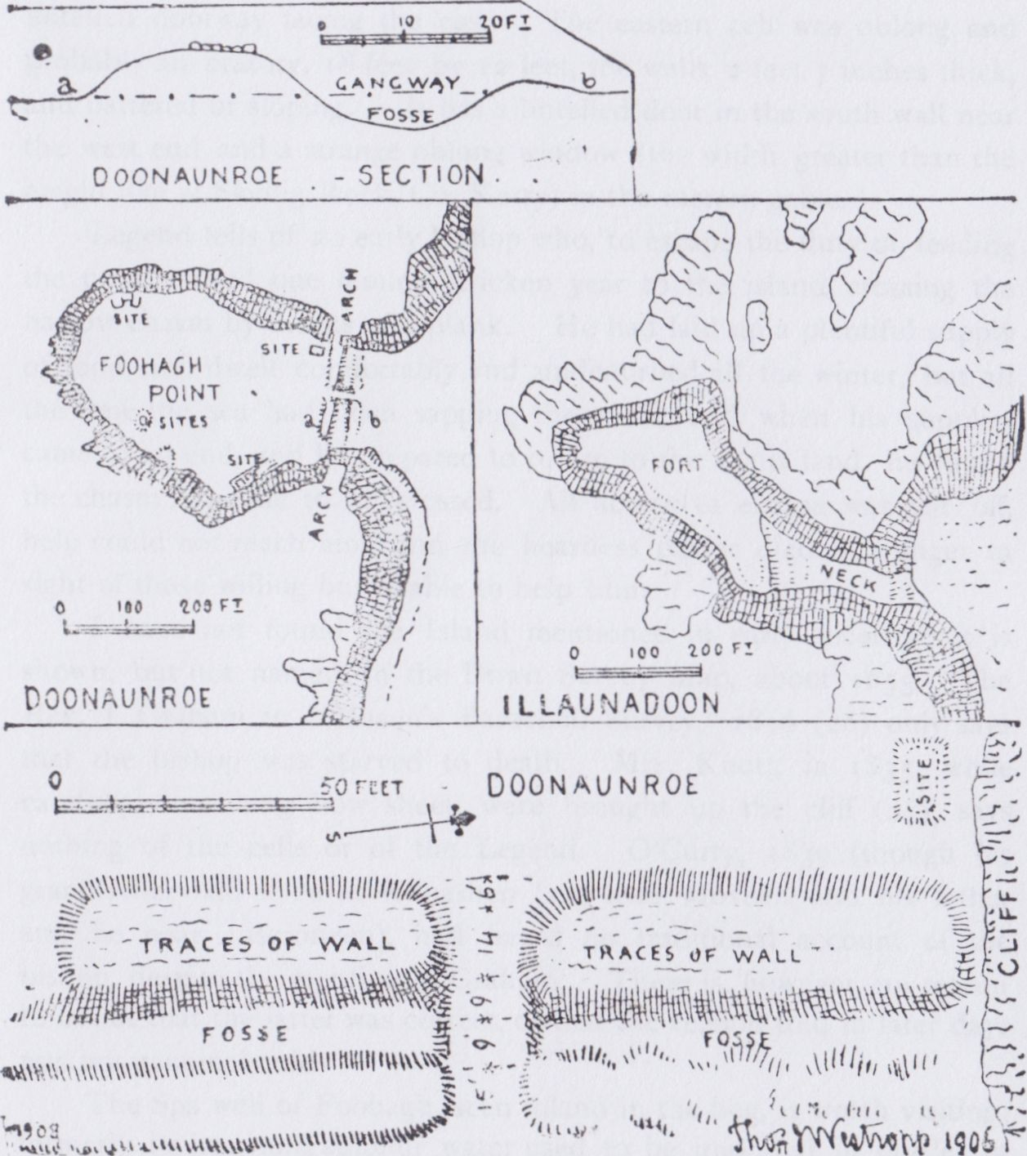

CLIFF FORTS, NEAR BISHOP'S ISLAND.

(Lent by R. S. A. I.)

Dunruadh cliff fort, on Valencia, but it is now nearly swept away; that at Doonaunroe was probably taken for road metal, another great cause of destruction of these forts.

227

In the cliffs south from Foohagh, at two places, a most picturesque phenomenon is often seen. Two streams leap over the precipice, and after rain when the west wind is strong we see the cascades rolled up the cliff and blown high into the air, sometimes falling back far inland. The same can be seen at Brumore in Co. Kerry, and elsewhere—

“Some, like the downward amoke,

Slow dropping veils of thinnest lawn, did go

And some through wavering light and shadow broke

Rolling a slumberous stream of foam below.”

Bishop’s Island(25) is locally known as Oiléan an easbaig gortaigh or “Illán an aspig usthig,” the isle of the hungry (or stingy) bishop. It was evidently cut away, as Foohagh Point is about to be. A cavern was drilled along a fault, it widened and the roof fell in, and the head became an island. It may have been even a promontory fort as at

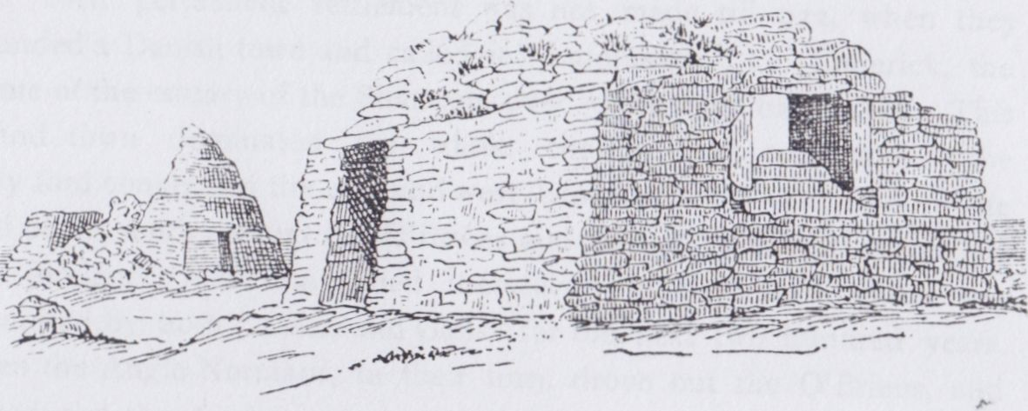

CELLS ON BISHOP’S ISLAND. (Lent by the R. I. A.)

Dunbriste, Horse Island, and Cashlaunicrobin in Mayo, and Dunnahineena in Bofin Island. At any rate a hut and a cell, most probably an oratory, with a pillar slab, stand on the island. The place being nearly inaccessible (save to an active cragsman, up a very steep slope in the north cliff) has rarely, if ever, been visited by people capable of describing the cells. It has apparently been done, and detailed measurements recorded by some informant of W.F. Wakeman; the the drawings, so far as can be seen through a glass from the opposite

1. Proc. R.I. Acad., vol. vi, Ser. iii (c), p. 166; Journal R.S.A.I., vol. xxxviii, p. 275, and W. F. Wakeman’s “Archaeologia Hibernica,” p. 58; “Two Months at Kilkee,” p. 77.

228

cliffs, are fairly accurate. The more western hut is circular, he writes (but from Foohagh it looks oblong). It was built in curious retreating offsets and had a domed roof, it measured 34 feet across, and had a low lintelled doorway facing the east. The eastern cell was oblong and probably an oratory, 18 feet by 12 feet, the walls 2 feet 7 inches thick, and battered or sloping. It has a lintelled door in the south wall near the west end and a strange oblong window (the width greater than the height like at Skellig Rock, Co. Kerry) in the eastern gable.

Legend tells of an early bishop who, to escape the duty of feeding the poor, retired one famine stricken year to the island, crossing the narrow chasm by means of a plank. He had laid up a plentiful supply of food, and dwelt comfortably and undisturbed all the winter, but all the time the sea had been sapping the cliffs, and when his supplies came to an end, and he prepared to return to the main land, he found the chasm too wide to be crossed. All access to escape was cut off, help could not reach him, and the heartless pastor died of hunger in sight of those willing but unable to help him.

I have not found the Island mentioned in early records; it is shown, but not named, in the Down Survey Map, about 1655. The Rev. J. Graham in “Mason’s Parochial Survey,” 1816(26) only says that the bishop was starved to death. Mrs. Knott, in 1835, while carefully describing how sheep were brought up the cliff(27), says nothing of the cells or of the Legend. O’Curry, 1839 (though his grandfather had lived at Kilcashen(28) near Moveen, and his father and he near Liscroneen), had heard no traditional account of the bishop, despite the mention in Graham. There is, however, no reason to doubt that the latter was correct, or that the version told in later days was not genuinely old.

The Spa well of Foohagh, seen inland in the bog, is worth visiting; formerly its iron and sulphur water used to be imported in bottles of doubtful cleanliness, and sold as a panacea to the country folk (along with dillisk, shell fish, and sometimes fruit) on the sea wall near the market place in Kilkee.

1. 26 W. Shaw Mason’s “Parochial Survey,” vol. ii, p. 428, under Kilrush Union.
2. 27 Loc cit, p. 77.
3. 28 Where, during a pestilence, he charitably buried the bodies collected in carts and sledges.

[to be continued.]

North Munster Antiquarian Journal Vol 3(1) 1913

KILKEE (CO. CLARE) AND ITS  
NEIGHBOURHOOD.

PART II.

KILKEE TO CROSS.

By THOMAS JOHNSON WESTROPP, M.A., M.R.I.A.

(Continued from Page 228).

To return to Bishop’s Island—it is only recently that (by aid of a strong field glass, and by an exhaustive examination from every point of view of it and of the land cliffs) I am able to speak with any assurance on itsformer state.

The remains of a flagstone wall extend along the top of a grassy slope to the east of the oratory and cells. Three patches over three feet high remain, and elsewhere the foundations have hardly a break till they merge into a low earthen fence at their southward extremity. At a short distance below, the slope is broken into the well-known precipice some 330 feet from the land. In the intervening space lie several tidal reefs the remains of the former neck. The landward cliff has also a steep slope, broken into ledges, and, just where its edge is most accessible from the land, a fortification commanded it. The faint crescent ring with the very slight ditch seen in Kerry, Mayo, and elsewhere, remains unbroken save by the fence and ditch along the edge of the cliff, the ring was evidently the base of a dry stone wall of flags, now all but removed and 6 feet thick about 80' over all to the edge and 54' across. From these existing remains, and from the marked cleavage of the next headland at Doonaunroe, it is certain that the headland now called “Bishop’s Island” had, like its neighbour, Illaunadoon, a deep valley across the neck. The seaward slope was strongly walled; upon the platform lay (and lie) a cell probably round or oval (though in certain

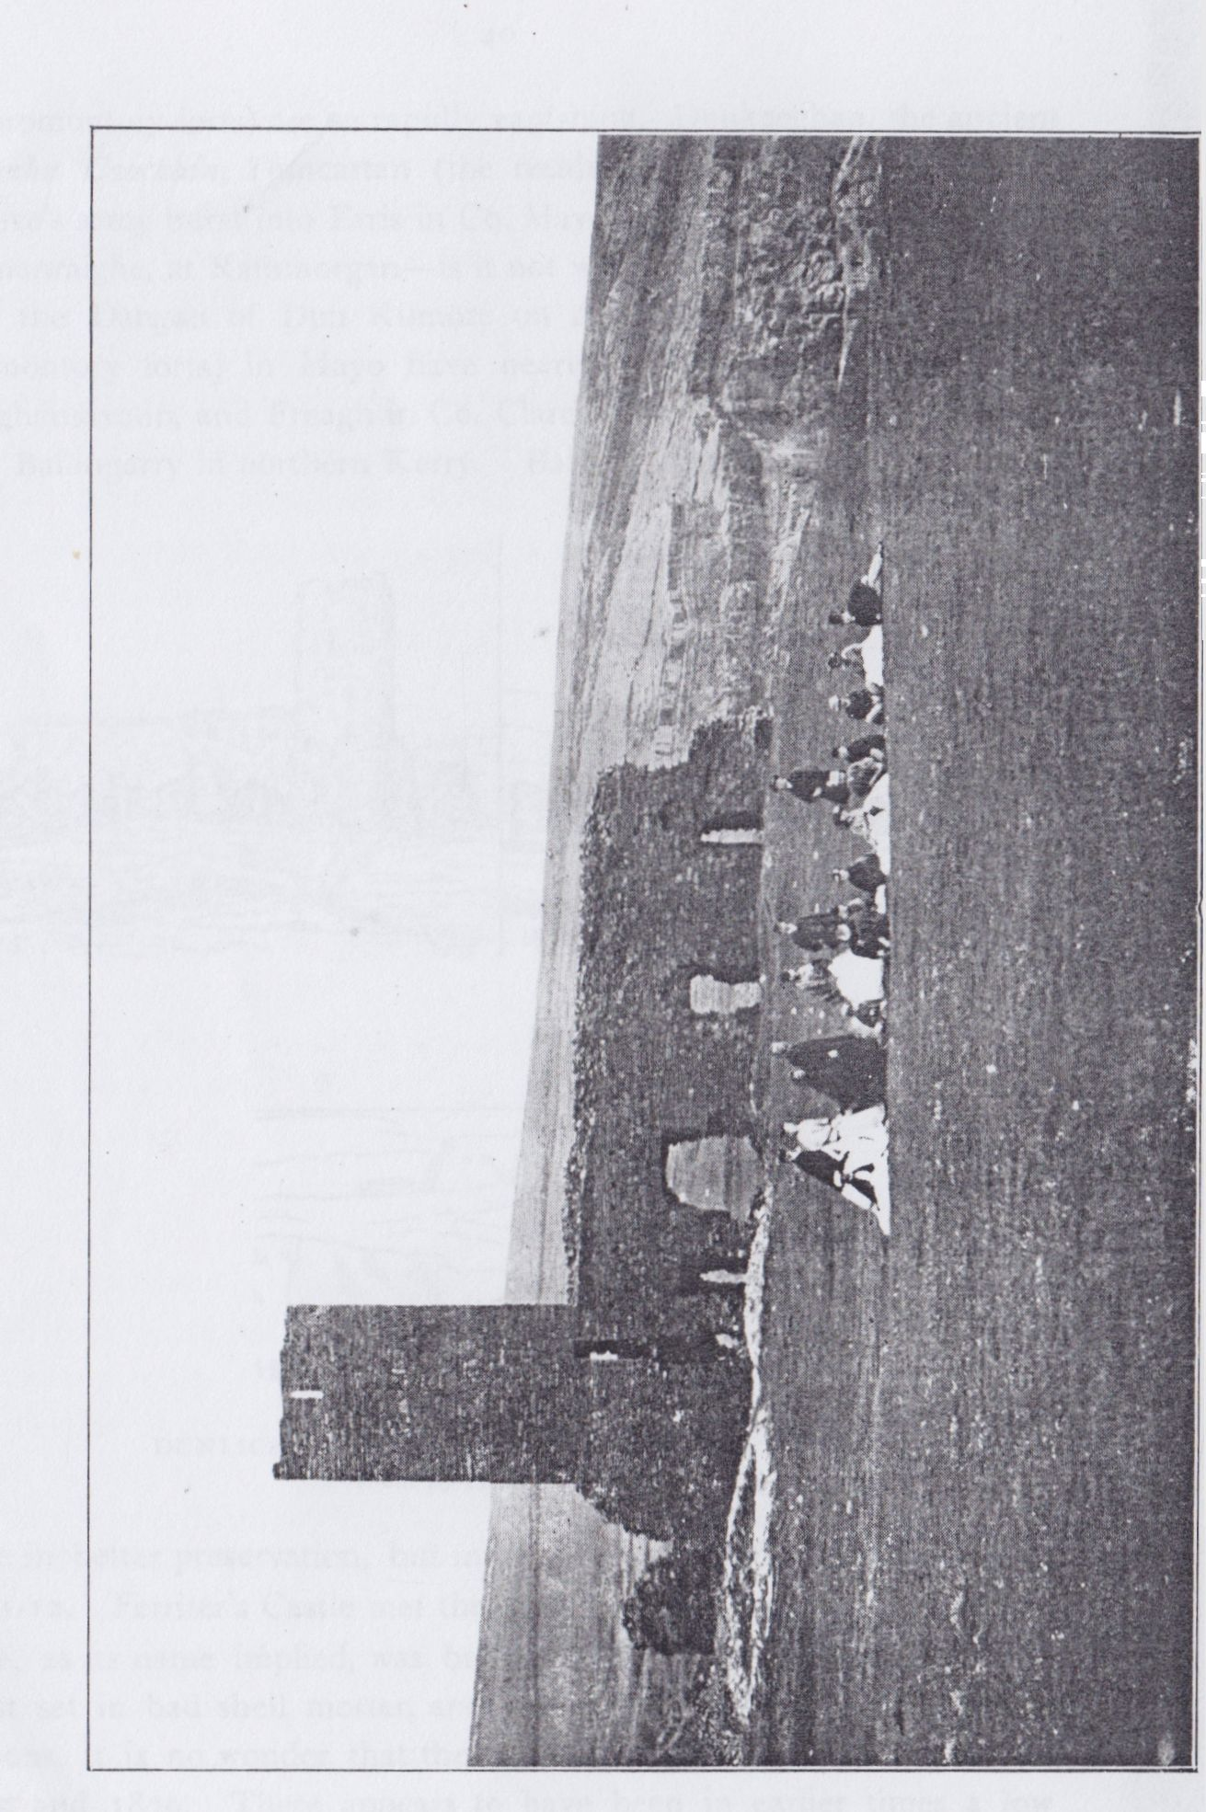

Doonlicka Castle 1868-1869 (from a photograph by the late P. Collins)

39

lights from its broken condition, apparently oblong) an oblong oratory, a pillar, and beside where the grassy slope runs down the north cliff, two apparent graves, two slabs in each a few feet apart. The path down the steeper landward end was defended by a small stone ring or crescent fort. Eventually arches were drilled in at least three places, like the row at present being eaten into the south flank of the Island itself; these as they were widened fell in. It may well have been that the first collapse was only a narrow gully, such as we see behind George’s Head, and could long be crossed by a plank. The collapse of a second arch might well have rendered the rock inaccessible in a few minutes. Whether the legend is founded on fact or not, its entire accordance with the geological and antiquarian conditions is very noteworthy, and I myself have little difficulty in believing it to contain much truth.

The fortified headland of Bishop’s Island can now be classified with Danes Island and Islandikane in Co. Waterford; Doonadell, Duncloak, and Dun-Oughaniska in Co. Mayo; Ballingarry, Co. Kerry, and with its neighbour, Illaunadoon (though the last seems to have had no landward defence), namely, a fortified platform cut off by a deep hollow at a narrow neck.

ILLAUNADOON. The “Island of the Dyn" was really a peninsula divided from the plain by a very deep hollow like Danes Island, or Illaunobrick(29), in Co. Waterford, or Duncloak in Clare Island. When I first remember the place it was accessible, though with difficulty, from the steepness of the descent, but a considerable cliff fall took place in the autumn of 1875 and since then it is cut off from ordinary access. Round the edge the low fence is visible to the S.E. and the N. of the platform, and a traverse or cross mound is also faintly visible(30). The Sailor’s Grave, a lonely mound on a slope, should be noted. Soon after passing it and the upblown falls we reach Dunlicky (or, to be more accurate, Dunlicka) Castle.

DUNLICKA. It is to be regretted that the interesting (though rude) little fortifications on the headlands (nearly always late additions

1. I have recently found an early record of this name in the Plea Rolls, Edward II. No. 121 mems. 18 and 19. “Watfd. Johana que fuit uxor Steph. le Poer versus Ric. f. Steph. le Poer red. in dot. 1 mes 465 ac in Ilanijbruyk ” (or Ilanybrilt) a claim for dower.
2. See plan supra, vol. 2, p. 226.

to promontory forts) are so rapidly vanishing. Dunkeeghan, the ancient Dumha Caochain, Duncartan (the residence of Certan when Queen Maeve’s army burst into Erris in Co. Mayo to attack Oilill, prince of the Gamanraighe, at Rathmorgan—is it not written in the Tain bo Flidhais) and the Dangan of Dun Kilmore on Achillbeg (one of our greatest promontory forts) in Mayo have nearly fallen. So have Dunlicka, Cloghansavaun, and Freagh in Co. Clare, and Leck, Doon, Pookeenee, and Ballingarry in northern Kerry. Ballybunnian and Browne’s Castle

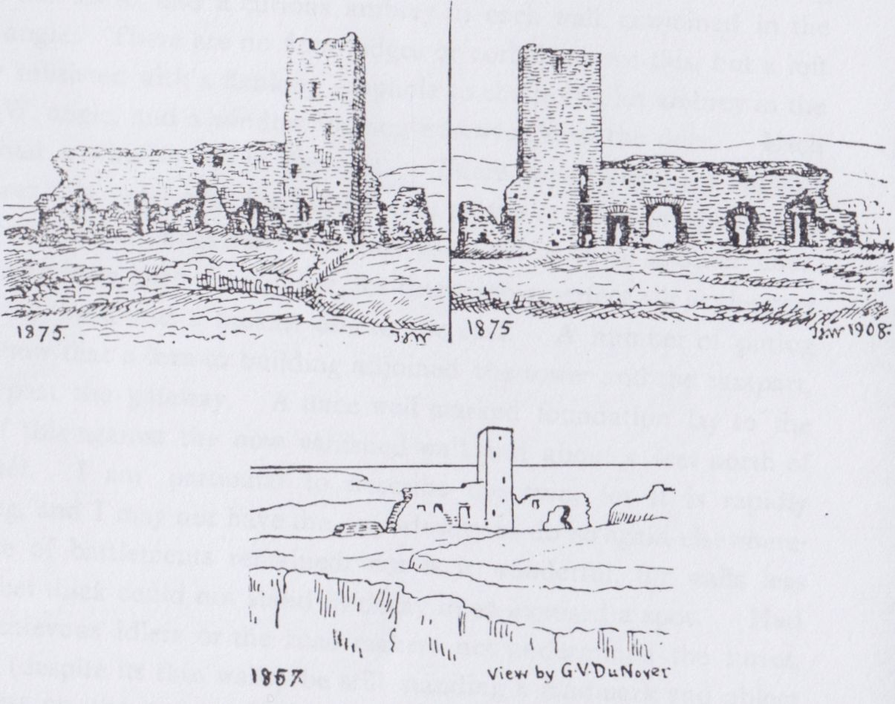

DUNLICKA CASTLE BEFORE THE TOWER FELL.

(Ient by the R.S.A.I.)

were in better preservation, but much of the latter fell in the winter of 1911-12. Ferriter’s Castle met the same fate some 70 years ago. *Dún Licé*, as its name implied, was built of the small flat flagstones of the coast set in bad shell mortar, and nearly undermined by mischievous persons, it is no wonder that the little turret fell between my visit in 1875 and 1879. There appears to have been in earlier times a low straight earthwork across the headland 15 feet thick; It was probably

41

capped by a drystone wall. It had a slight fosse outside(31) as in so many of the promontory forts. This probably sufficed for the inhabitants of the district for “many a vanished year and age,” till late in the 15th century. The “fashionable’’ mortar-built castles (then being constructed everywhere through the west) even attracted the owner, and he proceeded to build one. The drystone rampart, and the friable cliff to the south yielded plenty of material, so he built a turret barely large enough to hold ladders giving access to the battlements of the loopholed wall across the head, and to the summit of the outlook tower. When George Du noyer sketched the ruin in 1857(32), a reach of wall as long as the existing one ran on northward from the turret. Only about 10 feet of this remained in 1875, showing, I think, trace of a loophole: the turret was still perfect, but it was greatly undermined by road makers, and fell en masse in (I believe) 1878 or 1879. All the material is now gone; the side wall has not changed in my memory.

As it now stands, the low base of the earthwork and the fosse, fed by a small runnel from a spring, are seen respectively to the north and south of the ruin. The entire extent of the north wing has disappeared, even the foundations seem to have been dug out A considerable portion of the west (seaward) wall of the turret stands. The end of the wall is 5 feet 9 inches thick. Then going along its western face we reach the north edge of the turret, which rises on the main wall, without westward projection or seam. From 16 feet 3 inches to 19 feet is the narrow tall door into the turret; it seems to have been in a long recess with a window slit (still preserved) above it. I cannot fix the southern edge of the tower outside. There are three loopholes with slits 3 to 5 inches wide, but tall and in deep bays with flagstone heads and relieving arches over the lintel(33); they occur at 21 feet 9 inches to 26 feet 3 inches, 48 feet to 54 feet, and 65 feet 6 inches to 69 feet from the north. The gateway is from 30 feet 2 inches to 38 feet 6 inches from it; the outer door is 4 feet wide with a pointed arch under a flat relieving arch; the ruin in all is 78 feet 3 inches long; the S. end is

1. As at Dundahlen, already described, and at Dunnamo in Co. Mayo, a stream runs down the left wing of the fosse, which is largely its natural channel.
2. See Journal, R.S.A.I., vol. xxxviii, p. 44.
3. Like Kilcrony, Supra, vol. i, p. 234.

42

5 feet 7 inches thick. The outer face of the door was protected by a machicholated gallery resting on two corbels, each of 3 stones, each of which blocks project beyond that below it. The width of the turret cannot now be fixed, but the length is 18 feet 4 inches, the side walls only 3 feet thick, the interior 13 feet 2 inches long. Unfortunately, though Mr. George Hewson(34) gave the dimensions inside as 11 feet by 7 feet, the length is over 2 feet wrong; if he is right as to the width, the turret may have been about 19 feet each way, but to my recollection it seemed rather oblong than square. It had no vaults or flag floors, the lower story was gapped to the east, and had a flanking slit to the south, and a curious ambrey in each wall, conjoined in the N.W. angle. There are no floor ledges or corbels above this, but a loft clearly subsisted with a flanking loophole to the north, an ambrey in the the N.W. angle, and a window looking westward over the door. Each story had a window slit to the east. There must have been another floor over this, level with the battlements of the rampart to which skew doors ran back at either side, over this was a set back for another floor. There may have been yet another, for there was a perfect slit at the very top to the west, and a broken one to the east. A number of putlog holes show that a lean-to building adjoined the tower and the rampart, at least past the gateway. A once well marked foundation lay to the north of this against the now vanished wall and about 5 feet north of the turret. I am particular to describe the ruin, for it is rapidly vanishing, and I may not have the opportunity to do so again elsewhere. No trace of battlements remained, nor is it wonderful, for walls less than 2 feet thick could not stand in decay in so exposed a spot. Had the mischievous idlers or the road makers not undermined the turret, it might (despite its thin walls) be still standing a landmark and object of interest on the coast. Unfortunately, public spirit or interest in Ireland’s past is conspicuously absent in the district, indeed all through Munster, and we can only hope that the O’Curry College may foster such an object, dear to their sponsor, and to all true lovers of our country whose interest does not evaporate in talk and mere sentiment.

34 Journal R.S.A.I., vol. xv., consec (1879) p, 370.

43

Tradition and history penetrate but a short distance into the past in the case of Dunlicka(35). It stands in Moveen, *madmin*(36), in the “1390” rental of the O’Briens, and of course was on the tribe lands of the MacMahons. “Donnelykey” Castle was held by Torlough MacMahon in 1584. From him it passed to Teig Caech MacMahon, who mortgaged it to Owen MacSweeny of Kilkee. The latter continued to hold it under that deed after the estates of MacMahon had long been confiscated, down at least to 1609. It was confirmed to Sir Daniel O’Brien by Patent in 1622, being described as “Donlike alias Moyveene,” but only the latter name appears in the Surveys of 1655. The castle had evidently ceased to be of any value, and is shown as a ruin in the 1675 Survey, now at Edenvale. It was eventually sold to the Amorys, a Cambridgeshire family, who sold it to John Westropp of Lismehane in 1753(37), and his descendant sold it to the tenants under the Land Acts in recent years. The sales brought out many curious points; the actual “Boruma” tax had to be redeemed on two townlands in the form of a composition with the representatives of the Earl of Thomond for certain hogs, sheep, etc. It may be remembered that the O’Brien’s “head rent” was still called “borowe” in 1586, in the Inquisition taken on the death of John the MacNamara Finn. As a trustee, I had also to make affidavits that the mistress of a certain Monarch in the later 17th century (who had an annuity off certain lands) was dead; that the people of East Clare could not be compelled to use a certain ruined manorial mill, and that there was no coal mine in a coal-less rock! Graham in the “Parochial Survey” (of Kilrush, etc.), describes Dunlecky briefly as “a fortified place on a rock,” “a high narrow tower,” and a wall on each side including an acre. Mrs. Knott in 1835

1. See Mason loc cit, voi. ii, p. 442 ; “Two Months at Kilkee,” p. 79: “Ordnance Survey Letters,” Co. Clare (MS. R.l. Acad. 14 B. 23) p. 370; Journal R.S.A.I., vol. xv, p. 370; vol. xxxviii, pp. 44-47.
2. Probably “landslip,” as at Mountallon (madmin talmain) in this county; the name is certainly not “ little plain” in the early records.
3. I have copies of the papers relating to it. Lease 1737, Thomas Amory of Westminster and Robert Amory his only son to John Westropp of Lismehane, Co. Clare, Moveens and Kilcashem (sic). Lease 1749, Thomas Amory of Chesterton, Cambridge to same 31 years. 1753, the Amorys to same, having suffered a recovery of Moveens East and West and Kilcashem, Grant in fee-farm.

44

and O’Curry four years later, have less to say save as to the shell mortar of the walls. It was first described at any length by Mr. George Hewson in 1879

I heard, among my brother’s tenants in 1875 on Moveen, that an O’Brien of Carrigaholt used to woo a daughter of MacMahon of Dunlicka. She used to hoist a flag when her father was away to assure her lover of safety, but the old chief got to know, hoisted the flag, admitted O’Brien, who was on horseback, and fell on him with all his warriors. Resistance being hopeless, O’Brien rode full gallop to the northern cliff and leaped over Poulnagat Creek, escaping to Carrigaholt before MacMahon recovered his surprise and disappointment. Strange to say, the same legend, with the incidents reversed and Dunlicka omitted, was told at the less appropriate Carrigaholt(38). Henry O’Brien of Trummera fell in love with the beautiful daughter of Teige MacMahon of Carrigholt, but the course of true love runs, proverbially, roughly and askew, and MacMahon hated his would-be son-in-law. The lady got a message to her lover that she would hang a black scarf out of her window, save during her father’s absence, so Henry visited her and their secret was well kept for some time. Careless and engrossed one day, he forgot to notice the scarf, and rode into the courtyard of Carrigaholt before he realized that the terrible MacMahon was “at home.” The moment he was recognized, MacMahon and his men fell on him, and he had to leap into the Shannon and swim his horse to land. Teige hurried on his soldiers, got ahead and laid an ambuscade, and O’Brien was badly wounded in the second fray, but succeeded in escaping to Tromra. On his recovery he set off for England, fell at the feet of Queen Elizabeth, and denounced MacMahon, whose lands the angry Queen seized and granted to his hated foe. I am not certain that the marriage of the lady is recorded by the legend mongers. O’Curry tells no story of either place, indeed he seems to regard his recollections of the folk lore and tales of Moyarta as “childish things,” to be put away with the stories of his fears of Fuadh na h adarcha. (See above, vol I., p. 225.) He only says that “Caisleán dunlicé” in good external preservation stood in Moveen.

38 Mason loc cit, vol. ii, p. 444.

46

offset 3 to s feet wide round the inner foot of the mound, a very unusual feature, it is pitted with diggings of a local treasure seeker and a hut site lies near the middle of the garth. The fosse is cut in the shale rock 4 feet to 6 feet deep and 17 to 18 feet wide, round the north; more shallow, and only 6 feet round the south. It is still wet. It is very noticeable that in cutting this ditch a gangway has been left establishing such features where rock cuttings occur as part of the original design though apparently weakening the rampart. I have found other cases at Doon fort near Kilfenora, and the promontory forts of Rinanillán, Co. Waterford, Lissadooneen, Dunruadh, Dundagallán and Duneaner, on or near Valencia in Kerry and Dun Fiachra in the Mullet, Co. Mayo. There are six other ring forts near Lisduff which I need not describe.

GOLEEN. Of the creek a curious story is told(40) recalling Shakespeare’s “tender Rosalind,” and how she was “berimed” when she “was an Irish rat” in her previous existence. A certain Thomas Keane, living near Kilkee about 1820, told Eugene O’Curry that he was able to rhyme rats out of the mill on the creek(41) and the houses near Dunlicka with an obscure Irish charm. Not yet an antiquary, O’Curry did not write it down, though a little later at Kilkee he wrote in jest a charm in Irish which the local rats treated with all the contempt it deserved. He recalled other Clare tales, how John O’Mulconry (like Sir Peter Lewy’s in Athlone folklore)(42) “ratted” to the Established Church and became Protestant Curate of Kilrush and Kilfearagh. He lived near the latter churchyard and was horrified to find that it became so infested with rats that accidents occurred at funerals by attacks on the diggers by the vermin, and that bodies were devoured in a few hours. He repented (we are not told that he resigned the curacy) and prayed, and the rats left in swarms. John Foley of Querin, saw a low mist

1. Proc. R. I. Acad., vol. v., p. 362, on rhyming rats to death.
2. Mrs. Knott loc cit, p. 79, mentions in this creek “two of the most ancient-looking thatched mills for flour and oatmeal.”
3. This story probably arose from the contemporary carvings on the bridge of Athlone. One figure holds the nheon the armorial bearing of Sir Henry Sydney; the other (Lewys) a porcupine, Sydney’s crest. A later copy reduced the heraldic porcupine to a rat, the wreath under it to a pistol.

crossing a bog and feared the fairy host till he found that it covered a multitude of rats, when they reached the shore of the Shannon, all burrowed in the sand. Next, fishing nets were cut by the undesired settlers and the fishermen gathered a posse comitatus, and dug out and killed myriads till they were exhausted, but myriads remained so fierce and desperate that the men lost heart and fled, O’Curry’s father, Eugene Mór Ua Chomraidhe, among the rest. The legend seems probable enough to those who saw the great parliament of rats at Dromgloon, near Durra in the same county. I was told there by the late Mr. Pierce O’Brien and others that the animals literally covered the fields for a few days, but dispersed without doing harm, marching away in large bodies which melted off as they went till in a few miles they had all dispersed. Eugene O’Curry never heard how the Querin rats were got rid of eventually.

I ought, perhaps, to give another legend of Querin as I did not touch on its folklore,and hope that some of my readers may verify it, as some folk lorists regard its source with suspicion.

About 1670, on November Eve, a certain kern hid behind a ruined hut on Querin Strand to shoot wild geese. After waiting in vain, he saw a dark mass coming along the beach, which, as it came nearer, proved to be a corpse wrapped in white on a black bier supported by four men. He fired his gun, the bearers fled, and to his astonishment the supposed corpse was a lovely girl apparently sound asleep. He brought her home to his house, but for a whole year she lay speechless and eating nothing. He went the next November Eve to the fort of *lios* na fallainge to listen to the good people. There he heard much music, mirth and talking. At last one of the fairies began to tell of last year’s failure; the girl was a daughter of O’Conor Kerry whom they had carried off (strange to say across running water!). She had been shrouded in her father’s tablecloth, and if she were made to eat off it the spell would break. The kern accordingly disenchanted the girl, who told him that she had been promised to a Lord, and that the fairies told the truth about her. He brought her back to her astonished father who had mourned her as dead, and the chief took her rescuer into his highest favour; at last, learning that his child was in love with her benefactor, who, of course, was fully responsive, he blessed their

48

love with his consent, and, of course, all (let us hope the disappointed Lord as well) lived happily afterwards(43).

TULLIG CLIFFS. I will only briefly allude to this fine range which is consistently neglected,even ardent lovers of cliff scenery turning inland from the creek at the eastern end. The lack of such bold projecting headlands as abound up the coast prevents us getting a good flanking view. From the sea it is most magnificent with huge and lofty caves and arches, and the rich “rock masonry” of its stratification. The highest point is below Knocknagarhoon Hill which rises 414 feet over the surf. There was a signal tower(44) on the summit, which, like (Beltard) was called a castle, even by Frost The old map shows it as standing in a fort. I found no trace of any ring enclosure, and the last remains of the foundations, which, on my visit in 1908,were being dug out for building or road making, were of a late thin-walled structure not of a peel tower. No castle is mentioned there in any record known to me. Down the slope southward, in a boggy region abounding in Osmunda fern (which in June is a glorious mass of yellow, russet and bright green, crimson and brown) is a fine two-ringed fort in Carrownawealaun (Ceathramhadh na bhfaeilán) townland of the Seagulls. The Liss(45) is 75 feet across inside the ring 18 feet thick and 8 to 10 feet high, the deep wet fosse 21 to 23 feet wide and 5 feet deep. The outer enclosure is usually about 40 to 50 feet outside the fosse, the whole, 268 feet over all and much overgrown with furze and sallows. A stream runs round the outer bank.

Beyond Knocknagarhoon (*Cnoc* na Ceúrthaman (46) are two picturesque creeks formed by great collapsed caverns at Pouladav and Illaunaglas. The headland to the west was eminently suitable for a promontory fort, having natural fosses in the rock, but if one ever defended it all is now washed away for the headland is nearly bare. We pass a deep gully and reach a pretty bay also called Gowleen (Gaibhlin)

1. Lady Wilde’s “Ancient Legends, Mystic Charms and Superstitions of Ireland” (1887), vol. i., p. 49.
2. “Knocknagarhoon, with its dismantled telegraph.” Two Months at Kilkee, p. 79, the view from it is well described.
3. See plan *supra* p. 113.
4. Letter of Eugene O’Curry, August 1835, recently added to O.S. Letters cited supra, vol. i., p. 225, at the end, it had got bound into the Letters of another county, and so got overlooked by myself and others.

49

“the little fork” in facetious allusion to the great parallel reefs 900 feet long, like a giant fork, cutting the sea at its mouth. The coast again rises giving us a magnificent view over the scene of our former exploration out to Ross, Loop Head, and the Shannon, and across it to Slieve Mish and Mount Brandon in Kerry. As we descend towards the great cliff fort below us we see a levelled house ring 66 feet across, and 9 feet thick near the end of a bold bay.

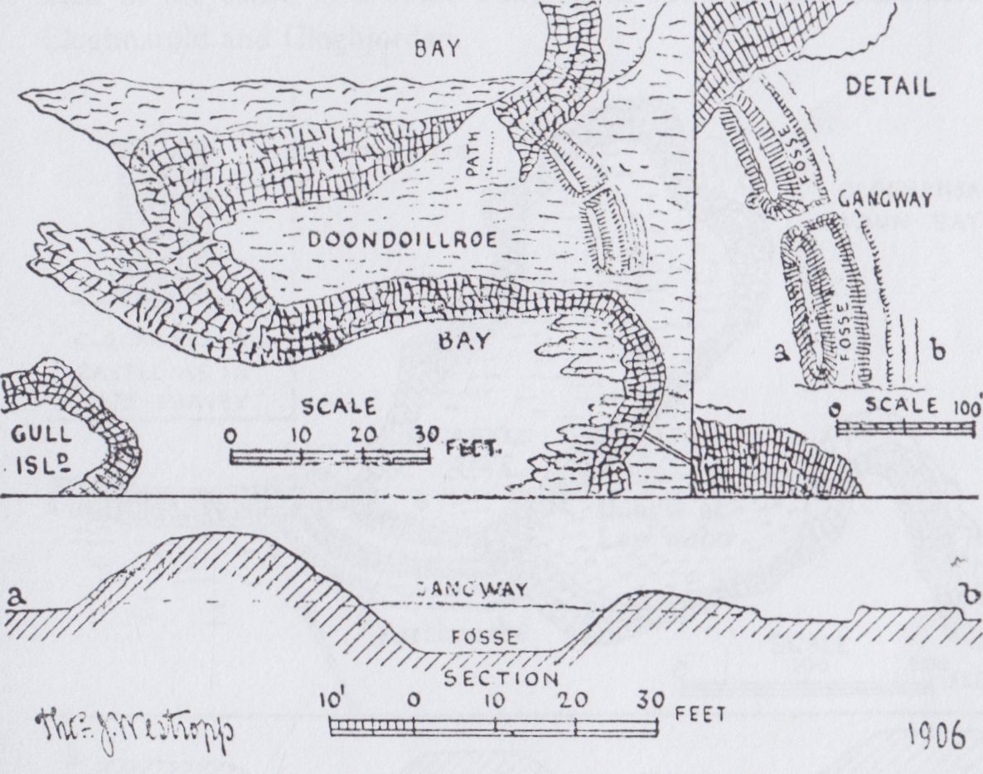

DUNDOILLROE CLIFF FORT, CROSS.  
(Lent by R.S.A.I.)

DUNDOILLROE. The fort is, after Doonegall, the strongest on the Clare coast. A huge mound of earth and rock splinters sheeted with sea pink forms its rampart. It is 45 feet thick and 12 feet on top, 15 or 16 feet high; outside it is a ditch 6 or 8 feet deep and 14 feet wide. The section north of the gangway has (like at Doonaunroe) been much filled with the outer ring. The latter rises 7 feet over the fosse, and is 23 feet wide, and there are slight traces of yet another ring 12 feet thick outside it. I saw no hut sites, but a steep slope leads

50

down the north cliff to a rock terrace covered by high tide in which is a beautiful, natural tank of the purest pale green water. Mr. Marcus Keane was told that an underground passage runs westward from the gap and gangway of the Dun across the moor. There is certainly a long green track (perhaps an ancient road leading to the fort) in that direction. A collapsed souterrain filled with stones is said to have been found on or near it. The fort is visible against the sky line far up the Shannon(47). In westerly gales a whirlwind forms in the bay beside it to the south whirling up the foam in spirals higher than the cliff. Farther southward is another “blowing up waterfall” and a low earthwork.

CLOGHANSAVAUN. My wish to keep together the promontory forts between Ross and Kilkee led me to reserve this interesting site for the present paper. It is situated at another most beautiful part of the coast, unknown to the vast majority of tourists whose drivers bring them close to it along the road to Ross, and, so far from sending them to see it, some of these false guides have even assured me, and others, that “there is nothing to be seen there.” A “society for enlightening guides and drivers” is a desideratum in Ireland. It may be seen to the north of the road, about half way between Cross and Ross. There an almost square bay, though nearly landlocked, catches the great waves on every breezy day into a glorious chaos of whirling foam, fenced by dark cliffs with great square-headed portals and regularly moulded arches over deep dark caves, where the breakers boom far under the field. A great pit in one case opens unexpectedly in the field down to the imprisoned waves. On the western headland were an entrenchment and a peel tower.

The name, as usual, first appears in the O’Brien Rental of about 1390 as Cluan Sumain (not as at present Clochan) as paying 8 pence and an ounce of gold to O’Brien of Thomond. The next records, the various Elizabethan maps, especially those of the Hardiman collection of 1570 to about 1610, give the more interesting name of Dún-Sumain in the forms, Dunsumayn, Donesavan, and Done s-uane. It is given as a castle of Torlough MacMahon in 1582, and was confiscated from Teig

47 The Royal Society of Antiquaries of Ireland has kindly lent the plans of all these forts.

51

Caech, his son, and given to Sir Daniel O’Brien, eventually first Viscount Clare; it is called Cloghansivan in his grant. The “1675” Survey shows it as a dismantled peel tower, tall and narrow, with the usual single window slit in each of its four storeys, the top one being even then broken into a wide breach, and the gables gone. It is evident that all three names once existed, Dun-Sumain, the promontory fort, perhaps the earliest; Cluan-Sumain, the adjoining plain; and Clochán-Sumain, the stone tower, for Cloch and Clochán are frequently used in the sense of a stone building in Munster and elsewhere—as Cloghnarold and Cloghjordan.

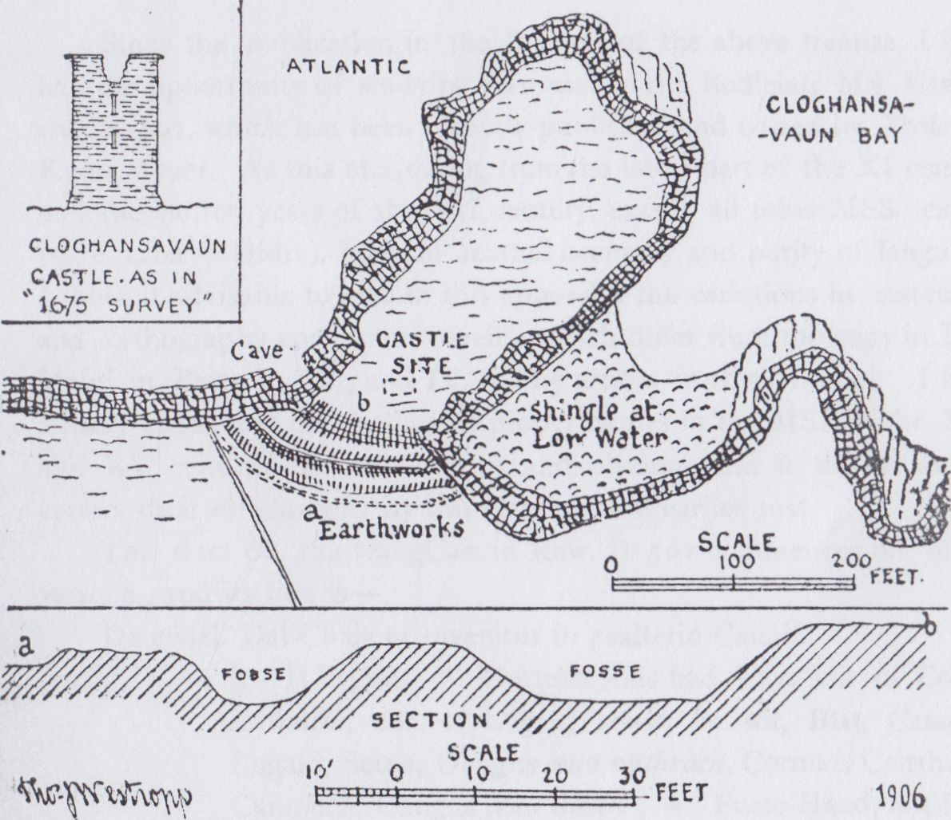

CLOGHANSAVAUN (DUN SAVAUN) CASTLE.

(Lent by the R.S.A.I.)

The artificially smoothed glacis, 10 feet high, at the head of which the tower stood, slopes down to two fosses, each with a mound outside it; they are 21 feet wide; the intervening mound, 30 feet and 12 feet

52

on top, usually 7 feet high, and an outer mound 7 feet higher than the fosse and 2 feet to 3 feet above the outer field and 25 thick, 18 feet on top. The works are convex to the land, the neck about 95 feet wide, the sea having cut along the fault directly behind them for 100 feet along the west, and an arch is being driven onward which must some day isolate the headland.

Piles of stones and debris marked the tower when I first recollect it. They were fairly abundant in 1896, but have since then been removed for building and roads, and hardly a stone now remains. The cutting of the sea behind earthworks is very common (for example, at Baginbun, Co. Wexford; Annestown, Co. Waterford; Lisheencankeeragh, Co. Kerry; and Cashlaunicrobin, Co. Mayo) in Irish Cliff Forts. It is also to be seen in Wales at Carn Fai and Llanunwas,and has been supposed to prove that the early fort makers defended the edge of the creeks, but the precipitous and stormy wave traps at the Irish forts preclude this notion being adopted in Ireland.

Tradition said that the tower fell in 1755, at the moment of the great earthquake and tidal wave of Lisbon. Graham(48), however, a far more reliable witness, in 1808 says that it fell in a storm on November 4th, 1803. Mrs. Knott remarked the foundations and outworks of the Castle of Clahansevan and its wonderful cliff structure, but even then most of the stones had been taken to build cottages(49). Graham says that it “was once used for the dreadful purpose of decoying ships to this iron-bound coast” as they mistook it for Loop Head Lighthouse. This seems most improbable; ships gave the Clare coast a wide berth, and Loophead as the end of the cliffs was unmistakable when seen. As far as I have seen the Dublin Castle records, I am able (as Miss Hickson was in the case of Kerry) to say that I found no damning record of the fiendish practice of wrecking against the people of the coast of Co. Clare.

(to be continued).

1. See Mason (*loc* cit), vol. ii, p. 443, he says “winter of 1802,” but in his Annals, the more explicit date, Nov. 4th, 1803 (Ibid).
2. Two Months at Kilkee, p. 222. See also Geological Survey of Ireland (1860). Explanation, Sheets 141, 142.

North Munster Antiquarian Journal Vol 3(2) 1914

KILKEE (CO. CLARE) AND ITS B NEIGHBOURHOOD.

PART III.

DUNBEG TO KILKEE.

By THOMAS JOHNSON WESTROPP, M.A., M.R.I.A.

(Continued from Page 52).

The coast to the north of Kilkee is less frequented than the southern cliffs, nor is this wonderful as no road runs along the edge, and to see them with comfort a long drive through an unpicturesque country is necessary. As to walking from Kilkee to Ballard the steep hill behind George’s Head repels all the less energetic, indeed, few who climb it go much farther than enables them to overlook Farighy to the long headland of Doonegall.

Let us begin by driving to Dunbeg, the farthest point in our district and work homewards to Kilkee.

DUNBEG AND DUNMORE.

We have been met at every point in the west of “ historic Clare” by the difficulty of finding any definite records, and still more, any likely to be of general interest. Dunbeg and its appanage, Dunmore, are the exception. Of course, as I have pointed out, it is unreasonable to expect a romantic tale such as attaches to one of the great English, French or Rhine castles, at every little obscure peel tower. They are not *castles* only the houses of private gentlemen; quiet, obscure people, living out of the stirring world, probably in a mere round of farming hospitality and local sport. Still had one of the Clare gentry in the 16th or early 17th century kept a diary how interesting even its simple, uneventful record might have been to more than antiquaries. The castle founders

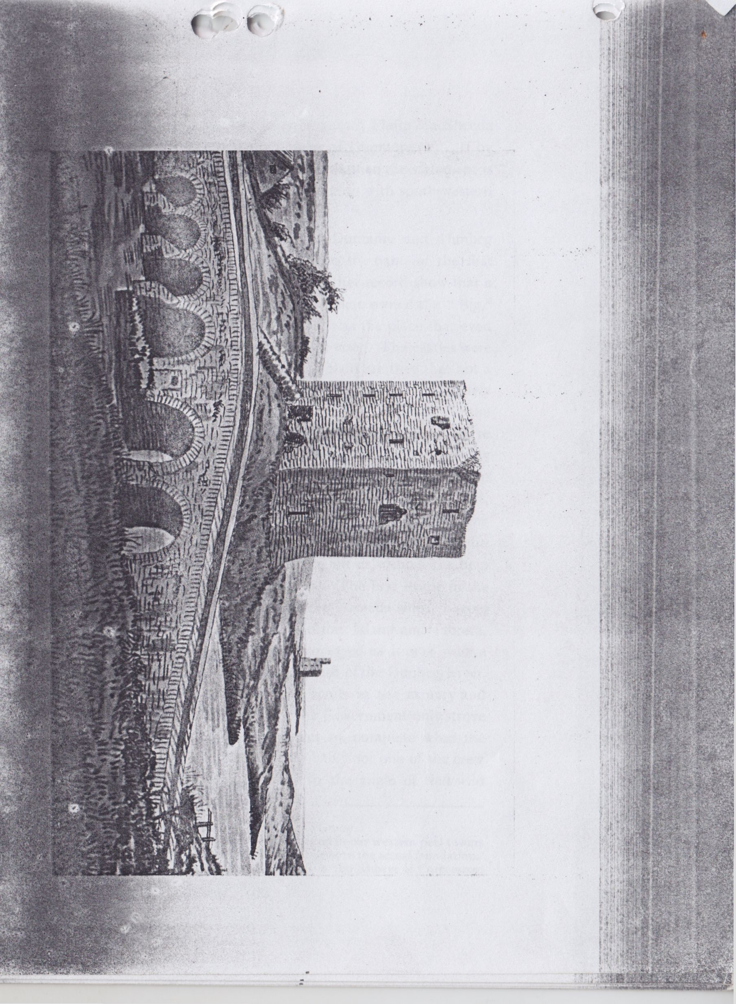

109

list attributes the building of Dunbeg to an unknown Philip MacSheeda More McCon, who is also given as the builder of Dunmore(1). If by “McCon” MacNamara is intended, as some think, then the statement is valueless, as that family had no recorded connection with south-western Clare till much later times.

The only glimpse at the past history of Dunmore and Dunbeg before the later years of Queen Elizabeth lies in the name of the first Dúnmór Mhic an Fearmacaigh. This and another record show that a family from Inchiquin of the blood of Cinel Fermaic owned the “Big,” and probably also the “little” fort. So obscure was the place that even its forts were nameless save as to their respective size. The castles were probably built about the year 1500. So utterly plain are they that not a moulding ora window head or a cut stone remains to tell us even vaguely, of their date. The Scotch peel tower flaunts the arms, the initials or the name of its founder and owner before the eyes of all. But with us native armorial bearings hardly existed, and neither the tribal ensigns nor any record of the founder(2) were carved in stone. So also there is no reason to believe that in the long gap from the English invasion to 400 years, later many of the kings or chiefs, or even of the clergy had their last resting place marked by effigy(3) or epitaph. It is, indeed, most unaccountable, but must be faced, for it has everywhere left us without the help found on every hand in more favoured places The first event in the records of Dunbeg was in 1588, when one of the Armada ships, having escaped the “shipwrecking reef” between Mutton Island and Tromra, on which its companion was lost (hopelessly embayed as it was with a north-westerly storm), went ashore near the mouth of the Dunbeg River. The people of the district must have got rich spoils in the estuary and on the strand before the great sandhills, for the Government only strove to secure the guns leaving the human wolves to complete with the waves and storms had so well begun(4). Probably not one of the crew even lived to be hanged so fierce is the surf in the angle of that wild

1. Founder’s list, British Museum. Ed. —S.H. O’Grady.

2 In the majority of cases the dates and initials found in our western peel towers refer to the insertion of a chimney piece or to later repairs, not to the actual foundation.

1. One only recalls the effigies of Kings and chiefs in the Abbeys of Corcomroe, Roscommon and and Dungiven.
2. “Calendar State Papers, Ireland," 1588.

110

bay. About the same time Mahon, son of Dubh MacGorman, whose remarkable castle and earthworks I have recently described(5), held Dunmore Castle. This in a deed in the Hardiman collection he surrendered to the Earl of Thomond, who, strong in the support of the Elizabethan Government, of which he was so useful a tool, was endeavouring to secure powers over the leading tribes like the O’Conors, the O’Loughlins and the MacGormans. Mahon’s rights were derived through his wife, Judith ni Mhic Gormain, to a third of Dunmor Castle then occupied by Donough, son of Dermot MacFearmacaigh(6) “The Four Masters” tell how in 1598 Teig Caech MacMahon of Carrigaholt, the last chief of West Corcavaskin (so often mentioned in these papers), seízed the castle of Dunbeg, which he had mortgaged to a Limerick merchant for a debt. Next year, 1598, the unrest everywhere encouraged him to more inexpiable acts. He seized an English ship with a valuable cargo at Carrigaholt, and with little concealment crossed the Shannon, and had an interview with the “Sugan Earl,” James of Desmond, a man of far higher character and ability than himself. Fooled to the top of his bent, and ready to defy all the English power by his own might, he returned to Carrigaholt. Destiny promptly set a trap for him, and he rushed into it. Not many hours ride from Dunbeg at Kilmurry Ibricken (cill mhuire o mbracain), lay Donnell (Daniel O’Brien), brother of the Earl of Thomond.(7) The weakest of Thomond’s chiefs determined to strike at the strongest, so on the long dark night of February 17th, he marched northward, and, before sunrise, had wounded and captured O’Brien, and slain many of his unwary guards, He brought his prisoner to Dunbeg, and (always vacillating) after a week of cool reflection got frightened at his own act, and released his captive without terms, securities, or even promises. In 1590, his territory was invaded by Theobald Dillon and Torlough O’Brien “to make their peace with Tiege MacMahon,” as they quaintly described it. He refused their terms, so they carried off some spoils and retreated. Doubtless he felt

5 Journal R.S. Anti. Ir., vol. xli., p. 122.

6 Hardiman Deeds, Trans. R. I. Acad., vol. xv. p. 83.

7 Some make it the Earl himself. “The Four Masters” account seems decisive against this (Ed. O Donovan, p. 2,097). It says, “brother of the Earl,” but also “son of the Earl,” and on p. 2,109, “dishonour shown to his brother.” The Earl had been in England for a year (p. 2,089) from January, 1598, and nearly three months with the Butlers (p. 2,109).

all the more confident in the impotence of the Crown forces and their Irish allies. The Earl got leisure about a month later to attend to MacMahon, so he set off and reached Carrigaholt the Monday before Easter that April. Blockading the castle, he sent bands to waste systematically all West Corcavaskin from Cnoc Doire (Knockerra) to Leim Chonchulainn (Loop Head) they swept up all the cattle, and drove them to the camp before MacMahon’s eyes. How many houses and forts were burned, and people wounded or slain, we can only fancy, but the tribe lay defenceless and no active resistance was attempted. During the week, though carefully observing the great day of Good Friday, the Earl pressed on the attack, and the town surrendered on the 4th day(8)—Easter Saturday. On the next Monday Thomond sent a boat to Limerick for artillery, and on its arrival marched to Dunbeg. No sooner had he planted his ordnance before the dark old peel tower than the garrison, one cannot call them “defenders,” surrendered, “they did not wait for a single shot.” They gained little by their cowardice for “the protection obtained only lasted while they were led to the gallows from which they were hanged in couples face to face,” as the Annalists, with grim sarcasm, note. “In the same manner the Earl obtained possession of Dún mór mhic an Fhearmacaigh.” He sent back the ordnance to Limerick and, trusting that the Mac Mahons were reduced to impotence, marched eastward to restore various other castles to their owners — Derryowen, in the north, the two Castletowns near Clooney and Lisoffin (Lis aedha Finn) near Tulla in East Clare.(9)

As I have so often told, Teige Caech and his son fled, overshadowed by doom, he tried to get refuge with the formidable O’Sullivan. Here, flying to Dunboy in the ship he had stolen from the merchant. O’Sullivan coveted the ship, Teige being with some O’Sullivans in a boat, called to his son to fire and fell shot. When the Spanish invasion of Cork had collapsed and they and some of their Irish supporters left for Spain, we catch the last glimpse of the unfortunate young man, landless, tribeless, his innocent hands stained with his father’s blood. “Terlaugh, son to Teige Keagh McMahowny, who slew his father, when Dunboy was besieged, and five Frenchmen that were taken by Teige Keagh when he took the ship and merchant of Galway, left Ireland for Spain.”(10)

1. Annals Four Masters, p. 2,109 (1599).
2. Annals Four Masters.

10 Carew MSS. Calendar 1601-3, p. 202.

I I 2

Daniel was well repaid for his week’s imprisonment at Dunbeg.. By the Earl’s influence, in 1604 the Government granted him the Castle of Donbegg and most of his captor’s estates. The short confiscation under Cromwell was cancelled by Charles II. under the Act of Settlement in December 1666. The Survey of 1675(11) gives rather conventional sketches of Dunmore and Dunbegg, unlike many of its other views which often give the salient features accurately. It omits the lofty turret that so recently fell at Dunmore which is shown like the present Dunbeg while Dunbeg is like neither of the towers. The castles were confiscated in 1688 and sold 1703. As to the tenants of the district—The Inquisition of July 19th, 1609, finds that various persons held lands from Teige Caech MacMahon, slain at Dunboy, June 15th the XLI. year of Elizabeth. Moyadda and Knockerry were held by Teige, son of Shoneen, Mac Gorman; Doonlickey by Owen MacSweeney; Dough (Kilkee) by Owen MacCahane (Keane); Corbally by William MacCraghe; Doonbeg by Nicholas oge Stritch (I presume the merchant mortgagee of the Annals); Owen O’Cahane also held Lisdeen, Liscunaghan. and Kildima. Another important record of Teige Caech’s lands dates March 5th, 1613. James Comyn held Doonbeg Castle and lands from the Earl in 1622. In 1641 and 1652 the following land holders may be noted—In Killard Parish, John MacNamara; James Fitzgerald; Glascloone by Mahone Kelly; Caherlean by Maurice Poche ; Doonbeg by James Fox and Maurice Roche. In Kilfieragh, Sir Daniel O’Brien held Corbally, Dough, Kilkee and Kilfearagh; Hugh MacSweeney held Kilkee under him; Farrihy belonged to the Earl of Thomond; Lisdeen and Lisluinaghan to Charles Cahane, the last place was sold to Benjamin Lucas and others in 1665.(12)

Between 1659 and 1664, the Earl of Thomond had let among other lands, Doonmore to John MacNamara and James Fitzgerald, and he granted in fee farm at the great sales of 1712. Doonmore to Robert

1. Now at Edenvale, an attested copy in Public Record Office.
2. Confirmations under Act of Settlement. I have a copy of a lease of Samuel Lucas of Esker, Kings County to Thomas Westropp of Ballysteen, and Mountiford Westropp of Ballyallinon, County Limerick, the lands of Lislonaghan in Moyfertagh, Jan 15th, 1733 (Reg. Deeds Dublin, Book 78 p 56). Benjamin Lucas, Sheriff of Co Clare in 1670, was confirmed in these lands under the Act of Settlement in 1671. (Roll XIX car II pars 3.) The Lucas family was of standing in Co. Clare, and has left a fine monument at Killone Abbey; a scion of theirs, the Dublin reformer, Charles Lucas, is of more than local note.

113

Hickman, Doonbeg to John Stacpoole, Glascloon to George Stacpoole and John Neill; Killard and Caherlean were sold to Mountiford Westropp. None of the grantees seem to have lived on the lands.

Hickman was a member of an ancient English family from Bloxam; their pedigree is preserved unbroken from 1377; by 1488 they had obtained Woodford Hall in Essex. Gregory, the third son of Walter Hickman of Kew, in Surrey, was a Hamburgh merchant and got a lease of Barntick in Co. Clare about 1612, being one of the first Burgesses of Ennis named in its charter. His three sons, Thomas of Barntic, Sheriff of Clare, 1678; Walter of Kilmore, Sheriff in 1675; and Henry of Ballykett, Sheriff in 1699, were founders of the families of Barntic, Kilmore and Fenloe.

Stacpoole was a member of a still older family, originally settled beside the pool at the Stack Rock, Stack Pool, on the coast of Pembrokeshire.(13) They appear in the earliest roll of Dublin citizens about 1180 and were well established in Limerick and Kerry by 1250. During the 15th century, and its successor they became some of the richest and most influential of the Limerick Merchants. Bartholomew Stacpoole was Recorder of the city and negotiated its surrender to Ireton in 1651. He was transplanted to Enagh near Sixmilebridge His cousin Clement, (son of Captain Robert, and grandson of Bartholomew Stacpoole of Limerick in 1595) was brought from Doon near Ballybunion in Co. Kerry(14) to another Enagh near Kilmurry Ibrickan. He was father of the George above named ancestor of the Duke de Stacpoole and of William ancestor of the Edenvale family.

Westropp was son of Montiford Westropp of Kilkierin, Co. Clare who had (after the death of his father Thomas Westropp of Cornborough and Newham in Yorkshire 1657) migrated to Limerick, being Comptroller of its Port from February 1660 (15), and Sheriff of Clare in 1674.

1. The portrait of their supposed founder Sir Richard Stacpole is mythical— They were merchants in Dublin, and were on the jury that enquired as to the injuries done in the wars of 1250-70 by Conor na Siudaine O’Brien and his sons. (Cal Docs., Ireland).
2. He had married Alice daughter of Mahon MacMahon of Doon Castle. It is described Journal Vol. XL, p. 23. He and his family are fully described in the transplanters certificates.
3. He appears in a quaint light as examined about an alleged plot of an old Cromwellian officer, Walton, in 1672 to seize Limerick Castle and bring in the Dutch. William Yorke had bullied Westropp, and after two “bloody” combats, the former was sent home in a very damaged condition. Old Walton delighted with the fight told the victor he would make him a captain if he had a regiment. (Cal Domestic Papers)

The family appear from 1282 in the neighbourhood of Westhorpe at Brompton near Scarborough, and have left a rich mass of quaint wills and other documents(16). Owing to the recommendation of one of them (grand uncle to the above Thomas) Ralph, Serjeant at Arms to Queen Elizabeth and James I, the mote-castle of Clifford’s tower in York was preserved from demolition in 1596.(17). His brother James “in wars to his greit charges served oin Kyng and two Quenes (Edward, Mary and Elizabeth) with du obediens, and died without recumpens.”(18) In more peaceful fields other members of his family have gone and done likewise. The younger Mountiford’s brothers Ralph and Thomas are founders of the families of Lismehane and Fortanne in Clare; Attyflin, Ballysteen and Mellon in County Limerick and several branches round Cork city.

Of 18th century record of the place and its surroundings little is of interest. In 1816 the invaluable Rev. John Graham tells us much about the union of Kilrush to which Killard was united, the latter “church is unroofed, but the walls are standing,”(19) He derives its name from the cliffs of Baltard, but beyond mention of Dunmore and Dunbeg has little to tell of the castles. These Mrs. Knott merely alludes to as standing near the strands of Killard and Doonbegg.(20) Graham describes Dunbeg Castle as perfect. A spiral stone stair leads to the top which is arched over, and has a grass plot on it. The castle is high, and commands the bridge which is near it. This is one of the castles of the O’Brien’s.

DUNBEG. The Castle stands a short distance up the creek, on the shallow river, beside a long old-fashioned bridge of six arches, between the two eastern of which, in a recess, long dwelt a poor old

1. See generally the publications of the Surtees Society Publications. Cartulary of Whitby p. 650 Testamenta Eboracensia I, p. 9, p. 146-412 III, p. 264-p. 266. Calendar of Inquisitions, especially Vol. IV., p. 107, Vol. XXIII., Edw. I., 1284, Inq. p. 17, 1289, Inq. p. 82, 12S9. Harleian MSS. Vol. 1394, p. 371. Vol. 1344, p. 6, Vol. 1394, p. 176, p. 149. Yorkshire Archaeological Association, Record Series Vols. XXI, pp. 57-60, Vol. XXIII, p. 82, Vol. VI, p. 182. XI, p. 241, XIX, p. 58, XXVI, p. 122. North Country Wills (Surtees Soc., Vol. CXVI., p. 257).
2. Calendar of Domestic State Papers, 1596 p261. The Castle ‘as standing to a great height on a very rare mount, it is an exceeding ornament to the city.” Oh, for such reports and results at present.
3. Tombstone 1580 Brompton Church, Yorkshire,
4. Monk Masons “Parochial Survey,” Vol. II, p, 416-442.
5. Two months at Kilkee, p. 87.

115

woman named “Mary Belfast;” though washed out of her nest more than once by unexpected spates she always came to shore alive. In 1893, when I first sketched the place, the Castle was said to be inhabited by seven poor families; two lived there in 1907 and one man (much worried by the village boys) lived in one of the small western rooms on my last visit.

Without any real picturesqueness there is something that catches the imagination in the two peel towers, especially before so much of Dunmore fell away. On a showery day about sunset the bleak, bare view, the low coast, on which the fierce waves literally raise walls of foam. The shallow murmuring stream, the sob, or roar of the sea, the cry of the marsh birds, all well harmonise with the bare and gloomy tower and the dark long bridge. Even the irregular houses of the village hardly diminish from the sadness and loneliness suggested by the centre of the picture.

The tower is about 60 feet high, 45 feet east and west, and 33 feet north and south. It stands on the edge of a bank, which is falling away from under it, along the south side; the masonry is good, of the small flat gritstone slabs of the district, with bold batter to each side to withstand the thrust of the lower vault. As I said, it is of the plainest character, narrow oblong slits, no mouldings or carvings, the door is to the south and quite defaced, there are no ancient outworks or buildings. I fear that the crumbling of the bank and the picking out of the lower facing must soon bring down the building. Unlike the rock-like mortar of the limestone districts that along the coast is poor friable stuff with too little lime, and the corner of the staircase at Dunbeg shows signs of settlement and impending collapse which the recent knocking out of a step-stone, by mischievous boys to annoy the solitary tenant, has rendered still more insecure as the steps above the break are now loose The porch was commanded by a “murder hole,” 3 feet by 1 foot 6 inches wide. The entrance to the spiral stair, which is in the south-west angle, is to the left. The porch leads into a dark vaulted basement with a vaulted recess athwart at the north-west corner under the small rooms, and a narrow recess under the stairs. The main (or east) room has defaced lights to the north and east and had a loft, or store, over it, the floor resting on beams, leaving the basement little

116

over 5 feet high while the ceiling stood. The loft has a small east light. A side passage, buried in rubbish, leads up at least 5 steps from the porch to the spiral stair; the latter has 61 steps and is lit by unglazed narrow slits, 4 to the south and 4 to the west. Eight steps lead to the next stage. A passage runs past the “murder hole” with 5 steps more up to the room over the basement vault. This has a recess into which the door opened back, there are two ambries in the west wall and one in the north-east corner; a broken fireplace in the south and recesses with windows to the east and north. The room above this rested on beams, supported by rough corbels, above the eastern part, for the western was under a cross arch supporting a passage hereafter noted. Strange to say the upper room is covered by pointed vaults to either end but is left open in the middle for about a third of the length. A passage leads to a small room, now inaccessible, in the north haunch of the eastern vault; the eastern recess runs through the vault like a chimney shaft but there is no other trace of chimney or fireplace. Up the west side of the tower three small vaulted rooms, with slits to the north and west and doors to the stair, lie one above the other. They measure 15 feet by 9 feet inside, their vaults run north and south, they are on the left of the under loft, the stone floor and the upper rooms.

Beside the top rooms runs a cross passage, over the arching above mentioned, it leads to a garderobe in a bending recess at the north wall. The passage was not vaulted. As to the staircase, 8 steps lead to the second floor, 10 more to the third, 13 more to the uppermost main story, 12 more to the small west top room and 5 to the grassy roof. The battlements, gables and chimneys have all vanished.

DUNMORE. Past the village of Dunbeg, in a low field to the west of the mouth of the creek, called Dunmugyda Inver in the charter of King John to the Archbishop of Cashel in 1215(21) (into which projects a green bank, with an artificial-looking cut, from the east shore) stands the second Castle, Dunmore. Balancing at the south-east corner of the bay and the south inbhir(22) the Castles of Liscannor and Dough, at the north it and Dunbeg are visible from the summit of the

1. Cal Documents relating to Ireland, Vol I.
2. O’Huidhrin ante, 1420, in his “Topographical Poem” calls Ibrickan “the land of the two creeks.”

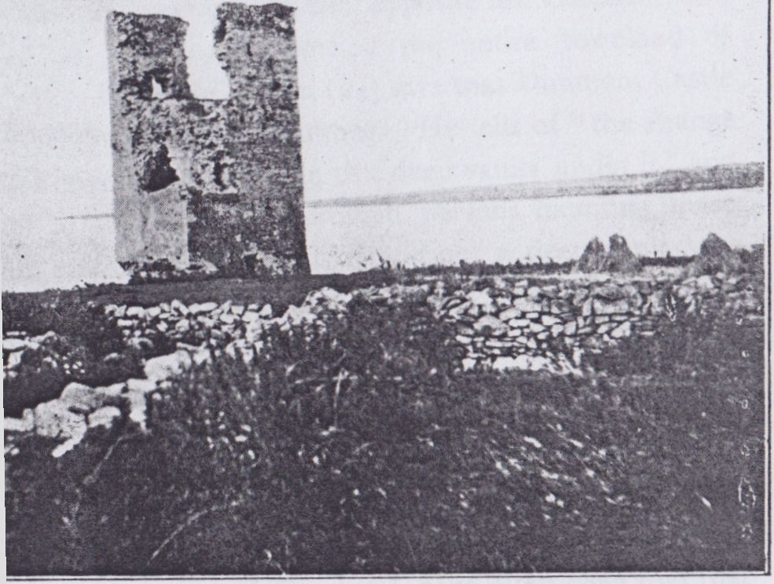

[ T. J. IVistrafy

Dunmore Castle, 1906 (photo by T.J. Westropp)

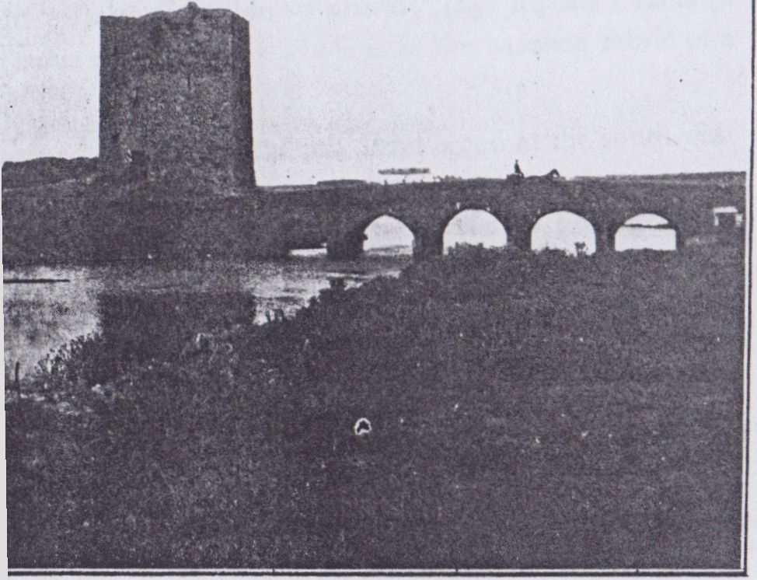

[Dr. G. Fogerty

Dunbeg Castle (Photo by Dr. G. Fogerty)

tower. It does not get its name, as some say, from its being larger than Dunbeg.The name long preceded the building of the tower, though to which of the several low earthen ring forts in the townland the name originally applied no tradition exists. “Dunbeg” is an insignificant little liss on the rising ground opposite the Castles. The townland absorbed as its western portion the entire townland of Cahirleanemore(23). In 1816 Graham(24) says that Dunmore Castle is about the same height and size as Dunbeg. He tells of “the strange and frightful noises made by the sea in the deep vaults under it,” and the popular belief as to ghosts of murdered persons haunting these dungeons. “Not one of these Castles is without a deep vault ‘the murdering hole’ as the peasantry believe” he adds. Now there are no deep vaults in Dunmore or indeed in any other castle among the peel towers of Clare known to me. All stand on the level of the field or above it on a rock. The basements are stores and the present day peasantry apply the term “murder hole” to the ope commanding the inside of the door. So also I have found it used in a document of the reign of James I. It is true that in Cork and Limerick (not to speak of eastern Ireland, Great Britain and France) I have often been told that garderobes both of Monasteries and Castles were prisons and their shafts used for disposing of the dead bodies. That at Quin Abbey was called (at least by the local gentry) “the prison of the rebel monks,” and that of Carrigogunnell Castle was where “the Danes used to put the Irish prisoners till Brian Boru put themselves there instead.” Crofton Croker in “Florry Cantillon’s Funeral”(25) repeats Graham’s story with picturesque effect but the whole is as the baseless fabric of a vision.

When I sketched it in 1893 the tall turret stood at the south-west angle: the wall far below it was even then badly broken. It stood, at least down to 1898. Unfortunately, I was not able to photograph it, and when I did so, in 1907, it and the east and west walls above the vault had fallen down. Since then the owner (fearing that the tall side

1. Earl of Thomond’s Rental, 1703; this gave some trouble in the recent sales as for some time Caherleanemore could not be traced,
2. Parochial Survey loc cit.
3. “Fairy Legends and Traditions of the South of Ireland.” (2nd Ed., 1862) p. 190.

walls might fall on his cattle) hitched ropes over the remaining fragments and pulled them down. The low portion from the stone floor down is all that now remains. It was plainly built of small flag stones, set in very bad friable mortar, which accounts for its collapse. It has a modernized door to the south, and the basement is barely lighted by slits to the north and west. In the north-west corner a lintelled doorway leads to a straight flight of steps rising southward through the east wall; 5 or 6 probably lie buried in rubbish. The passage has a window slit to the east. The stair at the 18th visible step becomes spiral in the south-east angle On the 22nd step we reach a door to a passage with two lights along the south wall and over the main door. Four steps lead from the spiral stair to another cross passage through the east wall. The passage runs northward to two garderobes in the north-east corner. One is in the north wall, and has an ambry and a north light. The other in the east wall has two east lights, before it is a recess to widen the passage, which has a door into the main room. The third story being over the vault of the basement has a stone floor. The floor of the room above it rested on beams, supported on corbels of two stones each. This was reached by a lintelled door from an upper cross passage, and is under the second pointed vault. The under room has in the south wall a recess to the east and a west window. The north has a similar arrangement. The west light was a ragged gap. The large upper room above the second vault is reached at the 55th step. The floor was evidently boarded, as the crown of the arch rises in the middle, the floor not being brought up level(26). The thin walls of the staircase and passages to the east side are split, and show daylight through the chinks in every direction. The whole, like Liscannor, seems to stand in despite of the laws of gravitation. Another passage runs through the spandrel of the vault. As to the former top room the turret up which led another stair was at the south-west angle, there was a window with a flat arch of thin slabs to the north, near the west end of the wall, and a small slit in the south wall. A corbel, as if for a flanking turret, projected in two steps at the south-east corner. A large defaced window looked westward, and there were narrow slits, two to the east and one

26 This is not uncommon in other Clare towers, but as a rule the floor is levelled up.

119

in the south wall near the turret. The turret in 1893 was ragged and broken down the east side and the south-west angle had been broken through below it at the level of the passage in the upper spandrel; this with the bad mortar led to its collapse. The whole angle of the upper room and the facing of the wall for some distance down, both to the west and the south, collapsed or was scaled off by the falling turret.

KILLARD CHURCH.

A long up-hill road, with pretty views of the long range of sand hills and the bay up to Moher, leads to the ancient church of Killard. The building maybe partly of the 10th or 11th century, to judge from the primitive character of its east window, but its founder or patron is unknown, and its first record is as “Kellarda” in the Papal Taxation of 1302. The well near it is dedicated to “the Creator of the World,” a term confined to the Second Person of the Trinity in local usage. Early Irish churches are never called after other than their founder no matter how highly exalted, so the original dedication is evidently lost here. The church is not at the top of the hill, but down the slope; possibly the position was chosen for the sake of the well. From 1302 to the late 16th century it has no record of any description known to me. The Register of Cashel in 1571, in the Public Record Office, Dublin, gives the procurations of the Rectory of Killard and the adjoining parishes. The 1615 Visitation of the Diocese of Killaloe mentions the Rectory of Killarda as attached to the prebend of Kilrush. The church and chancel were in repair, and the Vicarage worth only £3 a year, served by Robert Tuisden, the minister. In 1622, John Rider, Bishop of Killaloe, returned to the Royal Commissioners another and fuller report. Kilardah Rectory £6, impropriate to the Earl of Thomond; the rest appropriate to the prebend of Iniskatty (Kilrush). The Vicarage £7, filled by Edward Philips, minister and preacher, a man of good life and conversation; inducted 9th April, 1621, cure served by himself. Thomas Edens, the prebendary, of Inishkatty, therein alluded to, had an uneasy time in maintaining his rights against the Corporation of Limerick, “Graneer ye Dutchman,” and “others clayming under ye Earle of Thomond.” Abraham Holt, clerk, had been inducted to the Vicarages of Killard and Kilfierah on February 3rd 1619; no old registers had come into the hands of Bishop Rider. It is

120

a curious comment on the shortsightedness of the age that the bishop (though an earnest and conscientious man, of organising power and good intelligence) regarded it as a very satisfactory symptom that the most part of the Clare churches had been repaired “by the fines of recusants,” and as hopeful for ye gaining of ye natives who hitherto will not hear.”

On March 13th, 1633, the next Visitation was made. The Vicar of Kiilard was now Daniell MacBrodin. The Earl of Thomond got £15 now; the vicar £7 from the parish; comment is needless. MacBrodin was a schoolmaster; ordained deacon in 1628, and priest in 1624!! He was appointed Vicar of Killardagh and Kilfarboy in 1623, The confusion of dates suggests the hero “who lost a leg at Waterloo and died at Trafalgar.” Probably he was ordained deacon and made Vicar in 1623.

After all the ruin from 1641, it will not be wondered at that there is little to tell. Two Visitations were held. Thomas Price, Archbishop of Cashel, in 1667, only noted that part of the Rectory of Killardagh was impropriate to the Earl of Thomond, and the procurations of it and 18 other parishes were only worth £15. Henry, Bishop of Killaloe, in 1693, records that John Vandelure, prebendary of Enniscathrie, held the Rectory of Kilrush and the “Vicaridges” of Kilfieragh, Kilballyhone, Killard, and Moyferta, Only the churches of Kilrush and Moyferta were in use, and the latter was not in repair; nor have I reason to believe that any Protestant congregation, if any such existed, used Killard from 1633 down, or kept it in repair till the new church was built.

As for the townlands of Killard and Cahirleane, the Earl of Thomond leased them to Isaac Grainer, who on September 16th, 1680, leased Killard to the Earl’s seneschal, Thomas Spaight, a member of a Kentish family, who had settled first on the Earl’s manor at Carlow, and then at Bunratty. Spaight on August 10th, 1688, sold his interest to his brother-in-law, John Westropp, of Carduggan, Co. Cork, who died after 1698, leaving an only daughter. She married a Mr. Atkins, and died before 1700, her uncle, Ralph Westropp, succeeding to his brother's property. As we noted Ralph’s elder brother, Montiford, got a fee-farm grant of Killard in 1712. The lands were recently sold to the tenants.

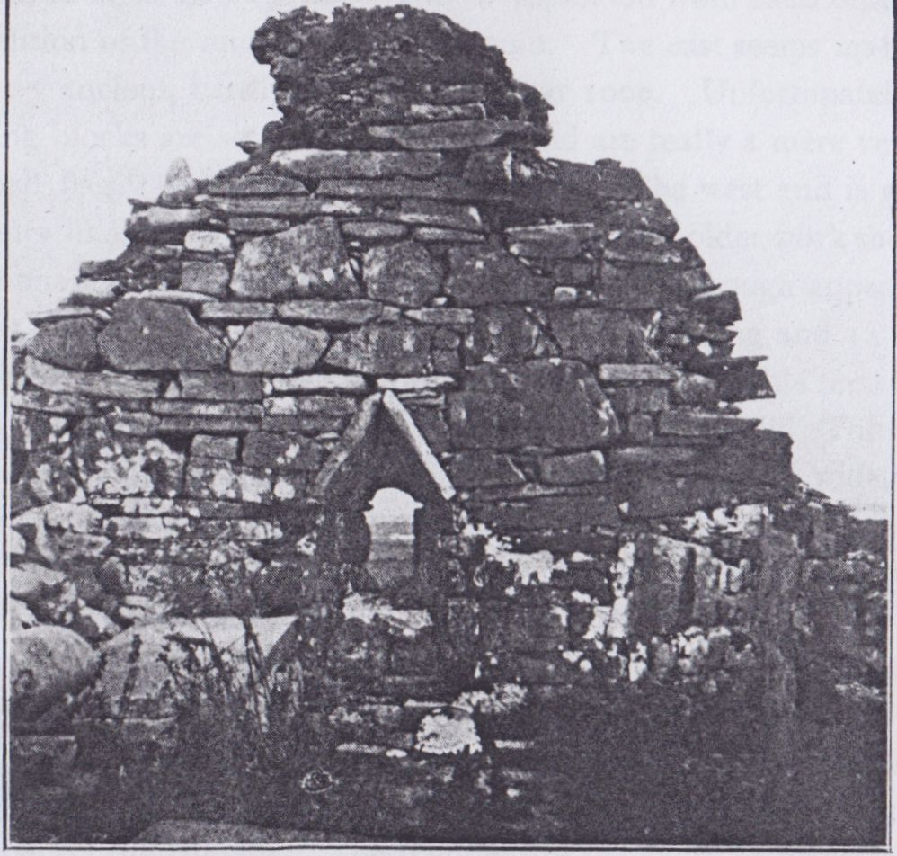

Killard Church (Photo by Dr. G. Fogarty)

[7'. /. Westropp

Photo by

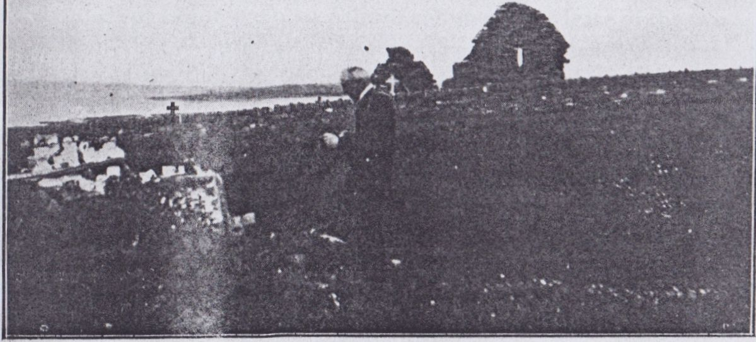

TOBARNA CRUITHNOER—KILLARD CHURCH.

121

The church is of two periods, now separated from each other by the demolition of the middle part of the ruin. The east seems massive, and is very ancient, hardly as late as the year 1000. Unfortunately its large facing blocks are set on their sides, and are really a mere veneer for a small flag “packing” with earthy mortar. The west end is good flag masonry like in the castles. It is strange that the older work should be as dishonest and “jerry built” as any modern villa, though appearing so massive and honest. The church is about 64 feet long and 14 feet 6 inches wide; about 20 feet of the wall adjoining the east gable remains; a defaced window, the sill showing it to have been a narrow slit. The east light has a semi-circular head cut out of a slab, the ope10in. wide, the splay tapers from 330 ½ to 24 ½ in., and is 3ft. 2in. high. The head is angular (of that primitive type seen in Round Towers and early churches) formed of two slabs leaning together. It is 5 feet high in all. One of the stones in its south jamb has late letters I.H.S., and a much older projecting head reputed to be that of Our Lord, to whom in popular belief, the church is directly dedicated. The west end has a neat oblong ope and window slit in the gable, and the traces of a small bell chamber on the summit. The fragment of the south wall adjoining it has another oblong window and the trace of a door.

The monuments are all late; that of the Blackalls of Killard and Killadysart is in the south-east corner of the church. The inscription runs—“This tomb was erected by George Blackall of Kilard Esqrre for his beloved wife Marcella Blackall, alias Burnell, who died ye 24th of June 1810 aged 48 years. Requiescat in pace. Amen.” The Blackalls were founded in Clare by Thomas, the son of a Limerick clergyman, who first settled at Leadmore near Kilrush and then got a lease of the two Killards from the Westropps. His sons divided the lands between them. Some of the slabs in the graveyard have uncouth and curious carvings. The Crucifixion appears on one over three hearts and between the 30 pieces of silver (15 in each row). It is in a frame of plump cherubs with flowers and foliage; angels blowing trumpets are at each corner, and below are the soldiers in modern top hats and boots. Another has a snake looped over the I.H.S. and under it two hearts under a crucifix. The symbols of the sun and moon, the spear and hammer occur, but I did not see the cock crowing on the pot, so favorite elsewhere in Munster from 1460 down.

122

The tombs are—Catherine Sexton to her sons Lawrence (1814) and Michael (1828); Hegarty, 1840; Blake, 1860; Talty and Corry, 1845; Hough, 1849; Devine; Keane; Kinnerle; Mescall; Maclnerney; MacNevin, alias Blacker; Ryan; Clancy; Kitson; Gleeson; Lynch; MacMahon; Byrne of Glascloon and Neylon. Many are later than 1850. One is of Dr. Richard O’Donnell, M.A., T.C.D., born 1873, died 1904.

The holy well, Tobercruhnorindowin (Tobar Cruithnoir an domhain) “the well of the Creator of the World,” is a rough little structure, heaped with the usual offerings, chiefly china figures and vessels; it lies in the open field not far from the north-west corner of the church.

The drive to Bealard (or Beltard) is not very interesting, even the upper road gives us no picturesque views of the coast. In a creek of this shore Crofton Croker locates the curious story of the “Soul Cages” how a young fisherman makes the acquaintance of the ugly, drunken merman, Cumarra, visits his submarine abode and releases the souls of the drowned sailors kept in cages like lobster pots. I never found any tale remotely resembling it along the coast. Unfortunately in my “Folk Lore Survey of Clare” my doubt there expressed was omitted in its proper place(27) Mrs. Dorothea Townshend of Oxford pointed out to me that the “legend” was probably imposed by Dr Keightley on Crofton Croker. As the latter however wrote only to amuse thoughtless folk rather than to give genuine and unvarnished folk tales, he may have accepted it as a freak of fancy. Keightley(28) (after a strong attack on Irish “Antiquities,” and the credulity and barbarism of our country and its people—“rude, ferocious, barbarous, and Christianity does not seem to have made them much better”) proceeds to claim that he composed legends, evidently not to “improve the Irish,” but to get his stories published among more genuine ones. He names the “Soul Cages” among the number, but says that it received additions from another

27 Folk Lore, Yol. XXII., p. 450. I subsequently got it re-inserted.

28 “Tales and Popular Fictions (1834), Thomas Keightley, p. 180.” It is probably a slight adaptation of a genuine story in Grimm’s Deutsche Sagen which it closely resembles and which was known to its editors.

hand, “the Nonsense Verse” being an “extraneous beauty”(29). So we may retaliate by extreme scepticism about his story and indulge in criticism as to its barbarism and bad taste; qualities rarely found in genuine peasant tales in Ireland(30). The strands of Killard and Dunbeg are famous for their beautiful shells. Among the rest the exquisitely tinted “Portuguese man of war” (or Janthina), long known only at Madagascar, is sometimes washed in. I have only seen it at Kilkee on Duggerna and once, in recent years, at Lehinch, it stains the very stones on which it lies with its magnificent purple blood. Washed up, most frequently in the equinoxes, the shells are rarely unbroken by the waves.

[to be continued]

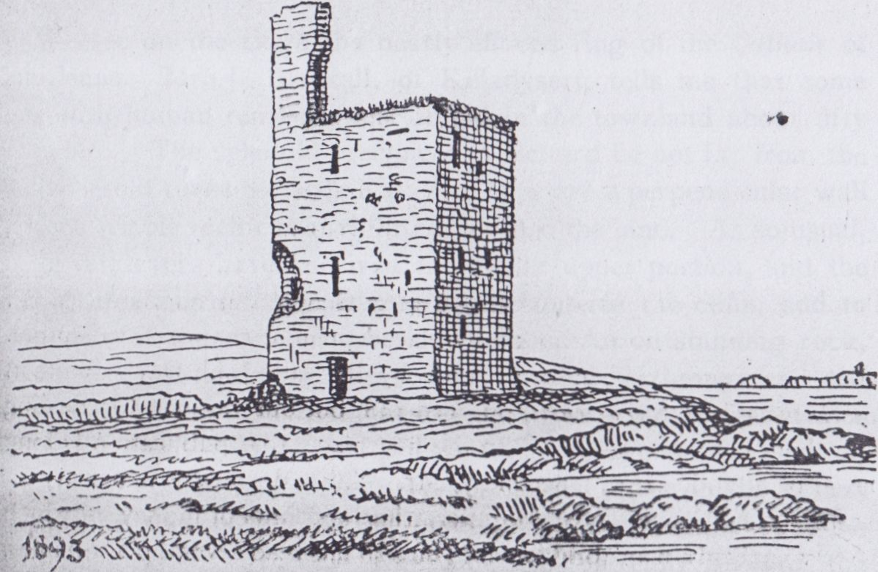

DUNMORE CASTLE BEFORE FALL OF UPPER STORY,

29 This shows how little Croker is to be taken seriously, for (p. 209) he alludes to the “Nonsense Verse” as “if indeed it be not altogether an invention of the narrator,” whereas they were evidently added to Keightley’s fiction after it came to his hands.

1. The worst examples were “rigged to amuse the quality," i.e the country squires.

North Munster Antiquarian Journal Vol 3(3) 1914

KILKEE (CO. CLARE) AND ITS NEIGHBOURHOOD.

PART IV.

DUNBEG TO KILKEE—Part II.

By THOMAS JOHNSON WESTROPP, M.A., M.R.I.A.

(Continued from Page 123.)

We see on the ridge the nearly effaced ring of the Cathair of Cahirleane. Mr. J. Blackall, of Killadysert, tells me that some cists with human remains were found in the townland about fifty years ago. The splendid precipices at Beltard lie not far from the road where it turns towards Kilkee. They are a perpendicular wall of black friable rock cut at right angles into the land. As so usual the lower layers have survived the looser upper portion, and the waves, breaking on their edges, a little outside the cliffs, add to the gloom of the darkly impressive scene. An outstanding rock, where the coast again trends eastward, is called Carrignageera, “the rock of the clergy”; I never heard any legend, but similar names elsewhere imply that hunted priests found refuge on such rocks, usually in Cromwellian times. The old signal tower on the loftiest summit of the cliff is usually called “Beltard Castle,” but no early building stood there. The name itself is really Bealárd, the high gap or mouth supposed to be the Horseshoe Bay. The latter deserves its name, and has in its recess two noble caves eating far back into the land. They can be reached by a canoe, and are well worthy the visit; besides, from facing north, the waves are less likely to break in unexpectedly than in caves facing west, as in those near Bishop’s Island. The sides, white, or like burnished copper from iron water oozing through the clefts; the pink, satin-like coralline and green fringes of sea-grass; phosphores-

154

cent water and sea weeds, and shadowy fish below the boat, make a scene of rare beauty and interest. Sometimes a seal is startled at the end to rush foaming past the boat with echoes like thunder. Even outside, the journey beneath the sky-scaling rocks, in the deep shadow, is beautiful and awe-inspiring. The end of this peninsula is deeply indented by a beautiful bay called Bealnalicka (or Hautbois Bay, as I learn from Dr. George Fogerty). At some distance from the end of the bay, out on the headland, we reach a long rampart. Most who have written on the promontory forts have never considered how far the rock structure affected their plan. Owing to this we have had theories that the straight forts were less ancient than the curved ones, where in many cases (perhaps in most) the builders followed the cleavage of the rock or the contour of the ground.

As we have seen, the lines lie at right angles, and one line of cleavage crossed the peninsula; along this caverns were formed, and, as the rock is nearly horizontal, where these got widened the roof fell in layer by layer. Accordingly, to the north of the bay we see the point cut into an island (the former arch having fallen) and the slopes up from it, to either side, and while in line with this,

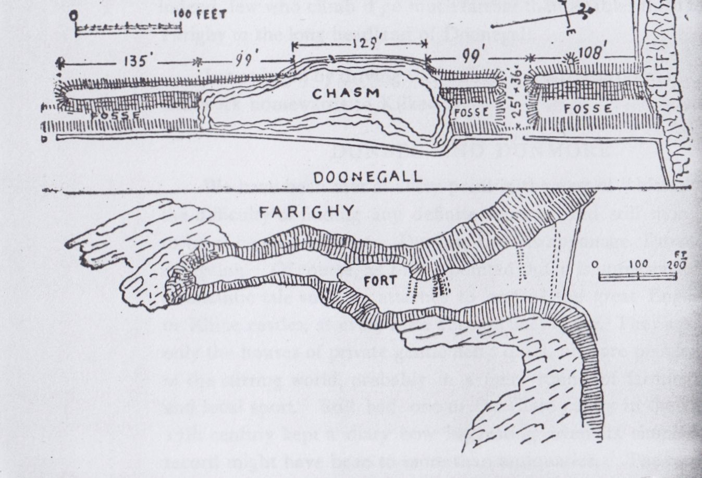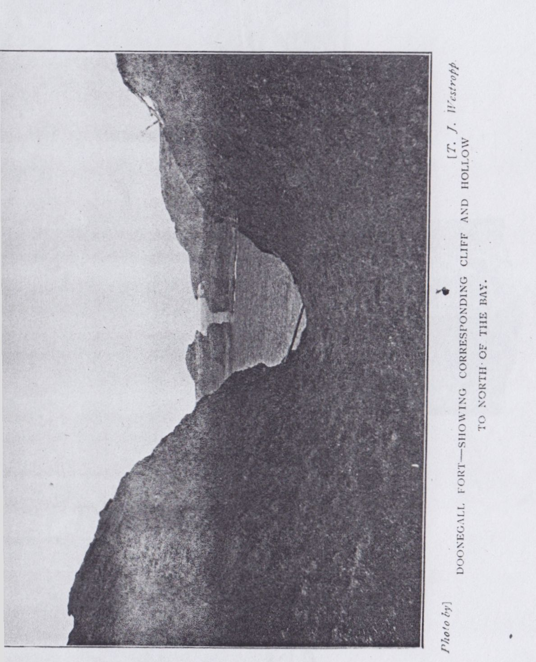

155

on the southern head, a longer cavern, still partly roofed, remains with a hollow above it.

The fort builders deepened and banked up this hollow into a long, very efficient, fosse and rampart. Long afterwards the middle of the fosse fell in and, as the rock still fell away, the middle of the mound was also destroyed. It is called Doonegall, the foreigners’ fort, an instructive name like the other Donegalls (one the promontory fort on Beare Island) and Dunabrattin (the British, or Welsh, fort) in Co. Waterford. Whether it was built by “the savage Dane,” when Corcovaskin was ravaged in 850 and later, and he—

“High on the beach his galleys drew   
And feasted all his pirate crew ”

in Farighy Bay below, or whether it was merely found, ages old, and adopted by the “strangers” we cannot tell. It is one of the largest of its type. Works similar to it occur at Porth in Mayo, at Bonafahy in Achill;1 at Dundoillroe farther south in Co Clare; at Brumore, Doon, Dunsheane and elsewhere2 in Kerry. The works were possibly once 2,150 feet long, the present width of the head at the tunnel. The latter was first noted by Mrs. Knott in 1835.3 Like many another visitor to Kilkee she was rowed through it; she describes it as “a remarkable tunnel or passage of 320 feet long through the rock, which forms the headland, from this bay into the next Oobawn” (compare “Hautbois”) bay. The centre of the roof has fallen in for 200 feet, but the ends remain, like natural bridges, one 210 feet, the other 110 feet. The sides of this extraordinary place are of perpendicular rock, 102 feet high; the breadth at the bottom, only sufficient for a boat to be pushed through by placing the poles against the sides, and even this cannot be done at low water. It can only be passed at a limited height of the tide, in very calm weather, owing to fallen rocks in the narrow passage.4 I first visited the headland in

1. Described in a paper intended to be published by the R. Soc. Antt. of Ireland.
2. Dunmore, near Slea Head, has works 1,570 ft. long.
3. “Two Months at Kilkee,” p. 84.
4. A large fall took place since I was last through it, and I am told it is nearly impassable.

156

October, 1875, and saw the great hollows and mounds. I passed through the tunnel three years later; and the year after that, the Stacpooles, doing the same, found a group of people standing in the water, their canoe having been wrecked. Only for the newcomers all might have been drowned when the tide turned, like the unhappy people in the Poulashantana,5 at Downpatrick, in Mayo, during the yeomanry raid of 1798. ”6

The inner mound of Doonegall rises 7 feet to 15 feet above the field inside, and 15 feet to 23 feet over the fosse. It is 42 feet thick at the base and 8 feet on top. The fosse is 16 feet wide below, and 8 feet to 10 feet deep, save at the gangway; the works are still over 640 feet long. The gangway is about 100 feet from the north cliff, the break from 207 feet to 336 feet from it, but little of the mound remains up to 429 feet. I saw no huts or foundations inside, but there are certain shallow ponds of fantastic shapes, which may be ancient.

As to Leimchaite, Leimchotta, or Leimconor, as it is variantly called, it is very noteworthy how often “Leaps” occur near promontory forts; we have the Leap of the Giant Geodruisge to Dunbriste Rock, at Downpatrick Head; the Leap of the Sea Horse at Dun Fiachrach, and the Leaps of the Priest and of Eanir and Darrig at Dunnamo, Dunaneanir and Dunadearg, all in North Mayo; besides the Leam an (fh)irmore, or “Big Man’s Leap,” east from the first. In Co. Clare, besides Leimconor, we have O’Brien’s Leap at Dunlicka, and Cuchullin’s at Loop Head. In Co. Kerry is the Leap of Ballingarry; in Co. Cork, the Hound’s Leap at Leamcon Castle, and in Co. Waterford the Heir’s Leap at Ardmore. O’Donovan attempts to account for these as from the “leaping” of the sea, but we have many inland “Leaps,” like the original “Leap of Cuchullin” up the Shannon, the Leimaneighs in Co. Clare and elsewhere, and the Horse Leap at Ardmurcher Castle. The legend of Cuchullin’s Leap once attached to a spot far inland on the Shannon.

1. As this name occurs in Co. Clare at an inland “thunder hole” at Lismuinga, near Ruan, with water in the bottom, I very much doubt the received translation, “Hole of the old wave.” The Ruan hole is locally pronounced Powlnashoantinny and Poolnashountana.
2. Journal R. Soc. Antt., Ir., vol. xlii., p. 111.

15 7

The view from the Horseshoe Cliff (which is nearly 250 feet high, the water below it 48 feet deep) sweeps up Malbay to Hag’s Head, and Aran: Liscanor Castle, the spire of Miltown Malbay, and the dark speck of Tromra opposite Mutton Island, are all visible, while southwards we see far towards Loop Head, and from certain points the Shannon and even Scattery Round Tower are visible. Hautbois Bay often abounds in gulls and seals, and is full of interest to the naturalist, whilst to students of folk lore the lake behind the shingle beach has an interesting legend, like Lough Neagh, Inchiquin Lake, Cullaunyheeda and many another Irish Lough. Folk told in 1836 how a city and tower in the then unflooded valley had been submerged through the fault of a woman. A magic well lay near the city, its guardian being Noule, the king’s daughter. A strangely handsome youth fascinated her by his love songs and she forgot her charge till the well burst out and covered the city and its inhabitants.

FARIGHY. Several forts lie round the lake near the village of Bealaha. Lisroe, the red fort, to the south, is the smallest. To the north of the stream in Glascloon lie Cahergal (white fort), Caherduff (black fort), and Doonbeg, the first is about 100 feet across; Bealaha Liss somewhat larger and the others smaller; the banks are high and steep, nearly all their stone facing is removed , for building and road metal. Bealaha Liss has mounds 9 feet to 12 feet higher than the ditch, and well preserved. On the road to Hautbois Bay is Bealard Liss with mounds 6 feet to 8 feet high, and little if any trace of a fosse. The group is alluded to by a deed of about 15507 by which Edmond Roe son of Gilladuff MacSweeney of Kilkee (*cil* caoidh) conveyed the place to (Donchadh O’Brien) the Earl of Thomond, with “the rath and quarter of Dunbeg, meared by the pool of Gaethbuidhe to the south, and by Loch Margraighe to the north, by the foot of Creeduff at the entrance of Island Mac Ulga to the east, and Cammanafeany to the west.” Most of these names are lost. Gaethbuidhe (yellow breezy pool) is evidently Farighy Lake; Lough Margraighe may be Pullen Bay, on the bounds of Cahirleane; Cammanafeany, ‘‘the little crooked

7 Hardiman’s Deeds Trans., R.I. Acad., vol. xv.

158

stream,” now a mere ditch, running down from Baltard. Caherduff and Cahermoyle forts in Upper Glascloon, appear in a grant of 1623.8 The 1675 Survey gives the Earl’s properties as Farrihy, Caherleane, Ballyard, and Glascloun. The manorial court was at Lisdeen, just over the edge of Killard Parish in Moyarta Barony, the Lis Duibhin of the 1390 rental of the O’Brien chiefs.

The headland of Farighy Point was formerly fortified (as so frequently) by two earthworks and hollows, the former capped by dry stone walls, nearly removed, even when I first saw it, in 1875. The earthworks are now much levelled to the south, the stones almost entirely gone. The first work lies about 180 feet from the end of the drift cap, which is rapidly falling away. The inner (western) mound is over 4 ft. high and about 10 ft. thick. At 33 ft. farther eastward is the fosse. This slight hollow is between two mounds; each of the three is 15 feet wide at the field; the fosse is 9 ft. in the bottom. The arrangement is similar to the Kerry Head forts, or the outworks at Doon Canuig in Kerry, and Reen Point near Castlehaven, in Co. Cork.9 About 30 feet farther landward is a bank 10 feet thick and 4 feet 6 inches high, and a shallow ditch 9 feet wide. At 430 feet from the end is the trace of a curved fence 10 feet thick, too strong to be modern. The ends of the works abut on steep sloping rocks unbroken by the sea for probably many centuries, though the end of the head is so wave cut. The total length to the present field fence is 490 feet. At least 20 feet have been cut away from the drift bank at the end since I made my former plan in 1906. The headland represents the head and body of a great crested bird dipping its beak in the waves. Out to sea lie the two Biraghta (Spit) Rocks. When I was a boy (in 1870 and 1872) I was told they were called Balka and Sea Foam from two alleged wrecks. The headland has a fine view of Doonegall and its ramparts across the Bay.

On a ridge, running towards Bealaha, are several forts and a little graveyard. The earthworks are of small interest, being usually low and defaced, mere house rings; only one has a name, Liscon-

1. Cited in the Earl of Thomond’s Inquisition, P.R.O.I.
2. Described in a paper on the “Castles and Fortified Headlands” of South Co. Cork in Proc., R.I.A., vol xxxii., p

ST. BRENDAN S HOLY WELL,

Farighy.

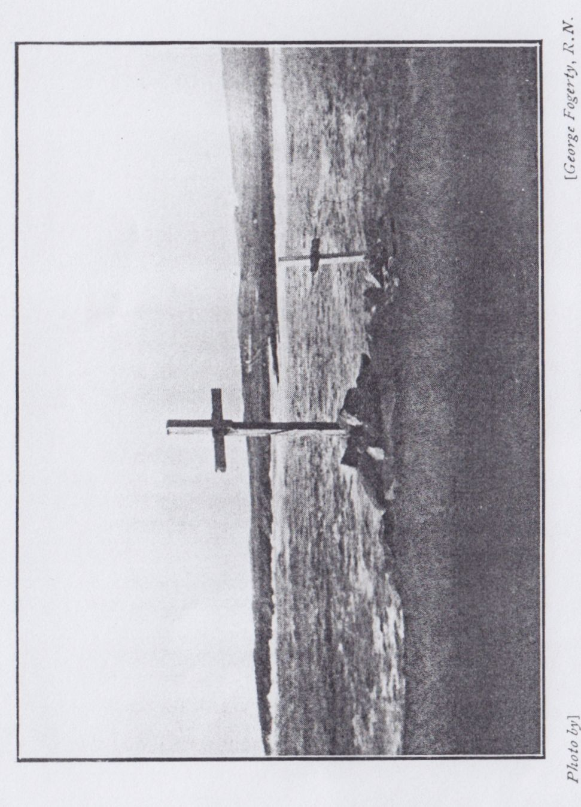

159

nell, another near some houses has fairly high mounds. To the N.E., on a parallel ridge, is a little graveyard. It has no old tombs, and but one late slab of interest:—“In loving remembrance of Captain Arthur Webb, aged 41 years, who was lost at sea, 31 Jan., 1886, at the time of the total loss of the ss. Fulmar; found Feb. 4th, and buried at Farrihy.” A holy well, dedicated to St. Brendan, lies near the shore and village; the modern chapel is dedicated to St. Senan.

KILTINNAUN.

Kiltinnaun lies some three miles eastward from Kilkee and, to judge from its name and position, was one of the churches founded by (or dedicated to) the Apostle of Corcavaskin, St. Senan. On the rising ground to the south of it, beside the road leading to Kilrush, the saint’s bell (the Mediaeval Lives tell us) descended, ringing sweetly, from Heaven, where a rude wayside altar and a popular tradition fix the spot. The bell, or rather its shrine, is that preserved in the Keane family, and I must thank Mr. Marcus Keane, of Beechpark, for bringing over the bell to Edenvale, in 1900, for me to sketch, and supplying much of the legendary material embodied in a paper that year.10 The church stood on an early earthwork of the low mote type, like the church of Moyarta, near Carrigaholt. This was beside a little stream full of rushes and flaggers in a long shallow valley. The earthwork was a platform five or six feet higher than the field, circular and surrounded to the east and south by a wet fosse fed by the stream, and to the north by a deep dry fosse through a low spur from which it was separated. There seems to have been an outer ring, but the modern wall runs round it. The platform is revetted with vaults, and the oldest graves lie thick on top. There may be traces of the church in fragments of flag stone walls on the platform. No building is marked on the 1839 maps. It is interesting to note how a fashion prevails in tombstones here as elsewhere. A single tombstone takes the popular fancy, and is recopied many times in an increasingly degraded form. Everywhere we see rude carvings of the instruments of the Passion, the 30

10 Journal R.S. Antt. Ir., vol xxx., p. 237.

160

pieces of silver, the cock standing on the pot, and the sun and moon. A holy well of St. Senan lies among the graves to the S.E. of the earthwork. The mound is surrounded, at least round the east and west segments, with primitive old vaults, small, with sodded roofs and half-buried in the ground. The old aspect of the cemetery is much spoiled by several ugly modern vaults outside the circle, in one of which bees have established a nest. I found no tombstone earlier than 1811; the oldest are Quealy, 1811 and 1812; MacNamara, 1812 and 1852; Quinlan, 1812; Mahony, 1813; Maclnerney and Kean, 1817, 1818; Kelleher and Shanaghan, 1818; Purcel, 1824; Griffith, 1825; Mahony, 1826; Foley and MacGrath, 1828; Conway, 1829; Haragan and Quinlan, 1832; Lynch, 1834; Kett, 1833; Murphy and Kinerk, 1836. From the reign of William IV. down monuments are numerous, but, so many being of visitors to Kilkee, they are less than the other graveyards connected with local history. I may note Carey, Clancy, Delohery, Fitzgerald, Foreham, Green, Haugh, Huolahan, Kelliher, MacDonnell, Meloher, O’Brien, O’Neill, Quinlan, Sullivan and Stapleton. St. Senan’s altar is a nearly shapeless grassy mound, 5 feet to 6 feet high, and about 12 feet each way, with large slabs of stone projecting. It stands on the summit of the low hill and beside the steep road not far to the south of the graveyard. The bell legend is vaguely remembered, and Mrs. Pat Welsh, of Farighy Cross, ' tells me that the Mass was celebrated at the altar of St. Senan when it was unsafe to celebrate it elsewhere. Standing on the end of a ridge, with the low large bog beyond, it overlooks a wide extent of country off to the low hills towards Drumellihy and Kilmihil.

LISNALEAGAUN FORT.

We again return to Kilkee and find, behind the ”east end” of the town, in the fields, not far from the station, a noteworthy earthwork named Lisnaleagaun, ‘‘the fort of the pillar stone.” No pillar stone remains near it. The fort must have been familiar to visitors from the first, but Mrs. Knott seems to be the first who noted it and gave it thereby a place in the compilations of guide book makers, who rarely see what no predecessor has ‘‘written up.” ‘‘A fine old Danish fort ... It lies behind

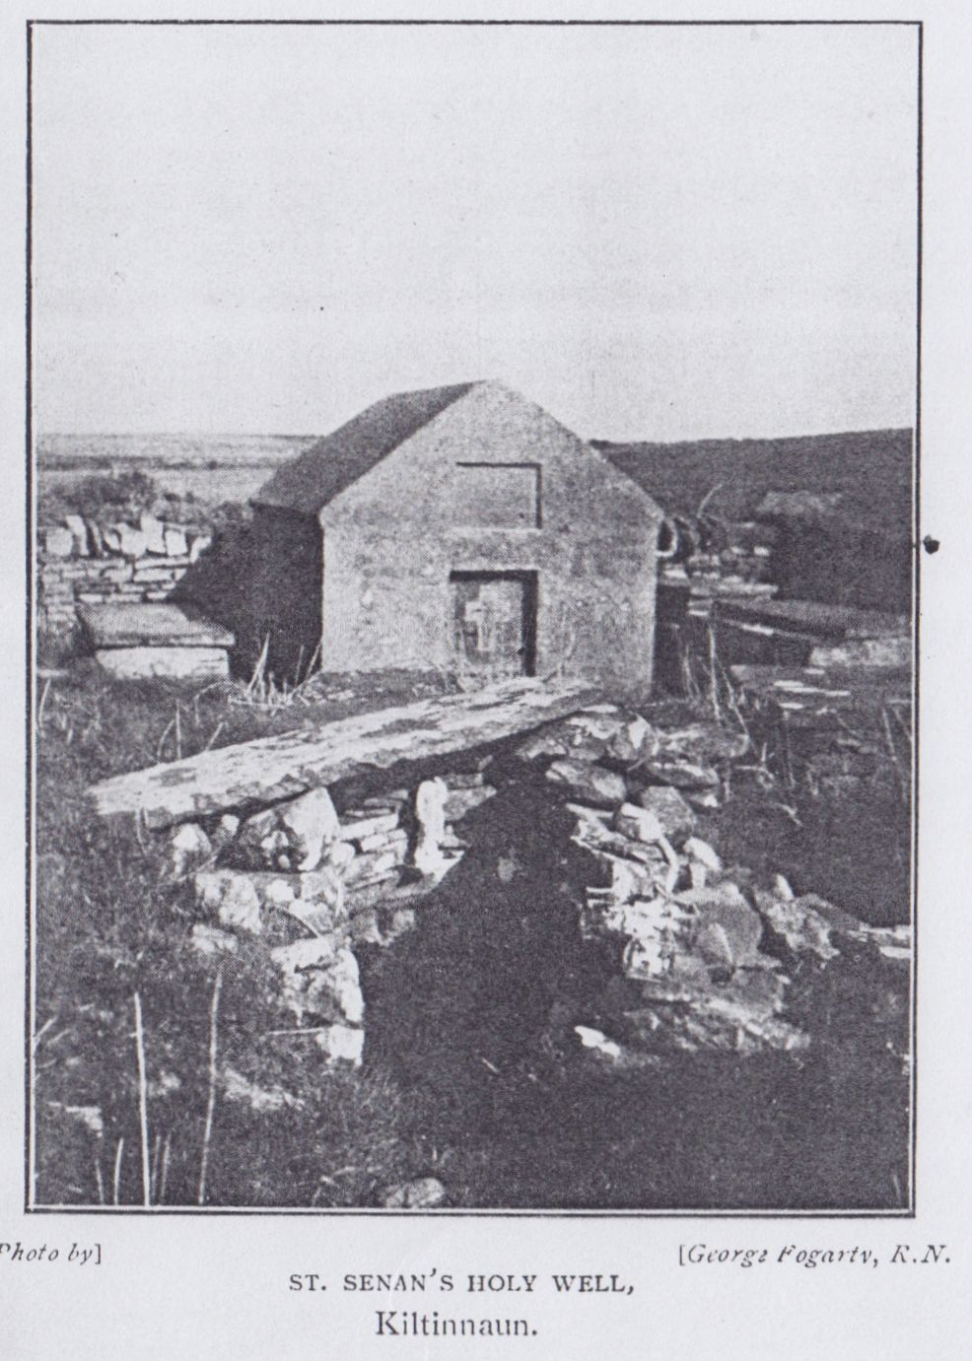

161

the town upon a little hill, and has a thick bank thrown up all round it; about 700 feet circumference; the moat, or ditch, is about 25 feet wide, the centre gradually rises from 16 to 20 feet, the summit is about 300 feet in circumference and nearly level. On the south side are two rather small openings which lead to subterranean chambers and occupy the interior of the second elevation; they are said to be extensive. The neighbourhood was thrown into consternation some time since by a ventriloquist, who caused sounds of distress and anguish apparently to proceed from these vaults.”11 She suggests that the apertures should be enlarged to enable “the curious to descend and explore the probable storehouse of the Northern depredators. The lads of the village are now the chief visitors of this antique circle.” They told how the ghosts kept clothes from being stolen while being dried on the forts, and how no labourer would help the landlord to level it. Almost at the same date, Eugene O’Curry examined it. He writes in 1835.12 He calls the fort Lios an chairn; 9 feet high from floor level to the top of the wall. About 1818, a farmer, seeing a cow motionless on top found that its leg was fixed between two stones. Digging and raising one slab they found the passage with walled sides and roof slabs; shells and bones lying about, and other passages running ‘‘in all directions.” 12 John Windele, in 1854, visited the fort; he describes it as 100 feet across, and the ditch 25 feet wide (C. C. ‘‘Supplement,” MSS. R.I. Acad., 12 K. 27, Vol. I., p. 7.).

The dimensions are 105 feet across, north and south, 120 feet east and west, and 14 feet to 16 feet high above the ditch, which is 20 feet to 25 feet wide, and 3 feet to 5 feet deep. The outer ring is usually levelled, save for about 70 feet to the north and north-west; it rises 10 feet over the fosse, and is 14 feet to 20 feet thick. The sides are very steep and may have been revetted with dry stonework and capped with a dry stone rampart, but no trace remains. The main mound has been injured to the east, but only

11 “Two Months at Kilkee,” p. 40.

13 The letter has been recently added to the Co. Clare Ordnance Survey Letters in R. I. Acad. For O Curry’s life see supra Journal Lim. Field Club, vol. i., part 3, and vol. ii., p. 177. At that time he signed “Curry,” or more formally “Ua Chomraidhe.”

162

slightly. The souterrain lies to the south, a small oval cell, 5 feet 4 inches by 8 feet 8 inches, with a slab roof, thence a small ope, some feet above the floor, gives admission to the main passage, and thence, by a second doorway with a small ope, to the west and another oblong cell beyond. The whole lies east-north-east and west-south-west, and is about 36 feet long. The roofs are now nearly all taken for sills and flags, and the rooms are filled with brambles and nearly inaccessible.13

The fort is of the low-mote type, rare in Co. Clare; similar earthworks occur at Lugalassa, near Bodyke, and Lisnagree, up the high pass of Formoyle, in the eastern hills near Broadford. The inauguration mound of Magh Adhair is similar, whatever be its origin, and, despite dogmatic contradiction, was certainly residential with its fosse and strong outer ring and traces of the common dry stone wall on top. This last may have been “a king’s grave” (like other low forts), a marsh fort and an inauguration mound, but narrow views should be excluded (especially in our present ignorance) from theories of Irish “forts.”

GEORGE’S HEAD.

The local belief in Kilkee is that the Irish name was Ceann Foirchig (Dark Head), which was corrupted to Ceann Seorsais or George’s Head. Dr. G. Fogerty procured this information from Mr. Halloran of Kilkee. I give it on the sole authority of the latter.

It were indeed strange if this bold promontory14 were unfortified. All round the coast from Sligo down the west and south coasts, and up to Belfast, I have not found more than a couple of suitable headlands without promontory forts; of these only one, Nalhea, in Aran, occurs on the west coast. Even in its case, a dry stone wall may have been carried away, leaving no trace on the bare crag, though I do not see any reason to believe that this occurred.

The remains at George’s Head are certainly uncommon, and perhaps their object is disputable, but when I describe them I think

1. See my paper on Ring Forts of Moyarta Barony, R.S.A.I., vol xxxix., pp. 116, 119.
2. It seems to have no recorded early Irish name; it was “Cream Point,” from the constant churned foam round it, in 1835.

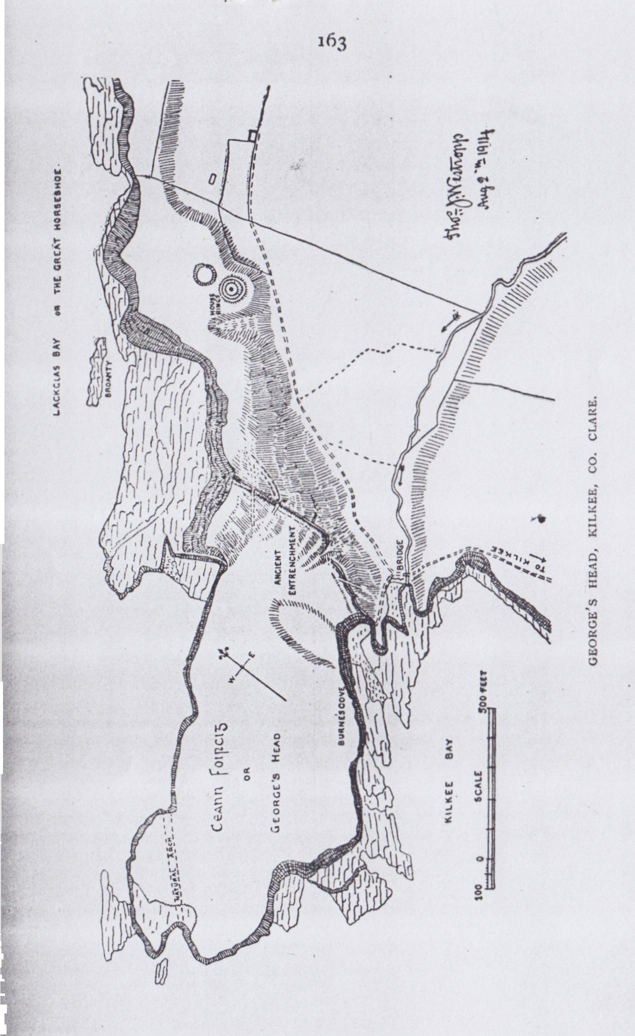

many (still more any that have seen the traces) will allow that they are remains of no field fence, but of a large promontory fort. First the mound is over 20 to 25 feet thick, the local fences are rarely 6 feet thick. The cattle tracks through the mounds are so deeply worn as to be evidently of great antiquity; no trace of the mound shows in these passes, which, if it were a fence to control cattle on the Head, must have been carefully closed. The objection as to the irregular line of the work applies equally to Dunmore Head in Kerry (the nature of its even slighter, though better preserved works is undoubted), or the deep bold fosse and massive works at Ferriter’s Castle on Doon Point in the same county. The following of irregular natural contours is a commonplace in the greater ring forts. As to the worn condition, anyone who has given the least attention to forts has seen hundreds of undoubted works equally time worn, reaching their culmination in the faint line across Dooega Head in Achill. There only at the fallen end do we see how deep its fosse and strong the mounds were before the ages of rain and storm filled up the one and wore down the other. The mound begins at Burne’s Hole, a favourite bathing cove. Thence it runs in a waving line somewhat northward or slightly east of north (being, as I said, some 20 feet to 26 feet wide) with a capping of stones buried under the sward, but probably once a wall, or rather the small filling of one. It has a shallow ditch in front and no outer mound, it extends to the edge of the steep crag slopes above the low rocks at the northern bay, ending in Lackglass rock and once known as “the Great Horseshoe.”

The works run unbrokenly for 230 feet. There is some difficulty in fixing the actual commencement at the broken cliff. They are concave to the land for 43 feet, then a shallow cattle track crosses them and is probably not very ancient; at 48 feet farther is a deep slanting path up the slope and a deep cattle gap in the mound 142 feet from the cliff. At 195 feet the convex bend sweeps round once more; about 200 feet the works are obliterated; at 250 is the great hollow way; there a break occurs 15 feet wide at a hollow. North of it they rise abruptly. They are well marked to the inside and outside of the line, and run for 330 feet to the edge of the slope. They are about 650 feet long. Two small house rings lie outside the mound; this again favours the antiquity, for such ancient outlying houses

166

are found outside the walls of promontory forts at Downpatrick, Duncartan, and Dunnamoin North Mayo, Dunnacurrogh on Achillbeg, Dunmore on Bofin, Dunnagappul on Cliara (Clare Island), Dubh Cathair in Aran, Bishop’s Island and Dundoillroe in this county; Pookeenee in Kerry, Old Head and Reen Point in Co. Cork, and elsewhere. The ring on George’s head is 48 feet inside E. and W and 41 N. and S., with a shallow fosse 10 feet wide, and an outer ring 10 feet thick. In all 70 to 80 feet across. A circular pit is in the centre. The more northern site, about 30 feet from the last, is easily passed by, but distinctly marked on the field. It is about 27 feet across inside, with a fosse 9 to 10 feet wide, and no existing outer ring—46 feet over all E. and W and 43 feet N. and S. Inside on the head I noted two regularly semi-circular bands of coarse grass, which resemble the circles elsewhere, marking otherwise vanished hut sites. I suppose the clay and wicker walls made a richer soil (maintained by its decaying vegetation) on the poorer soil of the Head, with close sea-pinked sward. So the ancient cattle tracks called “Dane’s Ditches” at Achill and elsewhere make green lines through the brown ling from fort to fort and dolmen to dolmen. Antiquaries here have much to learn from their brethren in Great Britain, who do not shut their eyes to the ancient tracks round the forts. I have noted these in Mayo, Co. Clare, Kerry Head, Lough Gur, Co. Limerick; Dunworley and the Old Head, Co. Cork; and at Tara, but fear I have overlooked many elsewhere.

The view from the wave-bared extremity of the headland is very fine, but it is excelled by that from the summit of the hill in Corbally, at the end of Lacklass Bay. The first outlook extends northward along the promontories to Doonegall, and even Aran, and southward down the coast over the foaming reefs of Duggerna, past Bishop’s Island, to Loop Head; while, up the Bay, is a panoramic view of the little town and its crescent strand. On clear days the higher view is extended to the giant peaks of Bunnabeola in Connemara, and those of Slieve Mish, Caherconree and Mount Brandon . in Kerry.

In the fields up the stream valley towards the new reservoir is another ring fort, 90 feet inside, with an earthen ring, stone capped and faced in parts, 16 feet thick and 7 feet high. The facing commenced at 3 feet above the fosse, which is 4 feet deep and 12 to 15

167

feet wide. No outer ring or inner house sites remain, but there are traces of a stone gateway to the east. It looks down the valley to Bishop’s Island and the entrenchments on George’s Head.

CONCLUSION.

Little remains for me to add in closing the long series of antiquarian papers on the pleasure resorts of Co. Clare, from 1903, in this Journal (then of the Limerick Field Club). In trying to give more than dry facts on the one hand, and more than tourist-guide- book-matter on the other, I may have failed in my design. I had the reward from the first in finding how many that never “professed or called themselves antiquaries” were interested in the brief history and notes, and went to study for themselves the remains they otherwise might have missed.

A few points require notes and additions:-

KILKEE FISHPOND (supra, p. 222). The dimensions of this got printed wrongly. They were intended to be “350 feet by 110 feet.” I can now give a careful plan. It may be seen that the pond is bounded to the north and south by parallel earthworks, but it is not easy to fix the actual length. The north mound is almost

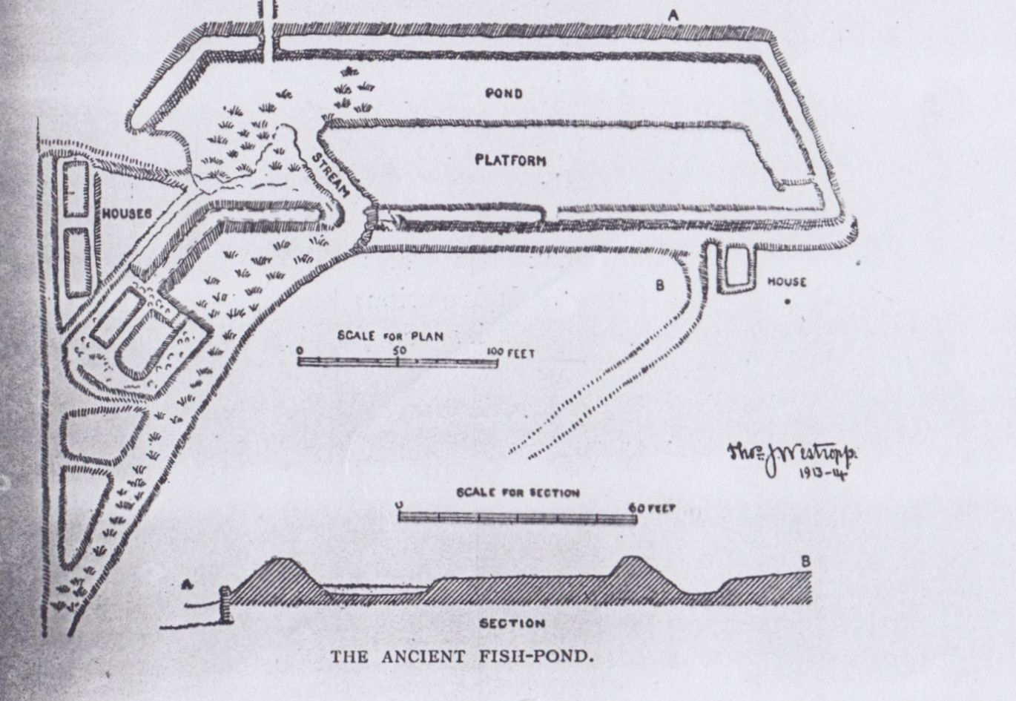

168

exactly 300 feet long, the south about 340 feet to 350 feet. The actual basin was 21 feet to 24 feet wide; but when full it must have been from 66 feet to 54 feet wide. The plan however gives a clearer notion of the arrangement. In all it is about 370 feet by 110 feet. About a quarter of a century ago it was called "Lady Isabella's Pond." She was said to have been an O'Brien.

KILFIERAGH. It may be interesting to people connected with Kilkee to do for Kilfieragh,15 their parish graveyard, what has been done for Kiltinnaun, namely, give a fairly complete list of the families commemorated. As usual in this part of Clare, even fairly old tombs are absent, nor did I find any object of antiquity  
or even a tombstone older than 1790. The oldest date I found was on the slab of Francis, father of the Patrick O'Brien, who died 1792, his wife Joan in 1823; Arthur O'Keeffe 1800, John O'Keeffe 1806; the Cox family 1810, 1813, 1832; O'Keeffe 1815; Arthur O'Donnell, of Kildimo; MacMahon, 1832; Maclnerney, 1832, 1835; and MacGrath, 1837. The tombstones of the reign of Victoria are of Maria, daughter of Dr. Thomas Ryall, 1840; Halpin, 1840; O'Dea, 1843; Couney and Belson, 1844; MacCarthy, 1848; Connellan, 1850; Thomas Conlan, of Nenagh, drowned at Kilkee, 1850; Denis Troy, of Dunaha, 1853; Kennedy, of Lisgarreen, 1855; Goulding, 1856; Doherty, 1859; Hough, of Kilfiera, 1867; Reid, of Querin, 1868; Keane, 1873 (aged 87). Few are of more than local interest. An undated one is of Hanah, daughter of Denis McMahon, of Carrigaholt, and niece of Captain D. H. O'Brien., R.N. The Hough vault is against the gable of the old church. The Connellan tomb has elaborate rude carvings of the crucifixion, the sun and moon, the instruments of the Passion, 30 pieces of silver, the cock in the pot. It is curious how the story from the apochryphal Acts of Pilate16 seized on popular favour in Ireland from the 15th century. The earliest example in Co. Clare is in the group of the Man of Sorrows, in Ennis Abbey, about 1460. The Troy tomb has a very curious carving of the Angel of Judgment,

15 Supra vol i., p. 223.

16 Journal R. Soc. Antt. Ir., vol. xxxv, p. 408, has a very interesting note by Rev. St. John Seymour, the first who traced the remote origin of this well known device in Ireland. He gives the text from the *Acta Pilati* and the Sahadic "Life of the Virgin."

169

clad in a tailed coat, with six large buttons, and blowing the trumpet.

"With uncouth rhymes and shapeless sculpture deck't  
Demand the passing tribute of a sigh."

The forts to the west of the church, Lisheenagreany and a nameless one, are levelled, merely circular mounds a foot or two high. Lissyoolaghan to the east is about 4 feet high, and had a dry stone facing and wall now nearly all removed.

MOYARTA FORTS—LISSAGREENAUN. This fort, lying in Moyasta townland, deserves a brief description as of the less usual type of liss in this part of Co. Clare. It has no outer ring. The fosse is wet, 15 feet wide and 4 feet deep. The ring rises 12 feet above it, the garth being a raised platform, 78 feet across N. and S. and 120 feet E. and W. inside the rampart, which is about 16 feet wide. No stone-work remains, nor any trace of a gangway or gateway. It has a good distant view of Carrigaholt Castle and across the Shannon, the new wireless telegraph station near Ballybunion being clearly visible.

The other forts near it are of the more usual type. One between Bellia village and the main road to Kilkee has a high ring and shallow fosse. Bellia Liss, to the S.E. of the road is finer, though the side road cuts through its southern segment in the fosse. The rings are 7 to 8 feet high, hidden in bushes, with a wet fosse and an outer ring 4 to 5 feet over the fosse. Lisnagreeve is defaced and overgrown, but of similar construction. One small house ring barely 60 feet across and 4 feet high, is N.E. of the road at Goleen, not far from the last; it is half levelled.

Another house ring, better preserved, but closely similar in size and arrangement, is in Carrownawealaun, whose fine two circled Liss I have previously described and planned. There is, however, an outer ring and a deeper fosse. Another small example, the garth 3 or 4 feet higher than the marshy field, lies nearer to Kilfieragh cross. I merely give these as most accessible from Kilkee for those anxious to study the ring forts near that place for themselves. The whole country is full of similar remains, showing how dense a population dwelt in the Irrus of Clare in early and mediaeval times.

North Munster Antiquarian Journal Vol 3(4) 1915

ANCIENT REMAINS ON THE WEST  
COAST OF CO. CLARE.

By THOMAS JOHNSON WESTROPP, M.A., M.R.I.A.

(Concluded from Page 169.)

Over ten years have gone by since I commenced at the suggestion of a valued friend only recently taken from among us, Dr. George J. Fogerty, R.N., a series of papers on the antiquities of the country round the pleasure resorts of Co. Clare. Begun just as peace settled down after the South African War, the series of papers ended as a more widespread and deadly war began. Great changes of every kind marked the eleven years during which the papers appeared. It is evident that in progressive work much new material accrues every year; also that mistakes get detected accordingly. I bring together in this paper some of the most necessary corrections and some additions to the series of papers.

CAHERMURPHY (Journal Limerick Field Club, vol. ii., p. 255). On a later visit to this place I was greatly impressed by the very curious earthwork in which the castle stands. The previous account in these pages is so inadequate that I must supplement it before I close these papers.1

If the tribal legends of its late owners, the MacGormans, be true, their tribe, the Ui Bairchi, or Ui Bricin, fled from Carlow2 and Slewmargy to Domhnall mór O’Brian, King of Munster, between 1170 and 1190, and was settled by him on the northern seaboard of Corcovaskin, still called from them Ibrickan. The O’Gormans, thus indebted for protection, freedom and territory,

1 See also Journal Royal Society of Antiquaries, vol. xli., p. 117.

2 See Rev. Mr. Shearman’s paper in the Journal of the Kilkenny Society (now Roy. Soc. Antiquaries of Ireland), vol. iii., series iv. (vol. xiii. consec.), p. 522; also the pedigree registered at the Ulster’s Office by the Chevalier O’Gorman.

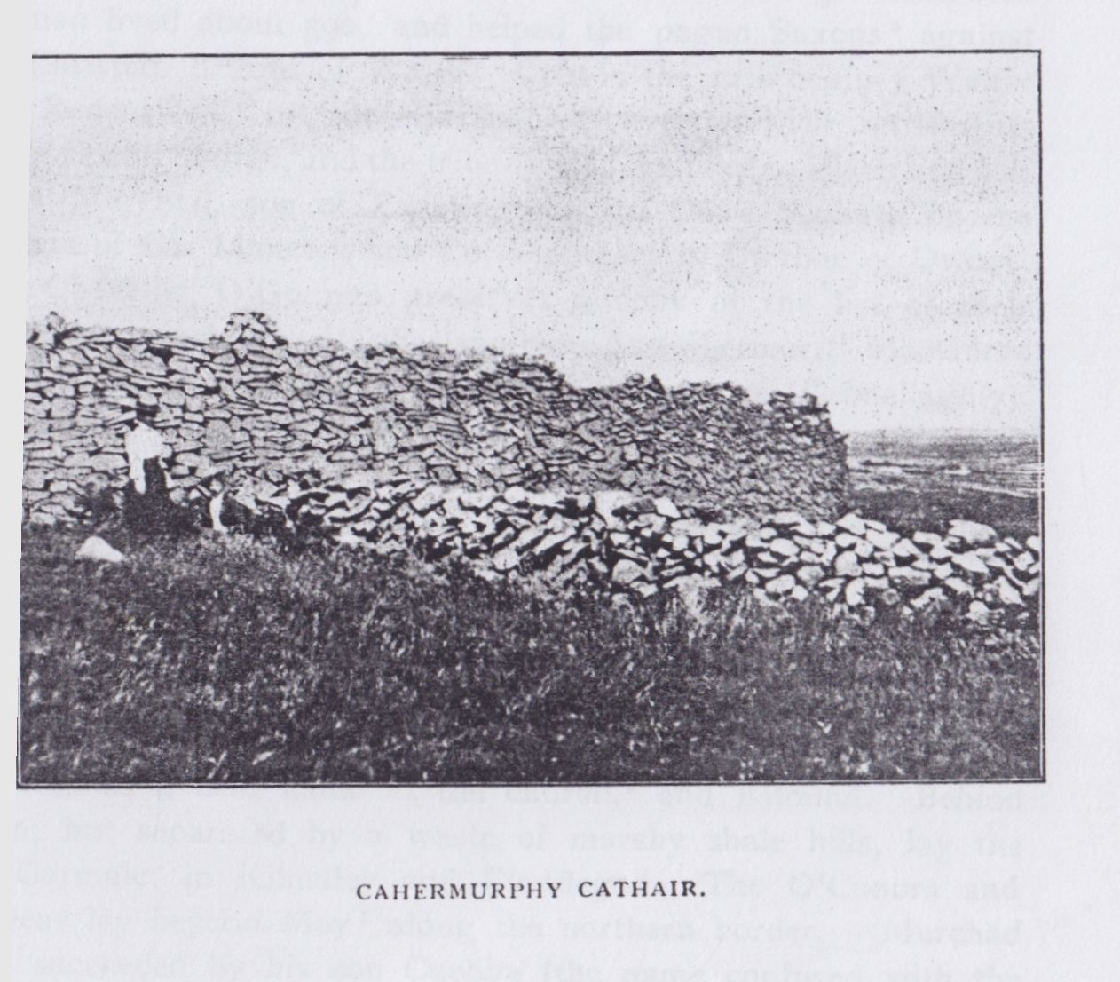

345

became a most loyal garrison, and they, the O’Briens and MacMahons of Carrigaholt kept down all traces of rebellion in the remnant of the Corca Bhaiscoinn and the Mairtinigh, their predecessors in the district. Wild stories were told of their ancestor Gorman; he was said to have been King of Africa, and his by-name, Maur, was equated with “Mauretanian” by too erudite scribes. In fact, the Irish belief that the Africans were blue men (Fir Gorma) sufficiently accounts for this strange assertion. Gorman lived about 590, and helped the pagan Saxons3 against the Christian Britons of Wales. Late in the 12th century Walter “de Redensford” or “de Ridelesford” overran their settlements round Sliabh Mairgi, and the tribe divided, half fled to Ulster and half under Murchad, son of Eachthighern, to Doire Senliath on the borders of Co. Limerick and Co. Tipperary in Uaithne or Owney. The Chevalier O’Gorman preserves a copy of the list of their tribe lands, including “Caher morrigu de Cahermor,” Monemore “Castle” (fort), Clahanes, Dromine, Gorman or Drimellagh(y), Tullycrone, &c. Whether “Cahermorrigu” represents some older form I dare not assert, but it seems most probable that Cathair Murchadha, the chief residence, was dug by order of Murchad, the chief, and in imitation of a Norman castle, with its bailies and fortified mound. The structure has more affinity with Norman than with primitive Celtic earthworks in design, but not execution. The tribe held the parishes of Kilfarboy, “De colle bovum (Oxmount) or Kilmurry, where the name “Oxmount” still survives as a field name at the church,4 and Kilmihil. Behind them, but separated by a waste of marshy shale hills, lay the Ui Cormaic, in Kilmaley and Clondegad. The O’Conors and O’Deas lay beyond Moy5 along the northern border. Murchad was succeeded by his son Cuebha (the name confused with the MacNamara name Cumeadha in the Registered pedigree), whence descended the unbroken line of chiefs. According to the Mac Bruodins, the succession ran through Conor, Donald and Cuebha, the last circa 1300, “David” (Dathi?), John, Cuebha, who died

1. “Three fragments of Irish Annals” (Irish Archaeological Soc.), p. 161.
2. I failed to recognize Oxmount in Collebonoum (Cal. Doc. Ir., 1302), but at once saw the identity in the De Collebovum of the Papal Letters. Kilmurry is described in the Journal of the Limerick Field Club, vol. iii, p. 6.
3. Maghombracain (the O’Gorman’s plain). Ann. Four Masters.

346

at Cuinche (Quin) in 1412, Melachlin (1438), Donn, and Melachlin Dubh, Chief in 1498, some say till 1522, which tallies with the date of his grandson. The Cathreim Thoirdhealbhaigh has much to say of Cuebha Mac Gorman, the near friend of King Turlough from 1277 onward, “his close door of protection while he slept and his shield on the battle field.” This beautiful friendship renewed itself, generation after generation, and we find it between their sons, the younger Cuebha and Prince Dermot O’Brien, when Cuebha and the three sons of Donchad O’Dowden were the bodyguard of the prince in the terrible battle of Corcomroe Abbey, 1317. The various lines of MacGormans after 1500 are numerous and complicated, so I will confine my notes to the chief castle.

It was said to have been “built” by Domhnall, grandson of Melachlin Dubh, but as usual “built” means “rebuilt,” for the tower is far older than the time of a grandson of a chief living in Elizabeth’s reign, or even of the earlier Melachlin, 1498. The reputed builder died of a broken heart in 1600; he may have built some of the houses near the tower, as his period is marked by growing ideas of comfort; the peel tower, a little earlier, sufficed to house the chief and a swarm of his family and retainers. In 1623, as we learn by an Inquisition of April, 1637, the castle had a hall, courtyard and two bed chambers, probably representing the three house sites outside the peel tower. The family shone rather in hospitality than in architecture, for not a piece of carved (or even moulded) stone remains in the ruin. On the other hand, the statements that they had entertained bards for 400 years, that they sheltered priests6 and that Donn was nick-named an fhiona, and described even in Latin documents as “Donus Vinifer de Caher Murrughu”7—all these suggest hospitality. So also Thomas Mac Gorman the Chevalier kept up a magnificent establishment in Paris till the Revolution chased him, an old, ruined and childless man, back to the shore of the Atlantic in 1793.

The castle lies on the southern slope of a low ridge, nearly isolated by streams and marshes, and evidently once a peninsula in a large shallow lake. Perhaps it was the “Monemore Castle”

1. Visitation of Dr. Rider. Bishop of Killaloe, 1622. P.R.O.I.
2. Registered Pedigree, Ulster’s Office.

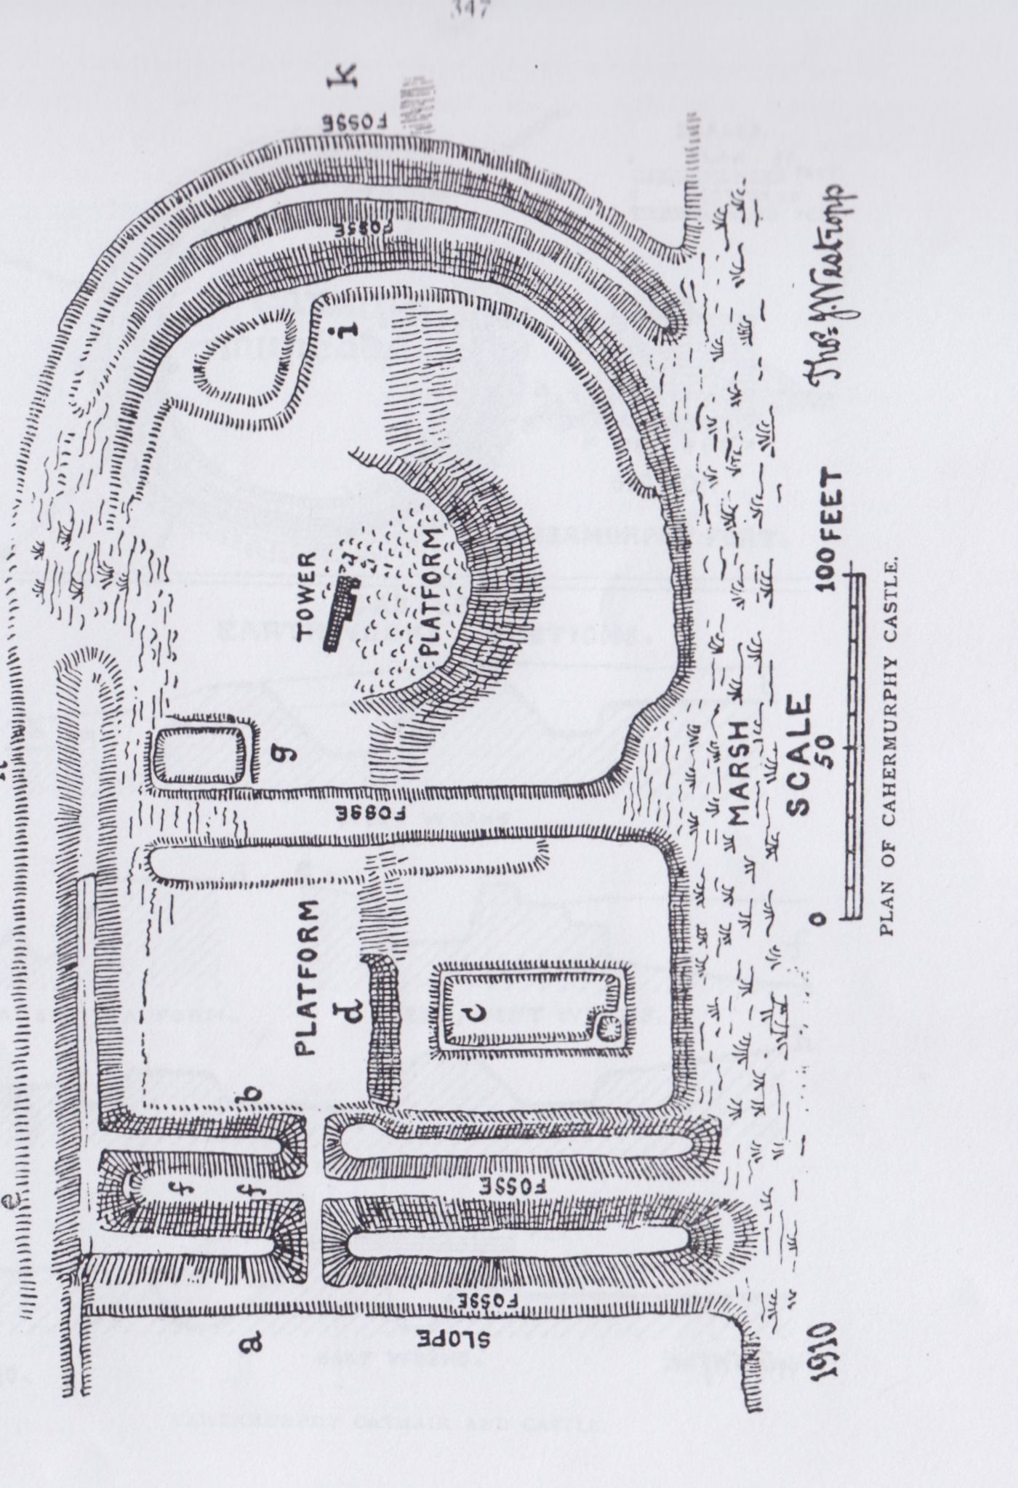

348

held by the chief Murchad after 1172, “Cahermorrughu de Cahermore” being the “large stone fort’’ on the edge of the Doolough tableland not far to the north, Monemore being evidently “the great marsh.” Had the fortification been made a few hundred feet to the north, it could have overlooked the valley, stood on a dry site, and been a place of some commanding strength. It could have equally well kept in touch with the lake by lines of ditch and mound, more defensible, if slighter, than the present works. These advantages were all sacrificed, perhaps for shelter. A site less commanding, more wet and more easily open to being “rushed” by an enemy were hard to find at any fort or castle in Co. Clare. It lies about 7 miles from the sea, not far north from the village and church of Kilmihil, on a little stream which (under the names of the Creegh River and, farther down, of the “Skivileen”) flows into the Atlantic at Rayoganagh near Dunbeg.

The fort makers dug unusually strong earthworks to either end of a steep wet slope. They joined these by a far weaker mound and fosse, so overhung that the court can be overlooked from close beside the ditch. An enemy crossing the ridge, even by daylight, could have assailed and probably scaled the defences a few minutes after the occupants had seen the foe on the sky line. The capture of the weak north-west corner must have put the two lines of really strong works on the western face into the hands of the enemy, and still further the great ramparts were then nearly useless, for they were joined at their upper end by a mound eminently suited for the enemy’s purposes.

The enclosure was a long oblong, with a rounded east end, and was terraced up into a west court of two platforms, divided by a fosse from a D-shaped east court, in which, on a rounded bastion-like terrace, stood the little turret. The western mounds are parallel running down the slope for about 170ft. N.N.E. and S.S.W., with a fosse outside and one between them. They slope about 1 in 2, and are respectively—the outer, 24ft. thick below and 6ft. thick on top, and 11ft. over the outer and 9ft. over the bottom of the inner fosse; the inner, 26ft. to 18ft. thick and the same height. The outer fosse is 10ft. wide and 4ft. to 5ft. deep; the inner 6ft. to 8ft. wide. The inner mound had evidently a

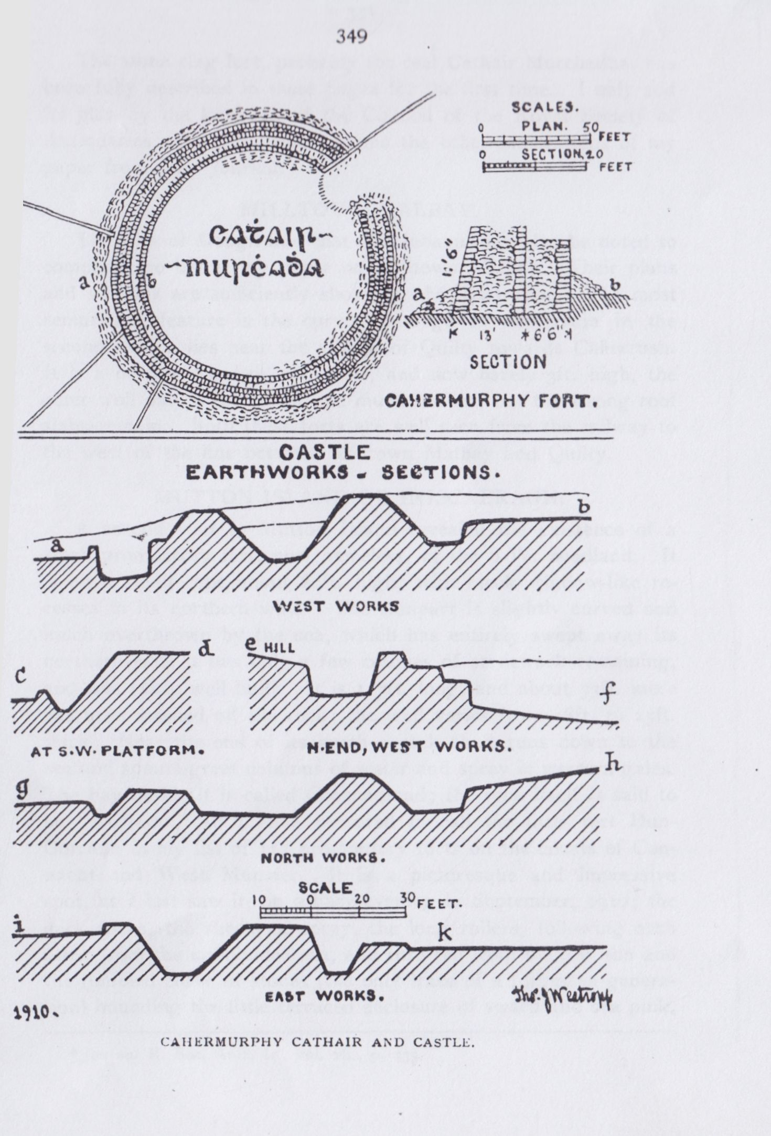

350

breastwork, and rises a couple of feet above the outer mound. The entrance through these is probably late, and lies 50ft. from the north end; a small drain is cut deeply inside for the southern reach. The cross rampart runs nearly due east from the north end of the outer mound; its fosse is 5ft. deep and 12ft. wide; the mound barely rises above the field, and is nearly levelled along the east courtyard. The part between the west mounds is terraced inside. At 72ft. from the west mound a wet fosse runs down the slope; small streams usually flow down all the fosses, and the upper east court is a swamp in wet seasons, even in summer. The fosse is about 25ft. wide.

The western court is in two terraces, the upper a square of 63ft, the lower 12ft. below the terrace, 69ft. wide, 84ft. N. and S., with the foundation of a hall 57ft. by 24ft., with a garderobe drain at its S.W. corner.

The east court is fenced at its outer end by similar works (in size and depth) to those of the west side, but, unlike them, semicircular, giving the main plan its shield-shaped outline. They seem to have been cut down, rising little higher than the field, 6ft. or 8ft. over their fosses; the banks are steep, 1 in 1, sometimes 1 in 2, and are covered with sallows, willows and furze. The east court is 114ft. E. and W. by 159ft. wide, but is irregular and in two terraces. There are house foundations at the N.W. angle and to the N.E. at the curve. In the centre, on a semi-circular bastion on the terrace edge, is the north wall of the tower, a fragment 23ft. long by 5ft. 3m. thick. Even between my visits in 1903 and 1908 the upper part with the window head has fallen. Traces of the porter’s lodge and of an ambry remain. The stairs were to the S.W., the basement was vaulted, and there were two storeys with floors above it.

The whole earthwork measures east and west 346ft over all, 290ft. inside, and 214ft. N. and S., at the west end, 219ft. in the middle, and 186ft. at the tower. The foot of the slope was terraced up some 5ft. or 6ft. over the marsh, but seems to have been unwalled at that side.

On the hill top to the N.W. is a small earthen ring, 4.5ft. inside the mounds, 8ft. to 10ft. thick, and over 5ft. high, with many traces of stone revetment.

351

The stone ring fort, probably the real Cathair Murchadha, has been fully described in these pages for the first time. I only add its plan by the kindness of the Council of the Royal Society of Antiquaries, who also have lent me the other illustrations of my paper from their Journal.

MILLTOWN MALBAY.

The Liss of Dough and that of Rinbaun may also be noted to complete the better my paper on Milltown Malbay. Their plans and sections are sufficiently shown in the illustration. The most remarkable feature is the curved passage or souterrain in the second, which lies near the village of Quilty towards Caherrush. It is a narrow passage, 2ft. wide, and now barely 3ft. high, the outer wall only a foot thick and much broken, but the strong roof slabs remain. Both these forts are well seen from the railway to the west of the line between Milltown Malbay and Quilty.

MUTTON ISLAND OR INISCAERAGH.

A second visit to Mutton Island revealed the existence of a small promontory fort, now nameless, at the S.W. headland. It is on a small cape about 60ft. high, with black window-like recesses in its northern wall.8 The rampart is slightly curved and much overthrown by the sea, which has entirely swept away its northern end; it has only a few courses of stonework remaining, and was fairly well built. It is 117ft. long, and about 33ft. more has been washed off the rock; the wall varies from 18ft. to 25ft. thick. Near the end of its garth a rock shaft runs down to the sea and spouts great columns of water and spray in western gales. The bay beside it is called Coosnadread; the rock itself is said to be “Gorraun,” so I have ventured to call the little fort Dun- Gorraun in my list of 112 promontory forts on the coasts of Connacht and West Munster. It is a picturesque and impressive spot, as I last saw it, on a hazy evening in September, 1910; the dark rocks, the sheets of spray, the long rollers, following each other from the unbounded sea, and rose red from the low sun and the tumbled curve of stones (the only trace of a forgotten generation) bounding the little terraced enclosure of sward and sea pink,

8 Journal R. Soc. Antt. Ir., vol. xli., p. 135.

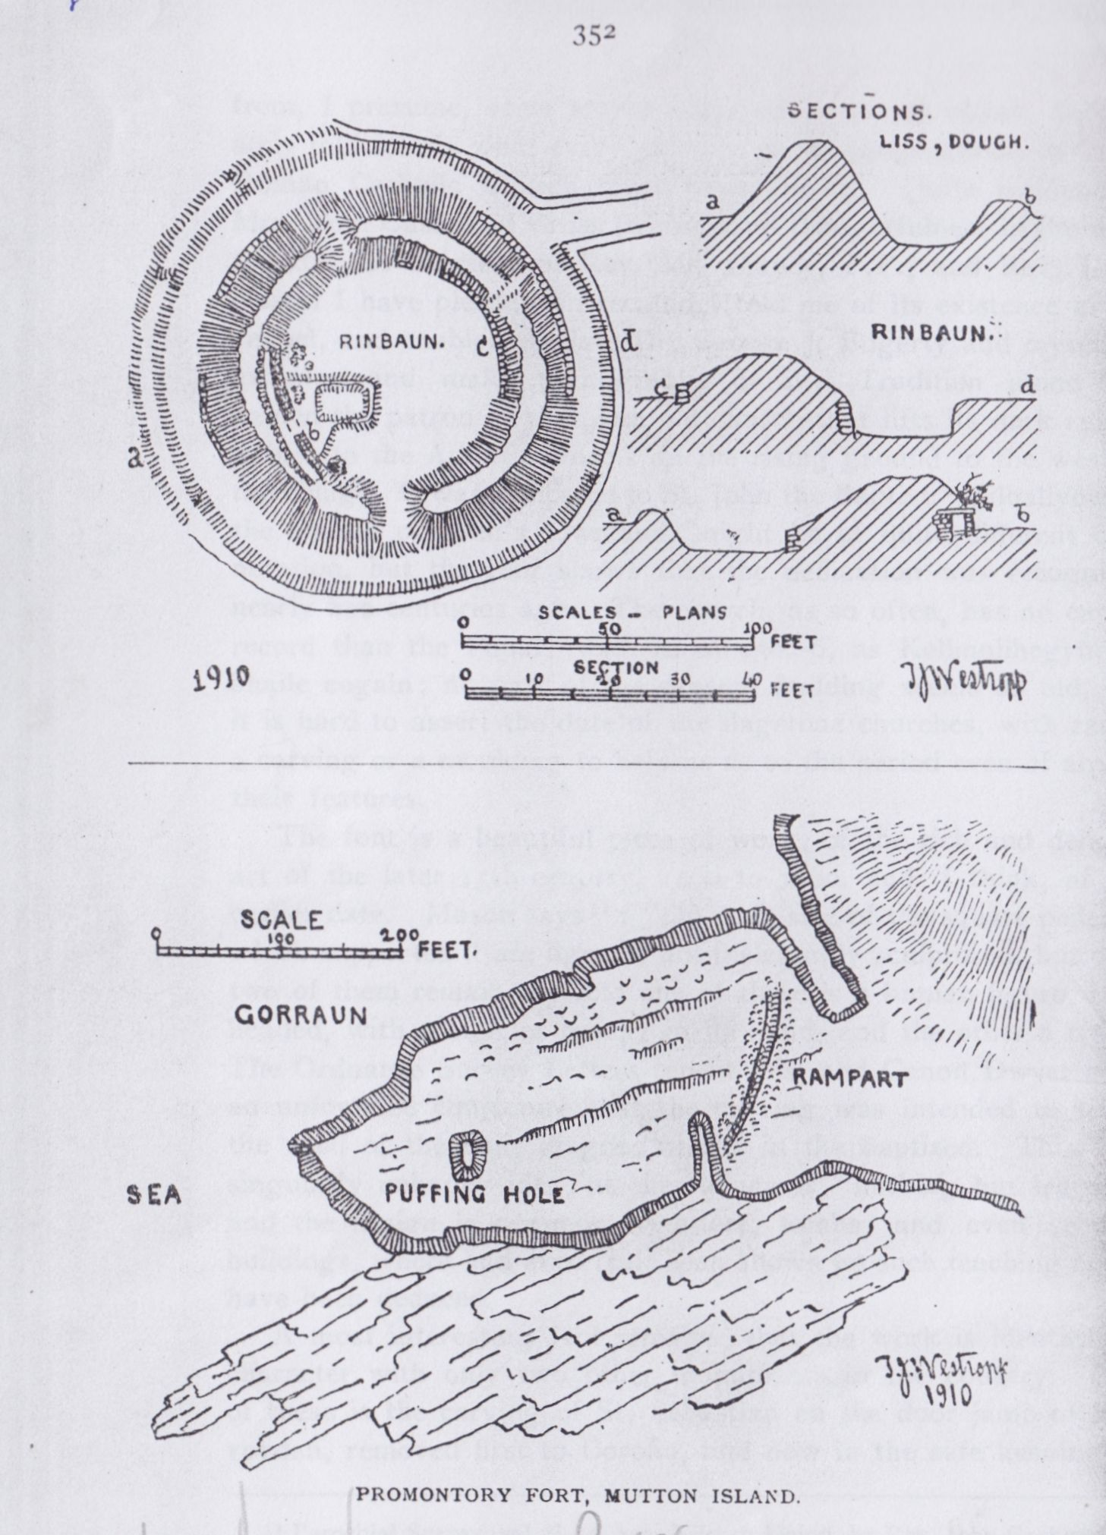

353

“where the waste land’s end leans westward” at the ancient Inis Fitae. The fact that the island was cut into three some time between 799 and 8049 by a tidal wave probably implies that the fort in its present form is later. The other fragments are Inismatail and Roanshee rock. Iniskerech and Inismatail are named in the grant of Donchad Cairbrech O’Brien, King of Thomond, to the Archbishop of Cashel, confirmed by the Irish Government of King John in 1215.10

The “cross” at St. Senan’s altar or station on this island has been broken (probably by the heat of a tar barrel lit on the “leacht”) since my visit in August, 1887.

LISLARD AND THE MOTE, CRAGGICORRIDAN (L.F.C., vol. iii., p. 50.)—The place is called Cracc I Corradain in the 1390 rental. These are fully described in Journal R.S.A.I., vol xiv., pp. 55-56, with plans and sections. The mote has an outer ring in parts 5ft. high, but much levelled to the north. It is about 84ft. across over all, and 12ft. to 18ft. thick. The fosse is about 5ft. deep and 9ft. wide below. There is a terrace-like ledge to either side, from the inner of which rises the “mote” about 12ft. high and the same, on top. Lislard has an outer ring 88ft. over all, a fosse, and a central platform, on which is a small low mound, 18ft. across and 3ft. high. Both are possibly sepulchral.

BALLYGANNER (N.M.A.S., vol. i., p. 16).—A closing section on the antiquities of this remarkable site is being published, R.S.A.I., vol. xv.

CROSS. THE KILBALLYOWEN FONT {Ibid., vol. ii., p. 115.)

On several occasions, from 1896 on, I made inquiries in and about Cross as to the carved font, noted by Graham (in his contribution to Mason’s Parochial Survey, vol. II., p. 431) in 1816, as lying in Kiimacduan Church. I was always told that no such object was known. All my “informants” were old men, and I regret to say that they, and they alone (of countless persons all round Ireland)

9 A.F.M. 799, An. Ult. 803, Chron. Scotor. 804, and Irish “Nennius,” p. 207.

10 Cal. Doc. Ir. 25, vol. ii.

354

from, I presume, some stupid suspicion as to my object, deliberately told falsely what every member of the congregation in Cross Roman Catholic Church must have known. Quite incidentally Mrs. Tom Cusack of Cross (whose kind thoughtfulness in the matter and the courtesy of Rev. Mr. Clancy, P.P., and Rev. J. A. Austin I have pleasure in recalling) told me of its existence in the chapel, and enabled the late Dr. George J. Fogerty and myself to examine and make photographs of it. Tradition alone has named the patron of the plain old church that lifts its dark ruined gables to the Atlantic storms on the rising ground to the west of the village. It was dedicated to St. John the Baptist. Kilballyowen, the church of John’s townland, might be of quite different connotation, but the font shows that the dedication was recognised nearly five centuries ago. The church, as so often, has no earlier record than the Papal Taxation of 1302-6, as Kellmolihegyn, cil bhaile eogain; no part of the present building seems so old, but it is hard to assert the date of the flagstone churches, with rarely a carving or a moulding to help us as to the period even of any of their features.

The font is a beautiful piece of work, of the rich and delicate art of the later 15th century, 1460 to 1480, and, I think, of the earlier date. Mason says11: “On each side of the square pedestal which supported it are figures, not inelegantly sculptured, but only two of them remain perfect; one of these is a human figure, bare headed, with a staff or crozier in its hand, and the other a tree.’’ The Ordnance Survey Letters repeat this, and Canon Dwyer adds an unfounded conjecture that the carving was intended to teach the need of the fruit of good works in the baptized. This is a singularly unhappy idea, as the foliage is “nothing but leaves,’’ and the design is common on altars, tombs, and even secular buildings, where had even fruit been shown no such teaching could have been deduced.

A most interesting fact remains, that the work is identical in character with only two other monuments in the country. One of these is the carving of St. Sebastian on the door jamb of Kilvoydan, removed first to Corofin, and now in the safe keeping of

11 Parochial Survey, vol. ii., p. 432, Iiilrush Union, by Rev. John Graham.

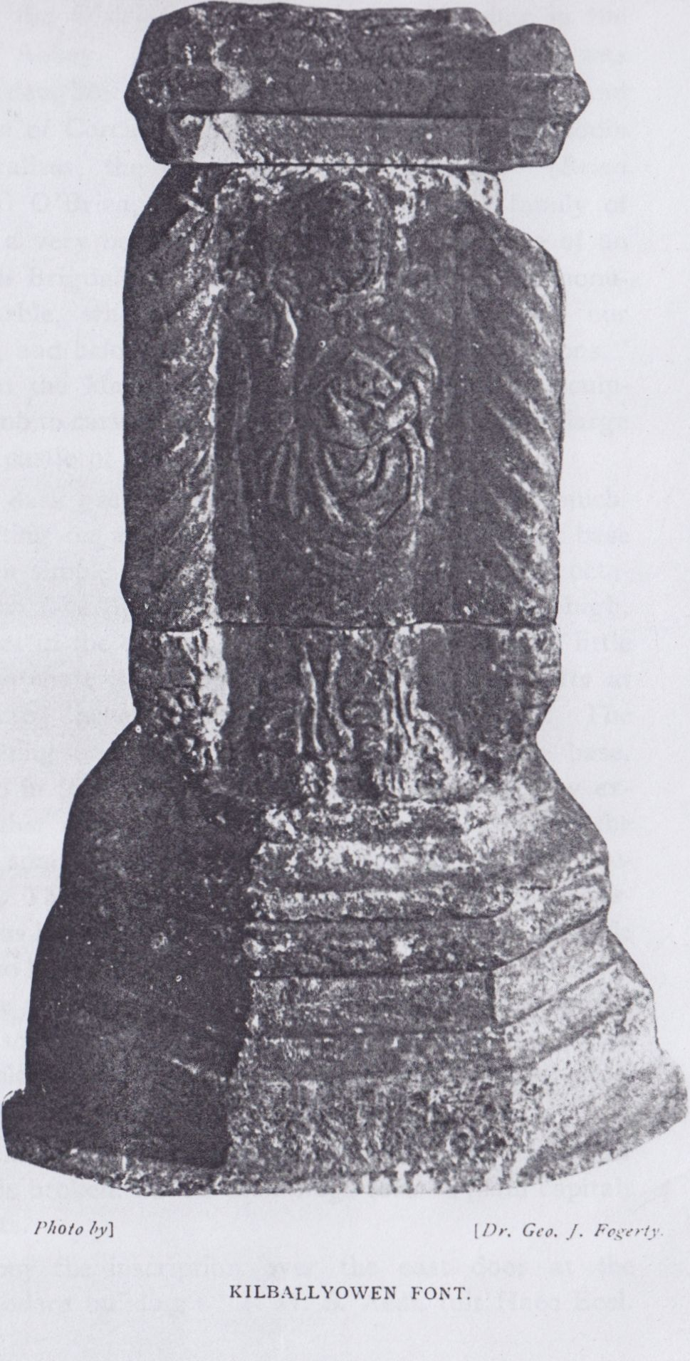

355

Dr. George U. Macnamara at Bankyle. The other is the once beautiful tomb of the O’Briens to the right of the altar in the chancel of Ennis “Abbey.” This last concerns us closely; it was built by Morina, daughter of O’Brien, King of Thomond, and wife of MacMahon of Corcavaskin. As Father Anthony Bruodin (ante 1643) generalizes, the descendants of “Bernard” (Brian catha an Aonaigh) O’Brien, along with the illustrious family of MacMahon, have a very beautiful tomb, built in the shape of an altar, or, as Hugh Brigdall records, in 1695, “the ancient monument of grey marble, whereon is engraved the story of our Saviour’s passion, and belongs to the family of the MacMahons.” It is probable that the MacMahons employed the cunning sculptor of the royal tomb to carve the font which they placed in the large church near their castle of Carrigaholt, about 1460.

The font is of dark grey marble, and consists of a now much- broken basin, resting on a hollow shaft and a base. (The base is well designed in simple moulding, and, like the shaft, is octagonal in plan, each face 8 ½ inches long. It is about 15m. high, being, however, set in the concrete floor, though I think but little is concealed. The shaft is square, with spirally fluted shafts at the angles; it is 10 ½ inches square and about 19in. high. The spiral flutings resting on small foliaged corbels above the base. The chief panel is in fair preservation, considering that it lay exposed to the weather and all wanton and accidental injury in the roofless ruin for some three centuries. It represents the forerunner of our Lord. The Baptist has long hair, short beard and moustache, and a curious lily-headed staff, bearing in his left hand a little lamb, in allusion to his famous saying, “Behold the Lamb of God.’’ He wears, not the rude furry tunic which represented the camel’s hair garment on so many carvings and seals, but a many-pleated robe and cloak held by a sexfoil-rose brooch. The opposite panel has a more defaced figure, which I cannot identify.

The side panels are of rich leaf work designs. All the upper part of the basin is broken, but its mouldings formed plain capitals to the spiral shafts.

I will only copy1 the inscription over the east door at the Sacristy of the modern building: “I. H. S. Aedi. fuit Haec Eccl.

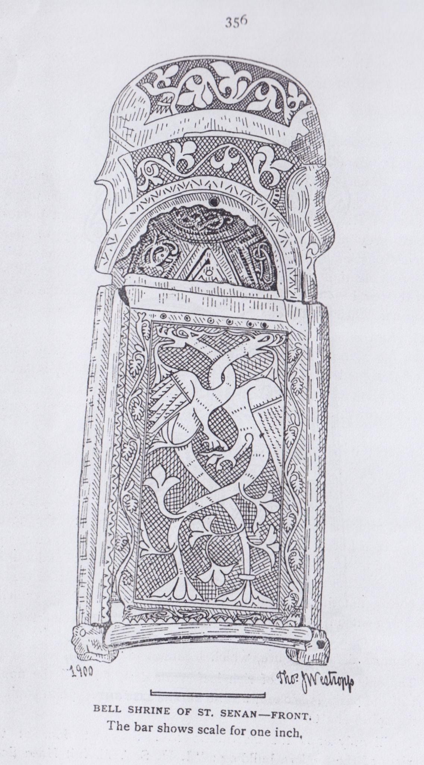

357

Imp. Par / A.D. 1806 R. C. O. Gorman, P.P., Haec porta Domini Justi intrabunt in eam Ps. 117, v. 20.”

ST. SENAN’S BELL SHRINE.

I must not close this paper without very briefly noting the remarkable relic, which tradition associates with the Apostle of Corcavaskin. It is in the possession of Mr. Marcus Keane of Beechpark and Dundahlin. As I described it very fully in the Journal of the Royal Society of Antiquaries on the occasion of their visit to Lisdoonvarna in July, 1900.12  I will only note it briefly for the completion of this paper owing to its close connection with S.W. Co. Clare.

It will be remembered that the Life of St. Senan (13th or 14th century) tells how a bell descended from Heaven, ringing loudly, and reached St. Senan at a place marked by the mound, or altar, on the ridge beside Kiltinnaun. The tongue then flew away. It was called Clog na neal (the bell of the clouds) and Clog an oir, probably from former gold ornaments of its shrine. It was, of course, most reverentially preserved by the comharbs of St. Senan. The last recognized lay comharb was Calvagh, son of Siacus O’Cahan, or O’Keane, who died in 1581; he had the courage to oppose the assumption of the “converbship” by Donald O’Brien, who was supported by the Elizabethan Government; the latter, howeverj did not care to cause discontent in the district. Nicholas O’Cahane was “Coroner” of Co. Clare at the time of the destruction of the Spanish Armada, in 1588. Charles Cahane held Lisdeen near Kilkee and Teige Cahane held Ballyowen, in 1641. Even after all the confiscations of the Commonwealth, Brian Cahane, in 1690, was “one of the chief gentry and ablest persons” near Kilrush. The bell shrine was in the keeping of the direct line of the family till 1730, when it passed by marriage to Robert Cahane of Ballyvoe, said to derive from the Ulster O’Cahans. In this line it descended to its present owner, Mr. Marcus Keane of Beechpark and Dundahlin.

It was first exhibited to scholars in 1826 at a meeting of the Society of Antiquaries in London.13 It and another relic, a bronzed iron bell, found (it is said at Scattery) by Mr. J. Cooke, were ex-

1. Journal, vol. xxx., p. 237.
2. Archaeologia, vol. xxi., p. 559.

1

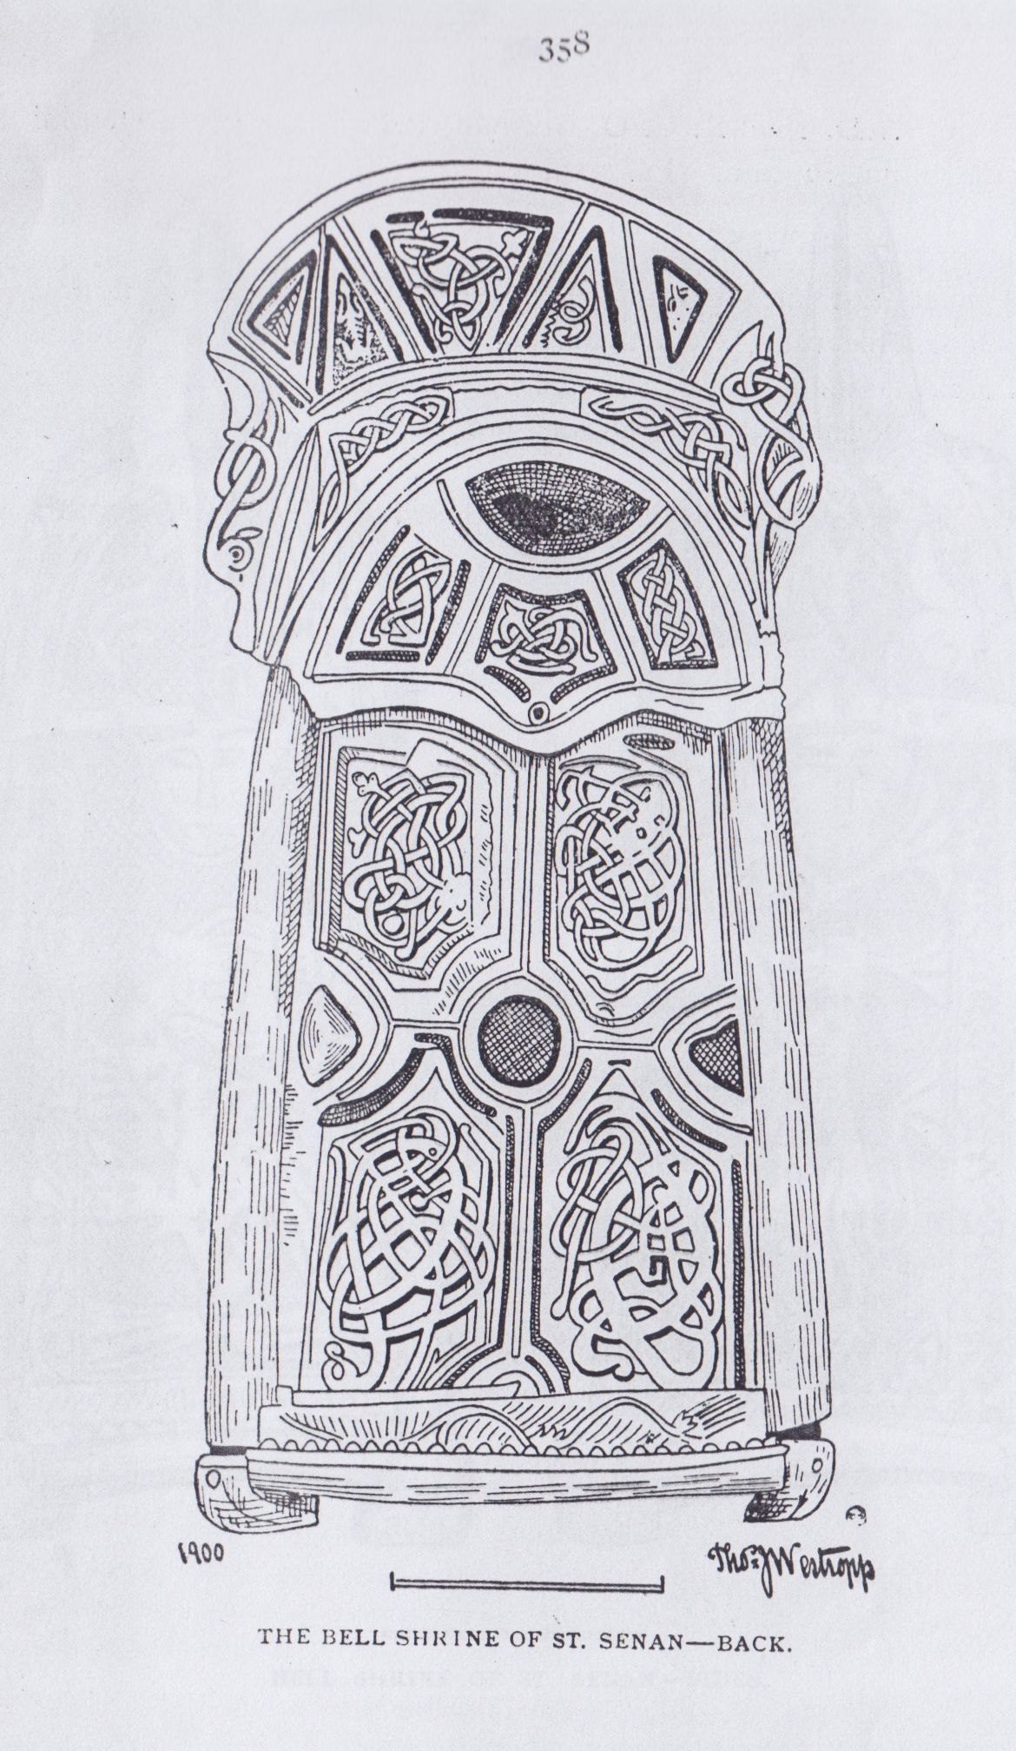

359

hibited by the latter and Mr. Francis Keane in Dublin, 1853; the latter bell was sold to the British Museum; I cannot learn whether it fitted the shrine or not. Mr. Keane lent the shrine to the Royal Irish Academy in 1864, and it remained for some years in their museum.14

Canon Dwyer gives an elaborate description, but, strange to say, from the lithographs rather than from the bell, which he must have had every opportunity of studying through his friendship with the late Mr. Marcus Keane, author of “Towers and Temples.” He makes some quaint mistakes; supposes the crowned monster to be dying; the dragons to be waltzing, and the “rampant leopard” to be springing at the neck of a man, who (or rather whose head) really forms no part of the “leopard” panel, being part of the older work. He attaches a symbolic meaning, “Sin militant, but Grace triumphant,” based on these imaginary devices.

The older shrine, popularly supposed to be the bell, is a strong case of bronze, more like a book shrine; the faces are beaten out from the inside to form a cross and four panels. A thin silver band is fused into the main lines of the pattern. The jewel once set in the centre is gone. The D-shaped sockets at the ends of the arms were set with green glass; one bit remains. There is no trace of gold work. The panels are filled with curious and quaint interlacings of serpents of unusual irregularity, and I think not older than the 11th century; there are no traces of the trumpet pattern, and the serpents are like those on the late 11th century doorway of Killaloe Cathedral and other buildings and crosses. The whole pattern, indeed, is rather crude and uncouth. The whole is enshrined in a case of thin silver plates, the pattern lined out with black enamel on the end panels. Enamel also occurs in the early work on the crown of the shrine; one of the side plates is lost; the other has the two-winged

14 Those wishing to pursue the subject are referred to the Life of Si. Senan (attributed to St. Odran, his successor, but far later in its present form), chapter v.; Mason’s Parochial Survey, 1816, vol. ii., p. 440; Archicologia, vol. xxi., 1826, p. 559; Archaeological Journal, vol. v., 1853, p. 331; Bells of the Church, Rev. H. T. Ellacombe, 1872; Diocese of Killaloe, Rev. Canon P. Dwyer, 1878, p. 538; History and Topography of Co. Clare, James Frost, 1893, p. 82 ; Journal R.S.A.I., 1897, vol. xxvii., p. 280, and 1890, vol. xxx., p. 237. The fine lithographs marked “Trans. R.I.A., vol.—Antiquities Plate” were never published. Despite their artistic character, the artist has idealized the patterns in the unscientific spirit of the period half a century ago.

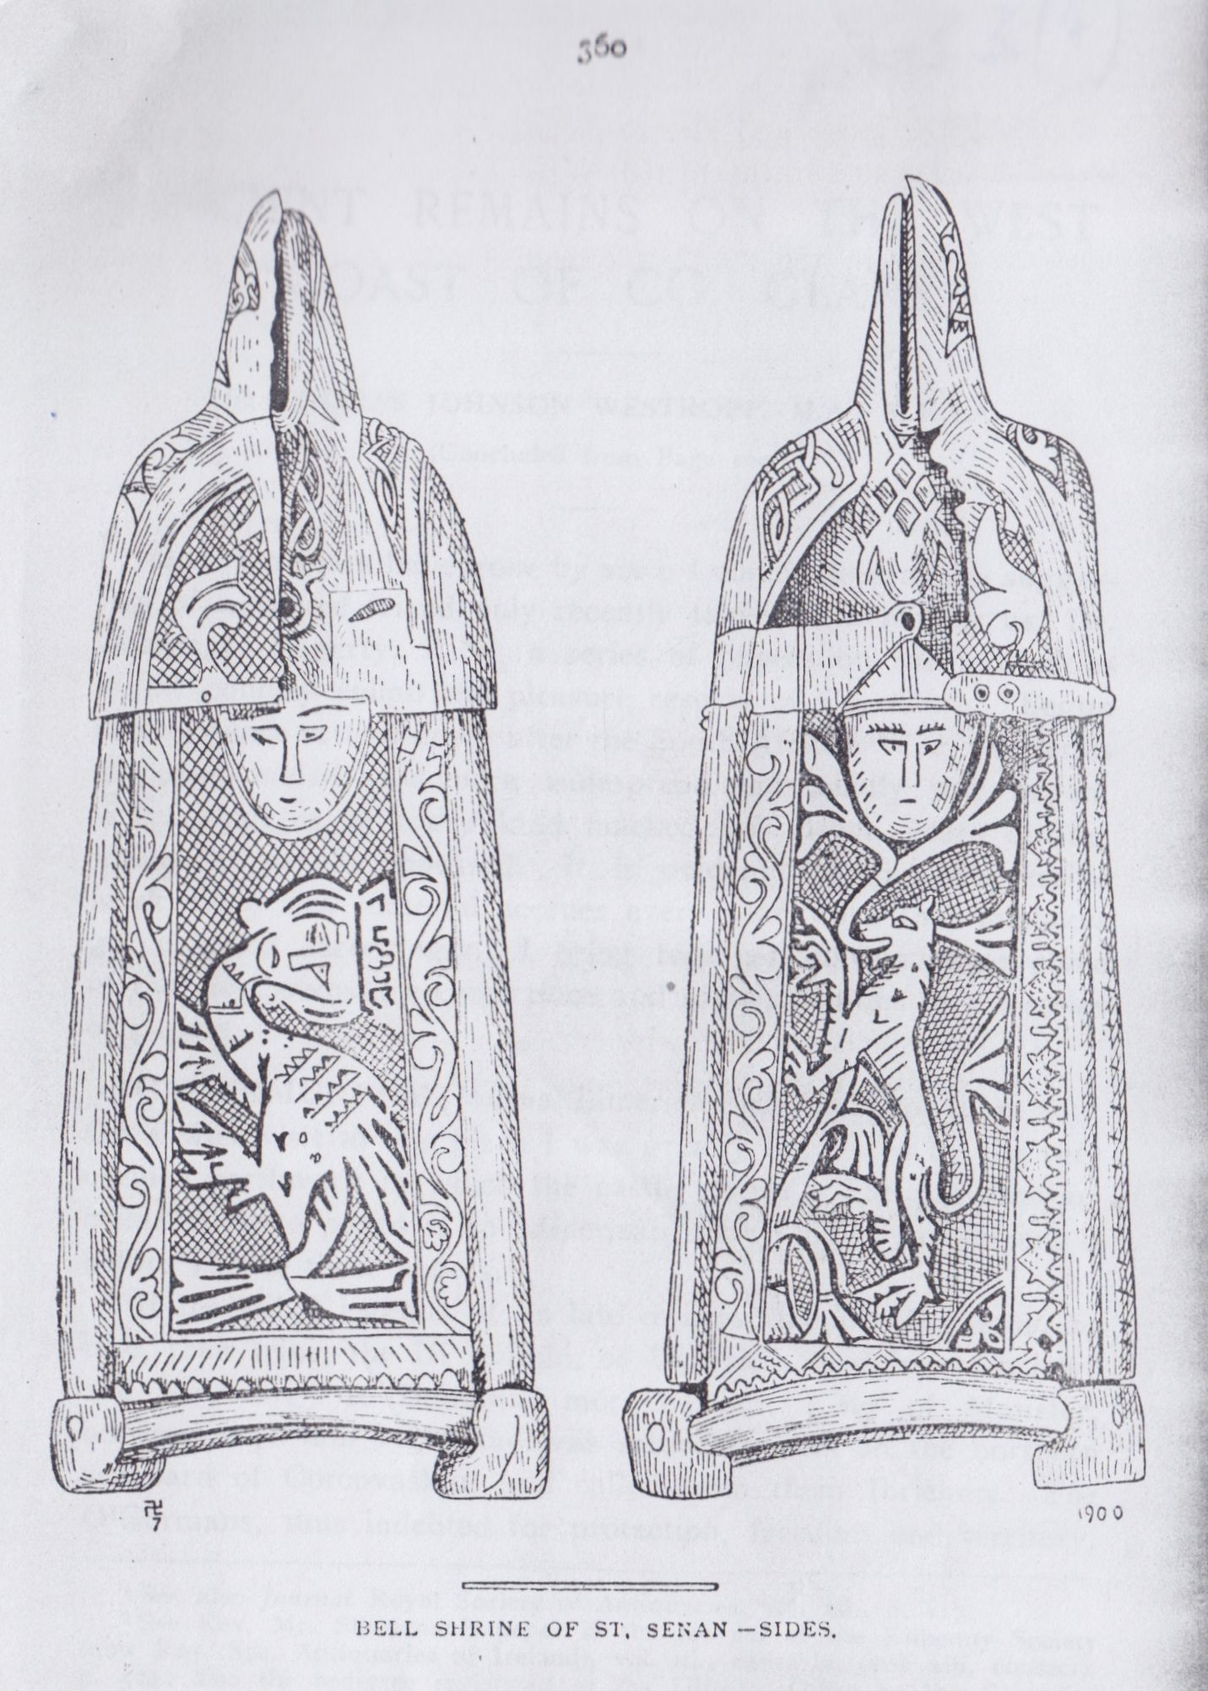

361

dragons; the left has the “collapsed” (really crawling) crowned monster, and the right end panel the leopard.

Space fails me to tell all the legends which the awe of the peasantry attached to the shrine. About 1834 a farmer was robbed of £20 in notes, and applied for the bell, on which suspected persons were often sworn. It was brought to his house with much ceremony to be used after the Mass on Sunday, but on the Saturday night the family were aroused by a crash, and found the window broken, and (on getting a light) the notes and even the string which tied them lying on the floor.

Once a gentleman in Co. Galway sent his servant to borrow it; the latter, who was guilty of the crime his master wanted to detect, got the bell, but flung it into the sea. On his arrival, after his long journey, he said the O’Cahanes would not lend it. “You are a liar, ’’ said his master; “for there it is on the table before you. ’’ The culprit, horror-stricken, at once confessed his crime. It was last used in 1834, and was believed to avenge a false oath by striking with convulsions and death, or at least by twisting and disfiguring the culprit’s face. Many other stories were once told about its power, but the two given sufficiently characterize the majority, for few persons dared the fatal power of the “golden bell” of St. Senan of Iniscatha.

I close with regret this series of papers, bound up as they are in my memory with many happy recollections. I had hoped to have included papers on Kilrush and Scattery, and on Ballyvaughan and Corcomroe, and should the Society pass successfully through the critical time on which it appears to have entered, perhaps some other writer may take up and complete these remaining places on the coast. At least I may hope that these notes have interested many, even of those well acquainted with the subjects of my papers, and perhaps may have led others previously ignorant of their existence to the many objects of ancient interest round the pleasure spots of the Atlantic coast that focus of beauty.

“Above, free winds and fiery clouds ranging at their will— brightness out of the north and balm from the south, and the stars of the evening and morning clear in the limitless light of arched heaven and circling sea.”