GÓILÍN -- IN THE BEGINNING . . .
This is based mostly on 40 year-old memories, so apologies for any lapses in accuracy.
In the late 1970s I was spending a lot of time in Club Conradh na Gaeilge, on Harcourt St – so much so that I was recruited to serve on the committee – as cisteoir, I think, in 1979. As is not unusual in social clubs of the type, the committee spent much time thinking up ways to encourage greater use of the club facilities and with that in mind Pádraig Ua Maoileóin (Dún Chaoin) and I were delegated to develop a regular event, from the occasional singing sessions that were happening spontaneously, in the Club. Tim Dennehy was also a regular in the Club at the time and he agreed to help with our efforts. After some discussion, however, we had to conclude that the Club rule prohibiting songs as béarla would be a serious hindrance which would leave us seeking for minorities within minorities and so, unlikely to succeed. Tim and I agreed that such a project could only work in an environment that permitted songs in English and sadly, that if it was to go ahead it would have to be at a different venue. Pádraig (who, like Tim, was a good singer) was not interested in alternative venues.
During the 1970s Folk Clubs had gained huge popularity in Dublin, as in the rest of the country, but they were mostly fairly formal venues, run for profit of performers and organisers, whereas the best sessions in the Club had always been impromptu, with the singers organising themselves. Of the other folk clubs, Slatterys in Capel Street was probably the best known and best attended with singing on Wednesday nights. If I remember rightly, the Bonnán Buí, an all Irish singing club in a hotel on Merrion Square (Majestic?) had ceased after a short run – maybe the hotel closed down?. Phil & Dot Callery were running a regular, successful singing session in the Neptune Rowing Club, but Chapelizod was quite far from our beaten path, and we felt a need to be closer to the city centre. Other clubs that come to mind are: The Coffee Kitchen, Molesworth St.; Universal Folk Club; Tailors Hall; Comhaltas sessions in Monkstown; The Four Star Hotel, Amiens Street (CCE); Leinster Cricket club in Ranelagh, and of course, Donoghues (post Paddy and Maureen!) and The Meeting Place.
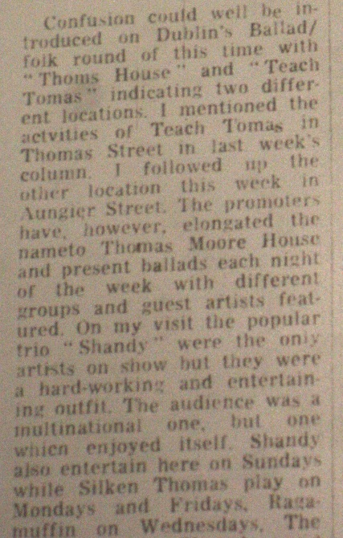
According to Gerard O Grady, in The Evening Press, April 20, 1979 “Thomas House, Thomas St., Dublin is now a weekly Friday night folk house” -- but that wasn’t us! We had agreed to start in the Pembroke Inn, on Pembroke Street, in the Bonnán Buí slot, -- Sunday Night -- in March 1979.

A lot of pints were consumed in the effort of finding a suitable name for ‘our’ club. My wife, Treasa, asked me once how I would respond if her mother, my mother-in-law, were to ask me ‘An bhfuil tú go maith ag góilín?’ This was an expression particular to Conamara and of course I wouldn’t have known, and when Treasa explained, I knew we had a name! In this context Góilín is a contraction of Gabháil Fhoinn, singing, lit. giving an air, but the word also means, according to Dinneen:
Góilín. See Gaibhlín
Goilín. g. id. pl.-í, m., a pit or pool, a swimming pool; a gulet or gully; a small rocky inlet; (Cm); ….
and for Gaibhlín
Gaibhlín. g. id.pl., -í, m., a small fork or groin; a strait or inlet; a stream between banks of sand at ebb; Cois an Gh., a place near Cahersiveen; oft gabhailín, pron. góilín; dim. of Gabhal.
Curious readers who choose to look up Gabhal in Dinneen, will find that the name would be apt for a night-club of a different sort.
I have heard the word used in Clare English to mean the vulva of a sow pig! Not quite what we had in mind in 1979.
Perhaps I could remark that the name we adopted was without the definite article, either in Irish or English – I notice a bit of change in that respect.
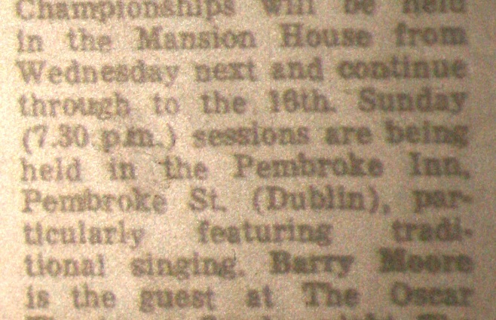
Publicity for a nascent folk club at that time was not easy. Obviously we had no funds for proper advertising so we depended mostly on word-of-mouth. Our initial (photocopied) A5 hand-bill was quickly replaced with a small ‘calling card’ which we hoped expressed our philosophy and could easily be passed around. The wording on the initial card, included: “Admission is free and performers are paid only the compliment of being listened to.” We visited the other clubs of the time and distributed the cards as best we could. I remember giving out lots of cards at the Willie Clancy Week, that year, and before I returned to Dublin, Marty O Malley gave me one of the cards and suggested that I should go there!
The only other free advertising forum was Gerry O Grady’s ‘Folk Scene’ column every Friday in the Evening Press. Here we were competing for space with people like The Chieftains, Stocktons Wing, etc. and it was not easy to get a look in -- our first mention (6th April) was brief and the second (13th April) was, to announce that we were closed for Easter Sunday!

St Patrick’s Day fell on a Saturday. So having our opening on the Sunday of a Bank Holiday weekend would have been quite satisfactory. There was a fellow from Donegal who used visit Club a’ Chonradh and sang with own guitar accompaniment.[edit – Art O Duffaigh ?] He and Tim were the main performers on that first night. The total attendance was about eight, with the beautiful Folan sisters contributing substantially as patient listeners both on the opening night and for the rest of that season! A few others did stick their heads in the door to see what was going on, but didn’t get involved.
The room in the Pembroke was in the basement, dark and quiet, almost sedate, with the bar upstairs. It didn’t have much character but it was very suitable for our purpose. The management didn’t bother us much.
There were some very good sessions over the next three months as the club slowly found its feet. Among the early singers to attend were Jem Kelly, who was, I think the sole Irish source for the song Lord Abore; Nuala Harris and Philip Price; Paul Mac Donnell; Liam Weldon; Brendan Phelan; Mick Kenny and many others whose names I can’t now remember.
The emphasis was, of course on singing but musicians called regularly, as well – Eamon McGivney, in particularly comes to mind – he was an accordion player at that time.
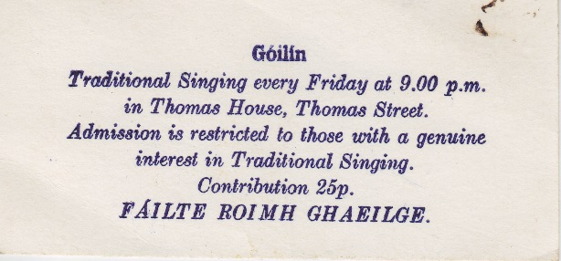
As we would both be travelling during the summer, we decided to close for July and August but we were sufficiently assured after the first short season to be agreed on re-opening in September.
The Pembroke was not available, as a venue, when we came to re-start in September and so we spent an enjoyable night visiting known available venues, looking for a replacement. The upstairs lounge in Thomas House was selected and we changed to a Thursday night and introduced a small cover charge.
At Christmas, we had our first Christmas Party on a Saturday morning in the downstairs bar in Thomas House, a very liquid, but thoroughly enjoyable event, where Luke Cheevers, by then a stalward of Góilín issued a scrolled invitation to all to attend Miss Mouse’s Ball -- it was written, in admirable script, on the equivalent of a postage stamp.
Our first away match was when a small group from Góilín attended the singing festival in Downpatrick in 1980. A truly memorable event for the singing but also because a few of us got on very well with the hotel keeper who also had a role in catering for the local Orange Lodge. He offered to give three of us a tour of the Lodge, and we jumped at the chance to see this magnificently pompous chamber, with its luxurious trappings and portrait of King Billy. I haven’t been back to Downpatrick since, but I was told that the hotel burned down shortly after our visit!
I think it was at the start of the second season in September 1980 that we switched to Friday nights.
This was a very different sort of venue from Pembroke St. brighter and breezier – a busy bar downstairs, a lot of traffic noise, (and often cash register noise from a barman who did not like singing and preferred to keep his finger on the register repeat button!) and the Treacy family, proprietors, were very helpful, and even contributed an occasional song. Also it was not unknown for the downstair’s customers to come up and join us for a bar of a song. (One such was the only person I have heard singing ‘Drive on or Else the Corpse Will Smash Your Head’!)
The number of singers attending improved rapidly and many became ‘regulars’ – Luke, Barry, Antaine Ó Faracháin, Niochlás Ó Murchú, Róisín Gaffney, Eamon Travers, Liam Nolan, etc. It is thanks to these ‘new-comers’ and, of course, to Tim, that Góilín is thriving today after many venues and forty years.
We continued to pester Gerry O Grady for publicity in his Friday column and eventually he came to see for himself and on the 26th October ‘79 he wrote:

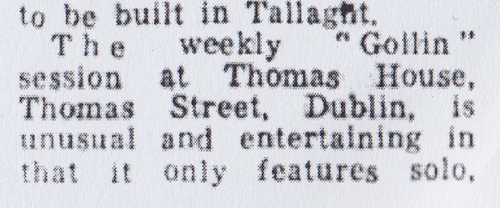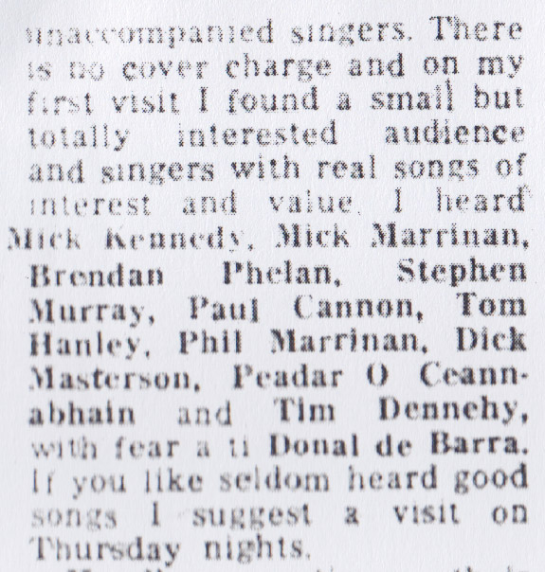
Finally, I should remark that although my name was used a lot by Gerry O Grady, who was never noted for accuracy, this may give a wrong impression as indeed Tim was the prime mover at the time.
Donal De Barra
February 2015 (amended March 2019).

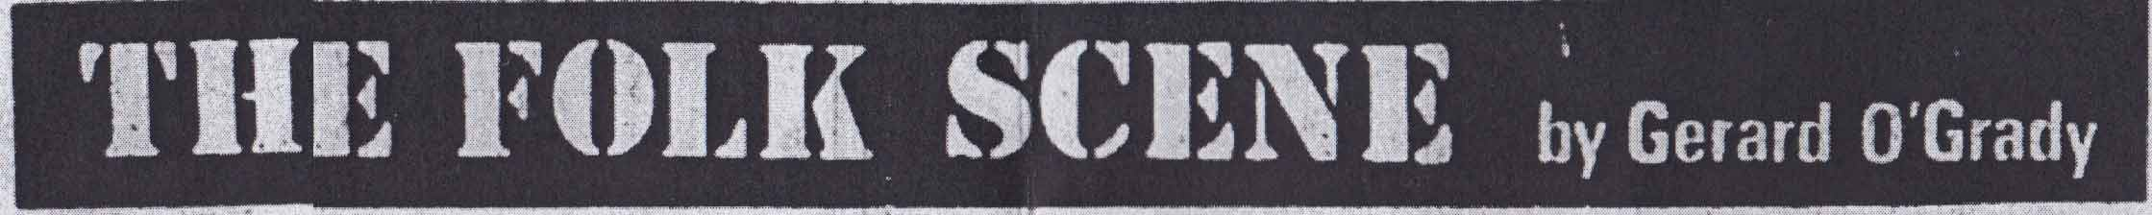
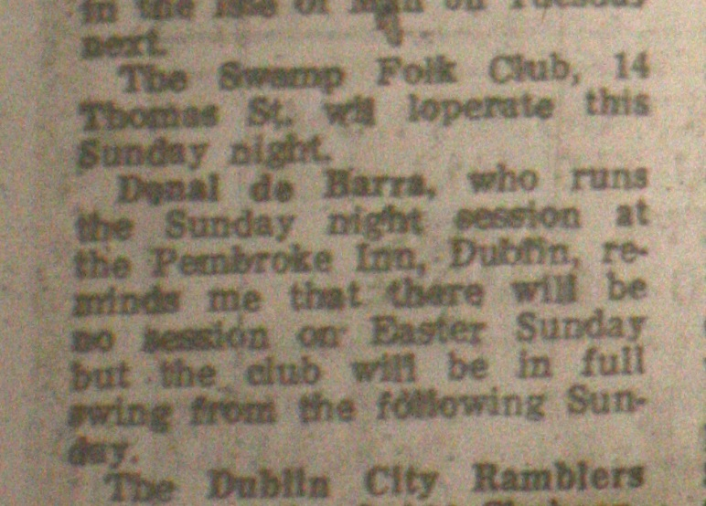
Evening Press April 13, 1979
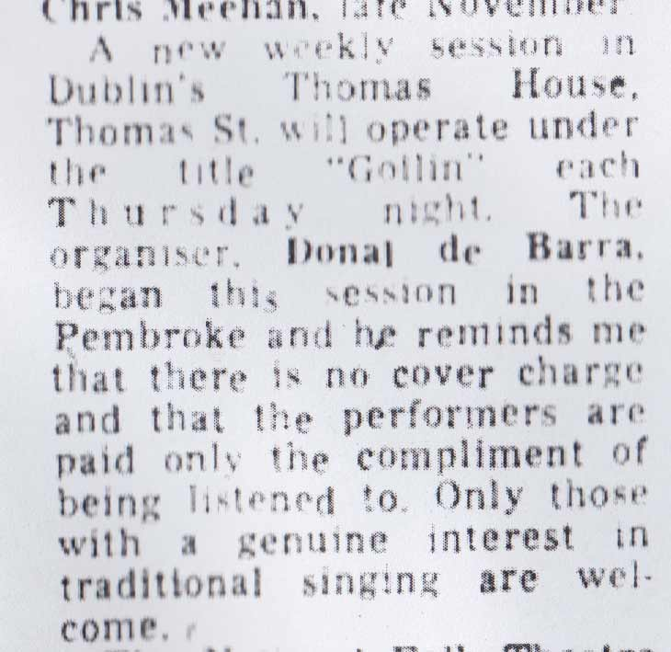
Evening Press, October 19, 1979

