Journal of the Royal Society of Antiquaries of Ireland  
Vol. 41, 1911

**CAHERMURPHY CASTLE AND ITS EARTHWORKS, WITH  
CERTAIN FORTS NEAR MILLTOWN-MALBAY,  
COUNTY CLARE**

**BY THOMAS JOHNSON WESTROPP, M.A.**

Corcavaskin  
MacGormans  
Cahermurphy Castle  
Cahermurphy Stone Fort  
Forts near Miltown Malbay Rinbaun  
 Caherrush Castle  
 Leagard South  
 Dough  
Fortified Headlands Freagh  
 Mutton Island

Summary of Fortified Headlands in Clare

Journal of the Royal Society of Antiquaries of Ireland  
Vol. 41, 1911

119

**CAHERMURPHY CASTLE AND ITS EARTHWORKS, WITH  
CERTAIN FORTS NEAR MILLTOWN-MALBAY,  
COUNTY CLARE**

**BY THOMAS JOHNSON WESTROPP, M.A.**

[Submitted 23 January 1911]

The unusual interest and abundance of the stone forts in the uplands of north-western Clare, of the lisses in the angle near the Shannon, and of the cliff forts might lead students to suppose that the hilly tracts between these rich districts contained another Burren or Moyarta. There is, however, no analogy, and save for one earthwork at Cahermurphy, so unusual as to call for careful description, one might be tempted to pass by the whole “hinterland” of south-western Clare, and leave its commonplace forts unnoted. It is, however, helpful to students to know that there is little to be seen despite the large number of its forts, nearly 240 being recorded,1 and that what remains, besides the Cahermurphy earthwork, is hardly of sufficient interest to call them out of their way to explore. I accordingly give, besides the chief subject of this paper, a few typical forts: a stone ring wall, a liss or two, a house-ring, and two fortified headlands—sufficient to show the character of the remains of Ibrickan and its border.

The district lay nearly outside the ken of early Irish writers—the all-accomplished Caeilte did not bring St. Patrick out of his way to visit or hear tales of the Corcavaskin. One legend alone in the Dind Shenchas2 is partly located on its frontier. This tells how Alestar, a contemporary of Queen Tailti, for a supposed slight on that lady, was compelled by her father, Eochu Garb, son of Dua, King of Erin, to make her a fort in Sengann’s heritage. The “third of Erin’s rath-builders” chose as its site a slope of Mount Callan (Sliab Colain) called Sliabh Leitrech, but, though the place was long called after him “Cluain Alestair,” the name and site are now lost. However, we see that the remote mythology of the region begins with the tribes of Sengann, and this is borne out by Ptolemy’s Atlas, giving the Ganganoi3 as dwelling at the mouth of the Senos, or Shannon, before the second century. The legend of an occupation of the present county Clare by the Ui Catbar and Ui Corra is very dim; still more so is that of the settlement of the Martini, who

1. The number, so far as I have recorded the forts, is—Kilfarboy, 42; Kilmurry, 73; Kilmacduan, 49; Kilmihil, 41; Killard, 34 forts ; but the last only in late times got assigned to the barony of Ibrickan.
2. Ed. Whitley Stokes, Revue Celtique, 1894, vol. xv, p. 317.

3. Gann, Genann, and Sengann.

118 ROYAL SOCIETY OF ANTIQUARIES OF IRELAND

fought a battle on the hills against Aengus Olmuchaidh, a prehistoric High King, somewhere in Corcavaskin (scholars confidently say at Moveen, near Kilkee1), but it is equally “probable” that its site was located in these hills) about “Anno Mundi 3790,” on “Sliabh Cailge.”2

The first historic tribe, at any rate, was the Corcabhaiscinn, or Corcavaskin. The tribe asserted a descent from Cairbre Bhascoin, son of Conaire the Great, the famous mythical High King, 122nd monarch of Erin, who is said to have been slain about a.d. 165.

The doubtless mainly historic foundation-story of St. Senan’s life gives us a picture of the Corcavaskin in the early sixth century.3 The lesser gentry owned farms, sometimes many miles apart, shifting their cattle from one to the other as occasion arose; the more important chiefs —dwelt in strong “castles” or duns (ring-forts), and when a raid was organized against a neighbouring state, all the youths of the district were called on to serve. The alleged blessing of St. Patrick also implies that the tribe was strong in ships.4 Their history is very fragmentary, only beginning in the Annals of the eighth century; this is the more remarkable that they evidently were of great power a century and a half later. An unnamed Abbot of Ui Cormaic (roughly speaking, the modern barony of Islands5) has left us a strong appeal, made to Feidlimid, king of Cashel, who died in a.d. 845. He prays the Eoghanacht monarch to protect the kindred tribes of Hi Cormaic and Tradraighe from the ravages of the Corca Bhaiscinn, who were not of the blood of Eoghan (Mog Nuadhat), and were pressing on them.6 It is evident that the Dalcassian kings reigning at Bruree collapsed before the first swoop of the Norse, when Limerick was founded or occupied. The hardier line of the Dal gCais, round Killaloe,1 set their backs against the impenetrable forest-clad mountains, and fought doggedly for generation after generation on water

1. Because this is the chief high ground in Western Corcavaskin; no other reason is given.
2. Annals oj the Four Masters. See also Onomaslicon Goedelicum, p. 606. O’Donovan conjectures Sliabh Callan.
3. The places, apart from the islands, named in Corcavaskin are Moylough, Termon, Dun mechair, Kilcredaun, and Ross in the Irros, with Dubhloch, or Doolough, in Kilmacduan in the northern part.
4. Vita S. Senani, Colgan, Acta SS. Hib., March viii. See also Lives of the Saints from the Book of Lismore (ed. Whitley Stokes).
5. Less Clondegad parish. The river past the latter church seems to have been the bounds of Ui Cormaic and Corca Bhaiscinn.
6. “Because of their strength they vouchsafe no justice to the Eoghanacts.” Poem is given by E. O’Curry, Manners and Customs of the Irish, vol. iii, p. 262. See also note by Dr. George U. MacNamara, Journal xxxvii, p. 407.

7 Aedh, “King of Cashel,” 571, is called of “Cragliath ” in the poem of St. Brenan of Birrha (see Journal North Munster Arch. Soc. i., p. 237). St. Molua and St. Flannan (the latter son of King Toirdhealbhagh) in the seventh century lived at Killaloe; Lachtna (father of Lorcan), contemporary with Felimi, King of Cashel, about 840, is also of Crag Liath, and his descendants, Lorcan, Kennedy, the later Lachtna, Brian Boru, and his descendants, kept up the family connexion till the second quarter of the twelfth century.

CAHERMURPHY CASTLE AND ITS EARTHWORKS 119

and land from Corc’s battle on Lough Derg, about A.D. 815, to the “crowning mercy” of Sulchoid, under kings Mahon and Brian, in A.D. 968. The Dal gCais thus broken or fighting for existence left the Corcavaskin unchecked, and the unfortunate folk of the open plains along the Fergus estuary had the Corcavaskin ships and forces threatening them from the west, and the Norse on their flank eastward. These wrongs, however, were avenged; the Corcavaskin, like hundreds of other races in Ireland, reaped the fruit of their selfish and short-sighted policy.1 Raid after raid of the foreigners, notably in a.d. 834 and 862, broke up and wasted the tribe. Whether the sons of Fergus mac Roigh and Medb, in Corcomroe, aided them we do not hear, but the Corcavaskin ceased to be a power in Thomond. They lost their prince Domhnall2 at Clontarf, in 1014, and suffered a fratricidal quarrel in their ruling house in a.d. 1049. Aedh O’Conor, the king of Connacht, wasted them along with their old victims the Tradraighe, in a.d. 1054. A similar Connacht raid slew their chief 104 years later. By this time a branch of the Dal gCais, the Mac Mahons, got powerful and became chiefs over the southern part of the Corcavaskin territory in the early twelfth century. Indications of the increase of the ruling tribe is marked by the settlement of the Mac Mahons in the south, of the O’Briens, at Tromra, in the early thirteenth century, and perhaps of the Fermacaigh at Dunmore.

The northern part of Corcavaskin, however, was to pass to strangers and to bear their tribal name for centuries after they, too, had ceased to rule, and the only local relic of the Corcavaskin kingship is now the name of a rural deanery.

The Mac Gormans, bound by ties of deep gratitude, were in reality a Dalcassian garrison, being personally attached to the O’Brien chiefs, even in the most precarious period of their fortunes.

I have found no satisfactory contemporary record, so give the story much as it was told by the tribal historian in later days3 with a few sidelights from other sources. They were a Leinster tribe who proudly claimed descent from the semi-mythical High King, Cathaoir Mor, and named themselves, after his son Daire Barrach, Ui Bairrche, Ui Bairchi, Ui Bricin, Síl Daire Bharraigh, and Mac Gormain.4 They were settled on the borders of the Queen’s County and Carlow, near the town of

1. They were ravaged (like the Tradraighe) early in the century, about 834, by a fleet (see Wars of the Gaedhil with the Gaill, Preface, xl, from the fragment in the Book of Leinster and text, p. 9).
2. Wars of the Gaedhil with the Gaill, p. 209.
3. Maolin og Mac Bruidin, 1563-1604 (Annals Four Masters), having succeeded his brother as historian in the former year. See also Trans. lberno Celtic Soc., 1820, vol. i, p. 175. Teige and Dermod Mac Brody witness Mahon MacGorman’s grant in 1694.

4 Wild legends were told of their eponymus, Gorman; he was said to have been a King of Africa. Father Shearman (Journal xiii, p. 522) supposes that this arose from the Welsh epithet “Maur” (Mauretanian). It is equally probable from the Irish belief that the Africans were blue (gorm); see Three Fragments of Annals (Irish Arch. Soc.), p. 161, where the captive Moors in Ireland are “na Fir Gorma.” Gorman himself lived about 590, and helped the Pagan Saxons against the Britons of Wales.

120 ROYAL SOCIETY OF ANTIQUARIES OF IRELAND

Carlow, and in Sliabh Mhairgi. Late in the twelfth century broke the storm of Norman invasion on the Leinster tribes, and the Uí Bairrche could make no head against Walter de Ridelesford and his “steel- frocked knights.” The tribe under their chief, Murchad,1 son of Donchad Mac Gormain, met and consulted; seeing no hope of retaining their lands and freedom, they decided to divide and seek refuge with clans as yet unsubdued. Part fled to Ulster; part under the chief sought refuge with Donaldmore O’Brien, king of Munster, a successful opponent of the Normans. They reached Daire Seanleath iu Uaithne (Owney), in eastern county Limerick, and were kindly received by the fierce old monarch. The Normans were clutching at Corcovaskin, and he determined to strengthen its weak and probably underpopulated northern part, so he planted the Ui Bricin from Callan down to Kilmihil and Dunbeg,2 and the place for the most part bears their name as Ibrickan. It seems very probable that the chief Murchad may have given his name to Cathair Murchadha, and dug the great earthwork at Cahermurphy Castle, a bad imitation of an early Norman entrenchment.

With the later rulers of south Corcavaskin we are not concerned in this paper. They descended and took their name from Mathgamhan (or Mahon), son of Murtaghmore, grandson of Téige, the son of Brian Boru, and near the close of the fifteenth century divided the territory, under the rule of two different branches of the Mac Mahon chiefs, into East and West Corcovaskin.

The Mac Gormains probably held the present parishes of Kilfarboy, Kilmurry Ibrickan, or “De colle bovum,”3and Kilmihil. The Ui Cormaic lay behind them in Kilmaley and Clondegad, but probably the wild forests and marshlands, the ill-reputed unhealthy “Brentir,” or foulland, and the uplands, from Callan (with its endless “boulies,” to which the cattle were driven up for the summer months) past the high ridge at Lough Naminna. Evidently the great bogs further southward interposed

1. The extremely inaccurate notes on the pedigree registered by the Chevalier O’Gorman make the Chief, Coueva, a supposed father of the historic Cueva a century later. I have to thank Mr. George Dames Burtchaell for notes from this pedigree. Father Shearman’s account in Loca Patriciana does not tally with the Clare legends, but it is also self-contradictory in part. He says that Eachtighern, chief of Hy Bairrche (whose father, Scanlan, died in 1124), had to fly before de Redensforde and de Lacy of Carlow to Doire Senliath in Owney. Murchadh, Eachtigern’s son,became O’Brien’s steward, and settled in Ibriccan (Journal, vol. iii, Ser. iv, xiii consec., p. 524), but no ancient authority is cited.

2 The Chevalier O’Gorman in the notes on his pedigree in Ulster's office, vol. x, I p. 43, records these as Clahanes, Monemore Castle (fort), and Caher morrughu de Cahermor; Dromine-Gorman, or Drimellagh(y), Tullycrine, &c. Clahane is possibly Cloughaunutinny in Kilmurry Ibrickan (Claghaneviletinny in the Earl of Thomond’s grant to John Stackpoole in 1713), or the Cloghann more and beg in Kilmacduan. Tullycreen is in Kilmurry mac mahon.

3 The older name is preserved in “Oxmount,” the slightly rising ground to the north-east of the church, near the railway. For a view and description of the church, see Journal of the Limerick Field Club, vol. iii, p. 6; for Kilmacduan Church, see ibid., p. 9, and for Kilfarboy Church, see same Journal, vol. ii, p. 248, and for Kilmihil, ibid., p. 267.

CAHERMURPHY CASTLE AND ITS EARTHWOKKS 121

a long neutral zone, rarely inhabited, between the groups of the two tribes. Save for nominal inefficient grants in the district, the Norman government did not interfere with the Leinster refugees.

Murchad was succeeded by his son Cuebha, from whom (if the MacBruidins be correct) the descent ran in an unbroken line, through Conor, Donald, and Cuebha, in the thirteenth century; “David,” John, Cuebha (who died at Cuinche, or Quin, in 14121) in the fourteenth century, and Melachlin and Donn to Melachlin Dubh MacGorman, the chief, in 1498, from whom all the landowners of the later family were derived. He is said by some to have been “sheriff of Clare in 1489,” but (as I have shown before in these pages)2 the shrievalty of Clare, as a county, only began in 1579. Melachlin died in 1522. The few external records agree with this pedigree. Turning to the fullest history from the Norman to the Tudor invasions, the “Cathreim Thoirdhealbhaigh,” we find Cuebha MacGormain, living in 1277, the chief friend of its hero King Torlough Mór O’Brien, “his close door of protection while he slept, and his shield on the battle-field”; the friendship survived their deaths, for their sons, Prince Dermot O’Brien and the younger Cuebha, were equally attached. Cuebha and the three sons of Donchadh O’Dowden were the inner bodyguard of the prince in the fierce battle of Corcomroe Abbey, in August, 1317. From 1500 onward the line is less easy to trace in its numerous branches. Whether Donald MacGormain, who died in 1484,3 is the “Donn” of the Mac Bruidin pedigree is uncertain. Domhnall, grandson of Melachlin Dubh, is said to have built the castle of “Castle Morrogh,” or Cahermurphy; but it seems far older than his time. He was attainted in 1600, and died soon after of a broken heart, aged sixty-seven. Domhnal had been given by his grandfather as a hostage to the Lord Deputy “in 1544,” says Father Shearman; but Melachlin had died twenty-two years earlier. He also states that Melachlin Dubh, who died 1522, left two sons, who died 1571 and 1577.4 We learn that the race had “nourished poets and fed the poor for 400 years.” Donald kept a “house of hospitality,” being “the richest man in Ireland in live stock;” while Melachlin, son of Thomas, a son of Melachlin Dubh, was also “a supporter of the indigent,” and keeper of another “house of hospitality” down to his death in 1571. Four years after him died Donald, son of Dermot, son of Melachlin Dubh, “famed for his trustworthiness, dexterity, and hospitality.” In numerous cases appears similar good report of the race and their absence from the crimes and petty wars (so numerous during that miserable century) in Thomond, bears out this character. In 1577, Thomas oge, son of Thomas, the son of Melaghlin Dubh, and chief of the race, died: his relative Seonin (“little John”)

1 He submitted to King Richard II in 1394.

2  Journal, vol. xxi, p. 6S. Clement Laragh, “sheriff of Thomond,” in 1376, was probably a titular appointment to make a pretence that Thomond was an English county.

122 ROYAL SOCIETY OF ANTIQUARIES OF IRELAND

was installed in his stead. In 1580, Donough, son of a younger Melachlin, also died. Also (May 1st) Melachlin of Dromellihy and Cahermurphy; his son and heir was Dermot Mac Gormain, then of full age. Daniel Mac Gorman died October 10, 1594, in possession of the said lands, leaving three sons—Conor, Melaghlin, and Caher. In short, the family flourished through the Tudor period, the only shadow of weakness being the surrender of Mahon’s rights (through his wife Judith) by “Mahon, son of Dubh Mac Gorman of Cathair Murcha(dha) ”1 to the Earl of Thomond. Mac Gorman held a third of Dunmór Castle, then inhabited by Donough, son of Dermot Mac Fermacaigh.2 The Earl was at that time consolidating his power by using his influence with the Government to press the independent chiefs into surrender of their rights, and then using his increased power to obtain more influence with the English. In matters of religion he was equally unscrupulous, carrying weight with the State Church by liberality, and with the persecuted monks by protection, which cost him little, and put valuable church plate in his hands.3 He was not a safe partner in a covenant, as proved true in his annexations in Ibrickan.

The history of the Mac Gormans is the history of Cahermurphy, and must be followed down the next century as such. The above-named Melachlin was known as “laidir” and “fortis.” He had a son (or grandson4) called “an fhiona”and “Donus Vinifer, de Cahir Murrughu,” who survived till 1626. He conveyed Dromellihy in 1618 to Daniel O’Brien (created Viscount of Clare in his extreme old age); in his time Murtagh Cam Mac Mahon devised Sheeaun, Knockbrack, and Lack to Scanlan Mac Gorman. From Donn is traced the main line through Mahon, Melachlin, Thomas, and Mahon, to the chevalier Thomas O’Gorman; not (as some have done, confusing the chevalier with another Thomas Mac Gorman of London) through the collateral line—Dionisius (sou of Donn) Melachlin of Tullycreen, Dionisius, James, and Thomas of Tullycreen, living in London, 1780. This collateral line is traced down to Purcell O’Gorman, and his son Nicholas Smith O’Gorman, of Kilrush, High Sheriff of Clare, 1878, and Richard O’Gorman of New York.6 The name was changed from Mac Gorman to O’Gorman by the chevalier. He had, when young, gone to France, where he lived in a brilliant circle of

1. Inquisition, Jan. 1627, Public Record Office of Ireland.
2. Hardiman’s Irish Deeds, Trans. R.I.A., xv, p. 83. The Four Masters in 1599 name the castle “Dún Mór mhic an Fearmacaigh,” which suggests the Ui Fearmacaigh tribes of O’Dea and O’Quin in lnchiquin, or Cinel Fermaic and the Brentir Fermacaigh.
3. See Father Mooney’s report on the Franciscan Convent of Ennis, temp. Elizabeth, but written about 1617.

4 The registered pedigree gives him as grandson of Malachlin “Fortis,” and son of “Donaldus mór.”

6 Journal, xiii consec., pp. 486—525. Nicholas was seventh in descent from Domhnall, 1600; but, like so many statements about this family, Father Shearman’s is evidently wrong. The present “O’Gorman” is Col. Nicholas Purcell O’Gorman, son of Nicholas Smith O’Gorman of Bellvue, Clare and Surrey.

CAHERMURPHY CASTLE AND ITS EARTHWORKS

society, and kept up a magnificent, establishment. He fled from the Revolution in 1793, a ruined and childless man, dying in 1810 on his ancestral estate at Dromellihy. He is stated to have been buried at Kilmacduach Cathedral, but probably the family burial-place of. Kilmacduan is meant. Father Shearman contradicts his own account in the pedigree by giving the place of burial as at Kilfenora. The chevalier had two brothers, John and Colman, and a sister, Margaret.

123

Of the family during the seventeenth century I may briefly note that Thomas Mac Gorman, who, in November, 1623, settled Dromdigus on his son, Thomas, of Tullycreen, died 1630, his son having married at that time.1 Teige Mac Gorman died 6 May, 1624, holding Tullycreen, his son Donald being then aged twenty-two.2 Scanlan, son of Mahone, owned (as we shall see) the Castle of Cahermurphy, and parts of Ardgowney, Barnanard (high pass), Kilcahermurphy, Cloggagh, and Knockeanville (the last name suggesting the lonely, wind-bent old thorn- bushes so frequent on the hills)—all forgotten parts of Cahermurphy townland. He had settled his property on his son, Thomas, in October, 1623; the latter died on December 20th, 1635, leaving a son, Daniel Mac Gorman, aged fifteen. It is probably this Thomas who is reported by Dr. Rider, Bishop of Killaloe, in the 1622 Visitation, for keeping the parish priest of Kilmurry (Teige O’Roughan) in his own house.

Daniel and Mahone Mac Gorman, of Cahirmurplhy4 took an active part with O’Flaherty in the siege of Tromra Castle in April, 1642, and one of Scanlan Mac Gorman’s sons, Daniel, the priest of Kilmurray Ibrickan, played a part in the epilogue of that sad event by expelling the bodies of the Wards of Tromra from the church of Kilmurry.5 This was probably remembered to the disadvantage of the family when the Cromwellians prevailed. In 1655, the “Book of Distribution”6 records Daniel Mac Gorman and his sons Daniel, Conor, Thomas, Teigue, Manchan, and Scanlan as owners of Cahermurphy. Thomas Mac Gorman held Binvoran and Drumdigus in Kilmurry, and Murtagh Mac Gorman held Tullycreen. These lands were granted to Sir Henry Ingoldesby and the Trustees for the ’49 officers. The chief land, Cahermorrohow, alias Carmore, as it there appears, was held in 1641 by Sir Daniel O’Brien, the two Daniel Mac Gormans, Conor, Thomas, Teigue, Manchan, and Scanlan, of that family. After the war these lands apparently were given to Daniel O’Brien, Viscount Clare, who, in the 1675 Survey, holds Cahirmorohoo,

1 Inquisition, April, 1630, P. R. 0. I.

2 Ibid., April, 1637, P. R. O. I.

1. Ibid., April, 1637, P. R. O. I.
2. With Daniel, son of Scanlan MacGorman, and Dermot MacGorman of Knockanalban.

5 Depositions in Library of Trinity College, Dublin; see also Canon Dwyer’s “Diocese of Killaloe, ” pp. 211, 214; James Frost, “History of County Clare,” pp. 358-9, and Journal Limerick Field Club, vol. iii, pp. 3, 5.

6 P. R. 0. I., Co. Clare, p. 351.

124 ROYAL SOCIETY OF ANTIQUARIES OF IRELAND.

alias Cahirmore, Kiltumper, Lack, and Leitrim, in Kilmichill parish, in Clondrala barony.1

As to the burial-places of the Mac Gormans—Donn, in 1626, Mahon, in 1665, and Melachlin, in 1709, were buried at Kilmacduan church, but I saw no old tombstones there; it was probably the ancestral cemetery. Thomas, son of this Melachlin, built, in about 1735, the chapel2 or burial enclosure at the east end of Coad (Comhadh) church, probably because his wife, Alice O’Dempsy, was of an Inchiquin family. Dermot, son of Melachlin, held Cathair Murchada; then Daniel MacGorman was owner, 1594 to 1620. He left three sons, Conor, Melachlin, and Caher. Another Daniel and his son held it in 1641; but it was confiscated after the Civil War, and granted to Lord Clare. When that noble’s descendant would not desert King James, it was again confiscated in 1688, and sold to Francis Burton, Charles Mac Donnell, and Nicholas Westby. The lands of Drimelihy were held along with it by the Mac Gormans, and they continued to live on that townland. In August, 1753, Silvester, son and heir of Dermot Gorman, leased his share of the latter townland to John Westropp, of Lismehane, for the life of Thomas Gorman. The lessee’s grandson, Ralph Westropp, of Limerick, and others, in 1809, after the death of Thomas the Chevalier O’Gorman, when the lands fell out of lease, purchased Drimelihy, and effected the curious partition deed that split Drimelihy into the strange long strips now bearing the names of the purchasers: Drimelihy-Burton, -Westby, -Macdonnell, and -Westropp, in 1813.3 The Chevalier will always be remembered as an indefatigable (if not very reliable) antiquary and genealogist,4 being compiler of most of the pedigrees of the native families in Clare towards the close of the eighteenth century.5

Other history of Cahermurphy is nearly lacking. The Castle-founders’ list attributes it to “Murrough, Mac Fergus, Mac Con;” but his identity and date are unknown. In 1600, the great army of Hugh O’Donnell swept up to the castle of Cathair Murchadha; but, us usual, it made no assault on the stronghold, and only gathered up the cattle spoils of the district.6

1 Now at Edenvale, an attested copy in the P. R. O. I., p. 26.

2 There is a sketch of the arms and crest (a horse saddled and bridled wading in water with three fishes in base—crest, a hand holding a spear, the arm vambraced) in Journal, Soc. Pres. Memorials of the Dead in Ireland, vol. iii, p. 234. “Thomas McGorman | De Cahir Moruchu | Hanc capellam sibi | et suis posteris Fieri Fecit | ano Xti 1735.” The motto “ Primi et ultimi Bello” appears on a later slab,with the words “This capel was Bu(ilt by) Thomas McGorman.” The arms in Ulster’s office are a lion passant between three swords.

1. Papers of Col. George O’Callaghan Westropp at Coolreagh, more fully given in Journal of the Limerick Field Club, vol. iii, p. 11.
2. Not to go beyond his own registered pedigree—Coueva (1274) MacGorman is confused with Cumeadha MacNamara. Thomas de Clare is stated to have been slain at “Dysertium in Tully Dea ” in 1332, and other less gross mistakes are recognizable.
3. He married Margaret Francisca Victoria, the daughter of Louis D’Eon de Beaumont, and sister of the famous Chevalier D’Eon, who, after many years of manhood, was alleged to be a woman, but was at his death proved to be a man.

6 Annals of *the* Four Masters.

CAHERMURPHY CASTLE AND ITS EARTHWORKS 125

**The Castle**.

Cahermurphy Castle1 lies on the southern slope of a low ridge in the middle of a broad, marshy valley. The only early description of it that has been noted is the brief mention of the hall, courtyard, and two bedchambers, in the Castle of Cahermurphy, in Scanlan Mac Gorman’s settlement of October, 1623.2 It is in the parish, and not far north from the village, of Kilmihil, in Clonderalaw barony, being 7 miles from the Atlantic coast and 8 miles north from Clonderalaw Bay on the Shannon. It is near a little stream running westward through Cahermurphy Lake, which, under the names of the Creegh River, and eventually of the “Skivileen,” reaches the Atlantic at Rayoganagh, close to Dunbeg.

The valley was evidently a large, shallow lake when the castle earthworks were dug. Perhaps it is the “Monemore” (great marsh) which, with its “castellum” (? earth fort), was held by the chief, Murchad, from King Donaldmore O’Brien, after 1172.3 The situation was very badly chosen. Had it been placed a few hundred feet to the north on the summit of the ridge, it would have dominated the whole valley, and overlooked the country beyond it in several directions.. Entrenchments, even if less elaborate than the existing ones, might have joined it to the marsh or lake and made it very strong.

Instead of this, the designers dug unusually strong earthworks to either end of a steep, wet slope. They joined these with a mound and fosse of little strength along the hillside, so overhung that one can overlook the works from close beside the fosse, and an enemy coming over the ridge, even by daylight, could have assailed and probably crossed the defences a few minutes after coming in sight of the fort. The capture of the weak north-west corner put the really great and strong western works at the mercy of an assailaut, for the highest ends were joined, and were dominated by a platform only 8 feet high outside. The garth certainly did not justify the sacrifice of the higher position, as it is steep and very wet. The only strong feature, that of access to the marshy lake, could have been attained at less cost, as we noted. The marsh was, however, an efficient defence, and justified the absence of a rampart along it, for, even still, the fields from the foot of the earthwork are in parts dangerously marshy, and are everywhere intersected by small streams and pools. “Far through the marish green and still, the tangled water courses slept,” and, like those in the poem, are “shot over with purple, green, and yellow” from the iris, loosestrife, and other marsh plants.

The earthwork is, in plan, shaped like a round-ended shield, with its square head to the west. It is defended on that side by two strong

1 See Journal of the Limerick Field Club, vol. ii, p. 255, for a view and a very brief note on the place.

2 Inquisition, April, 1637, taken at Ennis, P. R. 0.1.

3 Notes on O’Gorman Pedigree, Ulster’s Office, Dublin.

Journ R.S.A.I. :Vol 1, 6th series  
 Vol. xii, Consec Ser

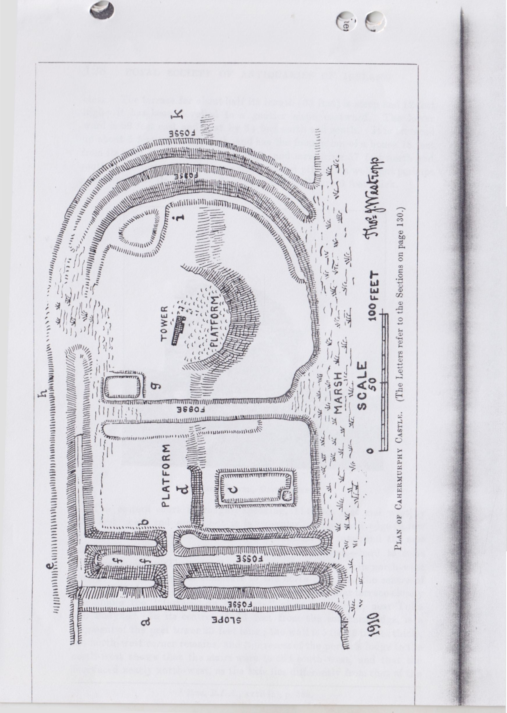

CAHERMURPHY CASTLE AND ITS EARTHWORKS 127

parallel mounds, about 167 feet long, running down the hill in straight lines, N.N.E. and S.S.W. by compass, with fosses outside and between; the slope is about 1 in 12; the southern ends run into the marsh. Taking them in order from the outside, there are—a fosse 10 feet wide and 4 to 5 feet deep; a mound 24 feet thick at the base and 6 feet on top, rising 11 feet over the outer and 9 feet over the inner ditch; a fosse, wet like the outer one from a water-flow under the upper earthwork; it is only 6 feet to 8 feet wide at the bottom; a parallel inner mound 18 feet to 26 feet thick at the base, and 9 feet on top, where there appears to have been a breastwork; it also is 11 feet high over the middle fosse, and 9 feet over the inner one, being a couple of feet higher than the outer mound. The entrance through these mounds lies 50 feet from the northern earthwork; the inner “fosse,” or rather drain, east of the inner mound, is only deep for the southern part.

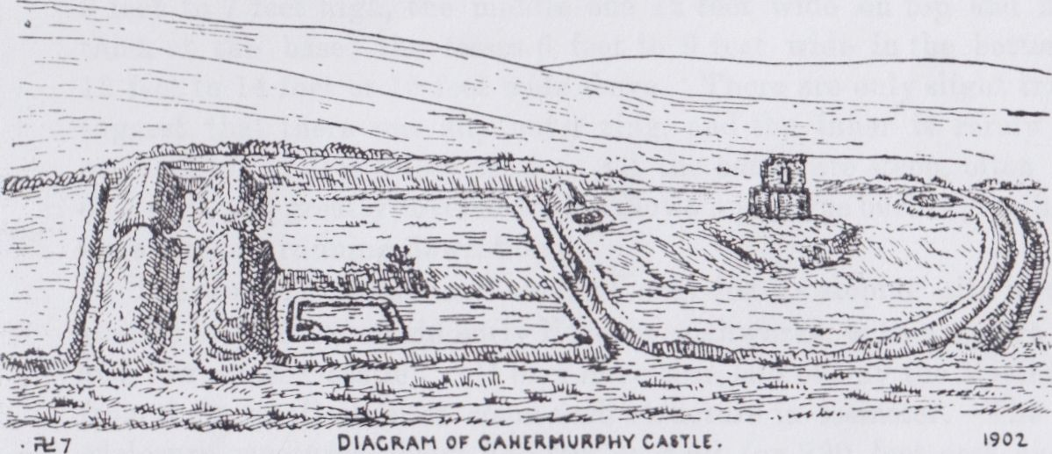

From the north-west end of the mounds another rampart runs at right angles eastward. It has a fosse outside 5 feet deep and 12 feet wide; an old laneway runs through it. The mound, if we except a possibly modern fence 3 feet high along its summit, is only 5 feet over the fosse and 10 feet over the western ditches; to the west it is 8 feet or 9 feet higher than the upper end of the garth. It is terraced between the ends of the western mounds, and slightly higher than the outer end. It is fairly perfect for about 135 feet from the cross-mounds, and is then entirely levelled for some distance; its continuation to the east will be described. It is 25 feet to 27 feet wide at the base, and 8 feet to 10 feet on top, parts being overgrown with bushes.

At 72 feet from the west mound a parallel fosse runs down the slope of the garth; it had low mounds to either side, which are much levelled, and its upper reach nearly filled up, but water flows down it from the hill. It is about 25 feet wide, and in the lower reach over 5 feet deep.

The garth is thus divided in halves, the western of which again is separated by a terrace into two parts, the upper ward a square of 63 feet

ROYAL SOCIETY OF ANTIQUARIES OF IRELAND

clear. The terrace for about half its length (33 feet) is steep and 12 feet high; it has been levelled to a gentler slope eastward. The lower ward is 69 feet east and west by 84 feet north and south. It is terraced up about 5 feet over the marsh, and has the foundation of a house 18 feet from its west side, hardly a foot high, and measuring 57 feet north and south by 24 feet wide. It has a small walled pit, like a well, but perhaps a garderobe, at its south-west corner; the walls are 6 feet thick.

128

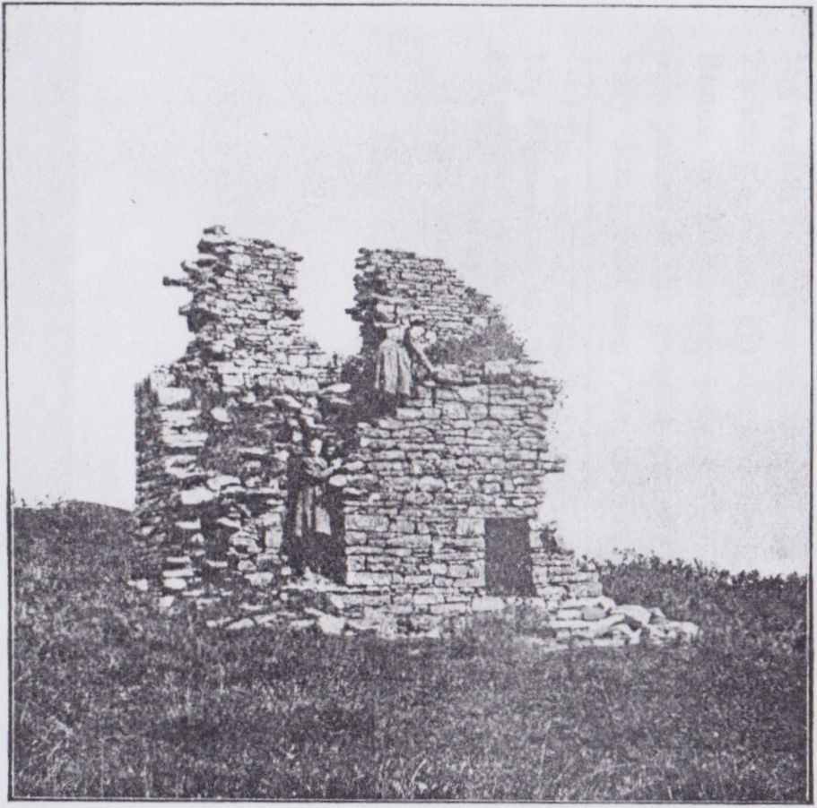

The Peel-Tower, Cahermurphy

The eastern court is, roughly speaking, 114 feet east and west by 159 feet north and south, but it is irregular. The south edge (a low terrace between 5 feet and 6 feet high) bends near the fosse, and the east end is rounded. The upper part is now absolute marsh—hard to cross after wet weather. There are the foundations of a house at its north-west corner, and a less regular enclosure to the north-east. In the centre of the ward, at 50 feet from the east mound, is a semicircular terrace closely resembling the “terraced-up hill forts” of eastern Clare, near Tulla and Bodyke.1 In its centre, at 33 feet from the southern edge, is a fragment of the peel tower 23 feet long; the wall is 5 feet 3 inches thick; the north-west corner remains, and the recess of the porter’s lodge to the north-west shows that the stairs were to the south-west, and that the door faced nearly north-west, as the axis lies differently from that of the

1 Proc. R.I.A. xxvii (c), p.383.

CAHERMURPHY CASTLE AND ITS EARTHWORKS

earthwork. The north wall of the under vault has a plain ambry at its eastern end, still entire, but that end is rapidly crumbling away. Some had fallen shortly before my last visit in September, 1910. Over the vault were at least two stories with floors; but, since I sketched the ruin in 1903, much of this upper part has fallen, some in the recent wet summer. There seem faint traces of the foundation and north-east angle; if actually of the last, the peel-tower was only 38 feet long, but the breadth is nowhere recoverable. The destruction is attributable to the poor masonry and bad, soft mortar, with too little lime, so general in the castles along the shale districts, though less frequent in the churches. The tower ought, for defensive purposes, to have been built at the northwest angle of the earthwork.

129

The eastern mounds are similar to the western in number and character, but are lower and laid in concentric semicircles. They are 6 feet to 7 feet high, the middle one 12 feet wide on top and 25 feet thick at the base; the fosses 6 feet to 9 feet wide in the bottom and 12 feet to 14 feet or 15 feet wide above. There are only slight traces to suggest that there was any outer ring, and the inner is rarely over 2 or 3 feet high; it is 6 feet thick. All the banks are steep, often 1 in 1 or 1 in 2, and greatly covered with sallows and furze bushes; both fosses have streams running down them.

The work is unique in Clare, and only for its sloping site is closely similar in plan to certain early Norman earthworks, with a square bailey and low mote “castle.” It may have been laid out by the MacGormans from their recollection of some such structure in Leinster. The whole enclosure measures about 346 feet over all (or 290 feet east and west inside) by 214 feet north and south at the west, 219 feet in the centre fosse, and 186 feet at the tower; the whole an enigma of unsparing labour and inefficient design.

On the hilltop to the north-west is a small circular house-ring, 45 feet inside, with mounds 8 to 10 feet thick and little over 5 feet high, displaying many traces of stone facing.

**Cathair Murchadha Stone Fort** (0. S. 48).

Cahermurphy takes its name from the strong dry-stone ring-wall of Cathair murchadha,1 in a commanding position at the northern end of the valley on a steep green hill, one of the outposts of the plateau from Mount Callan, southward where Doolough lies. Passing over the moorland, by the road past Doolough House, we cross the high boggy ridge called Gortaneera, 580 feet above the sea, and as we near its southern slope reach a spot commanding a wide view over nearly all the Irrus or southwestern extremity of Clare. The silver thread of Moyasta creek on the Shannon, the rounded hills of Rehy, Cahercrochaun, and Moveen near

1 Described (but not illustrated) by me in Journal Limerick Field Club, vol. ii, p. 254. Col. O'Callaghan Westropp made an independent plan identical with mine.

130 ROYAL SOCIETY OF ANTIQUARIES OF IRELAND

Loop Head, the “tumbled mass of heathery hills” of Moyarta and Clonderlaw, the high cliffs of Bealard, and the long reach of low coast

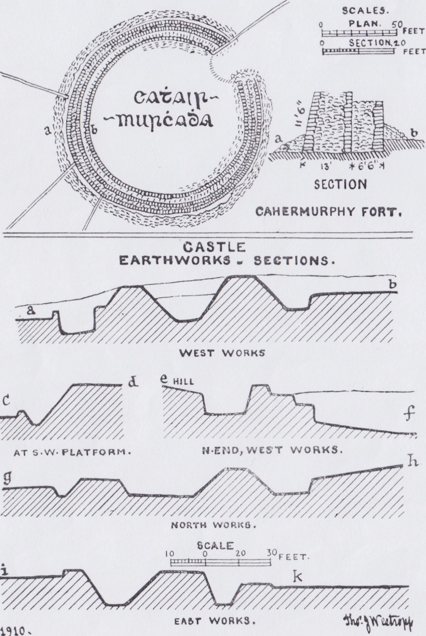

Plan, Cahermurphy Fort, and Sections at Castle.

with Inniscaorach, fringed with silver foam, in the midst of the sea, and on clear days the huge Corcaguiny Mountains, Slieve Mish, Caherconree,

CAHERMURPHY CASTLE AND ITS EARTHWORKS 131

and Brandon, faintly blue to the south. Lanes and roads, rich in bramble and woodbine, lead down to the valley, and, beside us, on a round green bastion, is the grey circle of the cathair.

The fort is almost circular in plan, 110 feet across the garth, the rampart, for most of its extent, being perfect, save to the north-east, where its former gateway and a reach of wall to either side were levelled. The rampart is a typical structure, being built in two sections : the inner is from 4 feet 4 inches to 6 feet 6 inches thick, and was probably a terrace; the outer is 13 feet thick, the whole from 17 feet 6 inches to 19 feet 6 inches thick. It is 6 feet 9 inches high to the west and 9 feet 6 inches to the south and south-east above the talus of fallen stones, being actually 11 feet 6 inches high outside and 7 feet inside. The masonry, though of rather small flags, is a model of dry-stone work,

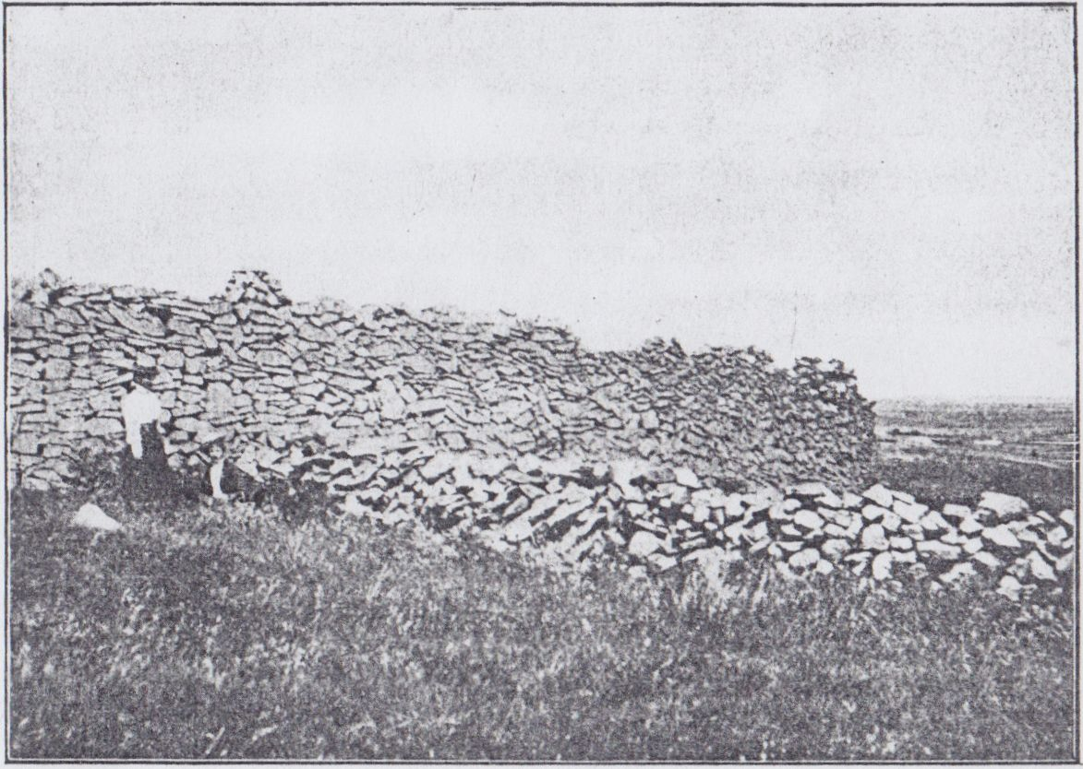

Stone Fort, Cahermurphy.

though its materials are so thin that I counted twenty-four courses where the wall is 9 feet 6 inches high at the point shown in the photograph. To give greater strength to the mass of small stones the builders used the utmost care in fitting them into a very close-jointed smooth facing with a regular curve and a straight batter of 1 in 4, not unprecedented, but unusual in forts of larger material. The sections have apparently got each two faces; the filling is large, and roughly, but carefully, laid; the whole an excellent piece of good masonry; there are no huts or traverses inside.

132 ROYAL SOCIETY OF ANTIQUARIES OF IRELAND

At the foot of the hill is a ring-fort, a circular platform, raised a few feet higher than the field. It is named Lisbaun, and is used as a burial- ground, and defaced by a modern wall. The names of forts in this district may be given here. Cathair names:—Cahercanavaun, Caherard, Caherrush, and Caherogan. The first is said to be called from the bog cotton, as it lies in low fields near a stream; but Canavan, white head, may be a person’s name, as with Caherogan. Caherard is a place on the high flank of Callan and Caherrush on the point of land opposite Spanish Point. *Liss* names:—Lissanure, Liscahan (from the Keans or O’Cathains), Lisballard, and Lissaltha, all near Miltown and (save the last) in Kilfarboy; Lisclonroe, Lissykeathy, Lisnadullaun (levelled), Lisnacloonagh, Lissyneillan, and Lisconry, all in Kilmurry and near Tromra; Lisnahoanshee, Knockalassa, Lisbaun, Lissatuan, Reanalassa, and Lissycrereen, near Knockalough, with two forts named Lisnaleagaun, one near Cahermurphy Castle, the other near the pillar-stones (between Kilmihil and Cahercanavaun), from which it takes its name. These pillars are in Termonroe, and probably marked the bounds of St. Senan’s church lands at Kilmihil. They are rough monoliths over 7 feet high near a fort called Kilbride, where, however, no church remains. Dun names:—Dunbeg and Dunmore, the last the old Dun mór mhic an Fearmacaigh.1 Doonogan and Doonsallagh lie northward. Grianan occurs as a fort name near Kilfarboy church.

**Forts near Milltown Malbay** (0. S. 30).

Most of the ring-forts in Kilfarboy and Kilmurry-Ibrickan have little special interest. About 42 remain in the first parish and 73 in the second, the barony possessing about 150 in all. I select as typical the following three examples, all near Milltown Malbay.

**Rinbaun**—The name is loosely applied to a ring-fort in the townland of Emlagh and not far from the village of Quilty. It lies at some distance from Rinbaun headland, which was called Emlagh Point in the map of 1838, no name for the fort being then given. The liss is a well-preserved earthwork. The outer ring has been much levelled to the south and east, and an old laneway runs through the northern segment of the fosse. The latter is from 12 feet to 15 feet wide at the bottom, and usually 5 feet deep. The mound is 25 feet thick at the base and 6 feet on top, being 9 to 10 feet high over the fosse and 5 feet over the garth. The earthworks were all faced with slab masonry, but little now remains. The garth measures inside 75 feet north and south by 78 feet east and west, being slightly oval; there are low mounds of a house site to the west, behind which, round the foot of the mound, is a narrow passage 2 feet wide and at present only 3 feet high; it is roofed with long slabs; the outer wall is only a foot thick; about 10 feet is

1 See Hardiman’s “Deeds,” Trans. R.I.A., xv, pp. 83-4. A deed of 1594 cited above, and the Annals of the Four Masters, a few years later in 1599.

CAHERMURPHY CASTLE AND ITS EARTHWORKS 133

broken out, but the firmly set roof-slabs project and hold up the bank; the passage is complete for about 10 feet to the south. It is a rare feature, especially in an earthen fort, being similar to those in the Grianan of Aileach and the so-called “Fort of the Wolves” at Fahan in

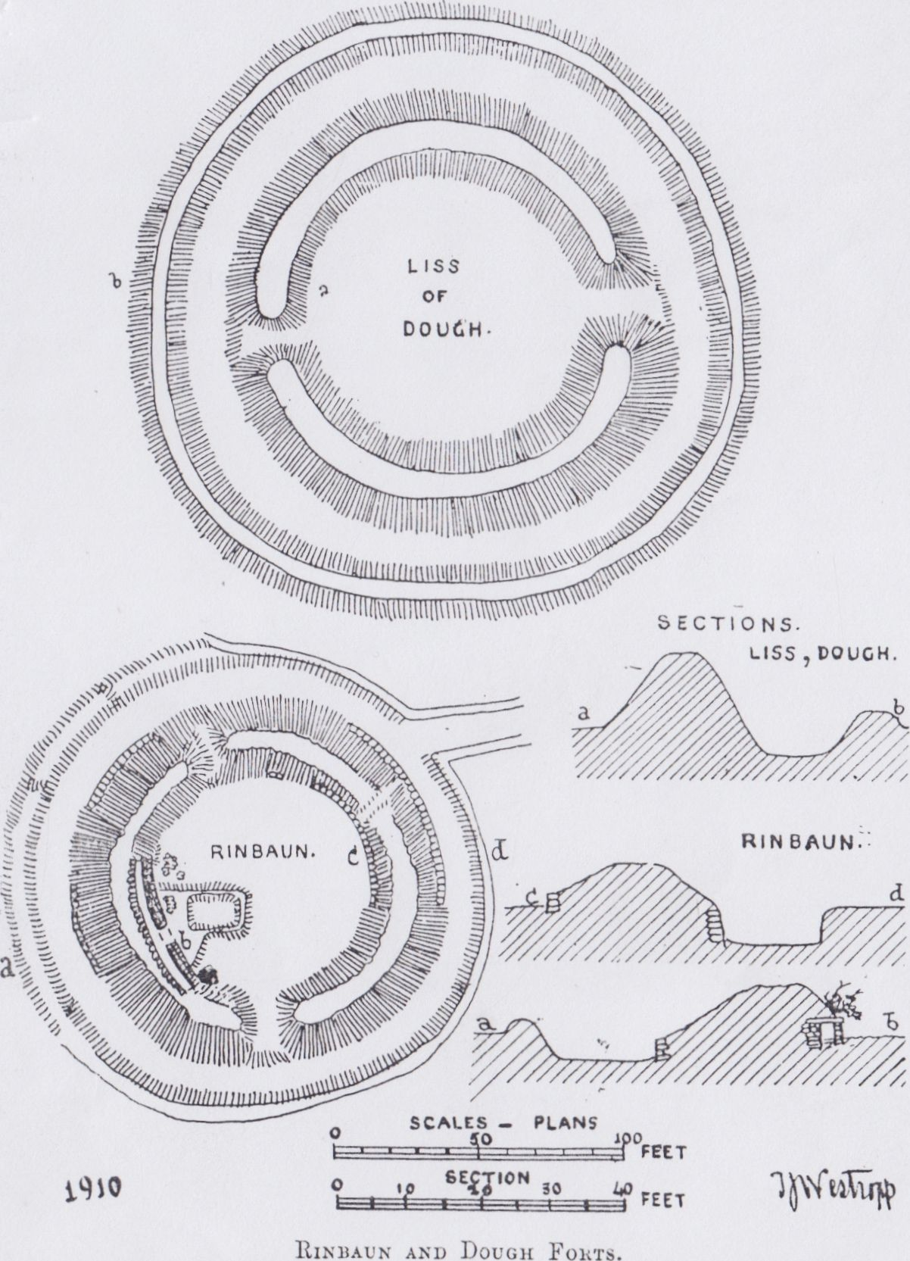

Kerry. The outer ring to the north-west is only 3 feet thick and high. The entrance was to the south, but there are cattle gaps to the northwest and north-east. The fort commands a pleasant view towards the sea. I found no trace of any fort at Caherrush. The castle, of which an angle134 ROYAL SOCIETY OF ANTIQUARIES OF IRELAND

was still standing in 1887, is now only marked by a mound of debris and a modern dry-stone pier as a landmark. A little to the east of it are apparent traces of a two-roomed but. The northern part is nearly destroyed by falls of the bank; a semicircle 35 feet across remains with a door-gap to the south ; beside the latter is a small cell 12 feet by 15 feet with a door to the east; the walls are 4 feet thick, 6 feet at the junction, and hardly a foot high; on the rising ground is an unenclosed killeen graveyard with rude slab-tombs.

**Leagard South**.—Passing the picturesque bridge of Bealaclugga we cross the sedgy Annagh River. The supposed meaning of Bealaclugga, ford of the skulls, was corroborated when, in digging for the foundations of the bridge in 1822, a number of human skeletons were found. Close to the bridge are the sandhills, covered with coarse grass and pansies, with harebells and other flowers, the highest mound being Knockatuder, rising 120 feet above the sea. Behind these was an extensive early settlement sheltered from the sea breeze. Thin layers of shells, burned stones and slabs, with much charcoal, remain about 2 feet 6 inches under the close sward. The shells are usually periwinkle and limpet, with a few specimens of the dog-whelk. In parts there is a second layer, apparently of limpets only, 2 feet above the former, just under the sward. The digging away of the sand has destroyed the actual settlement, for large hearth-slabs burned red and black, and numerous cooking pebbles, are never in situ, but abound in the dug-out spaces. I am told that stone implements have been found in the remains, but saw none.

The ring-fort of Leagard is beside the road to Milltown Malbay. It looks imposing with the thick, tall thorn-bushes on its earthwork, but is a mere ring with no fosse 4 to 6 feet high and 10 feet thick, the garth 69 feet to 70 feet inside, with no foundations. Crossing the low field and little brook southward, we pass up by the old road to the summit of the low ridge to a finer and more typical fort in Dough.

**Dough**.—The liss stands on a gently rising ground near the railway and Stacpooles’ Bridge.1 The name is most probably derived from the sandhills, Dumhach, but this word is frequently used for a fort. The liss was evidently, from its size and choice site, the chief residence of the neighbourhood, but the name is forgotten. It overlooks the country from Callan to Tromra and Moher, with a wide reach of sea and coast.

It consists of an outer ring 5 feet to 6 feet high and 15 feet thick, within which is a wet fosse, with springs to the north-east, 12 to 15 feet wide at the bottom eastward, and 5 to 6 feet deep. The inner ring rises 5 to 7 feet high over the garth, the entrance facing eastward. The interior is 90 feet across, with no foundations, the main ring being 32 feet thick at the base and 6 feet on top to the east and 26 feet thick to the

1. The Stacpooles’ old house of Enagh, the residience of an observant and satirical diarist and collector of letters, 1760-1795, William Stacpoole, afterwards of Edenvale, was intact and even partly roofed till 1908. it was then half demolished.

CAHEKMURPHY CASTLE AND ITS EARTHWORKS 135

west, where the fosse is 28 feet wide. It rises 11 feet over the fosse to the west, 14 feet to the north, and 9 feet at the entrance, and is thickly covered with brambles, sallows, and hawthorns.

**Fortified Headlands.**

The low coast had few projecting headlands to attract those who entrenched nearly every promontory on the west coast of Ireland; but two sites, though of very slight interest, remain in Ibrickan, and for the better completion of the survey of fortified headlands I may give them.

**Freagh** (22).—The place is almost devoid of historic record, and derives its name from the inner rising ground, which in parts is heathery, for I know of no heath growing near the castle and the sea. “Freth ye Castle ” is marked on the Map in Petty’s “Hibernia Delineata” of 1683. The castle has been removed save a large, top-heavy fragment, resting on two inadequate piers of a square doorway; that it still stands in so exposed a place is wonderful. The headland is so low at this point that the castle was clearly not designed to protect a natural defence, but only to command the shore. Further seaward the point is cut across by a narrow cleft, evidently a collapsed natural arch, left dry at low tide. A steep slope rises beyoud it, and from traces of stone facing near the top, it is evident that the now isolated portion was a promontory fort. There is a fine “puffing-hole,” Poulatedaun, in the next headland to the north which, with favourable wind and tide, throws up great spouts of spray.

**Mutton Island** (38).—This island, the only one of any size on the Clare coast, is of some scientific importance. Eleven centuries ago, at some time between 799 and 804, we read how Inis Fitae was torn into three by a great wave, and perhaps an earthquake. “On the day before the festival of St. Patrick a great wind arose, accompanied by thunder and lightning, and the sea swelled so high that it burst its boundaries,” heaping the coasts of Corcavaskin with rocks and sand, and drowning 1010 persons.1 The three fragments remain, known as Inismattle or Illanwattle (the southern), Iniscaeragh or Mutton Island (the central), and the bare rocks of Carrickaneelwar and Roanshee (to the north). The name Inis Fitae2 never reappears. In 1215, the Norman government (which then had little (if any) direct power in Thomond, but was commencing the policy that ended so disastrously for the English a century later) confirmed a grant of the native king, Donchad Cairbreach O’Brien, to the Archbishop of Cashel. This included the lands of Dunmugyda-inver (Dumhach, or Dough, creek, near Lehinch), Idul- culchy, Fumaneyn, Ydoonmal, Treanmanagh, Tromrach (Tromra opposite

1 Annals of the Four Musters, 799, Clonmacnoise, Chronicon Scotorum, 804, and Ulster, 803 (804), also Irish “Nennius,” p. 207.

2 Or, as the *Annals of Ulster* (803) say, “The sea divided the Island of Fita into three parts, and the same sea covered the land of Fita with sand, that is as much land as would support 12 cows.

136 ROYAL SOCIETY OF ANTIQUARIES OF IRELAND

Mutton Island), and two islands of the sea, namely, Iniskerech and Inismatail (Mutton and Mattie Islands).1 The last has now only a “slate” quarry to suggest that it was likely to be of any value. It is evident that the higher ground near the “Telegraph Tower,” rising 115 feet, broke the wave and turned its course over the low rocks and drift fields to either side, which it entirely removed. There may also have been some sinking of the coast, as submerged bogs and forests exist near Dunbeg and at Liscannor Bay.

The original island, measuring over the fragments, was at least two miles and a quarter long. Roanshee is so called as being the “seat” of numerous seals.2 These animals abound round the three islands to the disadvantage of the fishers. The use of “mutton” for the living sheep subsisted in Clare down to at least 1712, as seen in the numerous grants of the Earl of Thomond in that year, where variant numbers of “fatt hogges, fatt muttons, and couples of capons,” with “a Protestant soldier in times of necessity,” are to be supplied by the grantees of the various townlands. Petty calls the island Enniskerry in 1683.3 It eventually passed to the Stacpooles, who recently sold it.

This is no place to describe its picturesque, rugged cliffs with great caves and arches, up which the spray breaks before the west wind for over 100 feet, or the great double-arched hall with an up-shaft, called Iffrin- beg, or “Little Hell,” or even the rude “Bed of St. Senan,” a shattered rude cross find the gable of his little oratory.4

At the south-west corner of the island, however, we find a long, narrow cape about 60 or 70 feet high, and sloping southward, which was fortified by a strong, dry-stone wall. Across the neck, as usual at a strongly marked fault ending in gullies, is a semicircle of tumbled stones, here and there showing a few courses of the facing, proving it to have been fairly well built. It is 117 feet long at present, abutting at its southern end on a narrow gully. It probably extended 33 feet farther to the north, where the great waves have washed the cliffs bare and made a dark and horrible chasm. The wall had two well-built faces of moderately large blocks with filling, and varies in thickness from 18 feet to 25 feet thick. It was merely a refuge, too storm-swept for residence, but a sort of groove or terrace carpeted with sea-pink, is sufficiently sheltered by the northward rise of the rock to have been available for huts; no foundations are extant. The headland, seen from the north, is dark and impressive, with great black niches in its face. Out near

1. Cal. Documents relating to Ireland.
2. I saw a group of eight to ten together, and single ones elsewhere as I last crossed from Mutton Island.
3. Hibernia Delineata, Map 17. The same map gives the neighbouring names— Pollomallen (Milltown); Keiltis(Quilty); Fintrabegg (Cream Point Pay), and Breaghva (Breffy).
4. The later edition of Archdall’a Monasticon (Dublin, 1872), vol. i, p. 76, is wrong in saying that the ruins of a round tower remain.

CAHERMURPHY CASTLE AND ITS EARTHWORKS 137

the end is a down-shaft to the sea which spouts columns of foam in storms. The bay beside it is called Coosnadread; it is hard to get information, but I was told that the site was called Gorraun by some, Gray Rock, and Craglea, by others; “Carricklea” was the north-western headland in 1838, so I adopt the name “Dun of Gorraun’’ for distinction. Seen, as we last saw it, on a hazy September evening, with the sun setting beyond it, and the waves roaring up the cliff, it is a very impressive spot, and it is curious that no one seems to have visited so picturesque a place and noticed its sea-wrecked rampart “ where the waste land’s end leans westward.”

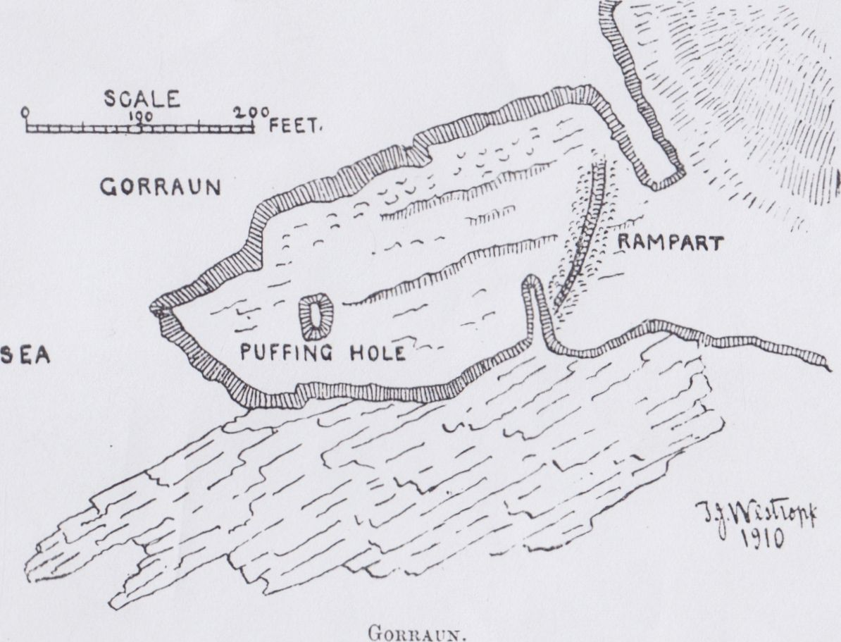

This brings the number of fortified headlands in county Clare up to fourteen — 1, Moher; 2, Doonaumnore (inland); 3, Annestown, Inchquin Lake : 4, Freagh; 5, Iniscaeragh; 6, Doonegall; 7, Farighy; 8, Doonaunroe; 9, Illaunadoon; 10, Bunlicka; 11, Dundoillroe; 12, Cloghansavaun; 13, Dundahlin; 14, Dunmore, or Horse Island.1

Probably there were also at Bishop’s Island, Loop Head,2 and Doonass, making over sixteen promontory forts.

1 For these, see Journal, supra, vol. xxv, p. 346 ; xxxviii, pp. 28, 221.

2 There seems some trace of building on Dermot and Grania’s Rock; perhaps the chasm was then narrow enough to be crossed by a slight bridge. Doonass Turret Rock is “the Rock of Astanen” in Elizabethan grants, and probably the site of the “Duneasa-Danainne ” of early records. The castle, the subsequent “Turret,” and the terraces built by the Massy family, have obliterated all old traces. It overlooks a fine reach of rapids, and the “Leap of Doonass.”