North Munster Antiquarian Journal  Vol 1, 1909-1911

CARRIGAHOLT (CO. CLARE) AND ITS NEIGHBOURHOOD.

By THOMAS JOHNSON WESTROPP, M.A., M.R.I.A.

Part I Introduction, The early tribes and history

The District  
 Eoghan O Curry

Kildeema

Liss na fuadh

Liscroneen

Termon and Molougha

Querrin and the legend of John Meade, Van Hoergarden

Kilnagalliagh

Doonaha and Morony

Poets and writers

Kilcrony

Lissaphunna and fairies

Part_II

State of archaeology in 1911  
Carrigaholt Castle, MacMahons

The Armada  
 Sir Daniel O Brien

The Cromwellians

Conor Second Viscount

Daniel Third Viscount

Daniel Fourth Viscount, etc.

Burton family

Peel tower

PART 3

Kilcredaun to Ross

Kilcredaun Church

Moyarta Churcyard and forts

Map of the forts of the Irrus

Kilballyowen Church

Templenanaeve, Ross

PART 4

Loop Head, origin of the name and of Malbay

The Rock and lighthouse

Cahercrohaun

Cahersaul

Dundahlin

Dunmore

Comments on contemporary archaeology, forts in the west of Ireland

Legend of Crochaun, Dahlin and Sall and mythical isles

There is a constant tendency in most men to go out into the corners and wild places of the world, and the tendency that made the history of the race so largely a tale of movements is as active as ever. The places that seemed very wild and secluded—places like Aran and Achill—are now accessible and frequented, and in a far greater degree the farther south west of Clare (so much sought after, even in days of less easy travelling,) is getting ever more and more familiar. Also, though many only go for bathing, idling, and golf, numbers go to study and get a pleasure unknown to the mere “pleasure seeker.” Such wish for information about their favorite haunts, and for such I have written several previous papers, treating of the places of interest around the health resorts further up the coast of Clare. After Lisdoonvarna, Lehinch and Miltown-Malbay, the neighbourhood of Kilkee naturally called for attention; so these papers are intended to supply a short guide for each of several possible excursions from Kilkee. Those depending on their drivers for information generally lose most of the interest attainable; so such papers, even if defective in themselves, are likely to be useful and to help to more special studies. I hope to give papers on Carrigaholt, Loop Head, Kilkee, Dunbeg, and their respective neighbourhoods; and though the forts, at least, have been described in detail elsewhere(i), I hope to show what there is of interest along the coast of the “Irrus” of Clare.

Irish historic archaeology is still so immature that it were out of place to go at any great length into the earliest history. The Ui Cathba and Ui Corra, with the Martini tribe of Firbolgs, and, far behind our native literature, at the beginning of our era, the Ganganoi (Gann and Sengann) tribes, lay at the mouth of the Shannon. The tribes, called after their reputed ancestor, Cairbre Bhascoin (2), “Corcavaskin,” occu-

1. Journal Royal Society of Antiquaries of Ireland, Vol. XXXVIII-XXXIX.
2. Son of the Ard Righ Conaire, **c.** A. D. 160.

220

pied in more historic times all south-western Clare, from the Shannon to Loop Head, the present baronies of Ibrickan, Clonderalaw and Moyarta. They grew so powerful that the tribes across the Fergus estuary, in Tradree, feared them and entreated the protection of the king of Cashel. How this great tribal confederation fell we have no clear record. It was most probably “bled to death” by the Norse wars. We hear of earlier battles, such as that in which St. Senan, in the latest 5th century, was forced to serve against Corcomroe: one in 717 with Connacht; one of the Corcavaskin, in alliance with Corcomroe, against the Ui Fidgeinte of the present County Limerick, who appear to have crossed the Shannon and invaded the Corcavaskin, probably in the Clonderalaw district, in 763. The ninth century opened with the death; of Aed Roin, King of Corcavaskin, and five years later (812) the Norsewars began. The first assault on Munster seems to have ended in the repulse of the foreigners with great slaughter; but band after band came across the sea, and the great estuary of the Shannon got widely known, even in Iceland and Norway(3). In 834 a great Viking fleet came up into the Fergus basin and landed swarms of mailed warriors, first in Corcavaskin and then in Tradree. Sweeping up the spoils and wasting with fire and sword the best parts of the north Shannon bank as far as Limerick, they destroyed the important Abbey and College of Mungret. After this, as if the Lower Shannon district had not recovered, the war was transferred to the upper reaches from Lough Ree to Lough Derg, where the obscure branch of the Dalcassians of Killaloe made the heroic, and eventually successful, resistance that ended in the great victory of Sulloghod, and the sack of Limerick over a century and a half later by Mahon and his brother, Brian Boru. The trouble again broke out in 866 and 867 ; Thomond was wasted from Corcomroe to Loop Head, and Cermad, king of the Corcavaskin, was slain by the Gentiles(4). His son succeeded and seems to have died in peace in 884. The Corcavaskin and their neighbours, the Ciarraige of North Kerry, united their forces against the foreigners, won a victory at Lemain, and slew the leaders of the Gentiles, Rot (or Rolt, i.e. Rolf or Harold), Pudarill

1. It is very striking in the Sagas to find how familiar voyages (trading and warlike) to Ireland and along the coast of North America (to “Vinland the Good,” “Whiteman’s Land," and “Great Ireland”) were to these early historians.
2. In Inisfallen: “Wars of the Gaedhil with the Gaill.”

221

and Smuralt (Thorold)(5). In 923, Murchad, son of Flan, king of Corcavaskin, died. In 964 we hear of a great slaughter of the men of 'Thomond on the Shannon, and they lost their ships. These were probably the Corcavaskin, as they kept a fleet in the lower waters. They rarely seem to have had any power after this, and entries of their history are few. The Dalcassian power, which had long rested content with a nominal tribute, also pressed hard on the Corcavaskin, and by the reign of Lorcan held them in entire subjection. Their chief, Dunadach, son of Diarmaid, died in 993, and the son of Cathasaigh in 1012; the tribe seems to die out in the greatest obscurity, and their place is taken by a line of Dalcassian chiefs, the Mac Mahons, claiming descent from King Brien’s great brother and predecessor, Mathgamhan, son of Cennedig; but the pedigree is derived from Mathgamhan, son of Murcheartach mór, son of Toirdealbach, son of Taidgh, son of Brian Boru, in the best established accounts.

The only man of any eminence in the Corcavaskin tribes was their apostle, St. Senan, of Scattery or Inniscatha, in the first half of the sixth century, and his influence is little marked in the Carrigaholt district, save that his disciple, Caritan, founded a church, which still bears his name, Kilcredaun. The termon or church lands of St.. Senan included the following:- “The termon of Iniskaha contained (1604) 16 quarters: 3 in Kylltyllinnge in Clonderalaw, 3 in Beallantallinge in Moyfarta, 4 in Kilrushe, 16 in Killygileagh (Kilnagalliagh) and Moyhassie (Moyasta) in Moyfasta, and 2 in Killcorridan (Kilcredaun), called in Irish Termon Shenan.” On one occasion, too, Senan, who had come over the creek of Moyasta to look after his father’s cattle, on the family land at Termon, was refused hospitality at a fort called Dun Mechair.

**THE DISTRICT**.

Leaving Kilkee, we drive southward, past the Protestant church, taking the road past Dunaha to Liscrona. Not far from Kilkee we pass a perfect fort very characteristic of its class, with two rings, lying in a marshy field to the east of the road. It is called Doonaghwee (or as the map spells it Doonaghboy), but was called “Doonaghbwee Caghir” (or stone fort) in 1655, when it was held by Teige O Cahane, a member of

5 Wars of the Gaedhil with the Gaill, p. 29.

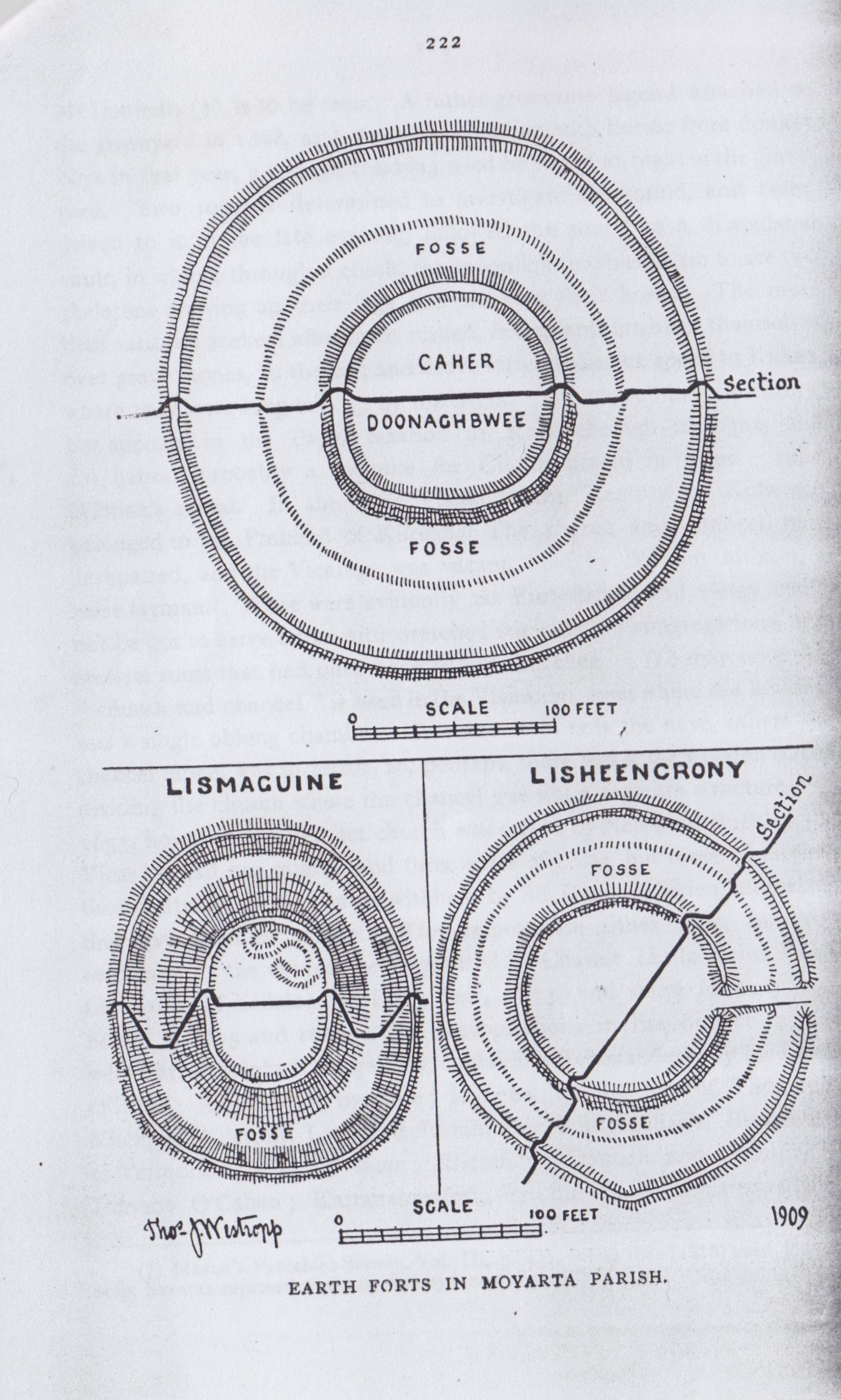

223

the Keane family. Dr. Joyce renders its name as “the yellow fort- abounding spot”(6) from the furze, but “Doonagh” probably stands for Dunadh, an entrenchment. No furze grows on the earthworks at present, though plenty brightens the fences near it, perhaps the “yellow” refers to the clay soil. Dunadh is a word which probably (rather than “Dún”) gave an epithet “Dunates” to the Gaulish war-god, Segomo, “Lord of the Camp.” The only trace among the Irish of this god’s worship is that of the prehistoric king, Nia (Niath, ogham Netta) Segamain, whose descendants in the Decies district in western Waterford have left us several Ogham stones with the tribe name “Maqi mucoi Netta Segamonas.” Doonaghbwee has two rings, 5 to 8 feet high, with slight fosses outside each, the inner, 108 feet, and the outer, 250 feet over all. There was a considerable amount of wood and brushwood near this fort in 1655, and some small trees and much brushwood is still to be found in the bogs. In 1816 the first full account of this region by Rev. J. Graham, of Kilrush, in Mason’s Parochial Survey, (Vol. II., p.419), tells of the attempts to replant the district with ash,birch, elm, alder, and Scotch firs. It has an interesting note on the bog trees, there were in early times fir, oak and yew trees, chiefly the two former, which are often of large dimensions, and serve to roof houses and supply material for furniture with the peasantry, Mr, Anthony Nolan, of Ballykett, sold a fir tree to Mr. Paterson for £14 19s. 6d. It was 38 inches in diameter, and at upwards of 68 feet from that part, 31 inches. It was used for a new house, and it is said to have been twice as large (only the sound heart being used) and to have saved Mr. Paterson a cost of £36. The manner of finding such trees in the more western parishes was by piercing the peat with a “tharagher,” or bog auger, early in the morning before the dew evaporates, as the latter never lies on the soil above such trees. The auger was only used to ascertain whether the wood was sound or rotten. Whatever be the truth in these assertions, the bogs in Kilfieragh and Moyasta are full of stems and roots of bog deal, most valuable for fuel and formerly for light. Driving over the ridge we pass not far to the east on the high ground the ancient Parish Church site of Kilfieragh. The old church has long since been levelled, and only the west end of the very late church, built by the

6 Names of Irish Places, See. II., Chapter I.

224

McDonnells(7) is to be seen. A rather gruesome legend attached to the graveyard in 1868, as I remember hearing with horror from donkey boys in that year, a strange creaking used be heard at night in the graveyard. Two tourists determined to investigate the sound, and being driven to it in the late evening, followed the sound to a dilapidated vault, in which, through a chink, the moonlight enabled them to see two skeletons drawing up their legs and creaking their bones. The more than satisfied seekers after truth rushed, falling and bruising themselves over grave stones, to the car, and drove with break-neck speed to Kilkee, where they were long laid up by the fright. The church has no history, but appears in the Papal taxation as Kelleheheragh in 1302, and Cil fiabra (probably a mistake for Cil fiachrach) in 1390 in the O’Brien’s rental. In the 1622 Visitation the Rectory of Kilfieragh belonged to the Prebend of Kilrush. The church and chancel were unrepaired, and the Vicarage was vacant, held by William Milsam, a mere layman. There were evidently no Protestants, and clergy could not be got to serve cures with wretched stipends, no congregations, and roofless ruins that had once been parish churches. We may note that “church and chancel” is used in the Visitation, even where the building was a single oblong chamber. In some cases only the nave, others the chancel alone, was in repair, so, perhaps, there was some wooden screen dividing the church where the chancel was not a separate structure. In 1633, however, the derelict church was served by Nathaniel Buckley, the Vicar: it had one quarter and three acres of glebe, but these (doubtless then, certainly in 1641) were withheld by Sir Daniel O’Brien, afterwards the first Viscount Clare. The impropriate tithes were, however, recovered by the church, being granted by Charles II. to John Roan, the Bishop of Killaloe, by Privy Seal, 1673, and more formally confirmed in 1675 and 1680. The impropriations in the district in 1622 were Carrickgolohy (Carrigaholt), containing Reinmacderig by Sir Daniel! O’Brien; Kilcarradan, by same; Kilbeha, by the Earl of Thomond; Kilclohir, Kilcrony, Lissen ad ffurrahmore, Killinagallagh, Bealantalin, orTermontenan, all by same; Kilcashine, Donogh and Clansha, by Dermot O’Cahan; Karranalongfort, by the Earl; Kilcarrowe, Kil

7 Mason’s Parochial Survey, Vol. II., p. 431, it was then (1816) used for worship, but was superseded about 1838 by a new church in Kilkee.

225

teelin, alias Termonafeerah, also Termonapriora and Moyasta, by the same; worth in all £108 and over(8). Near it are two forts of little interest, called Lissyoolaghan and Lisheanagreany. After passing the ridge, we get a wide view over the Shannon into Kerry. The hill of Knockanore is seen beyond the dark speck of Beal Castle and its great sand dunes, onward to the low cliffs that run from the bold cliff fort of Lissadooneen and the picturesque bays of Kilconly, to the Castle of Leck. Far beyond rise the outline of Kerry Head, and the great mountains of Corcaguiny, Slieve Mish, Caherconree and Brandon, with its long streamer of cloud whenever the west wind prevails.

We now approach the home ground of Eugene O’Curry, than whom few have laid Irish scholars and antiquaries under a heavier debt of gratitude. One of his earliest contributions to the subject to which his life was so fully devoted has practically escaped the notice of antiquaries. Eugene “Curry” wrote to George Smith, of 21 College Green, Dublin, in August 21st, 1835(9) (four years before the work done over Clare resulted in the manuscript “Survey Letters” ) giving his impressions of the scene of his childhood. I can only abstract from his long letter here. He notes (p. 371) the peninsula from Loop Head cut off by a great bog, and its numerous forts from Rath una (Rahoonagh) on the Shannon to Lios macandagha (Lismacadaw) on the ocean,and another line from Carrigaholt through Belleh (Bellia) to Cnoc na ceúrthaman (Knocknagarhoon) on the coast being a line of 7 forts in a line of a mile and a half, from Lios mac Fhin, on the river to Lios Fhin, on the bog, in Lisfin townland, but he gives no descriptions or traditional notes. Another line of forts runs from the river, the sixth is Dun Atharrcc, or Lios na fuadh (p. 372) on a ridge, which terminates “pretty abruptly,” skirted to W., S. and E. by another little stream. It is an eastern ring, circular, and very low, within a circle; at a radius of 300 feet is another circular mound, 8 feet high on the outside, and about 13 feet on the inside, its mean breadth 8 feet. Between this and the dun is a fosse 20 feet wide, once full of water. Within rises the dun, about 200 feet in diameter, the bank or wall about 7 feet high inside and 20 outside, one large gap or entrance to the east, some appearance of

1. Diocese of Killaloe. Rev. Canon Dwyer, p. 133 ; also p. 335.
2. MSS. R. I. Acad. 14 B. 23.

226

remains of ruins inside and perhaps subterranean chambers. “I know this well, being born and reared within 40 paces of it.”

There are at many spots traditions of “persons slain in combat by Fuad(10) na hadhairche (such as Tuarna Thadhaig Ui lioghaire and Tuam Ceatharnaicc an chuibrin, and Fuad na hadairche still maintains a respectable and prominent place in the nursery legends, as my bare shins and toes could well attest on many a hard winter night some 20 years ago ”(1815). About half a mile east of this runs another line of 4 forts from the river to the bog, they are inconsiderable. A low fort Cor-lios “occupies a little angle by a small but handsome creek now after 14 years absence (since 1819) I write from recollection”(p. 373). About a mile east from Cor-lios you cross a bog, and on its"northern verge is“ a handsome fort,”Rath an nioge, or Lios na falainge,“ a clean, single enclosure,” the wall about 10 feet high. It is the principal abode of the good people in this quarter, and various stories of their good and evil acts are on current record.

Kilkee has a fine fort, Lios an chairn (Lisnalegaun)(11), its wall 9 feet high, a plain lios, the floor on a level with the top of the wall. This striking circle remained unknown for ages, until, about 17 years ago, a cow got into it and remained. The owner(p. 374) seeing her on top, went up and found her hind leg stuck in the ground. He could not pull it up, and neighbours came and dug; they “hit” on a flagged floor, with the cow’s leg in a crevice. When they released her they found a narrow passage with walled sides and flagged. They fonnd shells and bones and passages in all directions. Near this fort is Lios lumeacain, Lios duin and others. The letter is pasted at the end of the first volume of the Clare Ordnance Survey Letters, and I must confess to have completely overlooked it on making my early notes from that source. It is a great loss to folk-lorists that O’Curry did not tell the nursery tales and local traditions of the home of his childhood. Strange to say, even in his later letters, he was equally reticent, and save in his

1. Fuat usually means a spectre, but it is the name of a person in the Dind Senchas (Revue Celtique, Vol. XVI (1895)p. 51, who visited the Isle of Truth, and brought back a sod to Ireland on whichno false sentence could bepronounced, whence Sliabh Fuat in County Armagh.
2. See Journal Royal Society of Antiquaries, Ireland, XXXIX, p. 117.

227

account of Loop Head, adds but little to our knowledge. To finish the later letters for this parish, we may collect a few notes. They name Killinny Burial Ground for children and the holy well of St. Martin in Clare field. The little graveyard at Kilcasheen, near Moveen, was long disused, but in a great “plague.” Eugene O’Curry’s grandfather, Melachlin Garbh O Comhraidhe, who held Moveen at will from the Westropps of Lismehane, charitably employed his workmen, with horses and sledges, to collect and bury the dead there. I remember sledges in use made of two beams, meeting in angle over the animal's back, and with cross pieces below. I do not know if such still exist in Clare. Kildeema churchyard, near Moyasta, marks the foundation of a St. Dioma, possibly Dioma, son of Cass, King of Munster, who, early in the Mission of St. Patrick, founded Kildimo, or Cell dioma, in Kenry, on the south side of the Shannon, and who died on May 12th, about 480. The site had, even in 1816, been desecrated and planted as an orchard(12). The church existed in the middle of the 17th century, when, after a skirmish with Ludlow’s troops, the head of Captain Scaff(13) was fixed on its gable by the O Cahanes. Kilnamanorha, on the same creek, was long since levelled. Stations were held, but on no particular day, at Tobar na mban ortha, its holy well(14). The names mean church (and well) of the holy women; it lies in Baunmore, the 'Cedramuin bain,” or “white quarter,” of the “1390” Rental of the O’Briens.

As to Lios na fuadh, or Dun Athaircc, the name was tranferred to an insignificant fort to N. E., called Lisfuadnaheirka, I was told (about 1896) that Fuadnaheirca was a horned ghost, but my informant evidently knew little of this once formidable being. As I described the fort under its present name, Liscroneen, in the Journal of the Royal Society of Antiquaries of Ireland(15) two years since, I need give no lengthy description. It is a very fine fort, and the deep and wide moat, full of yellow “flaggers” (iris), when I last saw it, and the steep earthworks, covered with brushwood

1. Mason’s Parochial Survey II., p. 434.
2. General Ludlow’s Memoirs.
3. O.S. Letters, Clare II., p 353.
4. Vol. XXXIX, p. 123.

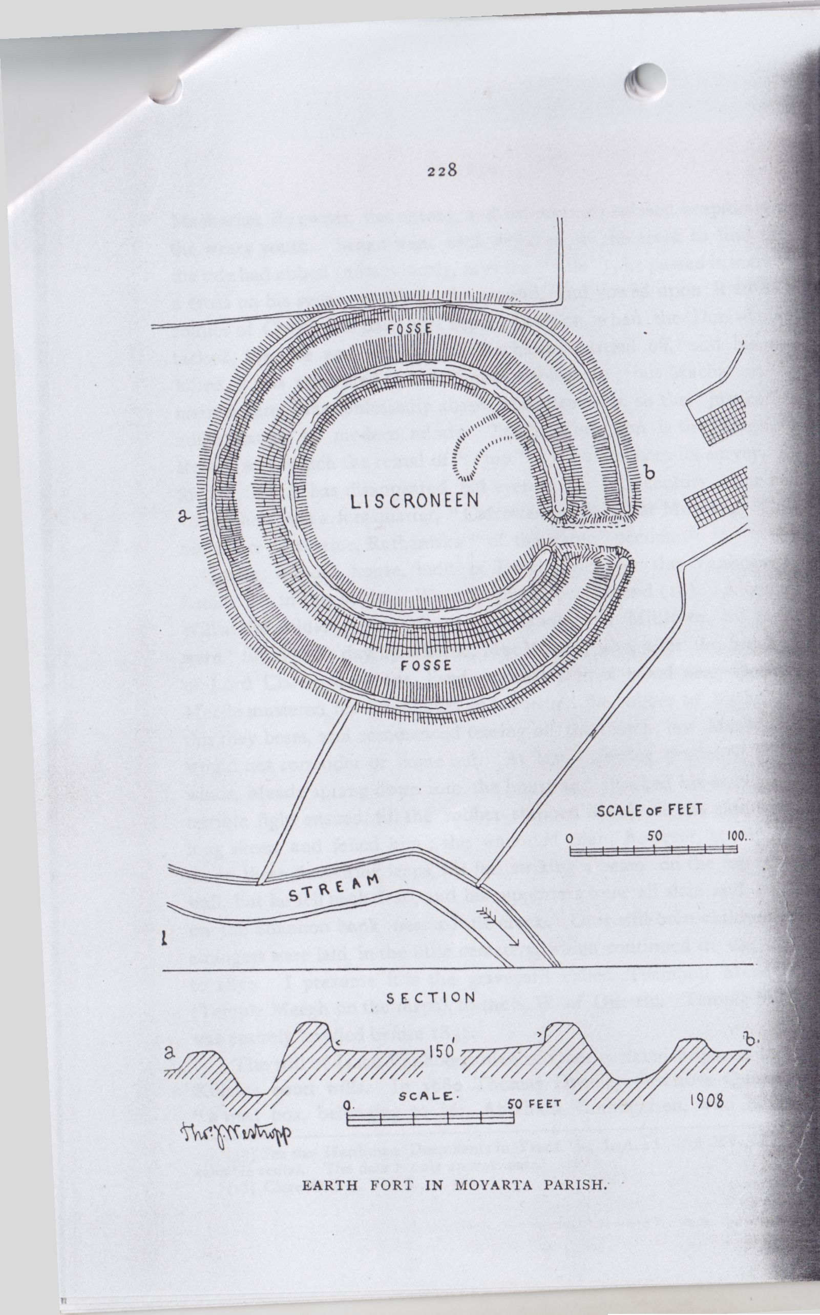

229

and low trees, give it an imposing sense of size. The outer ring is 23 feet thick, 5 feet to 6 feet high, and very steep, having evidently been stone faced till modern days; the fosse is 12 feet deep, and from the slope of the banks seems far deeper than it really is (6 feet below the field). It is 18 to 20 feet wide at the bottom. The main ring is 15 feet thick, the enclosure is 144 feet to 150 feet inside, the whole earthwork about 270 feet to 280 feet over all. It lies on high grouhd with a very pleasant view up the Shannon.

There are two smaller, but noticeable, forts to the west of Liscrona House, named Lismaguine and Lisheencrony; the first, lying in a field near the low grassy cliffs of the Shannon bank, has an unusually deep and wide fosse for its small size. The outer ring is nearly 4 feet high, and 6 feet thick, the fosse is 12 feet deep, over which the inner rises 15 feet, the garth is only 66 feet across. Down to 1898 the rings were covered by huge furze bushes which made the fosse a deep green tunnel; these are now burned and the Liss, seen from the road, gives no promise of interest. There were two huts in the garth.

The second fort, Lisheencrony, has a very curious feature, rare, but occurring elsewhere, a sort of ledge inside the outer ring, with a shallow fosse inside it. Whether this was a fighting platform or was palisaded with a “sonnach” or stakes is not clear. A somewhat similar, but much wider, ridge, available for huts, is at Doonaghwee. Lisheencrony is 93 feet across inside, and about 230 feet over all.

To the east of the line of these forts a few places may he briefly noted. Termon is on the eastern strand of Moyasta creek, the upper end of Poulnishery (or oyster pool), which once yielded abundant supplies of the shellfish, sent in donkey carts far into East Clare. As the name implies, it was part of the termon, or church lands, of St. Senan’s Abbey on Iniscatha. His early “Life”(16) calls it Tracht Termuinn, or the strand of termon. His father held Moylough, or Maghlachar, beyond Kilrush, where two early churches mark Senan’s birthplace, and a place in the “Irros” peninsula. Senan was sent to bring home the cattle there, but when he came to the ford, probably where the Black Weir bridge now crosses the creek, he found the tide full. He went to a neighbouring “castle” or fort, called Dun Mechair.

1. See Colgan’s Acta. SS., under March 8th.

230

Macharius, its owner, was absent, and his servants refused hospitality to the weary youth. Senan went back dejected to the creek to find that the tide had ebbed (miraculously, says the “Life”); he passed it, marked a cross on his spear, set this in the ground, and vowed upon it to be a soldier of Christ—an oath well kept. Later on, when the Dun was attacked, the wife and servants of Macharius carried off, and his son killed, it was attributed to the Divine displeasure; but Macharius, the main sufferer, was confessedly absent and blameless, so the “justice” is not apparent to modern minds. Tracht Termuinn is the Tragh, or strand, with which the rental of ”1390 ”(17) commences its survey. As for the Dun it has disappeared, but even in the 17th century, 1622 and 1675, there was a fort quarter, “Carrowenlongford,” at Moyasta. Only one other fort name, Rathaniska “of the water,” occurs.

Querin, an old house, built of Dutch brick by the Vanhogarten family, lies in this angle. We may give a local legend(18). A certain Williamite soldier, John Meade, got lands near Milltown, his cattle were “lifted” one day by a kerne, MacMahon, who, after the break up of Lord Clare’s dragoons, lived concealed in a wood near Querrin. Meade mustered his neighbours and pursued the robber to his house; this they beset, and commenced tearing off the thatch, but MacMahon would not surrender or come out. At last, throwing prudence to the winds, Meade sprang down into the house and attacked his enemy. A terrible fight ensued, till the robber stabbed Meade in the side with a long skeen and felled him; the wounded man, however, got up and made three despairing leaps, his feet striking a beam on the top of the wall, but he fell back dead, and his supporters were all slain and buried on the Shannon bank near a little creek. Only still-born children and strangers were laid in the little cemetery, which continued in use down to 1839. I presume it is the graveyard called Teampoll Meadhach (Temple Meegh on the maps), to the S W. of Querrin. Temple Meegh was entirely levelled before 1839.

The will of Isaac Vanhoergarden of Querin, dated 1650, is in the Killaloe court wills. In 1680 Thomas Dyneley describes Queren as “a neat box, belonging to Mr. Abraham Vanhogarten, who built it,

1. See the Hardiman Documents in Trans. R. I. Acad. Vol XV., for this valuable rental. The date is only approximate.
2. Clare O.S.L. Vol. I., p. 367.

231

holding it under the Earl of Thomond, to whom it had been granted by patent in 1620”(19). An Inquisition was taken at Sixmilebridge, May 2nd, 1666, relating to this Abraham Vanhogarten. The house was built in the old Dutch fashion, with two stories in its long projecting roof. It is credibly reported that all the timber, bricks, shingles, windows, &c., were brought in one vessel from Holland(20). In his will, in the Prerogative Registry, Abraham describes himself as a merchant of Limerick, and desires to be buried in St. Mary’s Cathedral. He left all his estates in trust to “Lawrence de Guer, Lord Commissioner for his Majesty in(?) Frieslande.” He cites a former will providing for his wife, which he confirms anew, Sept. 20th, 1665. George Hickman of Ballykett and Jane his wife; Randall Jones of Queerin and Catherine Jones his wife (alias Vanhoegarden, alias Hickman, sister of George), granted to Rev. John Vandeleur of Kilrush, June 23rd and 24th, 1714, for £800, Clone, Carekon (Cahercon), &c., as held by Teige MacDonnell and David Quinlan, the middle farm of Queerin as held by John Scanlan and C. Vanhoegarden in trust, the deed being witnessed by Edward Westby, Maximilian Vandeleur of Kilrush, and Anthony Daxon of Ballykett (21). It was registered in Dublin. Queerin passed to the Burrough family, descendants of the Vanhogartens, who held it down to the last century.

The Rev. John Graham, in 1816, in his valuable account of the S. W. Corner of Clare in Mason’s Parochial Survey(22), tells us how “the late Mrs. Borough was grand-daughter of Mr, Vanhoogort,” died lately at a great age, nearly 100 years, “retaining her faculties and a remarkable degree of ability and penetration to the last,” and that “The creek of Querin is remarkable for producing very fine shrimps and some excellent flat fish, and affords a safe harbour for herring boats and other small craft."

One other graveyard must be mentioned as lying on the creek. Kilnagalliagh was one of the foundations attributed to St. Senan in the early “Lives,’’ where it is called Cilleochaille, Kileochaille, and Kilnacallige, “very dear to Senan." The older form of the name suggests rather a yew (or oak) wood than a church. It is called Killinagallagh in

1. H. A A. S.. Vol. I., Sec. II., p. 188.
2. Mason’s Parochial Survey, Vol. LL, p. 427.
3. D. R. I), B. 14, p. 127.
4. pp. 427-453.

232

1615. In the 1622 Visitation, Killingallah, worth £5, was with-held from the church by the Earl of Thomond (that great benefactor of St. Mary’s Cathedral and other churches elsewhere.) In 1675 its ruins are noted as “Kilnegallagh,” worth 13s. 4d.; here stands an old chapel ruinated.” Graham, in 1816(23), says:-“The ruins of Kilnegallagh Church are near Clarefield, in the parish of Kilfieragh; part of the walls remained a few years ago.” It was founded for certain nuns, “ the Daughters of Noteus,” and was the burial place of the families of Cox and Scales, who leased the adjoining farms from Hickman of Ballyket during the last century (from 1816).

It is impossible to pass by Doonaha without some mention, however brief, of the Irish scholars, to whom, in the darkest days of our native literature, the place had been a centre. A few words may also be said on the place itself. Part of the MacMahons’ tribal lands for ages, it was free from the imposts claimed elsewhere in the district by the Princes of Thomond. The revolt of MacMahon and his unfortunate parricide son enabled the Government to confiscate the estates, early in the 17th century. In 1622 they were granted to Sir Daniel O’Brien, who, in extreme old age, at the request of his grandson, was elevated to the peerage as Viscount of Clare. In the patent it is called Downagh, alias Downaghy. The lands were seized by the Commonwealth, and duly recorded in the “Book of Distribution and Survey” in 1655; they had the then common feature of dwarf wood. In 1680, Doonaha East and West were held by Abraham Vanhogarten, but a family of Celtic origin were far more closely connected with them; Daniel Lord Viscount Clare granted them, with Lisheen and other lands, to Edmund Morony of Kilmacduan and Poulavullin, or Milltown Malbay, for the lives of the lessee, his wife, Jane Moroney, and their sons Pierce and John. Edmund was bound to build a house 50 feet long and 18 feet high and to plant two acres of orchard. If Lord Clare looked for a reversion of the improved property he was destined to be disappointed. His loyalty to King James led him to raise a famous troop of dragoons, which was, early in the war, nearly cut to pieces in an ambuscade; he fought at the Boyne, and came home to die before the new Government could retaliate. For the second time in the half

1. Mason’s Parochial Survey, II., p. 434.

233

century all his lands (first confiscated from MacMahon) were confiscated, this time never to be restored. Margaret, widow of Pierce Morony, successfully maintained her rights, and her family held the place for over a century later.

Whether the Celtic family of Morony or the influence of the MacDonnells of Kilkee, who patronised the dying remnant of the old “ollamhs” and bards, was to be thanked I have not found, but a succession of poets is found connected with Doonaha. It could claim descent from the mediaeval bards, for John Hartney of Kilkee, one of its first “professors,” had been a friend, and probably a disciple, of Andrew and Hugh MacCurtin, the last “Ollaves” of Thomond, who died respectively in 1749 and 1755, and Andrew himself was at times befriended by the MacDonnells of Kilkee. I have given a brief account of these scholars in telling of their native places, Kilshanny and Kilmacreehy in these papers(24). Hartney had a friend, Seaghan do h Orrda, or John Hore, of Kilkee and Cloonena, a poet, who died about 1780, and he and Thomas Meehan, a schoolmaster in Ennis, kept up a close connection with the Doonaha-guild. The Penal Laws were relaxed, and the Corcavaskin “Meistersingers’’ had nothing to fear from the Government; two other schoolmasters, Anthony O’Brien and John n h Aodh, or Lloyd, attained some local fame. The latter wrote an interesting and quaint, though rather inflated, little history or tour in Clare in 1778(25) It was enlivened by panegyrical poems of his friend Thomas Meehan, and is the first topographical history (so to speak) of the county, and the first “Tour” since the partial one of Thomas Dyneley in 1680. Lloyd was a tolerated dependent of several of the Clare gentry, but his trying and wandering life tempted him to drink and forget his woes, and he was found dead on the road. He was well known to Owen Ui Chomraidhe, Eugene O’Curry’s father. Malachi, another member of the O’Curry family, was pupil of another of the “school” Peter Connell, of Carna, was a poet who wrote between 1806 and 1818, others of the guild were Conor O’Doherty, a schoolmaster, Thomas Madigan (Eugene O’Curry’s friend), Michael Hanrahan, living 1820 in Kilrush, and John Chambers, of Ross. In some sense Eugene O’Curry, or Curry, as he at first called himself in

1. Vol III, p 209.
2. “An Impartial Tour in County Clare.”

234

English(26), was the last and most eminent of the Doonaha school, and he had at least the privilege of seeing the dawn of the revival of Irish learning, for which the previous obscure, poor and humble men struggled and laboured in its darkest hour, without hope or reward. Their little work, not then esteemed by the rich and educated, is likely to be held in remembrance (when many a pretentious work is ridiculed or forgotten), as a labour of self-sacrifice and loyal love deserves always to be held.

There are two defaced ring forts among the scattered houses of the village, and several lesser house rings, one at the cross road leading to. Liscrona, with such steep banks as evidently prove it to have had stone facing in very recent years. Another small ring, farther westward, had a souterrain. Lisheen, or Lisheenfurroor, though of little size or interest, is a conspicuous object, from its position on a rising ground. Lismadine, a low ring with a fosse, also lies to the north of the road. All command a wide view of the Shannon Estuary and the opposite field chequered shore of Kerry beyond the waves.

Kilcrony Church, standing close to the river, not far to the east of Carrigaholt, is one of the few churches of the Irrus in any state of preservation. It is, however, not very old, a rude plain oratory, with high gables. It measures 17 feet 4 inches by 12 feet inside, and has no ornamental features; the east window light has a round head, rudely arched, the splay arch is pointed, the two south windows have been destroyed, and the west doorway has a thin flag lintel, with a flat relieving arch above it. However, as seen from the road, the unusually high walls (proportionately) and gables, and the primitive-looking openings give it a deceptively early appearance. Round it is crowded a small burial ground with vaults and graves, once unenclosed and only recently railed in from the field. The ruin has no ecclesiastical record or tradition. It first appears in the O’Brien’s rental of “1390,” Cil Croine. It had a well, Tobercrony, in the graveyard, reputed as holy, but little reverenced. The constituent name is very prevalent in the neighbourhood, where we find Liscrona, Liscrony, Liscroneen and Lisheencroneen forts, it may be of some secular founder. Its appropriation by a layman, the Earl of Thomond, suggests that it was Abbey land, probably belonging to the termon of Iniscatha. The Earl held it in 1622, in the Visitation of which year the Bishop of Killaloe notes it as among

1. Irish speakers then considered it correct to drop the prefix when using their names in English documents; it was not (as some have supposed), an attempt to conceal their nationality.

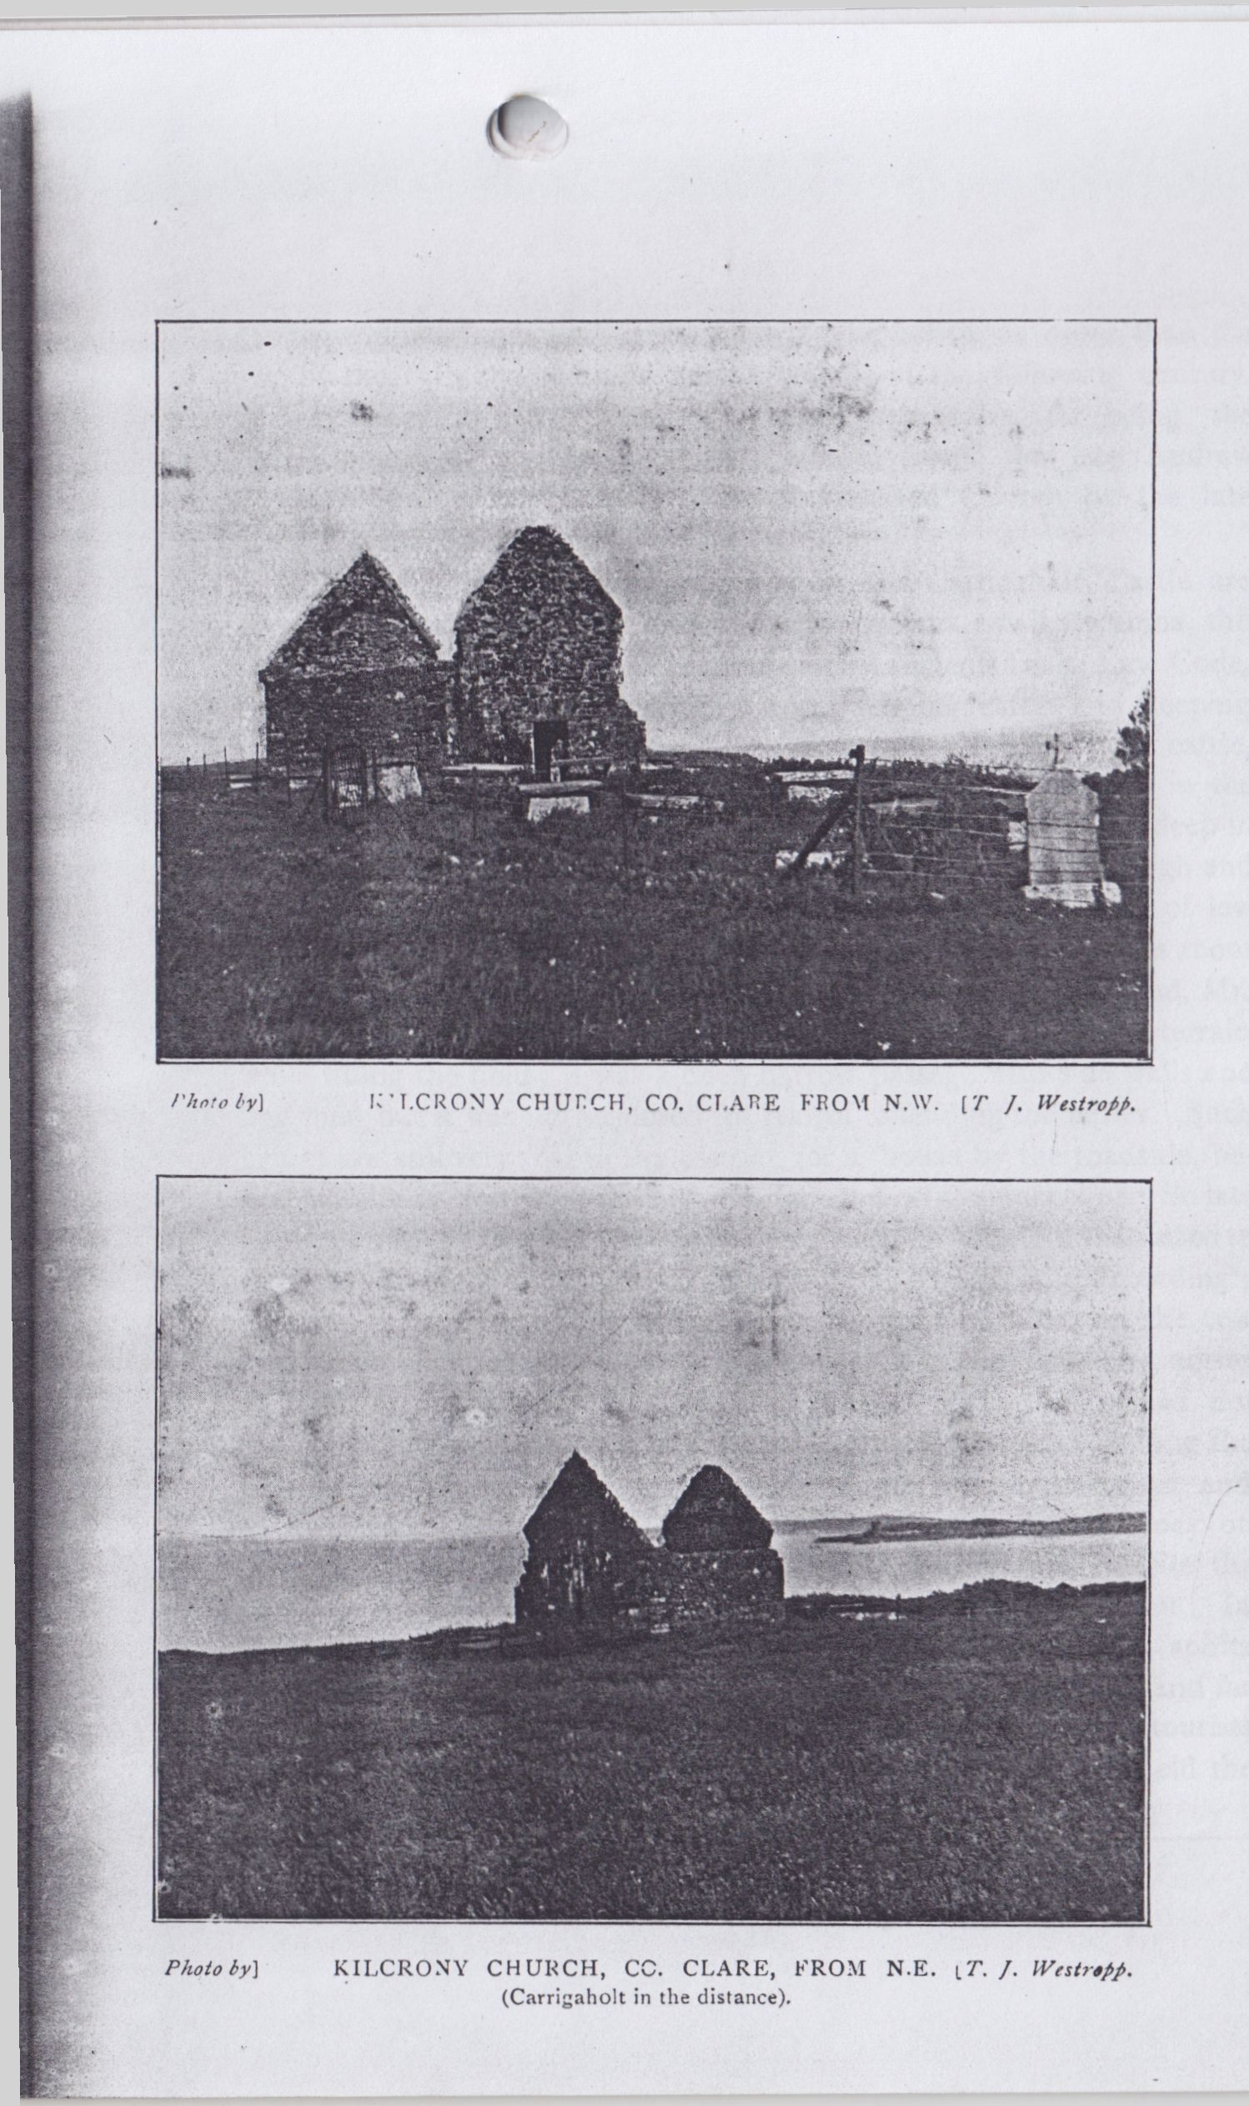

235

the impropriate lands and worth £5. It can hardly be older than the end of the 15th century, and might well be of the following century. Mr. Graham in 1816 notes it as only remarkable for being the burial place of the Morony family, whose head, the late Andrew Morony, of Dunaha, was won to the Established Church by the late Rector, Dean Coote(27).

The only object of interest between it and Carrigaholt Castle are certain earthen forts. The principal Lissaphunna or Lissyhunna, the (cattle) pound fort, recalls the section of the ancient Irish Law Code, the Senchus Mór, which provides for impounding cattle and keeping them in forts in dark nights, and the heavy cattle tributes, 1,200 cattle, besides cows, wethers and sows claimed from the Corcavaskin in the Book of Rights. The fort had an outer ring, a ditch 8 feet deep in places, full of water-loving plants, with a ring 5 or 6 feet high and 12 feet thick on top and 14 feet over the fosse. Another liss of low broken mounds, probably the bawn of its stronger neighbour, lies about 80 yards to the east. Near it, an old farmer in the neighbourhood, Mr. Peter Hanrahan, when a child, saw his uncle break into a souterrain while tilling the field; it was a deep narrow passage with side walls and flag roof, but it was not explored for fear of offending the fairies. Such beings are still very real in the district, for a house by the roadside, between Kilfiera and Liscroneen, was deserted on their account. So late as about 1895 “things” were seen there, and “a little old man used to come in at night and sit on a sod of turf.” The people accordingly deserted their good house, letting it fall to ruin, and fitted up the cow house as their residence. In another house, near the last, weird noises at night terrified the inhabitants into a similar flitting. We need not use such an incident to prove the necessity of education among the peasantry in the country districts, when, in the wealthiest classes and greatest cities, hundreds of willing dupes waste hoards of money on clever impostors, palmists, crystal gazers and spiritualists, despite the constantly reinforced evidences of fraud of the lowest description. In face of such wretched credulity, the honest belief in elemental spirits (even if it drives a family to live in a cow house), is respectable and far less contemptible in the believers. Yet we have known tourists steeped in the more fashionable superstition sneer at those who hold the less hurtful and more venerable one.

1. Mason’s “Parochial Survey,” II., p. 435.

[to BE CONTINUED.]

North Munster Antiquarian Journal Vol 2(1) 1911

**CARRIGAHOLT (CO. CLARE) AND ITS  
NEIGHBOURHOOD**.

PART II.

By THOMAS JOHNSON WESTROPP. MA.. M.R.I.A.

Continued from page 235.

The present time is indeed a critical period for Irish Arclneology; the old guardians (such as they were) of the ancient buildings are vanishing, and no one seems ready to take their places. Had the fear of the fairies been replaced by a rational pride in our ancient remains all could hail the more enlightened protection, but, as has too truly been said, men tear down a stone fort, or level a rath or dolmen, singing “Let Erin remember the days of old,” when not only remembrance but preservation is a duty to Ireland. The country gentleman had rarely any regard for antiquity, but a castle or a fort in his demesne was usually protected. Now, as the lands are broken up, one might hope that the descendant of the old tribes would show more tenderness for early relics of his ancestors than the descendant of men of another country and history, but this is far from being the case. Save for the support of the Archaeological Societies even publication might become nearly impossible in Ireland. This is a poor country, the interest in the past is satisfied by poor, often inaccurate, “popular” books, and by sketchy newspaper articles, sometimes, indeed usually, by most incompetent persons, inspired by the wildest and most unscientific theories of the dark days of Vallancey and Ledwich. Our wealthy men spend their surplus mainly on field sports and other amusements, and what has been spent in Clare in one year on hunting and racing may equal all the State grants (and even private benevolence) in support of the study of our past given during many years. In 1898 a short note on the forts of S.W. Clare drew from the Limerick Field Club the suggestion that this interesting district might be worked; I hoped that this might have been done locally, but nothing came of it. Ten years later I ventured to take up what no one else seemed inclined to do, and harvested (in some

30

degree) this rich field, so far as its principal forts were concerned. I now gladly take advantage of the willingness of the North Munster Archaeological Society to publish my notes, not only on the early remains, but on the castles and churches of the Irrus. Of the castles, none approaches in interest the residence of the O'Briens, Lords of Clare, at Carrigaholt.

From almost every point, from the high grounds of Moveen, along the ridge past Kilfieragh, and from the Kerry shores across the Shannon, the thin dark tower of the castle is a conspicuous object As we pass through the village, or see it from the fields to the south-west, or go round the shrubberies of Mr. Burton’s pretty villa, and the masses of flowering hydrangeas, the plain old tower is a striking and even beautiful object; the most picturesque view (that which we give here) is from the end of the little pier at the harbour. Unfortunately, when we deal with its history, the lack of records of the 15th century hampers our first step. In eastern Clare we have, at least, old (if not infallible) tradition in the castle founders’ list, but its compilers had little, if any, knowledge of the western peel towers, and Carrigaholt is not given. This castle probably dates in the closing period of the 15th century, or in the following years. There are no distinctive features in the earlier work, and most of the inserted windows evidently date about the same time as the fire place, i.e. 1603. The place was of so little note that it is only in 1598 that it is even named in history, in which, despite its fine position, it finds little place. The district (leaving out the early tribes(1) and their successors, the O’Donnells) passed into the powers of the Mac Mahons, perhaps about the middle of the 11th century, but every point seems uncertain. We have their pedigree from Brian to Donchad Carrach, but little more than the names in the main line of descent(2). In 1277, Torlough O’Brien, who had deposed his uncle, King Brian Ruadh, went to

1 The ancient chiefs of Corcavaskin (so far as recorded) are—717. MacTolamnach, slain by Connacht men; 817, Aedh Roin d; 862, Cermad, son of Cathernach, slain by the Norse; 913, Lena, son of Cathernach, d.; 918, Murchad, son of Flan, d.; 992, Dunnadach, son of Diarmait, d.: 1013, Donall, his brother, slain 1014, at Clontarf: from him the O'Donnell chiefs were named: Aneslis, his son, slain 1149; Ua Domnaill, slain by O’Conor, of Corcomroe, 1158.

2For the following see the wars of The Gaedhil with Gaill, the Cathréim Thordealbhaigh. The Annals of the Four Masters: Inquisitions in The Public Record Office: Frost’s History of Co. Clare,” pp. 65, 74, 75, 78: Book of Lecan, p. 430; old Kerry Records (Miss Hickson), vol. i.,p. 106.

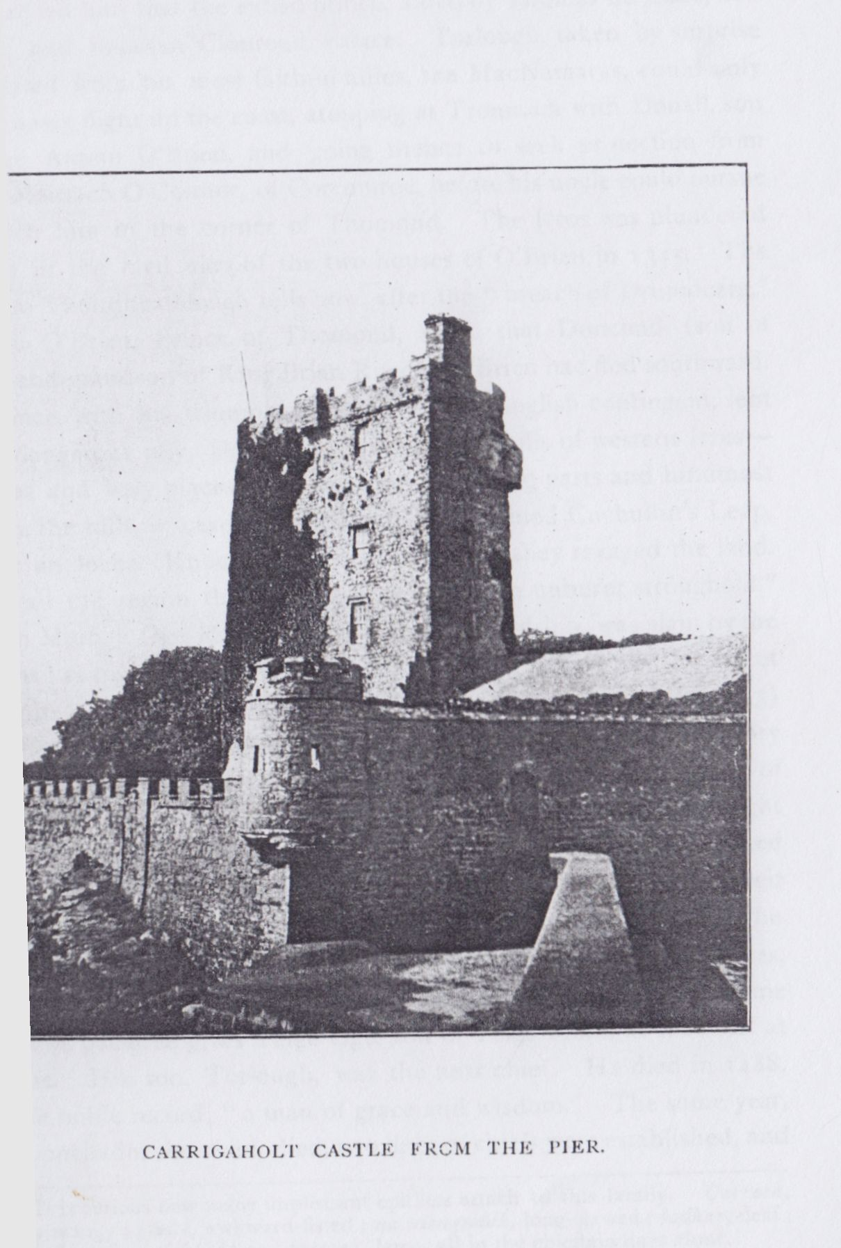

31

Corcavaskin to visit Teige Rory MacMahon. While there the alarming news reached him that the exiled prince, aided by Thomas de Clare, had returned and re-taken Clonroad Palace. Torlough, taken by surprise and isolated from his most faithful allies, the MacNamaras, could only make a hasty flight up the coast, stopping at Tromrach with Donall, son of Teige Aluinn O’Brien, and going thence to seek protection from Donall Mantach O’Connor, of Corcomroe, before his uncle could pursue and catch him in the corner of Thomond. The Irros was plundered later on in the civil wars of the two houses of O’Brien in 1315. The Cathreim Thoirdhealbhuigh tells how, after the “breach of Drumdearg,” Mortogh O’Brien, Prince of Thomond, heard that Donchad (son of Donall and grandson of King Brian Ruadh) O’Brien had fled southward. The prince, with his triumphant army and an English contingent, lent by his dangerous ally, De Clare, “entered the hills of western Irrus— churches and holy places excepted—in its outlying parts and hindmost nooks in the hills, in cave and deep glen, from famed Cuchullin’s Leap, to cnoc an locha (Knockalough near Kilmihil), they ravaged the land. Nor in all the region they punished left they an unburnt stronghold.” In 1359 Morogh Oge MacMahon, heir to the Lordship, was slain by the O’Briens; as his followers lamented, “the sapling blighted by the parent tree.” In 1383 died Donough an Chiul, or Donchadh Carrach(3) McMahon, Chief of Corcavaskin. His son, Dermot, was father of Rory Buidhe, who left a son, Torlough Bodhar MacMahon, Chief of Corcavaskin, who, in 1426, was burned by his own kinsmen in a night attack. His brother, Donchad na Glaice (“six-fingered”?), continued the line. Teige Mor (evidently his son Teige) died in 1432, while heir apparent. In 1460, the redoubtable O’Maille clan, true even then to the motto: “Terra marique potens,”(4) with certain O’Brien allies, attacked Corcavaskin, but were beaten off by the MacMahon, with some loss. The pedigree gives Teige Oge, son of Teige More, as the chief at that time. His son, Torlough, was the next chief. He died in 1488, with the noble record, “a man of grace and wisdom.” The same year, when Donchadh, the chief, died, two lines of chiefs were established, and

3 It is curious how many unpleasant epithets attach to this family. Carrach, scabby or mangy; glaice, awkward-fisted; na niongnadh, long-clawed; bodhar, deaf; caech, blind or short-sighted; and baccagh, lame, all in the chieftain lines alone.

4 Monument in the Monastery of Cliara (Clare Island), Co. Mayo.

32

Corcavaskin divided between them namely, Brian, his son, and Teige Roe, son of his predecessor, Torlough. This was the turning point in the fortune of the race; both lines suffered, and the Western lost all influence and sank into nearly complete obscurity till an ill-judged seizure of a ship sufficed to bring about its final ruin. Teige Roe died in 1513: his son, Mortough, in 1545; his son was chief, presumably in 1568, and died in 1594, whence three generations—Torlough Roe d. 1629(5). Sir Teige, Baronet of Clonderalaw, and Sir Turlough, living to the time of the great civil war, complete the Eastern line of chiefs. The Eastern line was known as “The race of Tuath na fearna” 1589, this being the “Toanefeorna,” reserved in Perrot s composition of 1585. That territory was bounded to the north by the Bealacorick river, and lay round the Castle of Dangan Moybuilc, a picturesque ivied tower, with a strangely-balanced turret on top, and itself on a boldly-upheaved rock ridge near Ballynacally.

There is even less to be told of the Western chiefs, with whose chief castle we are at present more concerned; nor have I (any more than my predecessors) been able to attach their line to the main stem of MacMahon. Donchadh Baccagh, “the lame,” Donchadh and Brien succeeded to the chiefry. Torlough, son of Brien, was “of great fame and character throughout Erin, if we consider the smallness of his heritage, for he had but one triucha caed of land.” He died in 1595, and his son, Teige Caech, “the short-sighted,” proved too well deserving in character, if not physically, of his sobriquet. Ignorant(6) and reckless he seized on an English ship, “which had been going astray some time,” and put into shelter near his castle of Carraig an Choblaigh in 1598. Teige took it from the crew, “with all its valuables, but the profit was very trivial and the punishment severe.” Not content with this the feeblest of the chiefs of Thomond offended the most powerful, the Earl of Thomond, and, as if he had not done enough, he seized on Dunbeg Castle, pledged to a Limerick merchant. Dissatisfied with the enmities he had aroused he sought aid from James, the Sugan Earl of Desmond, and thus reinforced, beat off Torlough O’Brien, who had hired a troop of

5 Father of the Amazon, “Maureen Rhue,” wife of Col. Conor O’Brien, of Lemaneagh Castle.

6 “He was bounteous, and a purchaser of wine, horses, and literary works,” but he evidently did not realise the trend of events or the strength of the Government.

33

English soldiers, and attacked Teige for his seizure of the ship. The Earl of Thomond, confident of an easy victory, marched to the west, but MacMahon, not even waiting to be invaded, went to meet him, surprised him at Kilmurry Ibrickan, scattered his forces, and took the Earl prisoner. He confined him in Dunbeg Castle, but after a week had cooled down the angry chief, some slight consideration prevailed, and he set his now implacable captive free without terms; ill-advised in this as in everything. Hugh O'Donnell’s invasions gave the Earl plenty of employment for a while, then came a pause, and the English party could attend to its less dangerous foes. Even still there was room for repentance, but Teige held out. Sir Conyers Clifford, the Governor of Connacht, sent soldiers, under Richard Scurlock, the sheriff of Clare, and others, to reduce various robber chiefs in Thomond. They arrived at Carrigaholt, and were ready to give peace to MacMahon, but he refused and shut himself up in his tower. Unprepared for a siege, and obliged to hurry back to Ennis for the sessions, they left him, after plundering his lands. About a month later the Earl of Thomond fell upon the district, which he plundered from Knockerra (Cnoc doire, four miles from Kilrush) to Leim Chonculainn (Loop Head), and four days after Easter sat down before Carrigaholt. A cannon was sent from Limerick, probably by water. Carrigaholt was besieged, and MacMahon and his son, Torlough, fled in the luckless ship. Having reduced the castle, which surrendered on the fourth day of the siege, the Earl next went on to Dunbeg. The fear of cannon, even of the little feeble guns of the day, was very great in Thomond, and the castle surrendered on terms which were instantly violated, for the Earl had not forgiven his imprisonment, “and the protection they obtained only lasted while they were led to the gallows, from which they were hanged in couples face to face.” He then took Dunmor mhic an Fheormicaigh, and restored other castles to their owners, and the power of the MacMahons was ended. Very briefly must we tell the tragic end of the chief of Corcavaskin. He went to Berehaven in 1602, and sought help from O’Sullivan of Dunboy. Again the unfortunate ship was destined to complete his ruin. O’Sullivan asked for her to send to Spain for help against the English, and Teige refused. The chief of Dunboy accordingly took his visitor with him in a boat, probably as a hostage, and rowed out to the ship. Suspecting a plot to seize his only possession, Teige, as they neared the ship, shouted

34

to his son, Torlough, to shoot at O’Sullivan. The unhappy young man fired, and shot his father(7). In the confusion the innocent parricide was able to sail away. He fled to Spain, and vanishes from history in agony and remorse.

The peasantry, however, told a different tale (which I reserve for the account of Dunlecky Castle), which attributed the ruin of MacMahon to his attempt to slay an O’Brien, who was making love to his daughter.

Daniel O'Brien, the hero of the legend, certainly stepped into possession the year after the death of his predecessor, the remodelled windows and the fire place, evidently by the same workmen, with “D.B. 1603,” attest this. The grant to him of MacMahon’s lands was only perfected a year later. It dates in September, 1604, giving him “Daniel O’Brien, brother of the Earl of Thomond,” the lands, &c., of Carigkeehowle, Donbegg, Ballekittes, Moyart, Dunlike, Dowagh (at Kilkee), Goer, etc., a very long list.(8).

Whether the young man deserved it by any service to the Government, I am not aware, but it is probable that the Earl being the victim of imprisonment by the imprudent, “short-sighted Teige”, was able to get the grant for his brother, so as to have a reliable ally in the south-west of Thomond. The Earl was all powerful and all necessary to the English, that he valued their friendship above honour and truth is seen by his conformity to the Established Church, while “a Catholic at heart,” for which Father Mooney(9) gives him no more severe censure than “that worldly nobleman.” He had been engaged in cajoling, or forcing, the independent communities, such as the O’Conors of Corcomroe, to subordinate their rights to him, and the O’Gormans had confirmed his rights in a remaining third of Dunbeg Castle. So it is evident that he regarded himself as his brother’s keeper, and procured Daniel’s advancement as a step to his own interest in a far wider scheme.

In our anxiety to keep together the tale of the MacMahon chiefs we were compelled to pass by a small episode of a great event. In the merciless north-west gales of September, 1588, several ships of the Spanish Armada put into the Shannon mouth in their frantic search for

7 Annals Four Masters. Inquisition, 22nd July, 1608, P.R.O.I. He was shot on June 15th, 1602.

8 Patent Rolls, James I., Ireland.

9 The report of Father D. Mooney, 1619.

35

water and rest. Sir Richard Bingham reports to the Lord Deputy that he has been informed that seven ships had arrived at Cargecolly, not 20 miles from Limerick, on February 8th. He was evidently uneasy, but six put out to sea on the 12th, after setting the seventh on fire, and letting her drift ashore. Dysentery from bad food and worse water was taking more than its tithe of the crews, and there were probably not enough survivors to man the whole number. The news of the Dunbeg and Mutton Island wrecks, and of the departure of the mighty Zuniga from Liscannor Bay, reassured the Government, and Bingham tells with pleasure how some hundreds of Spaniards, who escaped the sea in County Clare, were taken and put to execution.(10).

For Daniel O’Brien there was a long, rather curious career. He was the third and youngest son of Conor, Earl ol Thomond, by his second wife, Owney, daughter of Torlough Maclbrien Arra, and was a captain in the army of Elizabeth. He was knighted at Leixlip, July 1st, 1604, and was Member of Parliament for the County Clare, retiring in 1639, in order to take his place as its representative in the Confederate Catholic Parliament at Kilkenny. He took an active part in the war, and did some unspecified services for King Charles. In February, 1642, Sir Daniel helped to besiege Ballyalla, along with his son, Conor, then of Baliymacooda, Conor O’Brien of Lemaneagh, and others. The quaint details of the siege, and the wonderful “lethren goon” concern us not, save that it was Sir Daniel, who, after lighting a number of fires to distract the garrison, sent forty musketeers in the dark to capture the haggard, and cut off the defenders from the water supply. The garrison made the place too hot for the intruders, shot several, prevented food reaching them, and finally the Irish had to send a cot to relieve them across the lake. A little later, in a sally, all the men were killed, save one who swam across the lake(11).

In the depositions Sir Daniel’s acts of hostility to the English settlers find constant mention. Gregory Hickman heard that O’Brien’s followers had murdered William Mor at Kilrush, and he was unable to recover debts owing to him from Conor, of Baliymacooda. Teige Roe O’Brien, another son of Sir Daniel, took part in the Siege of Tromra,

1. Calendar State Papers, Ireland, 1588.
2. “Cuffe’s Journal of the Siege of Ballyalla” (Camden Society).

36

and "imprecated the curse of God upon anyone that did not join in the Rebellion.” Teige was at that time at Newmarket-on-Fergus. Sir Daniel took away £1,500 of the goods of William Chambers to Ballykett, and added to his injurious conduct by capturing the complainant, with Jacques Graniere, and the latter’s three sons, and imprisoning them in the same castle. A certain Robert Abraham complained of being robbed by Sir Daniel O’Brien of Carrigaholt. He also repudiated his debts to George Waters, of Ennis, merchant, but on the whole the recorded acts of Sir Daniel and his sons are either open warfare or somewhat vague ideas as to the sanctity of the property of non-combatants, no actual murders or atrocities are attributed to the family.

On June 16th, 1646, after the surrender of Bunratty Castle to the Confederates, under Rinuccini, the Archbishop of Fermo, Sir William Penn, father of the famous Quaker, the founder of Pennsylvania, sailed down the Shannon, frustrated of his attempt to hold the ancient castle of the O’Briens. He lay at Enniscattery on the 16th, drifted down to Sir Donnell O’Brien’s Castle of Carrigaholt, whence they sailed away to Kinsale the following day, leaving the west in the hands of the Confederates.

In 1651 the scale turned against the Confederates. Limerick was beset by Ireton, and Ludlow was sent to reduce Carrigaholt. Just then an untoward event (unfortunately still common in those parts) delayed the fall of the tower, but by very little. General Ludlow, in his draughty tent on a hill near Clare Castle, caught a heavy cold. There was no doctor, so he nursed himself. It brings “the man of iron” within the limits of our sympathies to read how he improvised a sort of Turkish bath in a cabin of which he had taken possession. He put on a buff coat over his clothes, a fur jacket over it, and over all an oil coat, and went to sleep. Next morning he was so heated that he had to lie up under the protection of two troops of horse, the foot soldiers having been sent on to Moyarta. He was unable to start for some time, and when they came up with the men it was in a severe gale, with hail beating in their faces till the horses used to turn their backs on it.

At last they came near Moyasta, near which they met the first and only active opposition. The O’Cahans succeeded in killing Captain

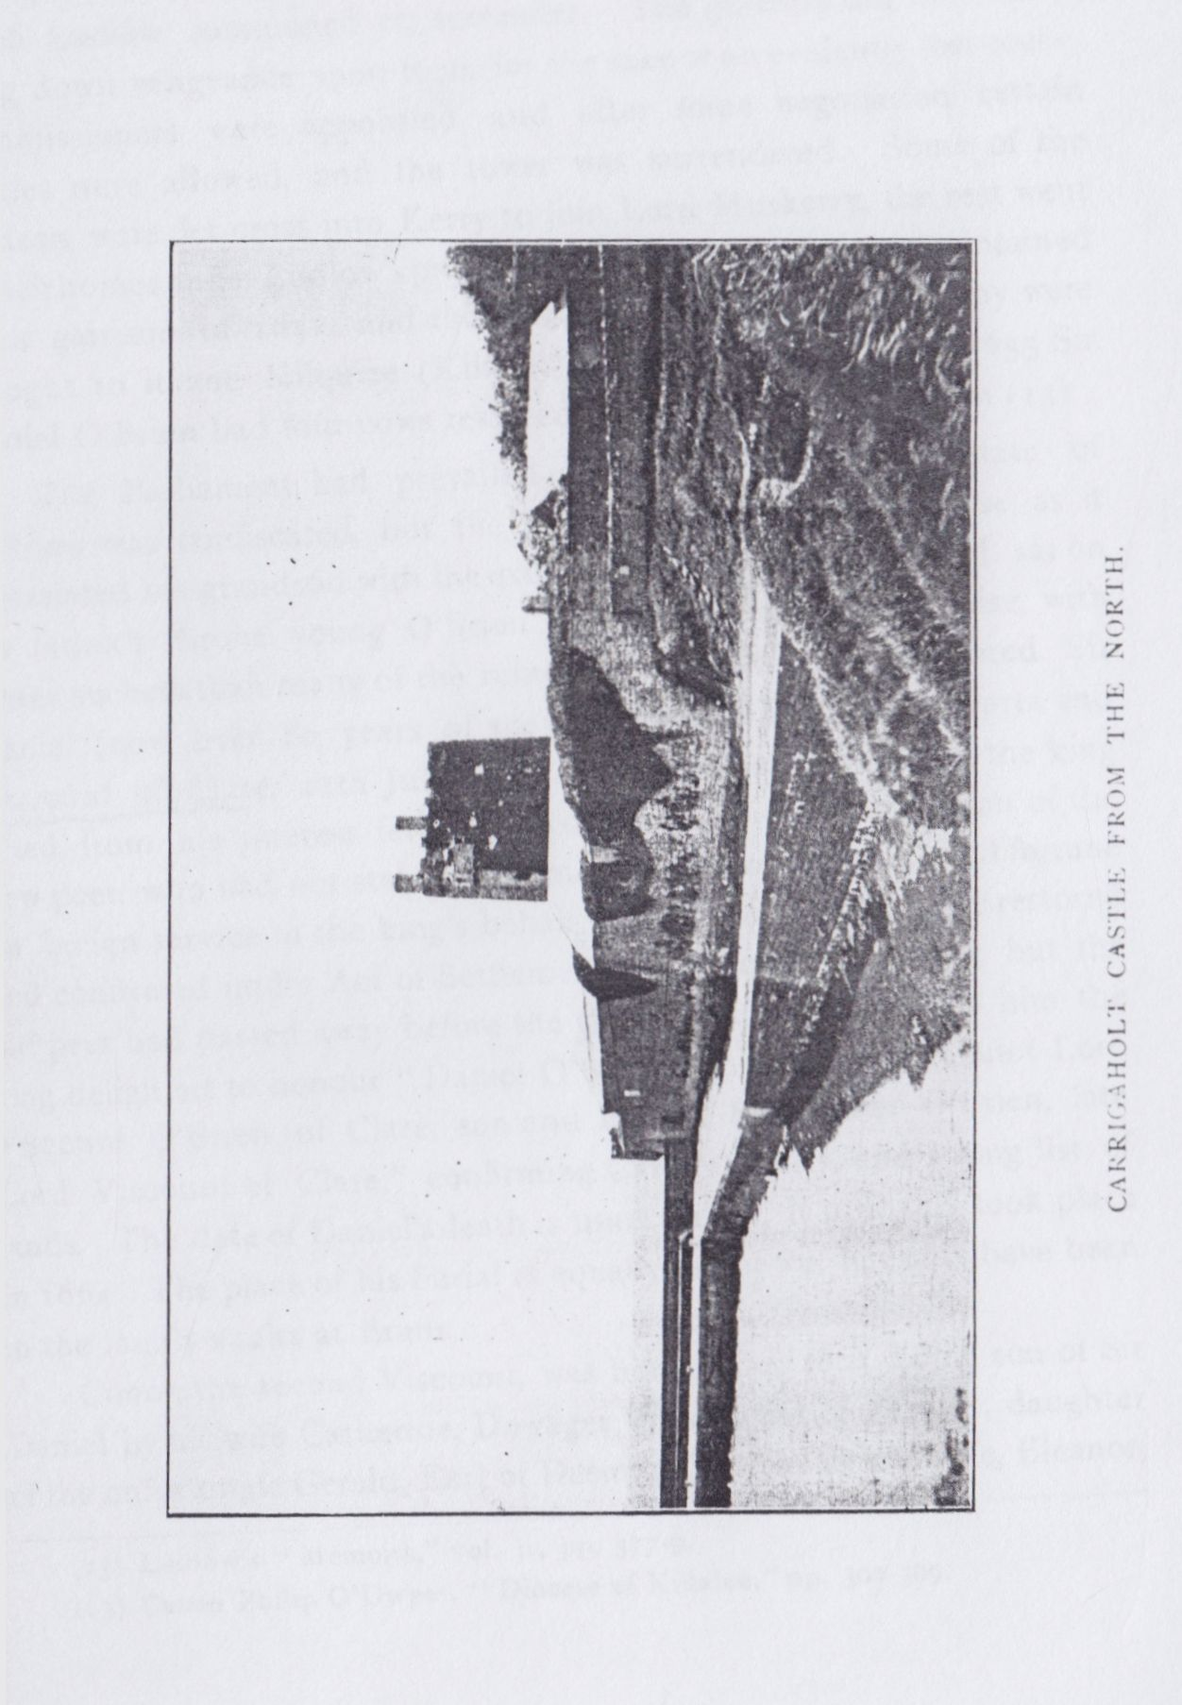

37

Scaff and cut off his head, fixing it on the gable of Kildimo Church. In fording the arm of the sea at Moyasta, near the Black Weir, they found the crossing troublesome, and the water up to their arm-pits.

At last the army of the Parliament was before Carrigaholt Castle, which Ludlow summoned to surrender. The garrison did not care to bring down vengeance upon them for the sake of an evidently lost cause. Commissioners were appointed, and after some negotiation certain articles were allowed, and the tower was surrendered. Some of the garrison were let cross into Kerry to join Lord Muskerry, the rest went to their homes under Ludlow’s protection(12). The building was maintained for a garrison in 1652, and the dues of oats paid by the Barony were brought to it and Kilquiee (Kilkee) Castle for storage. In 1653 Sir Daniel O’Brien had four cows restored to him by Samuel Burton(13).

The Parliament had prevailed, and the whole large estate of O’Brien was confiscated, but the exile was a blessing in disguise, as it ingratiated his grandson with the exiled king. When Charles II. sat on his father’s throne young O’Brien reminded him of his promise, with better success than many of the ruined royalists, it was fully granted. Sir Daniel (now over 80 years of age) was created Baron of Moyarta and Viscount of Clare, 11th July, 1662. The patent recited that the king acted from his interest felt in the younger Daniel, the grandson of the new peer, who had not stayed at home, but had ventured life and fortune on foreign service in the king’s behalf. The family estates were restored and confirmed under Act of Settlement, 27th December, 1666, but the old peer had passed away before the grant. It was made to him the king delighted to honour “Daniel O’Brien, son and heir of Conor Lord Viscount O’Brien of Clare, son and heir of Sir Daniel O’Brien, late Lord Viscount of Clare,” confirming Carrigahoullty, and a long list of lands. The date of Daniel’s death is unrecorded; it probably took place in 1664. The place of his burial is equally unknown, but may have been in the family vaults at Ennis.

Conor, the second Viscount, was born about 1605, being son of Sir Daniel by his wife Catherine, Dowager Viscountess of Fermoy, daughter of the unfortunate Gerald, Earl of Desmond, by his second wife, Eleanor,

1. Ludlow’s “ Memoirs,” vol. I., pp. 377-9.

13 Canon Philip O’Dwyer, “ Diocese of Killaloe,” pp. 302-309.

38

daughter of Edmond Butler, Baron of Dunboyne. He married Honora, daughter of Daniel O’Brien, of Dough Castle, of whom we had somewhat to tell of his humanity to the English, and his interference after the siege of Tromra, in former papers. Little of any interest is attainable about this nobleman, being nearly 60 years of age when he succeeded to the peerage, he probably yearned for quiet after the long years of strife and exile, and he lived at his old home so obscurely that even the date of his death is unknown, but probably took place in or about 1670. Then, at last, the man for whom the peerage was originally intended succeeded to the title.

Daniel O’Brien, the third Viscount, was destined to bring his family to irretrievable ruin. He held the extensive estates, all Kilballyowen Parish, and much of Moyarta and Kilfieragh, with other lands through the county, for about 19 years. Then, James II. was deposed and came to Ireland. Daniel’s loyalty to the Stuart line shone out; he raised two regiments of Infantry and one of Dragoons, for the King in 1689, regarded as the “flower of King James’ army,” but the doomed regiments were nearly cut to pieces in an ambuscade near Lisnaskea, July 26th, 1689. Lord Clare fought at the Boyne, and was outlawed in May, 1691, he died in that year(14) before the ruin fell on him, leaving a son, Daniel, by his wife Philadelphia, sister of Thomas, first Earl of Sussex, and daughter of Paul Bayning, Viscount Bayning of Sudbury, she had died 1662,

The estate of 56,931 acres was confiscated, and in February 26th, 1698, was granted by William to his faithful friend, Keppel, Earl of! Albemarle, who sold it at once to Francis Burton, Nicholas Westby, and James MacDonnell(15), thus forestalling its resumption by the Parliament, indignant at William’s favoritism.

Daniel, the fourth Lord Clare, a ruined man, retired to France commanding certain Irish regiments there, April 7th, 1690, King James formed them into part of the “Old Brigade,” at their head Lord Clare was mortally wounded at the victory of Marsaglia, gained by Catinat over Prince Eugene and the allies, 4th October, 1693, and died soon afterwards at Pignerol.

1. His will is preserved in an Inquisition connected with the forfeiture. It is given in the late Mr. James Frost’s History of Co. Clare.
2. Patent Rolls, Ireland.

39

His son, Charles, had accompanied Queen Mary, of Modena, to France, fought at Marsaglia, Blenheim, and Ramillies, where he was mortally wounded, and died in the Irish Monastery, at Brussels. Charles the sixth Viscount, like all his race, a brave soldier, was (before he had time to win his promotion) made a Captain at the age of 5, and a Colonel at 21. He was allowed to visit England, and promised restitution of his lands and honours if he conformed to the Established Church, but he refused. He was wounded at Philipsburgh in 1734, and made Inspector-General. His kinsman, Henry, Earl of Thomond, bequeathed him £2,000, and he assumed the title as next in descent, but it was never recognised by the English, and he was generally known as the Mareschal Compte de Thomond. He commanded at Dettingen, 1743, and Fontenoy, 1745, greatly distinguished himself at Roucroix and was made Knight of the Order of the Saint Esprit, 1746. He was Governor of New Brissac in Alsace, Commander and Chief of Languedoc, he died on November 9th, 1761(16) at Montpellier, and his young wife died two years later, at the age of 20. Their son; Charles, titular Earl of Thomond, seventh Viscount of Clare and Baron of Ibrickan, died unmarried, under age, 29th December, 1774, in Paris; his sister, Antoinette, married the Duc de Choiseul Praslin, and left descendants(17). Truly great were the sacrifices of love and loyalty made to the ill-deserving Stuarts.

The next owners of Carrigaholt were the Burton family, who still hold it. They are descended from Sir Edward Burton, of Longner and Boerton (Burton) in Shropshire, who distinguished himself in the Wars of the Roses, on the side of Edward IV., by whom he was made a Knight Banneret in 1460; six generations later his descendant, Francis Burton, settled at Buncraggy, near Ennis, in 1610, and from his brother, Thomas, of Eastwick, Shropshire, Mr. William Conyngham Burton, the present owner, and his cousins, the Lords Conyngham, of Slane Castle, on a beautiful reach of the Boyne, in Co. Meath, are descended.

1. Administration of Rt. Hon. Charles O’Brien, late Mareschal of France, 28th January, 1763.
2. The above, based on G. E C.’s “Complete Peerage,” with a free use of the Calendars of State Papers and Grants, under Act of Settlement, and Commissioners of Forfeited Estates, &c. See especially the Patent of James I. to Daniel O’Brien, of Moyartie, Knight. Act of Settlement Roll, 28., Cas. II. (in 15th Report of the Record Commissioners) 16th January, 1667, and Iniquisitions P.R.O.I.

40

It only remains for us to describe the Peel Tower. It stands on a low shore formed of long reefs of rock, with a bank of drift clay, into which the waves of the wide, and often stormy, Shannon are working great havoc. Tradition says (credibly enough) that Lord Clare used to drill his famous dragoons in a large and long-vanished field between the Castle and the river. How the place got its name, the Rock of the Fleet(18), or the Ulsterman’s Rock, is lost, the Records (as we saw) only commence at the very end of the 16th century, but shore names often have originated from some very casual circumstance, probably in this case from the drowning of some visitor from the northern province, or the wreck of a ship. The older name found in the rental of “1390,” and still attached to part of the lands, is Roin meic n dirge. The name form runs Carraig an Chobhlaigh, 1598, Carrigaholt in the Castle list, perhaps 1580-84. Carrighoylein, the Hardiman maps from 1590 to 1603. Carrickgoholgy, containing Reinmacderig, in the Visitation of 1622. Rathmacdirrigg in the Survey of “1675”(19) with a little view of “Carriggaholt Castle as held by Lord Clare.” The local belief has long favoured the less attested meaning.

The building, as is evident from the 1675 sketch, had a large mansion attached to the western side, and, indeed, apart from the projecting bond stones and other marks on the west wall, the tower evidently forms a porch to some vanished building. The 1675 house evidently replaced the usual main wing of the normal Peel Tower, with three stories, the lower usually vaulted, and the gateway section rising a story higher. The doorway, which we illustrate, faces the east, and is a neat pointed ope, recessed, with a shot hole in the south pier, and two sloping opes for pouring scalding water on unwelcome visitors; the porch is further defended by a “murder hole” in the vault; the inner door is pointed with a projecting slit in the west wall of the turret and there are pointed doorways to each side in the porch. A vaulted cellar, long used for wine till it proved to be too accessible to thieves, lies to the north, while to the south is a room from which a spiral stair ascends in the S.W. corner, with a small room to the east. A door opened into the stair passage from the demolished building, and old

18 Dr. Joyce: “Irish Names ofPlaces,” Series 1, p. 216.

19 At Edenvale, p. 31.

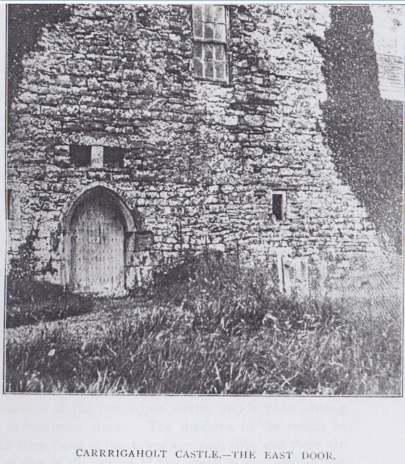

41

iron pikes were discovered built up in the wall of the cellar. The S.E. closet has the original slits to the S. and E. The steps have rounded ends, not a true newel, and are, like the greater part of the masonry, of thin flagstones. We reach the next floor at the 17th step; a side wing opened at the 35th; at the 46th is a window recess to the S., at 57th is a side room, at 68th another window recess looking southward, at 77th we reach the large unvaulted upper room with a stone floor, the large fire-place with D.B., and a turret to the N.W. The west window has a neat diaper pattern cut on its jambs, one of the few attemps at ornament in the plain old house. From this 16 decayed wooden steps lead to the battlements, the roof was in good condition in 1896, but the ends of the beams have since got greatly decayed, and it is dangerously near collapse. The view from the summit, though wide and pleasant, is rather flat and unpicturesque.

Taking the rooms under the main upper room in order, the upper has a pointed vault and decayed wooden floor, the next has a collapsed ceiling and floor, the next has a broken ceiling and a stone floor over the cellar vault, there being five stories in all. The second story has a curious curved passage round part of the spiral stair, the stairs are stepped underneath instead of the smoothly dressed work usual in limestone built staircases, and two of them have marks like mason marks, one an O, the other a centre line with two ribs or branches to each side. The vault under the top room was turned over wicker centres. All the inner doors are plainly chamfered. The lesser rooms have modern fire-places, and I hear that servants used to occupy these rooms in comparatively recent times, though the Burton family have not lived in them since early in the last century. The older windows are all closed, they run one above the other from the east door upward. The windows of the north rooms have angular heads with hoods ending in stepped drops, two oblong lights and lintels over the splays, but modern windows fill the old frames, they are evidently of the 1603 restoration. There is also one of these in each of the five upper stories, and a plain oblong light in the sixth, or basement storey. The windows to the rooms in the S.E. angle and other parts of the tower are plain slits, and there are machicholations at the N.W. corner of the upper storey, and in the battlements above the east door. The crenellations and chimneys do not seem very old.

41

I need not describe the forts round Carrigaholt, there is a lofty and well preserved example called Lissanuala, on the summit of the low ridge in Rahona West, visible from theCastle. It is 102 feet across the garth, 176 feet over all, with a fosse of 8 feet deep and 10 feet wide at the bottom and rings, the inner rising some 16 feet above it and 27 feet wide. A low fort hardly 4 feet above the field lies in Reinmacderrig, probably the Rathmacderrig of the 1655 Survey.

The churches and church sites of Kilcredaun, Temple an aird, and Moyarta I must reserve for the concluding section.

(TO BE CONCLUDED.)

North Munster Antiquarian Journal Vol 2(2) 1912

CARRIGAHOLT (CO. CLARE)AND ITS  
NEIGHBOURHOOD.

PART III.

KILCREDAUN TO ROSS.

By THOMAS JOHNSON WESTROPP, M.A . M.R.I A.

Continued from Page 42.

The triangular district in the S.W. of Clare, bounded by a line from Carrigaholt to Kilkee eastward, and by the Atlantic and the Estuary to the other sides, is very rich in remains of early times and contains some of the most beautiful cliff scenery in Ireland. It is very regrettable that few people take the trouble to examine its beauties from Dunlicka southward, so if, along with the archaeology, this paper induces a few persons to violate the etiquette of their drivers and see some places besides Ross and Loop Head the time is well spent. The geologist, naturalist, and botanist have fine fields for their respective studies, and the wonder is that one so rarely sees paintings of the glorious rocks and seascapes at Tullig, and southward to Cloghansavaun. Besides a wealth of ring forts and cliff forts, some of which we must briefly notice, and the chief of which I have described elsewhere, there are a number of church remains, Kilcredaun, Kiiballyowen (Cross), Temple an Aird, Temple Na Naeve at Ross and Bishop’s Island, as well as graveyards and church sites at Moyarta, Kilcashin, Kiltrellig, Kilcoan and possibly Kilbaha, Killeenagh, Killinny, and Kilclogher where the prefix may refer to woods, though the last two have Killeen graveyards, and so, very probably, had churches. Besides these there is mention of four castles, but only Dunlicka remains, an ever lessening fragment, and I neither know of any reliable record nor of traces to confirm the allegation of the 1839 maps and Mr. Frost(1) that one stood at Knocknagarhoon. It was certainly

1 History of Co. Clare, p. 91.

104

only a telegraph tower of which I saw the foundations dug out for road mending in 1908. I will describe first the churches in order;   
only Kilcredaun is of architectural interest, and the history of all is of little fullness, so I will deal with it together. Christian history in Corcavaskin, though St. Patrick is said to have blessed the tribes, evidently from Knockpatrick Hill near Foynes(2)commences with St. Senan,accordingly we may place first his disciple St. Charitan the founder of Cil Charitain or Kilcredaun(3) about the middle of the sixth century where appropriately the oldest architecture, though far later than Senan’s days, is still standing. Ross an Airchel is also mentioned as one of Senan’s churches, but the often asserted tale that it was founded by his nurse Cocha is absolutely unfounded. In fact St. Cocha, Conchad or Cuinche was nurse of St. Kieran, and her church of Rossbenchoir lay on “the eastern ocean” not the western as slated by Archdall and Dwyer(4) who took little if any pains to verify the statements of their predecessors in this matter. After a silence of eight centuries only one church, Kilballyowen or Killmolihegyn, is named in the oft-quoted Papal Taxation of 1302. Moyarta parish had evidently not then been established —the “1390” O’Brien Rental(5) calls Kilballyowen Baile I Eoghanain. The names of the churches in the “1390” rental are Cill beiteach (Kilbaha, Cealla beaga), Cros, Cil caeide (Kilkee), Cil cuirn (Kilcoan ?), Cilcroine, Cil fiabra (? fiacra, Kilfieragh),and Baile I Eoghanain; it possibly refers to Kilclogher as Oillen (? cillen) Clochair.

The next record of any value is in Edward White’s description of Thomond in 1574, published recently in these pages(6). “The Barony of Moyartha, which conteyneth West Corkewasken and is plowe lands after like rate XXV : Tirlagh Mac Mahowne chiefe in the same; Parishes—Vicar of Moyartha, Vicar of Inyskatty, Vicar of Kybruish, Vicar of Kylbairde” Kilballyowen being omitted this time. He mentions Tirlag’s Castles of Carighowly, Moyartha, Dunlykil, and Dunscomayn (Dunlicka, and Clonsavaun), the latter being invariably Dunsco- mayn and Dunsavaun in maps of the same period, probably from the

2 Tripartite Life (ed. Whitley Stokes, Rolls Series) Vol. I, p. 207, and Proc. R. I. Acad, Vol. XXV (c), p. 395.

3 Vita S. Senani under March 8. Colgans “Acta Sanctorum Hiberniae.”

1. See under account of Templenanaeve infra**.**
2. Trans., R. I. Acad., Vol. XV.

6 Vol. I. p. 80.

105

dun or early cliff fort in which the tower stood. The list is the original of numerous less accurate copies, the best known, that in T.C.D. 1584, does not give the churches. Sir John Perrot’s composition deed with the landowners on August 17th, 1585, states that “Tirlagh McMahowne shall hold the towne of Moyartie with two quarters” and other lands “as free domain to his house of Moyarte.”(7) As both castles of Carighowly and Moyartha are given in White's list it is evident that Moyarta was a separate castle, but no trace of it remains.

The 1571 Procurations of Killaloe Diocese in the Public Record Office of Dublin (p.154) give the rectories of Kilfieragh, Kilballyhone, and Moyfartagh, unfortunately no source condescends to any details, the names and at most the values alone interested the compilers.

The Hardiman Map of 1580-90 (No. 63 MS. 1209 T.C.D.) marks Carrig Hoyle and Kilcolgan (Kilclogher) “the mouth of the Shannon, bringing your wind with you care not for your tyde until you come to Tarburt.” Another (No. 2) of the same time marks Loopes Head and Can Leane, Kyllane, Donesuane, Donnelykey, Killegh (Kilkee), Kilcredan and Kilkerdan; yet another (No. 3) gives Kilcolgan, Carrig Hoyle and Tramore (Moyarta Creek). As for the other churches, Kilcashen, a part of MacMahon’s estates was granted to G. Earl of Kildare in a patent of May, 1601, but the building is not named.

It is only in Bishop John Rider’s Visitation of the Diocese of Killaloe(8) that we get any fuller mention. Killfieraghe Rectory belonged to the prebend of Kilrush and the church was unrepaired; the Rectory of Kilballihone, to the prebend of Tomgraney, at the opposite end of the country (a great abuse as it left the parish unserved taking its tithes far away) its church unroofed; the Rectory of Moyfartah, was impropriate to the Earl of Thomond, its church and chancel were also open to the sky. It had, however, a vicar, Robert Tuisden, who held the prebend of Kilrush (sequestered from a certain student Maurice Lynch) with a long district at least 15 miles long and 7 wide including the prebend of Kilrush, the vicarage of Kilmduan and Moefartah, the other

1. 50th Report, Dep. Keeper Records Ireland, p. 123, Fiant 4761.
2. Published by Canon Dwyer “Diocese of Killaloe.”

107

parishes in the barony were held by a layman, William Milsam, what protestants there were we are left to conjecture, they must have been very few and nearly confined to Kilrush where the service was performed.

In the later returns we find Kilrush served by the Prebendary of Inniskathy, Thomas Edens, and Kilmacduan by Murtagh O'Considin, a native and a minister, one that reads the Irish service to the people, and is of good life, inducted 1620. Kilfierah also had a minister and preacher of good life and conversation named Peter Ellis; Kilballihon had a minister and native, Dermott O'Harney, who had been inducted recently in April, 1622. while Moeffartah was under Peter Ellis. The list of lands and their lay "deteynors" shows how the greedy courtiers and adventurers were fed out the spoils among them, we need only at present note the church sites Kilcarradain, Kilbehah, Kilclohir, Kilcrony,  
Kilcashine. Kilquih or Kilkey, Killinagallah, Termontenan, Kilfierah, Kilcarrol, Kilmacdowan, Kilteelin or Termonfeerah, Kildeima, Killiny or Kilfinny held by Sir Daniel O'Brien, the Earl of Thomond, Dermot O'Cahan, and Owen O’Swiny of Kilkee, but chiefly by the Earl.

The Roman Catholic priests about the same time were Teig Owen of Moiffartah, and Mahoon c Jurcan of Kilrush. The Bishop of Killaloe says that no ancient registers had been preserved, so even in 1622 material of the older history was lost. Abraham Holt, Clerke, was vicar of Killard and Kilfierah since February 3rd, 1619 (1620).

The Visitation of 1633(9) gives Thomas Heaton, preacher, as prebendary of Inniskatty at £60 per annum, Murtagh Mac Considen, as vicar of Kilmacduan and Kilmihill, he could read Irish, and his salary was £10 a year; Nathaniel Buckley, as vicar of Kilfieragh at £8 and Francis Menerell, as vicar of Kilballihone, with no stated salary, he also held Moyfarta at £10. Murtagh Mac Considine “in re literaria studiosus had been ordained deacon in 1617 and priest the following year, his chief living was Kilmihill, so possibly Kilmacduan was still derelict: Menerell was ordained in 1633 in Ardfert when the living of Moyferta was resigned by Nicholas Bright (who was also incumbent of DrumcIiffe or Icormack and could scarcely have attended to so remote a parish), he was appointed to the same and Kilballyhone. Buckley

9 Also published to "Diocese of Killaloe."

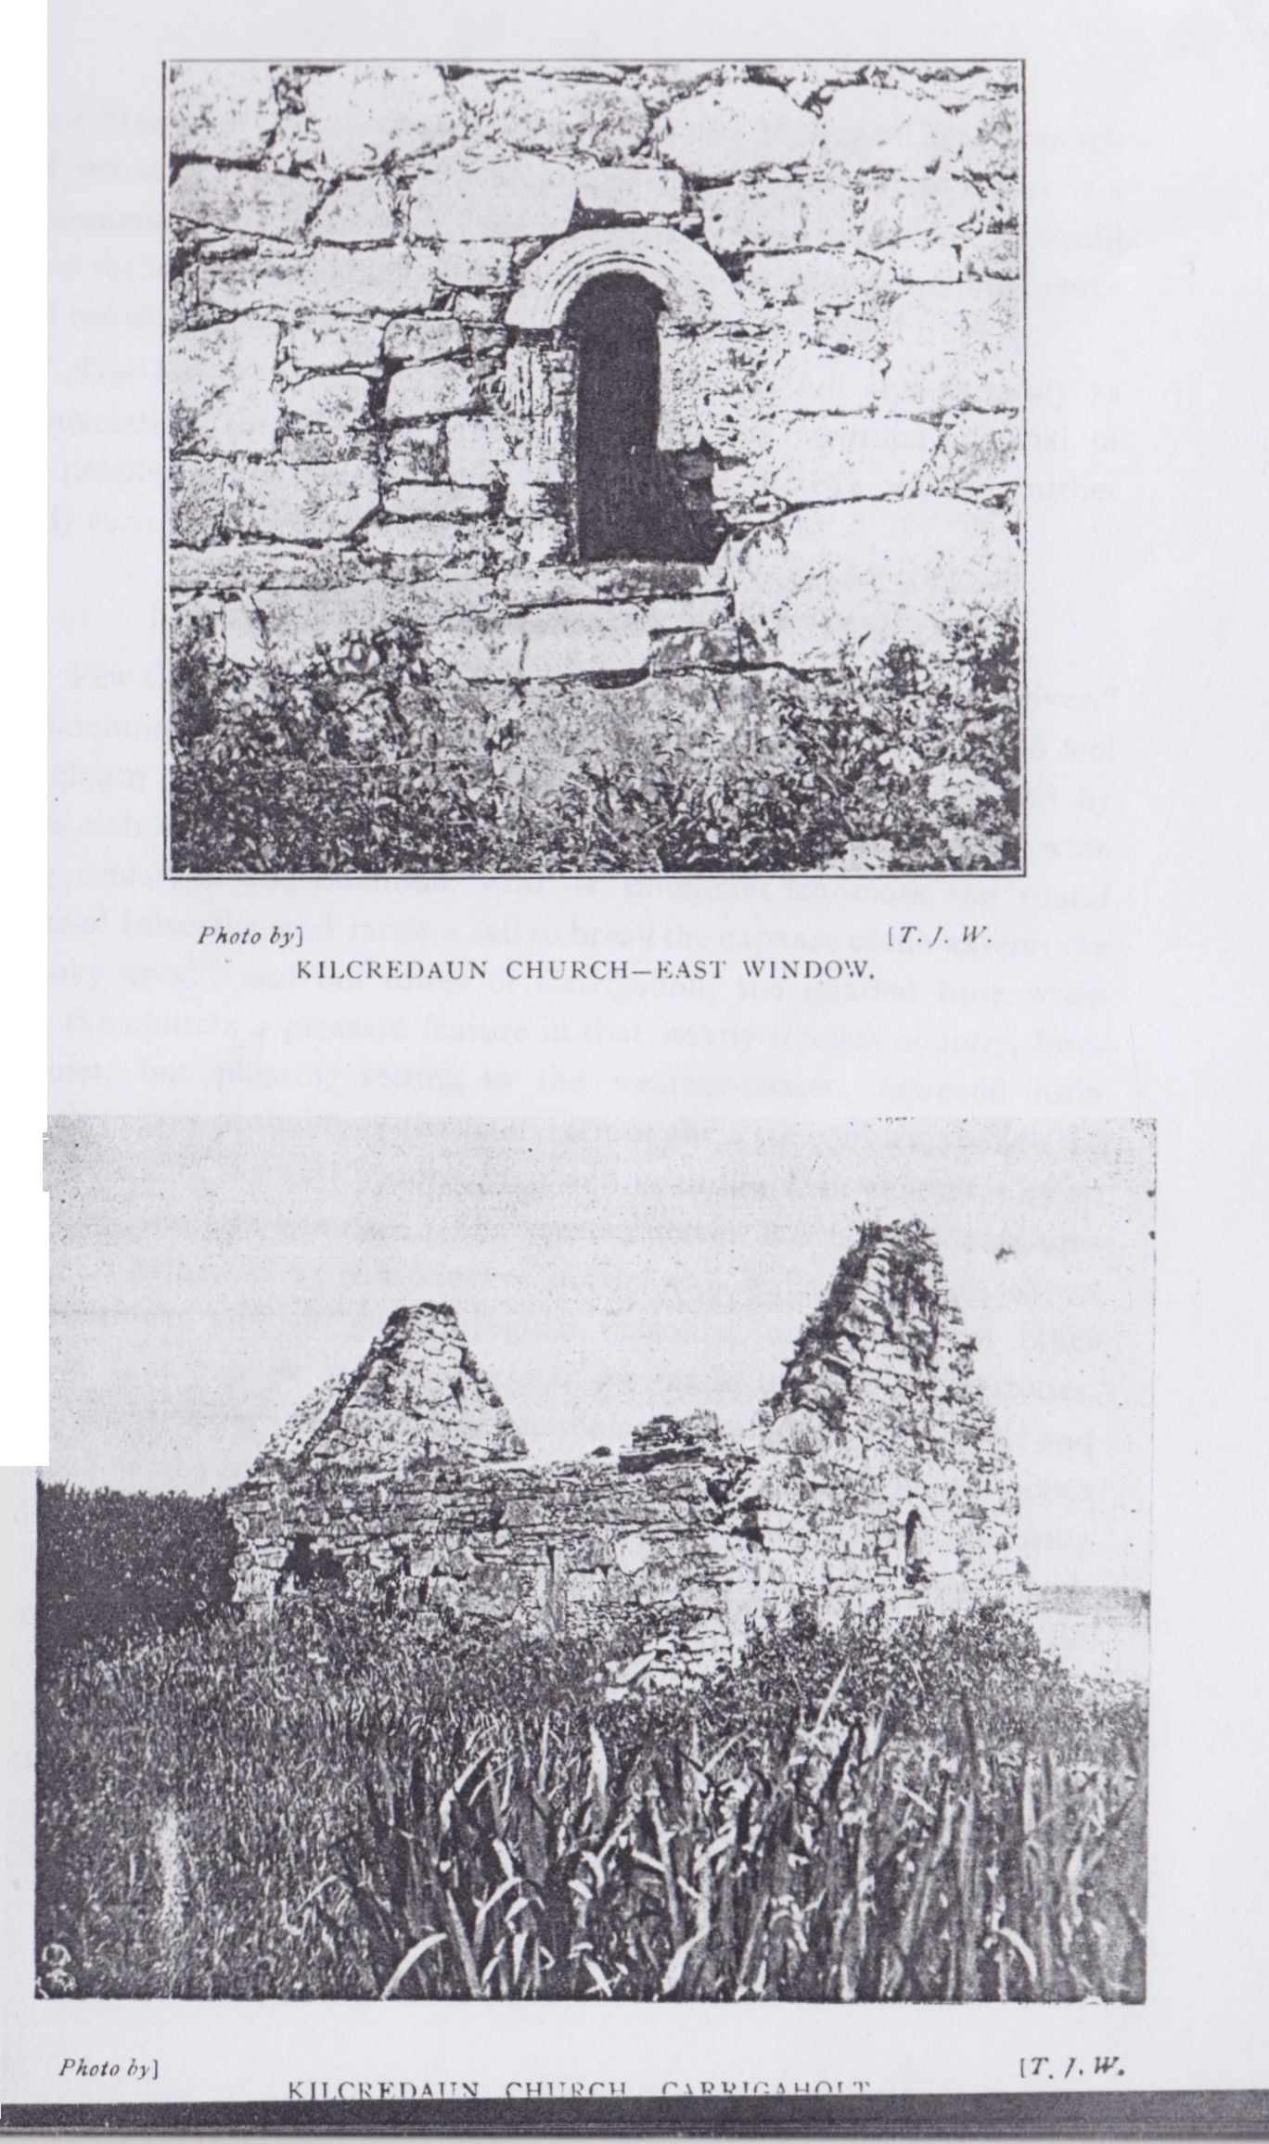

107

was a Master of Arts, ordained a deacon by the Bishop of Peterborough and priest by the Bishop of London in 1619. The whole report is a monument of the pains which the energetic Bishop Rider took to instill some reality into the work of his diocese with its endless nominal cures and ruined plundered parishes.

The history after the civil war is hardly as full and certainly as uninteresting, throwing no light on the condition, spiritual or social, of the people in this remote corner of Ireland, so we can without further study turn to the ruins of the deserted churches.

KILCREDAUN CHURCHES. (O.S. Map 72.)

Few that have ever visited the little “place of prayer by the river,” commemorating an obscure monk of the 6th century, have failed to feel the charm of the ruin and its situation to a degree often unexcited by more elaborate fanes. The rich marsh vegetation around it; the wide blue estuary of the Shannon, with its dominant landmark the round tower of Iniscatha, and rarely a sail to break the expanse of the waters; the “rooky wood” and tall tower of Carrigaholt, the gnarled little wood near the church, a pleasant feature in that nearly treeless country, form a quiet, but pleasing setting to the weather-beaten, lichened little church. It is probably of the later 10th or the 11th century, though the carved head of the east window may well be of the 12th century, and an insertion, but pre-Norman. The oratory faces E.S.E. and measures 23 feet 7 inches by 15 feet 6 inches inside, with walls 27 inches to 28 inches thick, and of good irregular masonry, unlike that of other ancient buildings in the Irrus which are made of tile-like flagstones. The east window has a neat semicircular splay arch, steep sill and inclined jambs inside; it is 6 feet 6 inches high, and from 45 inches wide below to 33 inches at the slight impost of the arch, the jambs being 4 feet 6 inches high. Outside it is less perfect, the lower jamb stones have been weathered or broken away, but enough remains to show the plain, neat mouldings to either side running round the semicircular head, which is scooped from a single block of stone decorated outside them with an ornament, budding into spirals and scrolls, very similar to that on some on the bases of the columns in the choir arch of St. Saviour’s at Glendalough, County Wicklow. Only one original

108

block remains in the south jamb, for the window has evidently been repaired. The south wall has a plain lintelled slit with oblong splay near its eastern end. Westward from this, the wall facing and the S.W. angle are much broken. Inside is a plain cornice of two layers of shore slabs evidently later than the main building. The west door is 3 feet 2 inches wide, and defaced, but it had a round arch of gritstone with a reveal. The gable has been widened by an edging of flagstones.

The ancient burial place of the McDonnells, of Kilkee, and now of Newhall, it is crowded with burials inside; in 1839 it was still called Teampul Sheorlais from a Charles McDonnell, who had been buried there in 1773, but I did not hear the name at any of my visits from 1896 down. The church lands of Kilcarradain were held by Sir Daniel O’Brien in 1622. and were worth £5, half of what certain parishes in Clare were then valued. The Castle Founders List in the British Museum says that Kilcredaun(No. 11) was founded by Senan Mac Richard(10) a curious corruption for the name of its founder- Abbot St. Senan Mac Geirrchinn. Thomas Dineley calls it Kilcardane in 1681, and about the same time the “1675” Survey gives “Kilcorrydone, or Kilcredane; here stood the old walls of a chapel ruined. Sir D. O’Brien held it in 1641.”

Near it, to the south, is the large vault of the Burton family, of Carrigaholt, standing detached from the older cemetery.

Ascending a long ridge to the south, we reach a conspicuous little church, smaller, later, and ruder than the last, and called from its high position “Teampull an aird.” It is held in no respect and is a filthy cattle shelter at present, but it has a beautiful view across the estuary to Kerry Head. There is no burial ground attached or any tombstones. The edifice is poorly built, and only 23 feet 2 inches by 11 feet 6 inches inside. The east gable has split near the S.W. angle, and may soon fall; it has a plain, oblong, lintelled window slit, with a splay 5 feet wide. The south window is more defaced, but is like the eastern, and there is a plain ambry. Farther west is the south door; it is now defaced, but was pointed and its blocks lie inside the church. The walls have a cornice of three layers of slabs, with a water table, and there are remains of the piers of a small bell chamber on the summit of the west gable.

1. See edition published by Mr. Standish Hayes O’Grady in the Museum Catalogue of Irish Manuscripts.

109

Not far away, in a rocky cleft on the shore, is the holy well of St. Charitan, Tobercredaun. There were the usual offerings of china, etc., when I last saw it in 1896, and rags, which, as there is no bush or tree, were held in their place by shingle. Graham describes it in 1816(11)—There is a well in one of the cliffs here dedicated to Credan Neapha (Naomh) ‘the sanctified Credan’ it is remarkable for curing sore eyes and restoring rickety children to health, on which account great numbers of people resort to it from all parts of the country in summer. It is said to have a circular motion like a whirlpool, the rapidity of which is considered as a measure of its efficacy on those who use it. The tide comes near this well, but never so far as to profane it by any ‘intermixture of its bitter waters.’ ”

Westward from the ridge and lighthouse is a denuded rock shore of very remarkable appearance, being cut into deep parrallel furrows like gigantic wheel tracks. The estuary is often frequented by numerous seals and porpoises, the gambols of which, near the shore, add considerably to the interest of a rest on the steep sloping rocks near the lighthouse. I have seen up to 25 porpoises often close to the shore while I was bathing, and have wondered how many died when the ancient annalist(12) spared a line to record their slaughter, even amid the terrible human bloodshed of the early Norse wars in 827, “a great slaughter of sea hogs on the coast of Ard Cianachta (Ferrard, County Louth), by the foreigners.”

MOYARTA CHURCHYARD AND FORTS (O.S. Map 65).

When Moyarta Church was built and to whom it was dedicated seem utterly forgotten; the parish does not seem to have existed in 1302, so we may conjecture that some time in the later 15th century, when the Castles of Moyarta and Carrigaholt were built, the church may have been built and a parish carved out of Kilballyone or Kilfieragh for its support.

The building had been levelled before 1816, the only fact of interest in the site was that it was built on the platform of a circular flat-topped fort, 7 or 8 feet high, and that the older tombs lie on it.

1. Mason’s Parochial Survey, Vol. II., p. 435.
2. Annals of Ulster (Rolls Series) Vol I.

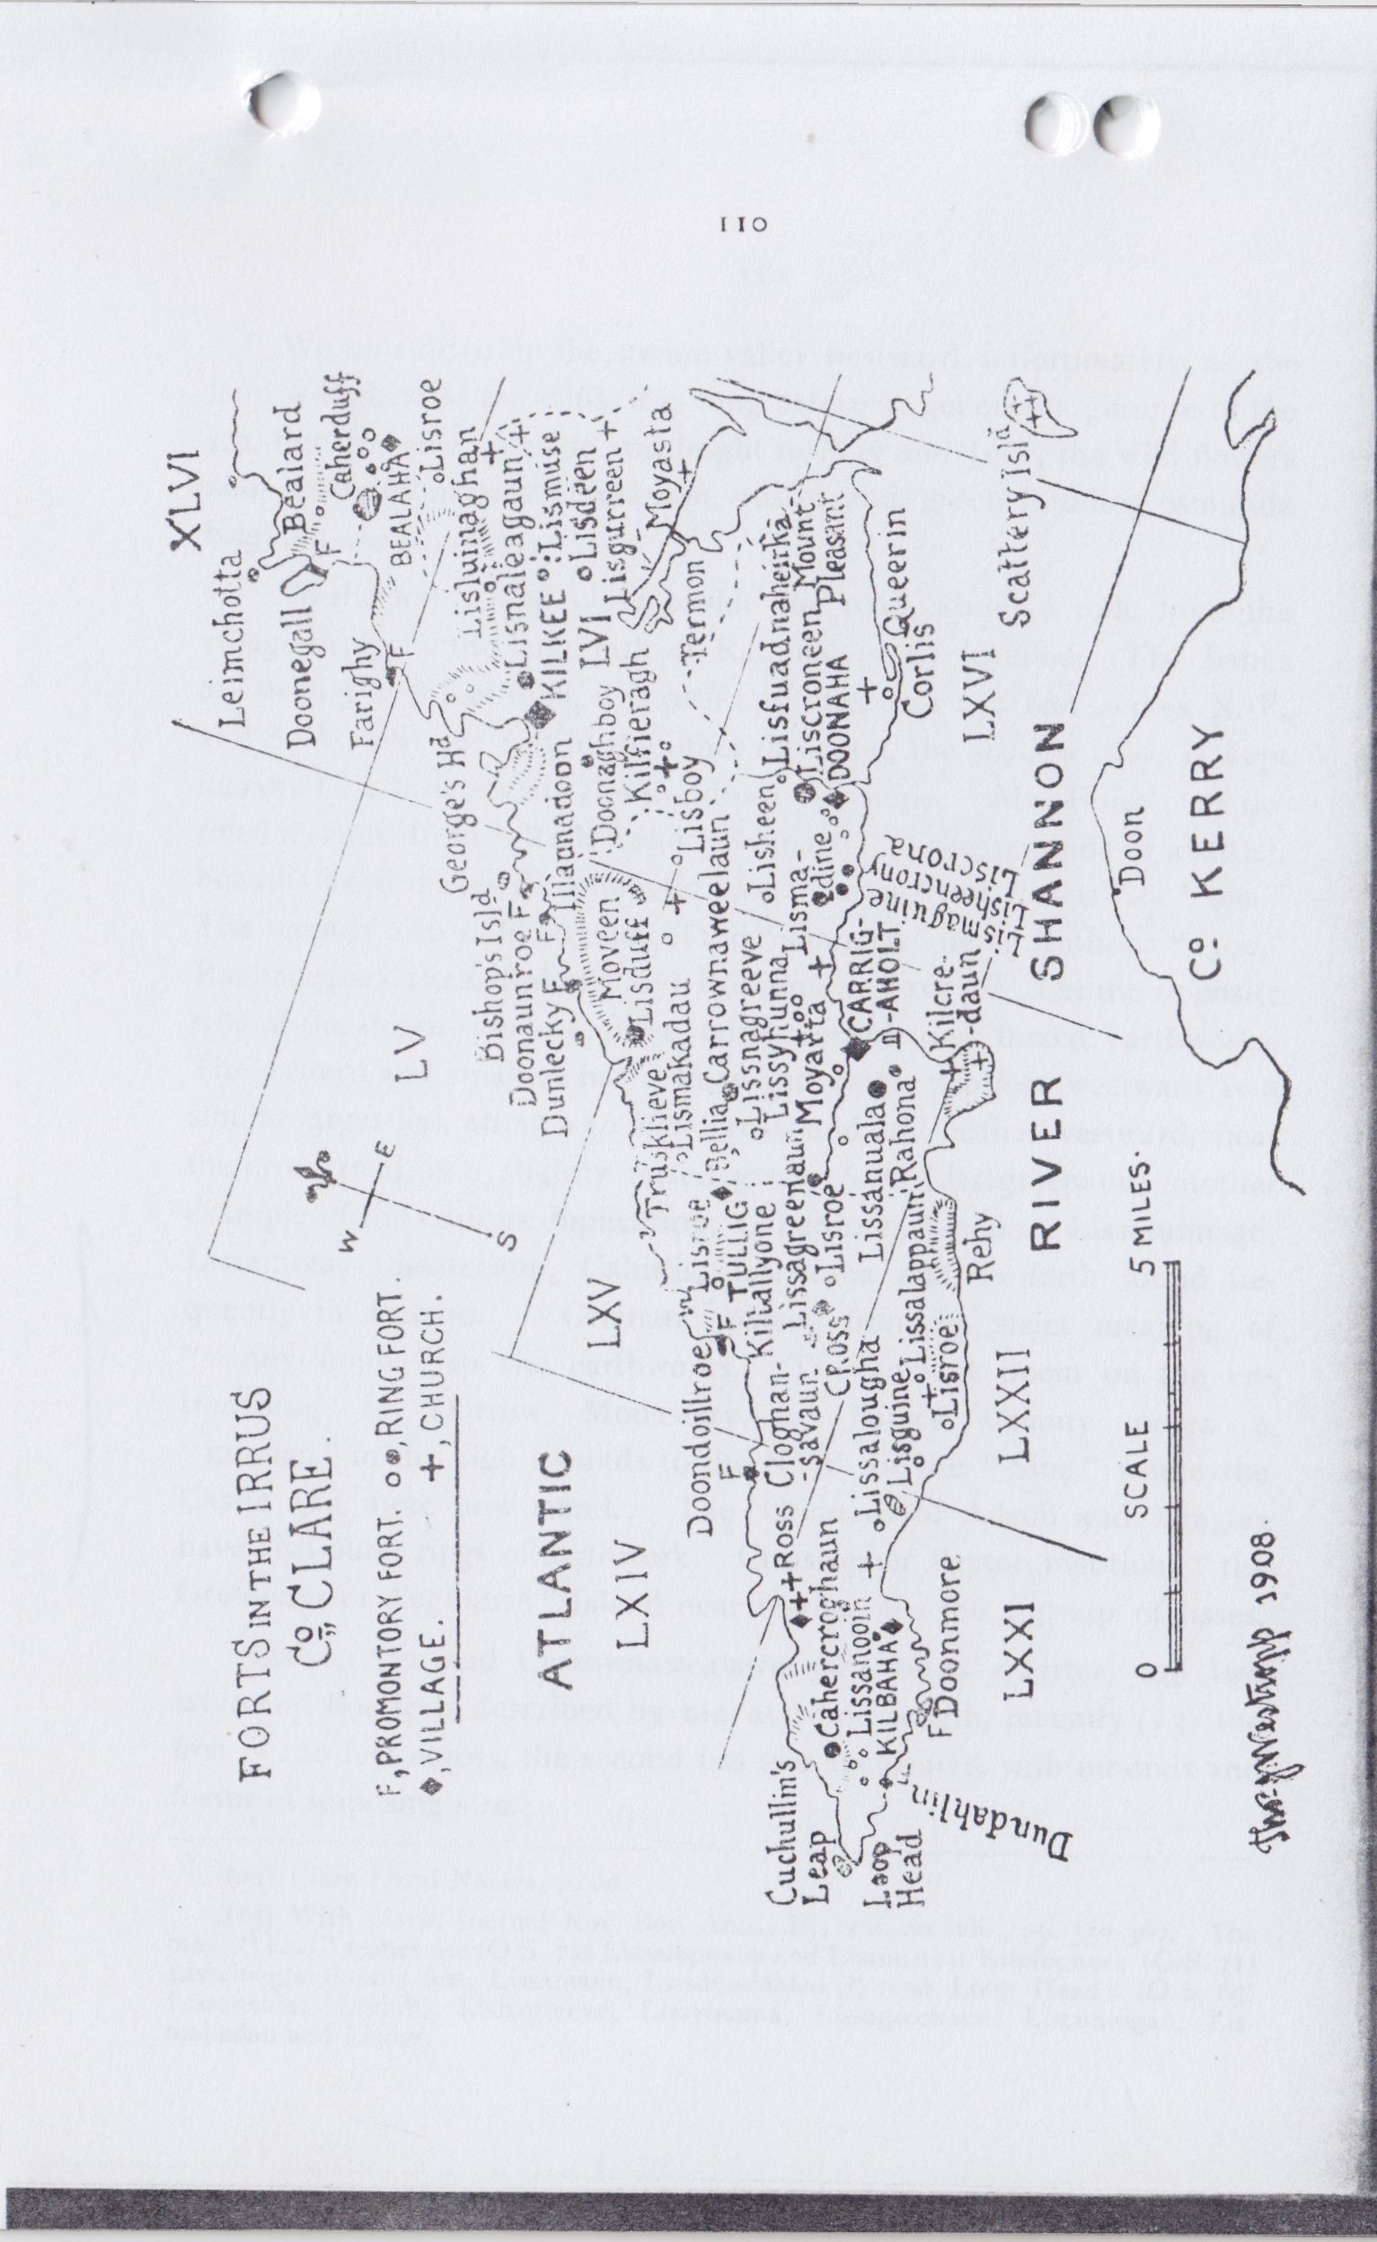

111

There are some traces of a shield-like annexe, a lower platform, nearly obliterated by the burials, but the main fosse is steep sided and well marked. None of the tombstones are old, the one so emphatically named by Graham(13) as possibly of an illustrious foreign guest at Carrigaholt Castle proves to be of a certain Margaret Contee, wife of Con Scanlan, who died Nov. 9th, 1794, aged 23. The MacMahons, O’Cahans and O’Honeens buried in the graveyard. An ancient bell was found in its enclosure a few years before 1816, but it was sent to Limerick and sold.

There is no trace or tradition (as we saw) of Moyarta Castle. At the foot of the hill, or rather the gently rising ground from which the graveyard commands so wide a view of the river, is an earthen ring fort of some importance with banks 8 feet to 9 feet high outside, and some trace ,of a fosse to the north, golden with iris. Two low rings lie due east and west from the graveyard and a far larger one in Moyarta West, a greatly defaced and furze-grown earthwork, on the slope to the west, is 350 feet by 250 feet over all; it was entire in 1839. Lissyhunna, which I have already noted, is not very far away to the N.-E. In fact the whole valley from Lissyhunna westward so abounds in these remains and all are so much of one type and usually of even closely similar dimensions and featureless that (though I have recorded many and all should be noted, even if the descriptions are not published) there is little to be gained in doing more than giving their number and position. It is a striking fact that from 1839 to 1900 one fort has been destroyed for every two years, as appears by the maps. Can nothing be done to preserve the more noteworthy and a few of the best preserved commonplace examples for future years? The ignorance, or laziness, of those conducting recent sales has led to constant returns of “ancient monuments—none” being made where such actually exist on the land. This and the base greed of certain tenants (an increasing band) who want compensation when “monuments” are about to be vested, has largely frustrated the wise intentions of recent legislation and will when irreparable loss has taken place brand the unworthy apathy and selfishness of our generation in western Ireland as it certainly deserves.

13 Ibid, p. 431.

112

We now drive up the stream valley westward, unfortunately, as the land is highest at the cliffs, it is long before we get even a glimpse of the sea, but the view is wide and bright in May and June, the wild flowers and splendid masses of maroon, russet and green budding osmunda brighten our journey.

To the south, and close beside the road, about a mile from the village bridge is the large rath of Rahona, partly levelled. The banks are from 3 to 6 feet high, it is oval and measures 250 feet across N.-E. and S.-W. and 200 feet in the other direction, the shallow fosse is kept marshy by a liltie stream flowing down the slope. Mr. Frost(14) derived its name from "Rath” and “Sonnach” (a ring palisade or abattis), but this word makes the phonetic form “tunna,” not “oona” or “ona.” The records also yield no trace of the “sonnach’’ being Rathona “1390,” Raahaneghes 1622, Rahone and Rathona in “1675." On the opposite side of the depression are three fairly conspicuous furzed earthworks. The eastern and smallest has a fosse and rings, 700 feet westward is a similar larger liss, about 130 feet across, and still farther westward, near the cross road, is a slightly raised grassy fort, Lissagreenaun, another example of the curious duplication, Caherdoon, l.isdoon, Lissatunnagh, Lissamota, Lissateeaun, Cahirlis, Lisnaraha and so forth found frequently in Ireland. “Grianan” passed from its strict meaning of “sunny house” to the earthworks. The ancient poem on the entrenching of Durrow Monastery in King’s County notes a “grianan” in the high mounds to the N.-W. of the “Sine” where the Castle and mote now stand. The Grianans of Ailech and Craglea have also outer rings of earthwork. Christopher Peyton mentions “the Griannans of Aughinish” Island near Foynes in 1586 a group of lisses.

Lisnagreeve and Carrownawealawn (sea birds’ quarter) are two large and fine forts described by me, at some length, recently(15) the first is 200 feet across, the second has two enclosures, with mounds and fosses of imposing size.

1. Clare Local Names, p. 60.

15 With plans, Journal Roy. Soc. Anti., Ir., vol. xxxviii., pp. 359-360. The other “Liss” names are (O.S. 72) Lissalappaun and Lisroe near Kilclogher; (O.S. 71) Lissalougha double fort, Lissanooin, Lissdundahlen(?) near Loop Head; (O.S. 65) Lissanuala, Lisduff, Lisnagreeve, Lissyhunna, Lissagreenaun, Liscunnigan, Lismakadau and Lisroe.

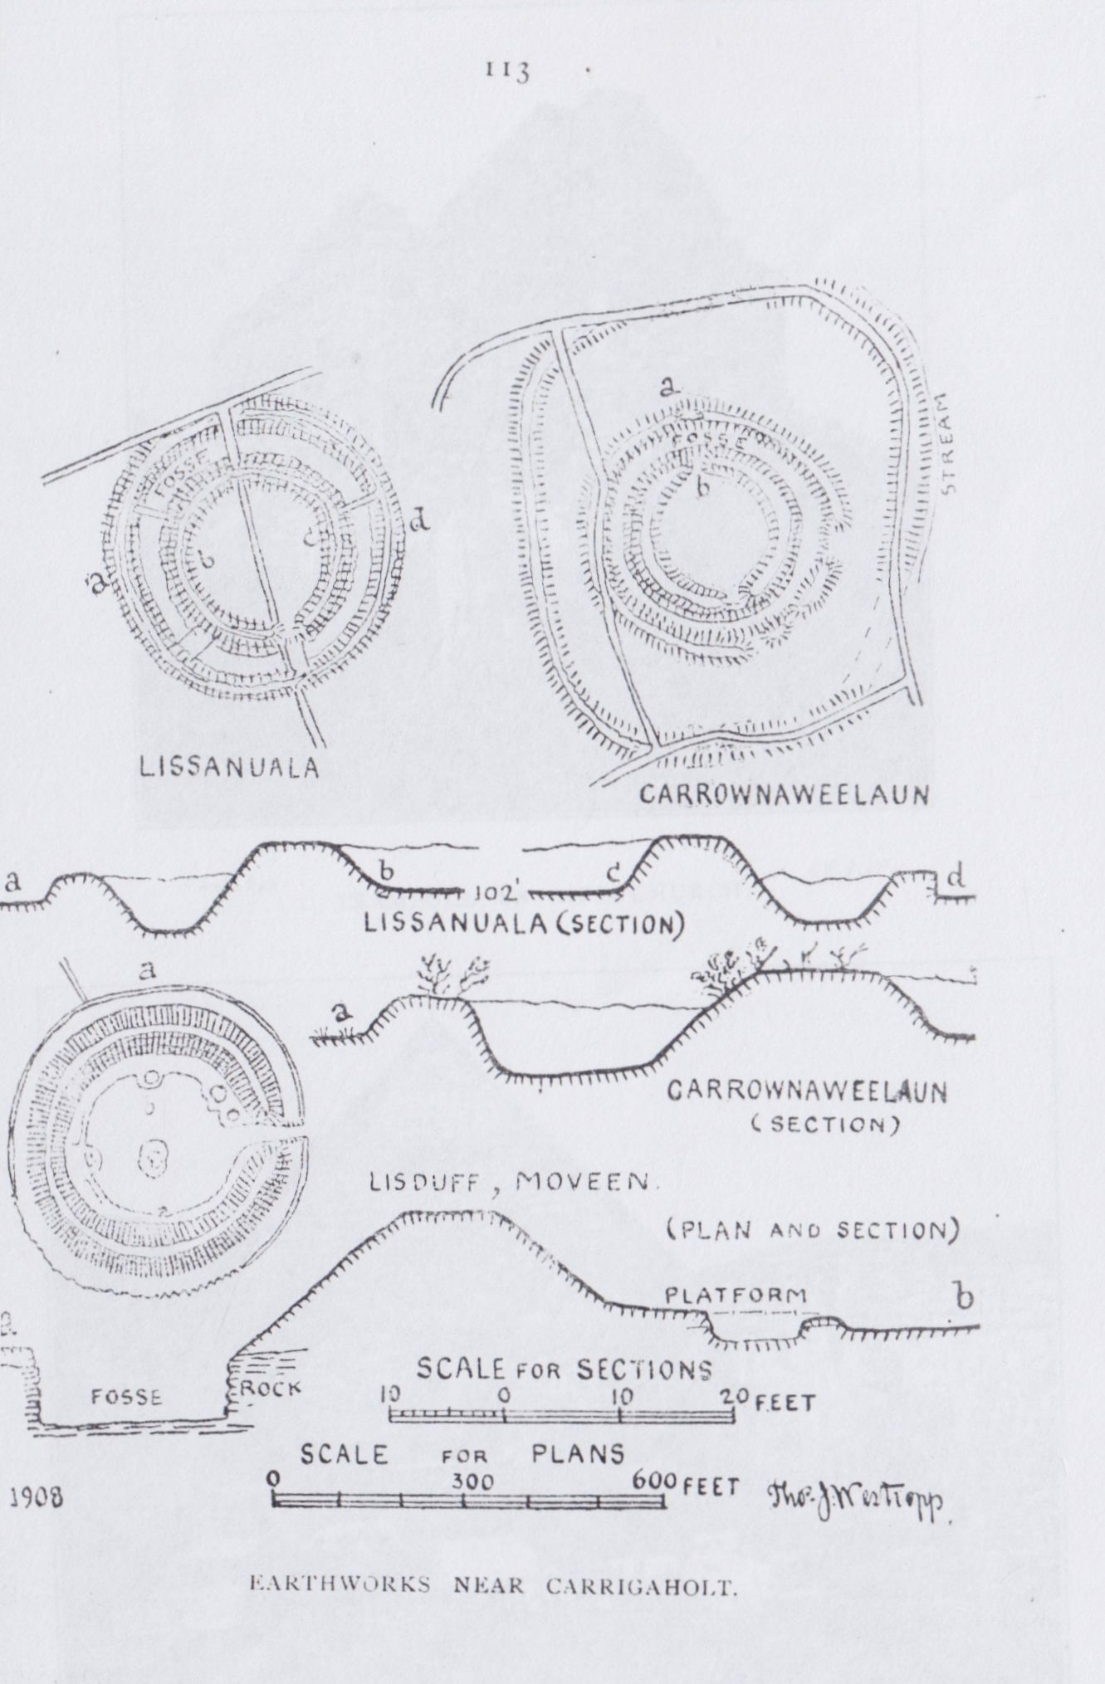

114

KILBALLYOWEN CHURCH (O.S. Map 65).

Passing the village, named now, as in “1390,” Cross, probably from some monument marking the eastern bounds of the church lands, we see beside the road at the summit of the ridge a long dark building with lofty gables, the Church of Kilballyowen(16). It derived its name, as we saw, from Baile I Eoghanain and that from an old family of the district, confused with the O’Honeens, an entirely different name. To the north-west we now overlook the fine cliffs of Tullig (too little known to visitors, but one of the finest reaches of that noble coast) and the mounds of the great headland fort of Dundoillroe to far out into the Atlantic. Southward we see all the Shannon estuary from Scattery and Beal (if not from Tarbert) to the sea, save where the ridge of Rehy shuts out a portion, rising as it does abruptly for 386 feet above the river shore.

In 1839 a building called “the friary” lay to the north of the road, 600 feet eastward from the church, opposite to the end of the long eastern fence of the field in which the graveyard lies. It has long disappeared, and strange to say the recent maps mark its site in 1899 at a spot in the old glebe 200 feet from the church, and 700 westward from the site given by the older maps when the building apparently still remained, no traces now exist at either place.

The church is without a known patron, and is surrounded by a village of plain flagstone vaults, being itself built neatly with these tile-like stones, with occasional larger slabs. It has the usual plain bell chamber, covered with a flag, on the summit of the west gable. The building is of the plainest description and, save for the belfry and the long narrow slit in the east end, seems featureless as seen from the road. The side walls have on their inner faces slab cornices, above each is a row of 27 simply rounded corbels for the root beams. The building is 76 feet 6 inches long by 21 feet wide inside, the walls about 3 feet thick and entire; of its features, the east window is a long narrow slit 7 inches wide with a bold splay 4 feet 6 inches wide, a slight ledge projects inside the top of the light, but the splay has a very slightly arched head. A smaller, but closely similar, loop and splay are in the south

16 There is a good description in Ordnance Survey Letters, Co. Clare, (R.I.A., 14B 24) p. 68.

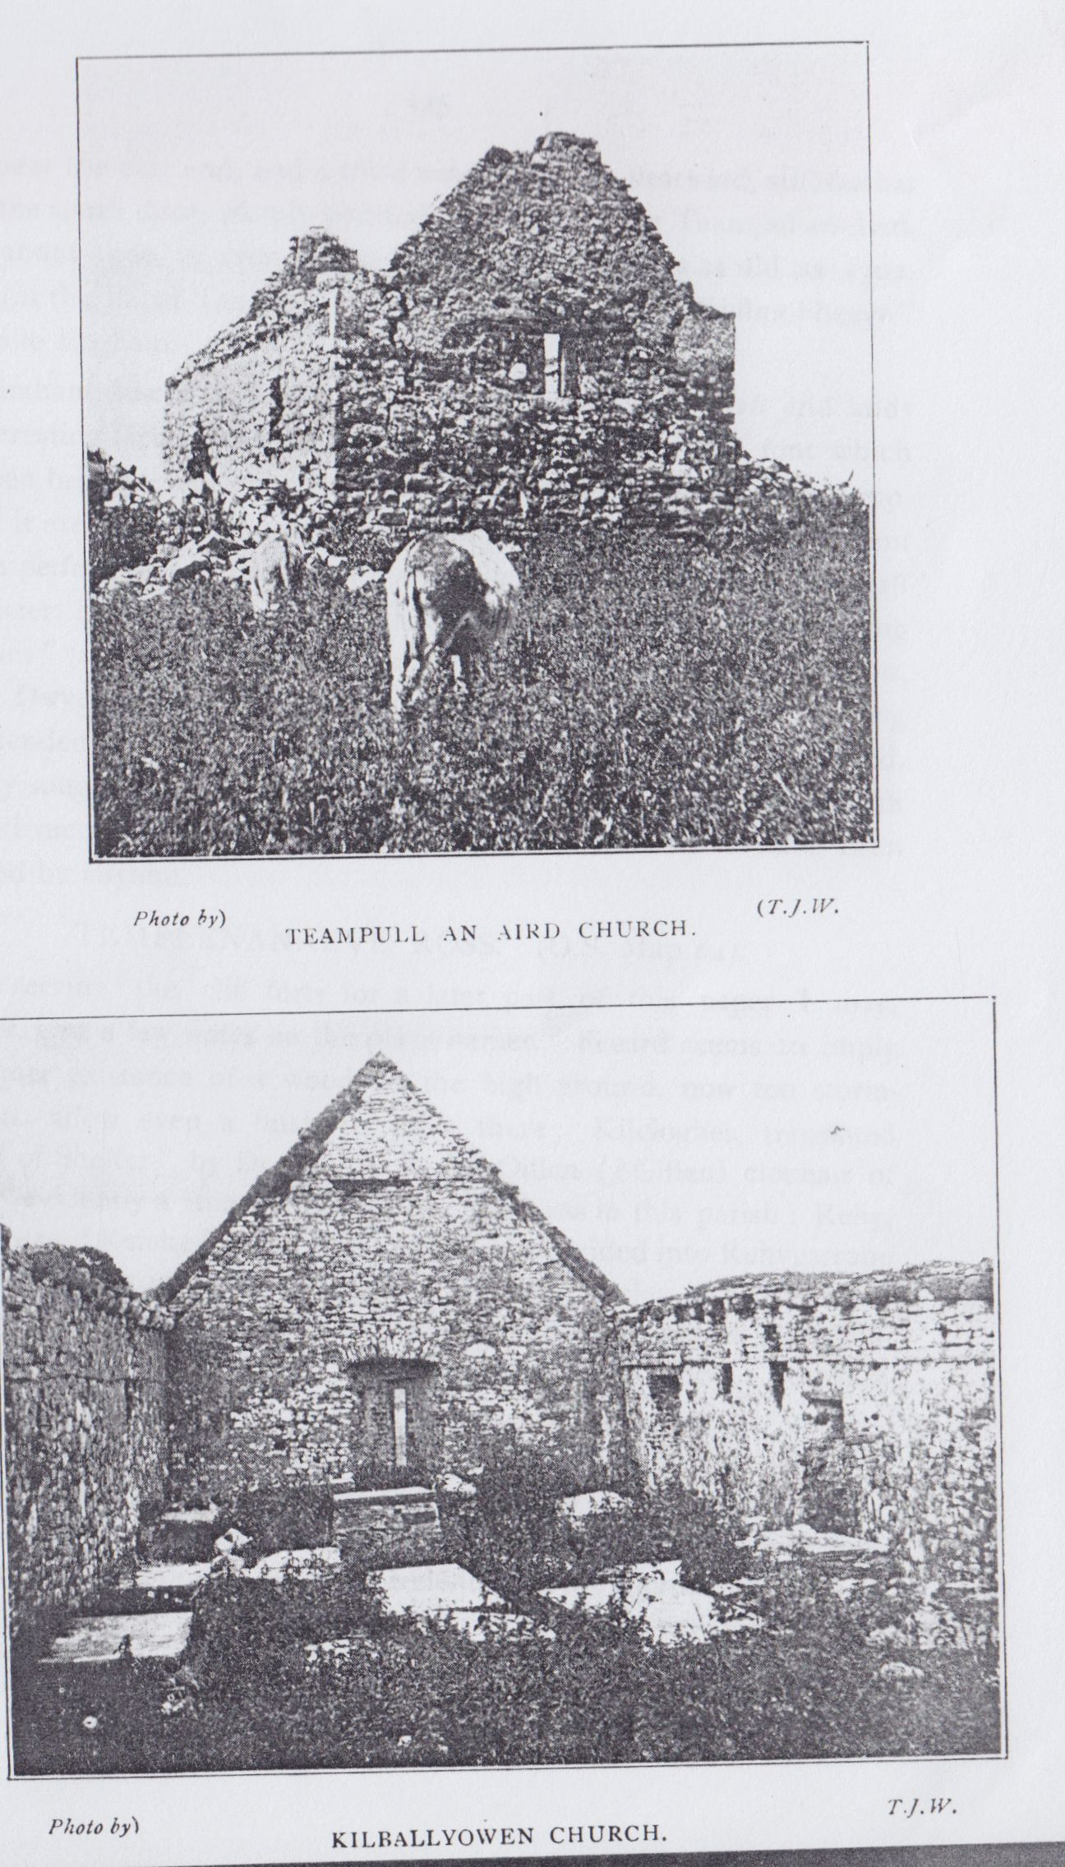

105

wall, near the east end, and a third window farther westward, still farther on is the south door, plainly pointed; the whole, like Teampul-an-Aird, dates about 1500, or even a little later. No part seems as old as 1302, when (in the Papal Taxation) it is first mentioned as “Kellmolihegyn” cil bhaile Eoghain.

Graham describes it at, for him, unusual length in 1816 and adds an interesting fact—“Here are the remains of a baptismal font which has been broken: but on each side of the square pedestal which supported it are figures not inelegantly sculptured: but only two of them remain perfect, one of these is a human figure, bare-headed, with a staff or crozier in his hand; and the other a tree, with two projecting branches”(17). The Ordnance Survey Letters repeats this description, Canon Dwyer follows them, only adding the conjecture that the carving was intended to teach the need of the fruit of good works in the baptized. I vainly sought on three occasions for the carving and inquired with equal ill success as to whether it was known to exist or to have been removed by anyone.

TEMPLENANAEVE, ROSS. (O.S. Map 64).

Reserving 'the cliff forts for a later part of this paper I may, however, give a few notes on the place names. Feeard seems to imply the former existence of a wood on the high ground, now too storm-swept to allow even a bush to grow there; Kilclogher, translated “Wood of Shelter” by Dr. Joyce, is the Oillen ( ?Cillen) clochair of “1390” evidently a stone-name like the clochans in this parish: Rehy, ramhill, was “Reiche” in “1390” (18), it was divided into Rehygarrane and Rehydadrien in “1675” (19), and Thomas Dineley, in his sketch of 1681, calls it Knockray; Trusklieve, the high track below Knocknagarhoon, was “Trosg Sliabh” and Fodry (soddy place), Fotra “1390”.

St. Senan is stated in his early life, given by Colgan under March 8th(20), to have founded the Church of Ros-an-Airchee in Corcavaskin, which, as we saw, has been confused with St. Cocca’s Church of Rosbenchoir on the opposite coast of Ireland. The Church of Ross is

17 Mason’s “Parochial Survey” vol. II., pp. 431-432.

18 The O’Brien Rental usually dated 1390. Trans. R. I. Acad. vol. xv.

19 Survey at Edenvale p. 32.

20 Acta Sanctorum Hibernice.

116

however, not recognised as his but is called locally Templenanaeve, or, more correctly, “Teampul-an-Naomhar-Naomh,” the Church of the Nine Saints It is a low and shapeless ruin, looking rather like a ruined cabin than like a church as seen from the road, and stands on the edge of what was once a marsh, on the opposite side of which is found the site of its companion church, Kilcoan or Kilquane.

As usual, Graham, in 1816, is our earliest authority. He notes it as "near the natural bridges, on the remote and wild bay called by this name.” It was 30 feet long by 15 feet wide, the eastern end had fallen inward and the altar was rudely rebuilt. In fact the little oratory is 34 feet 6 inches by 15 feet 6 inches wide, and is a most venerable looking, weatherstained ruin with some large stone work which probably is the only trace of the older church. The south door was defaced before 1838, it was pointed outside, but all that face is gone, and only the large flat lintel of the inner part remains. The only other ope is the south window, a plain, oblong slit and splay, near the east end. A carved corbel with a human head lies on the altar, it was probably an ornament of the collapsed east gable and is described by Graham as "a graven image of limestone” lying on the altar, beside it there is now a somewhat flat shingle stone into which a saucer-like hollow has been ground. The tomb of ''the nine saints” is a kerbing of blocks filled with earth and stones and one small rude cross at the south end, the greater length lies north and south. The church probably continued in use during the stress of the penal laws, but the graveyard, which was a favorite burial place, had (Graham says, in 1816) been disused for over a century on account of a miraculous occurence. A body, which had been buried there, was found above ground and continued to revisit the glimpses of the moon every time it was re-interred, till the people of the district got alarmed and took it to another graveyard(21).

Graham mentions Kilcoan(22) Church as demolished, but its remains had been “some years ago perceptible.” He says that Coan was the survivor of the nine saints, but, having fallen into mortal sin.

1. A similar tale is told of Torry Ireland, Co. Donegal, and an acient version relating to the same place is found in the Leahhar na hUidhre before 1100.
2. The above cited account is in Mason’s “ Parochial Survey,” Vol. II., pp. 436-7.

117

after their deaths, he was not laid with thetir bones. He must evidently have made an edifying repentance, for his burial place was reverenced, and a church and cemetery existed there. The site is now barely known, and all trace of any building there has disappeared. As I noted, only unfenced killeens, hardly ever used for burial, mark the probable sites of the churches of Kilbaha, Kiltrellig, and Kilclogher. The modern Roman Catholic Church at the first place has a very curious relic of the days when the landlords’ power was nearly absolute, and the shadow of the Penal Laws had not yet followed their reality. It is a sort of movable oratory and altar of wood which could be rapidly removed from place to place to shelter the priest at the service, for the landlord would not allow a site for the chapel. It is so curious, and I think unique, as to be worthy of illustration. The late Mr. Marcus Keane does not describe the ruin in “Towers and Temples of Ireland”(23). Probably it was too poor to be attributed to the skilled “Cuthite” architects. He, however, gives the legend (really referring to the “eastern ocean” church of Rossbenchoir) of how St. Ciaran “used to go to the sea rock that was far distant in the sea, while his nurse, i.e. Cocca, was without ship or boat”(24). A stone, the writer adds,was shown at Kiltrellig, on which the saint used to sail round Loop Head to and from Ross in evidence of his superior sanctity.” Though such legends are not unknown in Ireland (notably at Ardmore, Co. Waterford) the suspicious mention of St. Ciaran suggests that it was inspired by some learned follower of the mistake made by Archdall, and the subsequent followers of his “blind leadership.” Otherwise it may have been given (as too often occurs to incautious persons) in response to a leading question out of politeness and a benevolent desire to please the querist. Canon Dwyer(25) as usual, follows his predecessors and adds no original observation, although he knew and admired the place and its surroundings.

There is greater likelihood that the visitors to Ross may not be shown the ruin than that they may see it and not be told of the natural bridges, so long a place of tourist resort. Nevertheless, it is well to

1. P. 376.
2. Martyrology of Donegal, p. 504. See Silva Gadelica, Vol. II., p. 11.
3. Diocese of Killaloe, p. 504.

118

mention those wonderfully regular, natural edifices across a long creek, L-shaped in plan, a collapsed cave. Persons who have only seen Bartlett's wonderful engraving, so exaggerated in drawing and of such impossible perspective, alone can be disappointed by the lowness and comparative smallness of the bridges(26). The large blocks of rock thrown up on the low cliff near them are said to have been washed up by the tidal wave after the frightful earthquake that destroyed Lisbon.

I am indebted to the kind permission of the Royal Society of Antiquaries of Ireland for the plans of forts used in this paper, and to the Royal Irish Academy for the view of the exterior of Kilcredaun Church.

26 Scenery of Ireland.

North Munster Antiquarian journal vol 2(3) 1912

CARRIGAHOLT (CO. CLARE) AND ITS NEIGHBOURHOOD.

PART IV.  
LOOP HEAD.  
BIy THOMAS JOHNSON WESTROPP, M.A., M.R.I.A.  
Continued from page 118

For the completion of this paper, those who may have read a former one on the same district will, I hope, forgive any repetition in this account of that very interesting reach of coast from Loop Head to Dundahlin and the creek of Dunmore. The most remarkable headland in Co. Clare is Loop Head. One of the pillars at the entrance of the Shannon, it is all the more strange that its name appears on none of the early Italian maps, from 1300 onward. All merchant vessels must have looked for it when trading with Limerick and Galway, and most of the other salient points, Skellig, the Blasquets, Valentia, Iveragh, the Maine, Mount Brandon, Dingle, and even the mythical “Brazil,” Aran, Black Head and Galway are given. In Irish records, though of less vital importance to the authors than the maps were to those whose safety depended on the “portolanos,” or coasting maps, it received full recognition. As in ancient Israel “Dan to Beersheba,” so among those writing of the Kingdom of Thomond “Birrha to famed Cuchullin’s Leap” became a proverb; for the headland bore the name of no obscure person.

Greatest of Erins heroes, the mighty Setanta, the hound of Ulster and its sole defender, at the ford of Firdia (Ardee) against Queen Medb and all the hosts of Connacht, the name of Cuchullin flamed out of heroic legend, in the darkness of the past, as a star of surpassing lustre. Gods and godlike men were honoured at the great features of their lands and the culminating point of rock, beside the mighty river that

135

bore the name of the mother of the gods, was not unfit for such dedication. Far out in the sea, girt by great cliffs, as perpendicular and regularly marked as the lesser walls raised by mere men, from before a.d. 860, probably from long before it, the tribes of Thomond called the place “Leim Chonchullaind” after the son of Dectire. The Triads placed it as one of “the three conspicuous places of Erin,” and the “Wars of the Gaedhil with the Gaill”(1) in about a.d. 869 (not long after the date of the poem) told of the Norse ravage through Corcovaskin to the outmost limit—Leim Chonchullin. The Synod of Rathbreasaii, about 1112, names it as a limit. The last King of Munster, “Donaldmore” O’Brien, in 1189, inserted in his charter, confirming the rights of the new “Abbey of the Blessed Apostles Peter and Paul of the Forgas,” now Clare Abbey, the phrase “usque ad saltum Congoluni.” The “Cathreim Thoirdhealbhaigh,” again and again, mentions it as the farthest end of the kingdom of Thomond.

One point of interest in the name is that it seems to imply that at least 1,000 years ago and more the features were, in the main, as now, a narrow gully or “leap” with an island beyond it. The gully must have been then, as now, sufficiently wide to make it a superhuman feat to leap across. Probably the tradition now told, but found in no early writer as attached to Loop Head, was then and presumably long before told of Cuchullin’s Leap. It was first told of a place far up the Shannon near Ardstra. The Dind Senchas relates how Cuchullin, pursued by one who loved him “not wisely but too well,” leaped across a chasm at Fich m buana. The lady followed, and was dashed to death against the rock(2). So, at Loop Head, a sorceress, Mal, pursued a reluctant hero, nameless in the later legend, some said an Irish warrior others (anxious to clear their country from so ungallant an episode) a Dane(3). He found himself hemmed in with the sea before him on every side and the lady in full pursuit; his flight was stopped by the chasm. He leaped across, but the lady sprang lightly over and reached the platform. He then sprang back to the mainland, she attempted to follow, leaped short, and was dashed to pieces, her blood staining the

1. a. Ed. Dr. Todd’s, pp. 65, 2, 7; b. Todd Lecture Series R.I.A., vol. 13, p. 7,
2. Dind Senchas (ed. Whitley Stokes, 1894, in Revue Celtique XV., p. 57).
3. Lady Chatterton’s “Rambles in the South of Ireland” (1838), Vol II. p. 220.

136

sea out to Hags Head, and giving to that reach of coast the name of Malbay. Every age since then has called the place Leap Head, Cuchullin’s Leap, the “Hound’s” Leap, and in more corrupt form from 1540 onwards it is Can Leame or Lupas Head, and in 1574 Leyme Concullen(4). It is believed to be the Ioldulaup of the Norse sagas.

The next point of interest is that the detached rock was evidently fortified, very little of the dry stone revetment remains, but that little is unmistakeable. Had the only people who, in recent years, gained access to the rock, been capable of an intelligent study of the site, much more could be said. As it is, the fact is clear that a fortress, remarkably like some of those extant in Co. Mayo, once defended the rock. We have also a similar dry stone revetment at Dunmore, not far away. It is not impossible that, as at three forts in Mayo and Galway, and one in Kerry, a narrow natural arch connected it at one time with the land, and thus formed a promontory fort with a deep chasm for a fosse.

The rock opposite the island was known in 1839 as Bullaun a leime, the new maps, probably on some “tourist” information, have moved the name to a beautiful headland far from the “Leap.” Near the actual site was a hollow at the edge of the cliff where, some said, Mal had struck the rock before falling back into the sea. There was also a “turning stone” called Cloch-an-umphy, which I could not see or learn what had happened to it. It was described to Dyneley in 1680(5) as a place on which if a person turned he could get his wish, but few were brave enough to do so, perched as it was on the edge of the abyss. It appears to have been remembered if not actually extant in 1866 when his “tour” was partly edited. The light-house was preceded by an older one built under an Order of Council, dated July 1st, 1711(6). It must have been very inaccessible for over a century, for the “heads of bay roads” only reached Loop Head in 1822, and the new road was almost impassable in 1835, when Mrs. Knott undertook her exploration of that nearly unknown corner of Ireland(7). Dyneley, in

1. Carew MSS. Calendar, 1574. It is Cap Leane alias Loop Head in Petty’s “Hibernia Delineata,” 1683.
2. Dyneley’s Tour in Journal Royal Society Antiquaries, Ireland, vol. v. of New Series (viii. consec.), p. 189.
3. Warrant Books of Dublin Castle in P R.O.I., 1711, Vol. XIII., p. 42.
4. “Two Months at Kilkee,” p. 144.

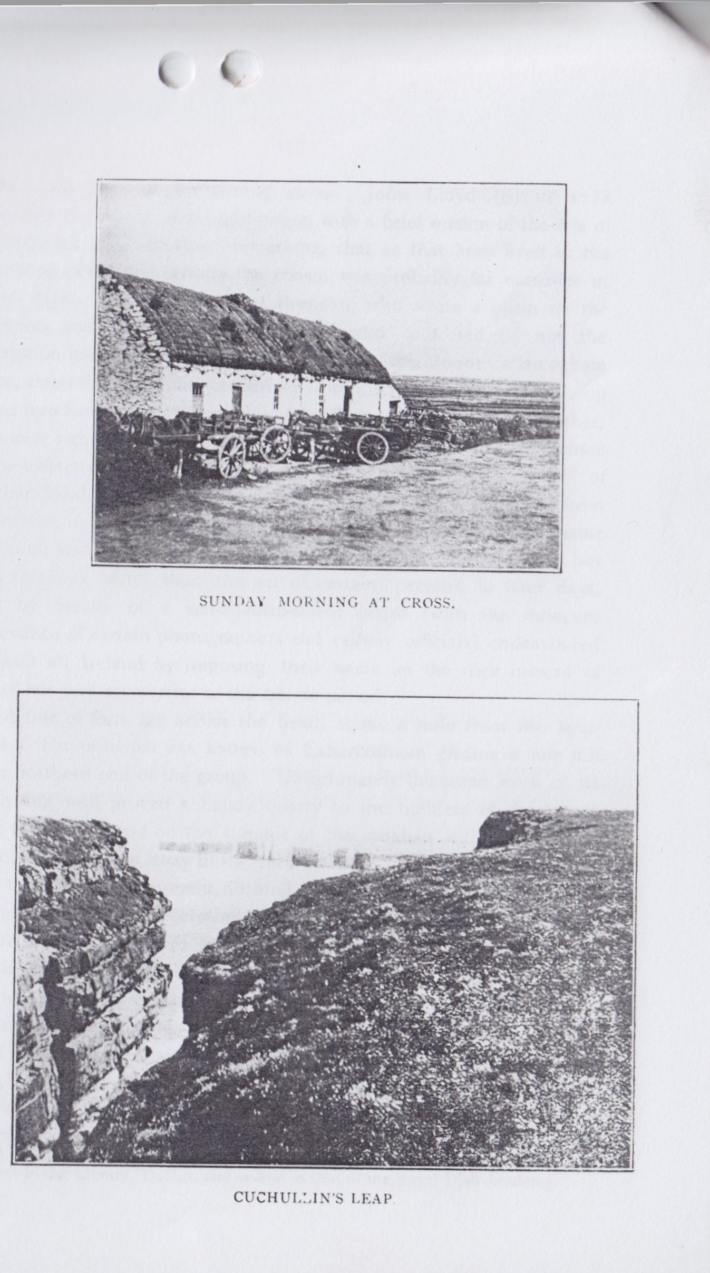

137

1681, tells only of the turning stone. John Lloyd(8) in 1788 describes the Head and Light-house, with a brief version of the tale of “Congullus or Cuchollan,” remarking, that as that hero lived at the beginning of the first century the chasm was probably far narrower in those days. In 1794. Michael Brennan, who wrote a poem on the Shannon, and Theophilus O’Flanagan, who confected (if not the inscription itself) the five wonderful readings of the Mount Callan ogham stone, assert that the name was derived from Cuchullin leaping from Loop Head into Kerry. This is denied both by Eugene O’Curry and his father, who were rich in the local legends. It probably arose from ignorance of the existence of the detached rock, or from a “forgotten memory” of another local story, how Finn Mac Cumhail threw a rock from Cnocanoir, in Kerry, to Carrigaholt. It is not known how the name “Dermot and Grania’s Rock” got placed on the maps of 1839, but even this was better than the act of certain persons, in later days, who, by means of a self-advertisement board (with the innocent connivance of certain photographers and railway officials) endeavoured to insult all Ireland by imposing their name on the rock instead of that of her greatest warrior of the heroic period.

A line of forts lay across the head, about a mile from the lighthouse. The principal was known as Cahercrohaun girding a low hill at the northern end of the group. Unfortunately the stone work of its strong ring wall proved a handy quarry to the builders of the signal tower that once stood on the summit of the croghán within its ambit. The tower was swept away in its turn possibly for the light-house and some field walls. At present nothing is left but a broad ring of gray, weather-beaten stones, enclosing a space 180 feet over all. The summit of the hillock rises 272 feet over the waves, and has a noble and beautiful view. Eastward we look up the Shannon to Knockpatrick, from which St. Patrick blessed the men of Corcovaskin, and foretold the birth of St. Senan and his monastery on the “green island in the mouth of the sea" at Iniscathaig. The latter low island, with its slender round tower, is barely visible. Southward to Knockanure, in Co. Kerry, along the cliffs from the promontory fort of Lissadooneen and Beal Castle,

1. “Impartial Tour in Clare.” There are copies of this little pamphlet, but all imperfect in the Library, Dublin, and several in that of the Royal Irish Academy.

138

past Ballybunnian and Kerry Head out to the great hills of “Slieve Mish, the red-maned”(9) (where the great fort of Caherconree recalls the hero Curoi) to Mount Brandon (with its long streamer of cloud, 3,000 feet above the sea), and to the Blaskets. From Brandon St Brendan started on his adventurous voyage by Traighli and Aran, to search the marvellous islands of the Atlantic for the Land of Promise(10). Northward the view is equally suggestive. Mist-like, even on the clearest day, rise the Twelve Pins of Bunnabeola, in Connemara. Before them lie the three low isles of Aran, a focus of early learning and piety, full of memories of Saints Enda and Brendan, Kieran and Columba, and many another saint and sage. Attached to the great forts, invisible from this distance, are memories of the Firbolg chiefs, Aenghus and the sons of Huamor and their conquerors Cuchullin, Keth, Ross, and their compeers, “Along the pleasant coasts as far westward as Dun Aenghusa in Aran” as sang Mac Liag, King Brian’s bard, ere the bitter day of Clontarf. Thirty miles northward we can see the spray dashing against Moher, and over the legendary, golden roofed towers of Kilstuithin.

The cathair must have been an exposed and comfortless refuge, only to be used when an enemy had raided the peninsula. Swept on every side by the storms, and with hardly any level ground, save on the summit, permanent residence could have scarcely been possible, unless some huts crouched under the shelter of the rampart. The shore below is a magnificent piece of rock scenery, one gully leads down to a beach and commands a fine view of Loop Head and the great rock castle. Up the side of this cleft an active climber can reach a small tunnel, leading to the face of the outer cliff opposite another fine tower of rock called Gull Island. Nearer Loop Head is a remarkable reach of cliff, the “Hull Rock,” a great, smooth, convex reach of uplifted strata, like the side of a vast ship. North from it is a picturesque headland, now wrongly called Bullaunaleime, of regular lines, crowded in the nesting season by hundreds of sea fowl. It was pierced into a lofty “arch” (or rather a portal, like the lintelled gateway of an Egyptian temple) in the late autumn of 1898. I had seen and sketched it, and have a photograph taken by Mrs. McDonnell about the same time. Though

1. “Cath Finntraga.”

10 See The Lives of “ St. Brandanus.”

139

not so lofty as the cliffs at Tullig, Beltard and Moher, in this county, they hardly yield in picturesqueness to any in western Ireland. The light and atmosphere are usually magnificent, and when (as is rarely otherwise) there is a western or north-western breeze, the long tide-ways and blue waters out to sea, and the emerald and silver of the great waves as they roar against the cliffs, are in the last degree beautiful and impressive.

“An iron coast and angry waves

You seemed to hear them climb and fall,

And roar, rock-thwarted, under bellowing caves   
 Beneath the windy wall.”

The bleak moor above is in the summer brightened by multitudes of stone crops and marsh pimpernels. Some broken ground south from the cathair, near the road to Ross, was the site of another ring fort complete in 1839, now hardly traceable; broken mounds and pits suggesting no plan. It was called Cahercoolia and plays no part in the legends.

The third fort was named Cahersaul, probably Cathair Saile, the fort of the brine, which in storms blows across its site, though at some distance from the cliffs. The house and fences absorbed the stonework and even the low ring of foundation, rarely so much as a couple of feet high, is scarcely complete. The cathair was remembered as fairly perfect, but the hand of the “improver” is merciless to our ancient remains. Mr. Marcus Keane, of Beechpark and Dundahlen, remembers an open souterrain near it in 1865, but this has been destroyed or filled up, and I could not ascertain its site in 1896 or since. Mr. Henry Keane, an uncle of my informant, hearing that there was a passage from Cahercrohaun southwards to Dundahlin, sought for some trace and at last found it(11). Souterrains, as we noted, are not unknown outside of forts in this part of Clare, and even in the limestone hills of the Burren I have recorded some examples. The cathair was a small house-ring, barely 60 feet across inside, and evidently of rather small masonry, easily removed.

11 Very often the belief as to a long passage originates from the existence of a souterrain, or even of the track of an ancient road as at Dundoillros not far to the east of the Head.

140

The maps marked two other forts, Lisdundahlen and Cathairnaheanmna. I carefully examined their reputed sites and utterly failed to get the slightest evidence that such ever existed(12). In the first case, the Ordnance Survey letters say nothing definite about it, while noting the existing fort of Dundahlin. The latter was inexcusibly omitted from the maps of 1839, being actually the only conspicuous fort of the group. One fears that “leading questions begot misleading answers,” as is so common where incautious people seek for place-names and traditions and have on more than one sheet of that fine survey (so little edited by any qualified antiquaries) introduced names of more than a doubtful quality.

The most southern of the line of forts is Dundahlin—dún daithlionn. The component name is found across the estuary, at Glendahalin, on Kerry Head, where it is the name of a saintly lady. Here it is supposed to be that ofa man. It is a very good example of a promontory fort(13), and shows the skill with which the early inhabitants selected the sites which they intended to fortify. A stream down the hillside had cut a deep gully to the south, leaving a clear rock face. Another line of cleavage developed a cave, which, as its roof was gradually cut back or fell in, defended the low headland to the west. A curved fosse 10 feet wide below and about 8 feet deep (save in the middle, where there is a gangway) was dug into the earth, and shale. A mound rising 6 to 7 feet over the garth, and 12 to 14 feet high outside, and 21 to 26 feet thick was thrown up and neatly faced. It is 150 feet long across the horns and well preserved. There are traces of the side fences, so common wherever the sides of the headland are well preserved,and also of a low mound or traverse inside in the garth, judging from the stronger strata of the lower part ofthe headland, which remain for a considerable distance outside the present extremity, the lighter shaly rock above has been much cutaway in recent times. The landward end is, however, much sheltered by the projection of the rock to either side. The present garth is about 180 feet long. Mr. Keane tells me

12 It is hard to locate the last on the heathery moor, but I walked over all the part near which the map seems to mark it.

1. See Journal R.S.A.I., xxxviii., p. 228.

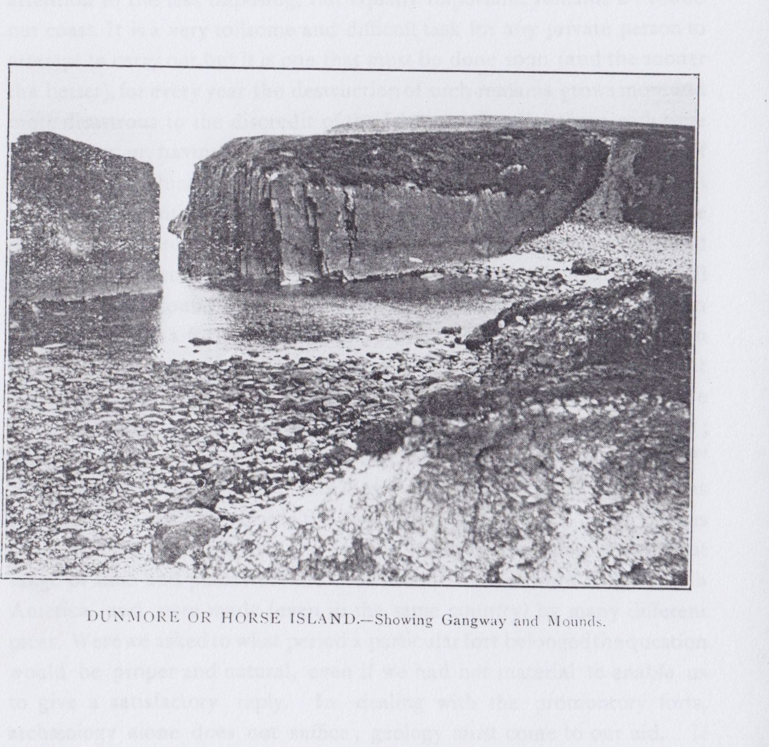

141

that a large bronze pot of doubtful age was found in the garth, but as some Egyptian water vessels(14) of modern date were also found, it were risky to regard the other object as in use among even the later fort dwellers. None of the objects are known to exist.

A pleasant walk through the heather and flowers eastward brings us to an early homestead and to the last of the cliff forts of this group— Dunmore, or Horse Island. Of the first, an irregular foundation of an enclosure remains levelled to within a foot of the field, like all the forts on the headland, except Dundahlin. It has traces of several chambers, and two small, but perfect, souterrains—one curved and inaccessible outside the hut; the other open and oval, with a short passage to the east. Both have walls of small field stones and roofs of uninscribed lintels, almost level with the field. Middens of limpet and other shells, with traces of charcoal, surround the remains. The curved and other souterrain and group of huts recall the larger and more important examples in the great promontory forth of Porth, or Portnafrankagh, in the Mullet, County Mayo(15).

Below, with the estuary and a wide panorama of the Kerry coast beyond it, we see Horse Island. This, despite its name of Dunmore, was not recognised as a cliff fort till when searching for the hut sites, along with Mrs. McDonnell in 1898, I found it to be such(16). The site is a curious illustration of the skill with which the fort builders economised work and selected the most suitable natural features as fortifications. At some very early date the hollow curves of the rock strata were cleared out, leaving a long parallel trough open to the west Then (during the glacial period most probably) the trough was filled with drift clay. This in its turn was much cleared away to either end, especially after the parallel rock was cut through to the east. The human workers took it up at that point, shaping the mass of drift (which alone joined Horse Island to the mainland at high tide) into a regular gangway. On the upturned edge of the strata they built a strong dry stone revetment along the landward side of the island, raising a backing of earth, where

1. Probably brought back, like the Malay axe found at Scattery, by some soldier or sailor to his family or friends.
2. Proc. R.I. Acad., vol. xxix. (c), p. 25.
3. Journal R.S.A.I., xxviii., pp. 409-412, and xxxviii. p. 226. Proc. Acad., vol. vi. ser. iii , p. 446. Ancient Forts of Ireland, section 124.

142

the wall rose above the platform. A natural arch has been cut through the island to either end, and the eastern has fallen in since the rock was fortified. Only a few perches of the revetment remained, and some of that has been destroyed since 1898. It is most unfortunate that, save when confronted by such great stone works as the Black Fort in Aran or Dunnamo, in County Mayo, O’Donovan and O’Curry paid so little attention to the less imposing, but equally important, remains all round our coast. It is a very toilsome and difficult task for any private person to attempt to carry out, but it is one that must be done soon (and the sooner the better), for every year the destruction of such remains grows more and more disastrous to the discredit of the Irish people. For those with time and money, or, having those, with any inclination beyond idling and golf (two excellent things in moderation), a pleasant holiday interest of great value to the scientific study of Irish archaeology lies open. Much could be done with little trouble for the exploration of the middens in our forts and sandhills. In even my brief examination of the shell heaps behindthe wall of Dunmore I found a polished fossil coral. Not long since a French antiquary found a fossil (ammonite) in the midden of one of forts in his country(17). If our middens yielded other specimens, we might get evidence of a custom only accountable as the using of amulets. We are often asked—sometimes even by thoughtful, well-educated people; often by dilletant antiquaries—“When was the fort building period?” What race built the forts ? Were they built by sea rovers”? It were as reasonable to ask “What was the sword-making period?” The various forms of earth work in plan, and even in features, occur over a very great range of time and place from the Ural Mountains westward and in North America, and were made (even in the same country) by many different races. Were we asked to what period a particular fort belonged the question would be proper and natural, even if we had not material to enable us to give a satisfactory reply. In dealing with the promontory forts, archaeology alone does not suffice; geology must come to our aid. If we have the greatest evidence for the destruction of the coast, and if its rocks be of loose thin layers, with abundant faults and joints, the evidence (prima facie) is against any vast antiquity. If, on the other hand, the situation is fairly well sheltered, or the rock structure strong, the headlands

17 Carnoles Fort, Soc. Préhist de France. Notes on Congrés, No. 2 (1907, p. 70.)

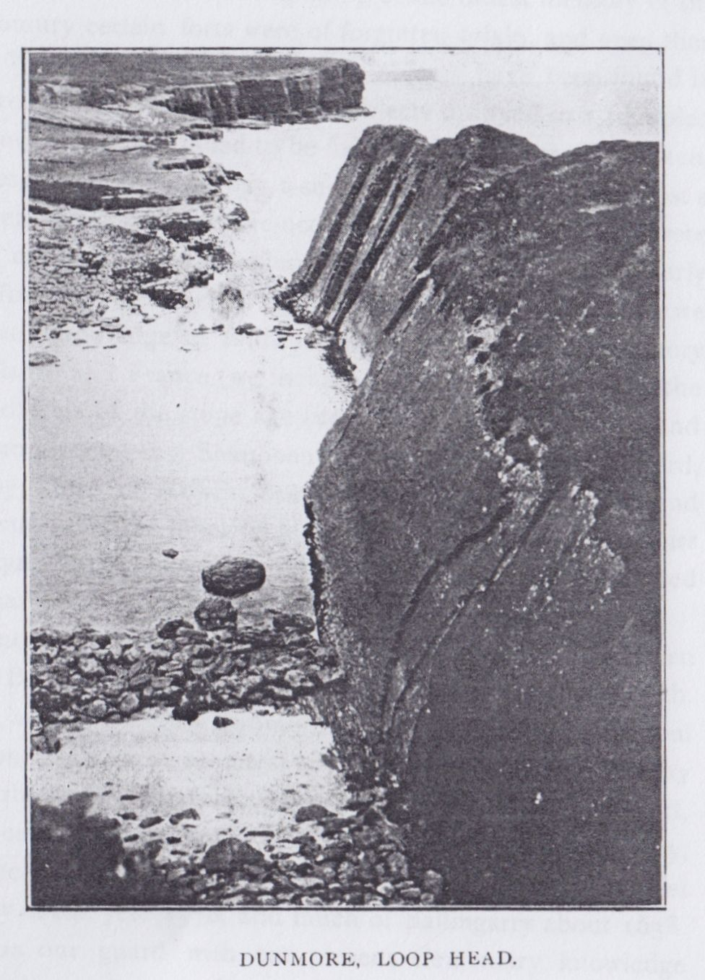

143

(and, therefore, the forts) may be of great age. The rest depends on excavation and common-sense deductions. The oldest legends of Ireland regard certain promontory forts(18) as of the remotest antiquity. This, at least, implies that at the beginning of the oldest memory of the past in our country certain forts were of forgotten origin, and even then prehistoric. When we consider how few objects have been found in dozens of levelled forts it is evident that objects dropped in a trampled and limited enclosure rarely failed to be found. Even were a fort taken, and its inmates slain or carried away, a suitable site would—at the most a generation later—be repaired and re-occupied. All objects of value were certain to be carried off by the plunderers. Hence the lack of early objects in a fort is of little weight against it being very old. When we concentrate our knowledge of finds in the cases of all the promontory forts of our islands and France (we include those on spurs far from the sea), we have objects of the stone age (usually in its later periods), and of the bronze and iron ages. Shanooan or Dunmore Fort in Waterford, and the Bailey Forth of Howth, near Dublin, have yielded flint and stone implements. On the other hand, so far as occupation and repairs it cannot be questioned that numerous cliff forts have been so treated from the Norman invasion down to Stuart times.

There is no reason to reject traditions of Dunnamo having been repaired by the Bourkes, probably after 1300, and in the days of Elizabeth. In Kerry, while, as I have shown, Dunmore in Corcaguiny may be a tribal sanctuary, Doon Eask of the remotest antiquity, and the forts on Kerry Head, Cahercarbery more and beg, closely similar to a Welsh hill fort, possibly of the century before our era; others, like Dunbeg, near Ventry, show an advanced and late character in the defences, while Fort del oro is essentially of the year 1570, and much of Ballingarry about 1638. We must be on our guard with our present elementary knowledge against “dogmatic archaeology.” I incline to regard the straight

18 Caherconree, Dunseverick, the Old Head of Kinsale, and, perhaps, Howth. The growing confirmation of our legends by Archaeology is a noteworthy feature of the time. When a brooch belonging to the century, in which Eamhan (Emania) is said to have been founded (4th century B.C.), is discovered in the ambit of that great fort. When the ornaments described in the Tain bo Cuailnge correspond with those only in use for a few generations at the very epoch of the legend, we see that we only wait for a Schliemann to remove the Irish ‘Iliad” to the archaeological position of its mightier Hellenic equivalent.

144

defences as later than the curved ones, but, at Port Conaghra, in county Mayo, and at Doonaunroe and Doonegall, near Kilkee, the straight works originated in natural clefts, and so may date from the remotest past. As to sea rovers such possibly visited our coasts (but more probably the more accessible and richer eastern coast) from time to time in very early periods. Our earliest legends are of a series of invasions and settlements, and we hear of expelled tribes returning and re-establishing themselves by force or compact; of sea-faring warriors; of sea rovers like the Fomorigh, and of invasions such as still impress the legend of Ventry and the Mullet. When we come to history all is changed. We read of a plundering invasion of Erin by the Saxons in a.d. 434 or 435(19). (“The first prey of the Saxons from Erin,” as the Annals of Ulster call it). Then I believe nothing more till the pithy record of 782—“Geinte in h Erind” —“the Gentiles in Erin,” heralding the two centuries of Norse and Danish raids. As to the names (and names, in early times, were usually full of meaning), we may be fairly certain that the great straight works at Doonegall, Dunabrattin, and Baginbruin, were used by Danes or Norsemen, Welsh or British and Normans, but would do well not to attribute the origin to any of these nations without more evidence. When we consider the question of the promontory forts of County Glare and its neighbours, alone, it is evident that, with hardly an exception, they were places to which the inhabitants of the districts could retire from landward attack. Doonegall is the only one (though even its bay is very exposed), which an invading force might have used as a base for attacking the inland people. This is, however, more than doubtful, where a few hours more sail brought any sea force into the shelter of the Shannon, and its rich fields and convenient creeks. All the other Clare forts are on long reaches of harbourless coast, the most improbable places that any invader would choose, and the same is true of Kerry down to Limerick, and of Connacht up to Inishbofin. An early Norse poem written on (and near) the time of the battle of Clontarf, regards Ireland as about to be ruled by the “new coming” nations, who, before the battle, had dwelt on “outlying headlands”(20). Many of these early headland forts were strengthened by later castles; for example,

19 Annals of Inisfallen and Ulster.

1. Niala Saga “Burnt Niall” ed Dasent, 1900, p. 328. It was sung by the Norns, the Fatal sisters, according to the saga tellers.

145

Dookeeghan, the ancient Dumhach MacUicaechain, on Broadhaven in Mayo; the great fort of Bunkilmore, on Achillbeg and Dunlecky in Clare, have all got turrets and mortar-built walls over their primitive earth works. Pookeenee Castle, near Ballybunnian, cuts into the curved works of a great cliff fort. Doon Castle and Leck, near the last Ballybunnian Castle, Browne’s Castle, Castle Shannon, Ballingarry; Ferritter’s Castle, near Limerick, and Reencaheragh Castle, near Valentia, are all 15th century peel towers on early cliff forts. In County Cork the list is even longer—Dunanoir, Inisherkin, Dundeady, Dunnycove, Dunowen, Power’s Head, and above all the old Head of Kinsale. In the north we may name Bruce’s Castle on Rathlin, Dunseverick and Dunluce, with the castle at Dun Balor on Torry Island. As we have seen there is reason to believe that in several cases the rocks on which the fortifications were made may have been but little affected in the last thousand years, while in other cases most probably dozens of early forts have been swept away altogether, and others, like Dun Briste, Cashlaunicrobin and Spinkadoon in Mayo, Dunahineena on Bofin, Farighy, and Illaunadoon in Clare, and Lisheencankeeragh have barely existed long enough to be recorded, and in another generation may have left no trace(21). Both in County Mayo and County Clare this class of structure has suffered greatly at the hands of man. The earth works in the former county are usually slight, the main defence being a strong wall of rather small flagstones easily removed to its very foundation. In Clare this was true of Moher, Freagh, Farighy, and in a lesser degree of Doonaunroe. The same probably applies to the forts of Moneenagarroge, Dunbinnia, and Dunaweelaun, to the west of Dingle, and was certainly true of Minard fort to the east of that town.

It only remains to tell once again the chief legend of Loop Head after that of Cuchullin and Mal. Though probably treaed somewhat freely by Comyn in “The Adventures of the Sons of Thorailbh mac Stairin,” it is founded on local legend, is accepted as genuine by Eugene O’Curry, and found by me to tally fairly well with untouched legends of the Lehinch district. I will give it as briefly as possible.

1. I may refer to my report published by the Commission on Coast Erosion, 1911, and to my papers on the Promontory Forts of Kerry. Journal R.S.A.I., vol. XLI., and County Mayo in course of publication in same journal, for fuller discussion.

146

Just before our era commenced, in the days of the High King, Choncobhair MacNesi and the Red Branch heroes, three brothers, Crochaun, Dahlin and Sall, dwelt with their sister on Loop Head. She was known as Aenbhean, “the lone woman,” but she had not always dwelt in solitude. She had come from the land of the Amazons, and while at Tara had been seen by Diarmait Ua Duine, who deeply desired her; but Cathba, the chief Druid, foretold that, when she should leave the single life a deadly fate should overtake her brothers. The three young men fortified the headland; it was guarded by the water dragon, the piast Dabhram, who dwelt in a cave in a southern cliff. To landward they built three forts, and behind the lines a fourth for their sister, and the forts were called after their own names—Cathaircrochain, Cathairsaill, and Dundaithlionn—the inner fort being Cathair na heán mná—the fort of the lone woman. Diarmait, filled with love and despair, sought council of the God Aongus of the Brugh of the Boyne, the son of the Daghda. The god gave him a ring and a square wax candle, telling him to wait on Mount Brandon (not then so called, nor for five centuries later) and watch the Clare coast till the red stone in his ring turned green.

At last his opportunity came. Who can fight destiny? as the tales of Danae and of Balor's daughter show. The lands ol the brothers were invaded, and their cattle swept away by Ruidhin, Ceannuir and Stuithin, who dwelt in the forts of Moher and Liscannor, and on the island of Kilstuithin in Liscannor Bay.

The brothers forgot all save their insolent foes, and drove hard on their track, overtaking them at the ford of the Daelach, before Liscannor, at Creachillán. The battle was fierce, but the Corcomroe chiefs were driven back. Stuithin escaped to his island, which sank beneath the wave. The rest perished, and the brothers wasted their forts and territory, Diarmait had seen all, and, launched in his magic curach, with the charmed candle blazing, flew to Loop Head. The monster was plunged in a charmed sleep, and was easily slain(22). The lone woman in joy fled with her lover, and when the brothers returned their ward was

1. It was awakened with a sort of boomerang (made by Lugh Lamhfoda, which returned to the thrower’s hand), and slain by the ring, thrown down its throat and repeated blows of the missile. The sea birds swarmed to feast on its body.

147

gone. They tracked her footsteps to Aillantriur cliff, thence they saw the lovers reach the Kerry shore. The doom was impending, but might be forestalled by an easier death. In brief farewell, the three clapsed each other’s hands, sprang into the Poll na peiste under the cliff and perished.

The Lehinch legends located the battle at Bohercrochaun, and told how in the thick of the melee, Stuithin lost the golden key of his magic island, and it sank out of sight, only to rise dimly above the waves once in seven years. Pardonably anxious for the honour of Corcomroe they make their tribesmen drive back the brothers. This variant does much to confirm the general outline of Comyn’s recension. The legend is transparent. Crochan is the humped hill that keeps watch from within its fortress wall over the headland. Sall is the salt spray, blowing ever across the fields. The piast, the cruel waves, withing along the cliffs and keeping off all intrusion from the seaward, “the Deep, couching beneath !!”

We are told that the monster of Iniscathaig, the formidable Catha (long afterwards slain by St. Senan), avenged its sister, Dabhran, by wasting the river banks on both shores for as far as the tide runs, and destroying every ship or boat that attempted to sail on the estuary. In the hunting of Sliabh Trium(23), Finn Mac Cumhail is also said to have killed a monster in the same place.

“Fionn banished from the raths  
Each piast he went to meet;

A piast in the refulgent Shannon,

That destroyed the happiness of the people,

He slew by frequenting the ‘lake.’ ”

I could not learn anything of the second mythical island of County Clare, mentioned by the Rev. J. Graham in the very interesting letter (published in Mason’s Parochial Survey) on the Kilrush Union(24). Graham, however, is a painstaking and reliable witness; and O’Curry, in the Ordnance Survey Letters, does not contradict him, as he is so ready to do in the case of other writers on Irish antiquities and beliefs.

1. ed. John O’Daly, “Trans Ossianic Soc.” (1858), vol. vi. p. 123.
2. Vol. ii., p. 490.

148

Graham gives a circumstantial account of towers and buildings being seen under the sea at the submerged island Kilstiffen (or Kilstapheen) in the Shannon. He also tells how the enchanted inhabitants raise destructive storms over it, while elsewhere all is calm.

Mr. and Mrs. S. C. Hall (25) repeat the legend of—

“... old palaces and towers,

Quivering within the waves intenser day,

All overgrown with azure, moss and flowers,  
For whose path the Atlantic’s level powers   
Cleave themselves into chasms -- ”

There is a shoal in the estuary at a spot opposite Loop Head, but whether Graham or his informants have brought down the legend of the other Kilstrapheen, or Kilsmithin, in Liscannor Bay, and planted it in the Shannon, I have no means of testing. Such as it is I give it, for I must confess to the fascination of these sea tales of the lost lands, so dear to the human race on the edge of the great sea. The whole length of the old world away from Loop Head, the Japanese told of the happy isle of “Oraisan,” far out to sea in the Pacific. The Chinese told of the Islands of the Blessed, 700 miles beyond the Yellow Sea, and how the Emperor Tshe Huan, 219 years before Christ, learned their secret, and how certain youths saw them far away in roseate light, but storms drove the ships back to land(26). So the Greeks had their Hesperides and Calypso’s and Circe’s isles; the Arabs, Portuguese, and Italians, their isles of Fantasy, Antilha, Maida, Verde and Brasil; the Scotch their Inis Flaith; the Cornish their Avalon, and the Irish their endless sunken isles—Ballyheige, the Kilstuithins, Monastra Ladra, the great Sunken Land and Tir Hudi, and far in the outer deep the Isles of Promise, the Isle of Youth and Hy Brazil, the Isle of the Blessed.

1. “Ireland, its Scenery and Character,” vol. ii., p. 436.
2. “In Northern Mists,” F. Nansen (ed. Chater, 1912), vol. i., p. 377.