Journal of the Limerick Field Club Vol 3(10) 1906

ANCIENT REMAINS NEAR LISDOONVARNA.

ByTHOMAS JOHNSON WESTROPP, M.A. M.R.I.A.

Introduction

Lisdoonvarna  
 Kilmoon

Kileany – St Enda

Oughtdarra

Part 2 Introduction

Ballinalackan with note on history of Peel Towers and castles

The Glasha Ridge – Cahermaccrusheen

Cahermaclanchy and Caherglasha

Tooclae and Knockfin

Killilagh

Toomullin and St. Brecan

Doonagore

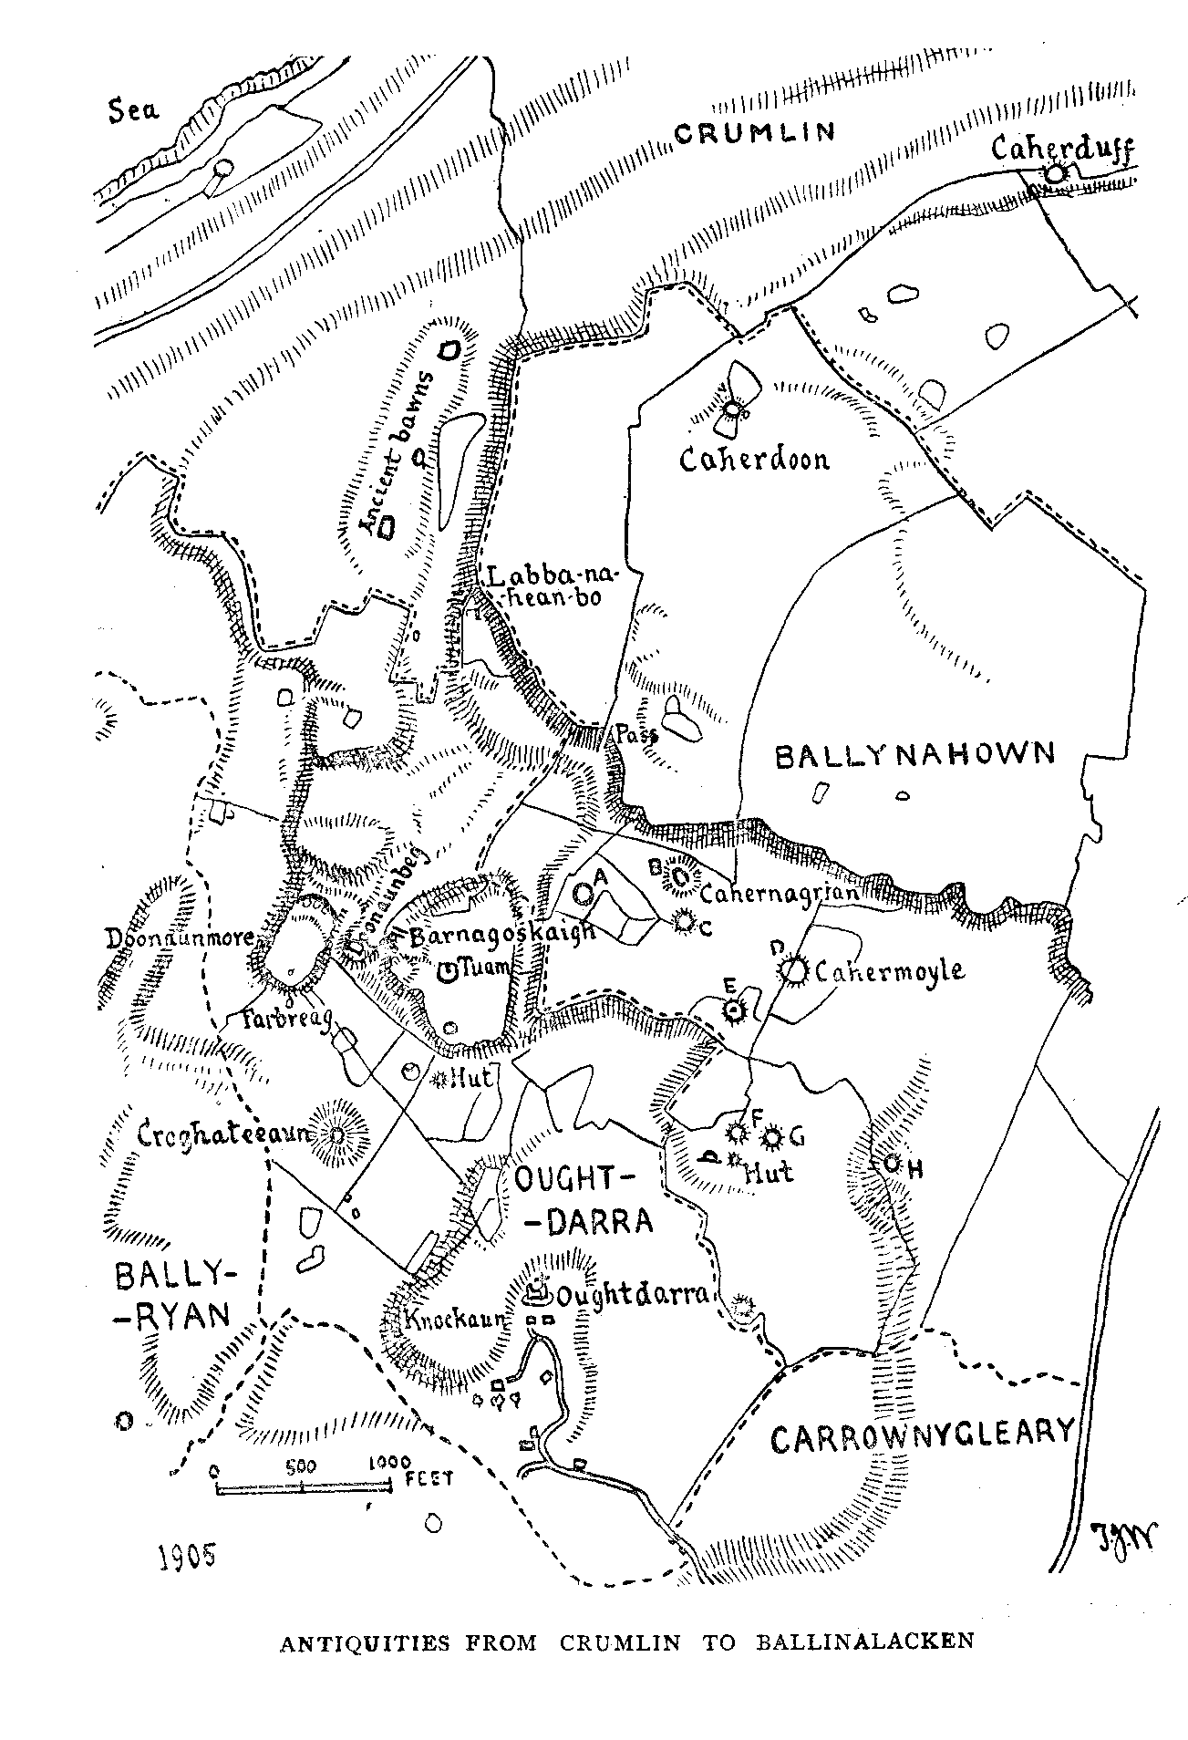

39

ANCIENT REMAINS NEAR LISDOONVARNA.

ByTHOMAS JOHNSON WESTROPP, M.A. M.R.I.A.

When a traveller visits a pleasure resort outside of Ireland and desires to see and know what there may be of interest in its neighbourhood, he invariably finds all his wants in this respect abundantly supplied. Books—from the briefest little guide to elaborate country histories (and all usually of good quality) “can be had for the buying, and his only cause for complaint is that everything has been illustrated and described, and that there are no new worlds left for him to conquer.” Very different in both respects is his condition in Ireland. There are few guide books, and those often, as has been truly but maliciously said—“calculated to the meridian of the tripper.” The county histories are often not attainable, and when consulted, tell little or nothing about the lessor antiquities. On the other hand, anyone sufficiently energetic, can find many objects undescribed, and sometimes only known to a few. Both in Natural History and Archseology there is much to be done for Ireland to bring her sciences to the level attained in other countries.

The encouraging interest shown in our previous paper on the antiquities round Miltown—imperfeot and disconnected though it was —leads me to attempt a similar work for persons staying at Lisdoonvarna. Like its predecessor, the present paper is mainly suggestive of districts to be explored and the classes of objects to be found in them.

How well we, who travelled to Lisdoonvarna ere the railway existed, remember the journey from Ennis. In any sort of endurable weather, especially with a companion who knew the district, it was a time of enjoyment, fresh, bright, full of interest. To the antiquary, every few miles brought some new object for speculation. The ivied gables and grey window tracery of Ennis Abbey, the grim old ruins at

40

Drumcliffe, the brown church of Kilnaboy, with its round tower, and the cathedral at Kilfenora, recalled the Christian period. The houses of the chiefs—Ballygriffy, Ballyportrea, Shallee and many others;— Inchiquin, ivy-clad, on its post before the beautiful lake and great wooded mountain of Cenn-Nathrach and the wrecked Lemaneagh, the gate of Burren, told their tale of unrest and violence; while of that dark period—behind the times of English, Dane, and even Christian — one saw the dolmens, burial mounds, cairns and forts of Carran,. Roughan, Leanna, Ballyganner, the great wall of Ballykinvarga behind its “ sonnach " of stone spikes, and the great hill fort of Doon, crouched on its lofty ridge over Kilfenora, and looking for miles across the Atlantic. Then we crossed the moor, seeing afar the blue sea and the “island of houses ” among the bogs, the goal of our journey, carrrying away, too, the refreshing sense of drives through woods, past grey crags, rich in flowers, over hawthorn clad ridges and deep valleys with clear, bright streams.

LISDOONVARNA. Lisdoonvarna itself calls for but little attention in these notes. So new that it does not appear on the first Ordnance Survey, and save for its deep cut stream-beds and strange tortoise like concretions, the interest lies at some distance from its site. It exists by its spas and is blessed in having no history. Its place names are however of more interest. Ballinshenmore and Beg on which the village stands show that it was not always, as now, bare and unsheltered, but forested with ash trees. The tree was not unknown in Burren, for, up the craggy upland, far to the east, we find Gleninshon. To the west, the townland of Knoekaskeheen suggests one of those dreary thorn bushes, “with its back to the wind,” that elsewhere are picturesquely supposed to spring from the dust of the dead, blowing restlessly before the gale. In the neighbouring valley to the northeast was once an oak forest at “ Derrynavahagh,” while the wolves made their lair on the hill of “Knockaunvicteera” to the south of the spas.

When we mention the Irish wolf (a by-word even in Shakespere’s time, and the avowed enemy of all the contending parties in “the land of Ire" three centuries ago), we may note how strangely rare are finds of his remains. The elaborate excavations of Mr. Richard Ussher, in the caves of Edenvale, Newhall and Ballybeg, three years since

41

disclosed some 50,000 bones of elk, reindeer, bear, and other animals, but little undoubted trace of wolf. None, so far as we know were found by Miss Parkinson in the crannogs of Dromcliff and Claureen, or in the early settlements among the sandhills of Milltown, Bealaghaline, Lehinch, or Fanore, or in the middens and souterrains near Doonmore on Loop Head. Literature but rarely alludes to the wolf of Old Thomond. Caeilte in “the Colloquy of the Ancients,'’ is made to tell how, in the severe winter, “the stag of frigid Echtghe’s summit catches the chorus of the wolves;” the Four Masters tell how in 1573 the wolves and ravens made merry over the slain profaners of Inghean Baoith’s church. The place names, especially of western Clare, however,, bear witness to the presence of the “grey beast,” for the name “Breaghva” occurs in Moyarta, Kilrush, Kilmurry MacMahon, Clondegad and Kilchrist, while “Breaffy,” near Miltown-Malbay, has been noted in these pages. Add to these, perhaps, the nearly levelled fort of “Cahermacateer,” called in old documents “Caher na McTire,” near Wilbrook.

The great earthen fort of Lissateeaun lies between the spas and the old castle of Lisdoonvarna, and probably gives the place its name. We find beside the road to Kilmoon the foundation of a cathair built with large blocks, and called “ Caherbarnagh,” and lower down the valley we find “ Lisdoonvarna,” each fort being named after the “gap” or pass. The latter name has also that interesting and archaic feature of reduplication which we find in so many fort names here and about Ireland. Caherdoonerish, on Black Head, Caherlisaniska, near Glensleade, Lisnaraha, Lisdangan, Rathdangan, Lissatunna, Lissamota, Dunalis and Lismoher. Lissateeaun is a reputed fairy mount, and appears to have been carved out of a natural hillock. Little is left, and as little known about the castle of Lisdoonvarna. Of the ruins, we only find reaches of low, unpicturesque walls round its outer enclosures. It was confirmed in 1621, to Boetius Clanchy, (Pat R) a relation and namesake of the famous Spanish-hanging sheriff. The castle was subsequently occupied by the O’Davorens, the Fitzpatricks, 1641, and the Creaghs, 1679. 1723, a lease of Rickard Connell, of Ruscagh, to William, Earl of Inchiquin, grants Lisdoonvarna. The last O’Davoren of Lisdoonvarna, was Donogh, a haughty and tyrannical man. It

42

passed to the Hogans, and from them to the Stacpooles. Reg. Deeds, Dublin, b. 41 p, 280.

KILMOON CHURCH (O.S. 8.) North from Lisdoonvarna, a short distance from the main road to Ballyvaughan, is the ancient church of Kilmoon. It stands beside a by-road which leads up the hill to the high bog land between Knockauns Mountain and Slieve Elva, a paradise for botanists, as every runnel, deep cut in the shale, and the heathy moors between, abound in plants.

The church is a greatly defaced but very early structure; the masonry and plinth at the S. E. angle should be examined as a fine example of pre-Norman work. The north wall is still standing. The church measures 52 feet by 18 feet inside. A very curious and unusual feature is traceable at the east end. Later builders in the late fourteenth, or early fifteenth century, built a pier to each side of the altar, about five inches from the east wall, over these they formed a pointed arch, with a chamfered rib, resting on one of those neatly moulded angular corbels so common in the cornices of the churches and castles of that period, and under the tower arches of the abbeys. The recess left the east window unimpeded, and added the effect of a chancel to the otherwise simple interior. Only the right pier and the spring and corbel of the arch are preserved—the foundation of the left pier is, however, traceable. There is slight trace of a south window near the east end. A sort of side chapel, or, perhaps tomb house was made, probably later than 1600, it measures about 24 feet north and south by 20 feet east and west, and stands clear of (but only 5 feet from) the church.(l) In the field at some distance to the west, is St. Mogua’s well, and tree and altar, the latter has some of those round stones usually called “cursing stones,” such as are found at many ancient churches. We have noted them in County Clare, at St. Columba’s church, at Kinallia; at Ross, near Loop Hoad; at Killoue well, near Ennis; and (as we shall see) at Killeany. In many cases they were probably used as a sort of rosary for keeping count of the requisite prayers, and we have seen them so used at Killone. Occasionally they have, however, been used

(I) It has plain, chamfered oblong windows, with hoods ending in stepped drops ; the door is pointed. Some of the stones of the church may be found lying about the graveyard, one has a slot for a key-shaped iron tongue of a frame.

43

for the far different purpose of malediction. It is not many years since an inhabitant of an adjoining barony beat and lamed an old woman who threatened to “turn the stones of Kilmoon agin him.” The ease was tried at petty sessions, and it was “proved” that, by a fast and certain prayers, going round the altar and turning the stones “against the sun,” the face of the “cursed person” could be twisted, and from the real belief in this method the violence of the threatened person was charitably regarded as a mere act of self defence.

To the east of the church, at some distance, on the summit of a ridge, the tall pillar called “the cross” or “the standing stone of Kilmoon” rises against the sky. It is a rude uncut monolith, and measures 11 feet 6 inches in height and 13 inches by 8 inches in thickness. It probably marked the limit between Kilmoon and its neighbour church Killeany.

There are no early records of either of these churches. In the Papal Taxation 1302, we find both recorded as Kilmugown and Killeny. In 1404, John O’Dalayg, the Chancellor of Kilfenora, was priest of Kylleney-Innabyr (2) and Ybflachnyed. Very little else is told of the churches down to the time of the visitation of 1615, when both had been long in ruins, The chief lands and proprietors in 1641-1655 were—in Kilmoon parish—Kilmoon held by Donogh O’Brien and Turlogh son of Loghlen O’Loghlen, it was transferred to Lord Inchiquin and Piers Creagh, the other original proprietors in the parish were members of the Clancy, O’Loughlin, O’Coilehane, Neylan and FitzPatrick families. The last held Ballytiege and Lisdoonvarna, while the O’Loughlens held the site of the present ‘town’ of Lisdoonvarna. In Killeany parish the owners were mainly O’Briens and O’Conors, with one O’Loughlin. Killeany itself was held by Donough O’Brien, and transferred to Pierce Creagh, a member of that ancient family (probably an offset of the Russells, but claiming descent from the O’Nialls), who were seated at Adare, Co. Limerick, from 1321, when Agnes, widow of Richard Russell, had a suit for dower against John Crevagh and another. John Russell, alias Crevagh (3) was Mayor of Limerick in

1. Killeaney in Fionnabhair [Kilfenora], and Killilagh.
2. This points to a different origin from the “received” family tradition of their descent from O’Niall, which is, however, as old as the time of Elizabeth, and is perpetuated on the modern tablet set in Ennis Abbey.

44

1216. In the survey of “1675,” now at Edenvale, Sim Creagh held most of Killeny, with the exception of Ballygastill which was in possession of Henry Ievers the founder of the Sixmilebridge family. In the parish of Kilmoon, Creagh again appears to have held ten out of thirteen townlands, including Lisdoonvarna Castle, Kilmoon church lands and the site of modern Lisdoonvarna.

KILLEANY (O.S. 5.) Between Kilmoon and Killeany churches lay two remarkable stone forts, but modern vandalism has destroyed the more generally interesting features. The one on the high ground over the road down that long picturesque valley, past Elva to the “Khyber Pass,” is named Cahercloggaun. A great part of its finely built ring of dry stone walls is still standing. Towards the S.E. a great mound, showing foundations of mortar built walls and traces of a cupboard or ambrey and a staircase, is all that remains of a castle of the O’Loughlins. (4) The second fort, Cahermoyle, is greatly lowered, but of even finer masonry, standing on the edge of a steep little ridge. Local legend renders Cahercloggaun as the “fort of the silver bell,” possibly an appurtenance of the church in the valley below. (5) Both these forts have been described at full length along with the two cahers of Caherbullog farther northward and the large but overthrown cromlech of Cooleamore. The whole valley is full of interest to students of our stone forts, but beyond reference to the published descriptions we must confine ourselves to the buildings of the historic period. (6)

In the southern end of the valley, in full view of the great brown ridge of Slieve Elva, we find the ancient church of St. Enda, who, with

1. “ The place is called ‘Kaercloghan’ on the Elizabethan map of 1560. Hely Dutton ingeniously revises its name to “Cahercallaghan.” Its inhabitants seem to have been in constant trouble with tne Government : in 1570, Brian O’Loughlin of this place needed a pardon: the next year another inmate, Donough Mac Rorie O’Loughlin needed another; and in 1585, a large group of its inmates received pardon, Donough appearing again with his tenants or retainers, Edmond and Owen MacSwyny, Teige MacBrien and Teige O’Tyerney.—Fiants. 1641, 4-753, Book of Distribution. It subsisted as a castle till 1652, when it was allotted to the transplanted Pierce Creagh, of Adare, County Limerick, who eventually settled at Dangan, near Quin.” In 1626, Terence O’Brien of Ballinalacken, held the castle, vill, and land of Cahercloggan, with Kilmoon, Cooleabegg and other lands.
2. The stream to the west is Owencloggaun, and there may be (or have been) a legend of some hidden bells of either of the neighbouring churches.
3. R.S.A.I. Journal xxxi, p, 12.

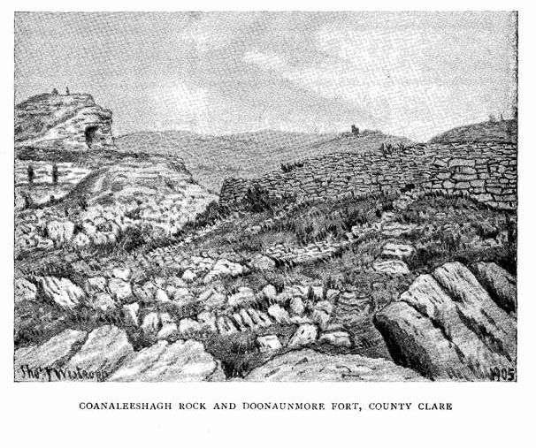

45

St. Brecan, a member of the ruling house of Thomond, evangelised the Isles of Aran and parts of Corcomroe and eastern Clare towards the close of the fifth century.

We may gather a few of the old traditions that pass for the history of St. Enda, the patron of Aran. The “lives” of himself and his equally saintly sister, St. Fanchea, are very late and overlaid with fable, and that of Enda is grievously lacking in that local colour, which often gives a high topographical value even to absolute fiction. We however probably can read between the inconsistencies, mistakes, and aimless miracles, a real legend of a real, self-sacrificed and holy life.

Enda, Fanchea, and a second sister Darenia, wife of Aenghus, King of Cashel, were children of Conall Derg, King of Oriel, or Orghialla, which lay in Louth, Armagh and Fermanagh. Connal was son of Daimhim, son of Coirpre-Domhairgid, of the race of Colla da Chrioch and his wife was Aebhfinn, daughter of Ainmire, son of Ronan, King of the Ards. Born about 460, Enda was brought up as a young chief and warrior, and was of a fiery and angry disposition, though of pure life. Fanchea had become a nun, and settling at Ross Oirther or Rossory, in Fermanagh, attracted round her a group of holy women. On the death of Conall, Enda was chosen to succeed, but, apparently, in the face of considerable opposition, probably on account of his youth. He however mustered his friends, defeated his enemies, and at the head of his men marched past Rossory singing war songs of triumph. “This vociferation,” said Fanchea sadly, “is not pleasing to Christ.” She paused as she heard her brother’s voice and added “he is a son of the Kingdom of Heaven,” and she met the blood-stained warriors to rebuke Enda for bloodshed. The young man defended himself and pressed her to give him one of her companions whom he named to be his wife. Fanchea left the poor girl to choose for herself, she selected the religious life and died immediately. Fanchea then led her brother to the chamber of death, and in the awful revulsion and distress Enda determined to resign his chieftainry and become a monk. It is the frequently recurring story of the middle ages, nay even of our day, and like many another man, Enda, along with religion, sought the blessed solace of hard work, and by his unsparing labour he dug the fosses and mounds round his sister’s cells, of which all trace has not vanished from

46

Rossory. He went with her to Killeany and was set on by robbers, his warlike spirit rose, and seizing a post from the timber, stacked for building the new convent, he was about to fall on the men when Fanchea called to him to put his hand on his head, and on feeling the tonsure, he laid down the post and left the robbers unmolested. Fanchea seems to have feared for his fierce disposition, and so persuaded him to go to St. Mansenus, an Irishman, named Manchene, abbot of Rosnat, in Britain (“Monasterium Vallis Rosina” in Wales.) Enda sojourned there for some time, visited Rome and founded a cell called Latinum (or Laetinum), in Italy or Gaul, which has been identified or confused with St. Fursey’s cell at Latiniacum, in Gaul, founded in 640.

On his return to Wales he was visited by Fanchea, who advised him to settle in Aran. The advice was good, for “the Aras of the sea” were an appanage of the King of Cashel—is it not written in the “Book of Rights” ? So Enda set out to his brother-in-law, Aenghus Mac Natfraich, King of Munster, who dwelt at Cashel. Fanchea had died soon after her return to Ireland, on January 1st, about 480, and Enda had no other tie to Oriel. King Aenghus, after a vision of the distant Isles from a hill near Cashel, gave them to his relative who set out to reach them.

Aran, according to tradition, had about the beginning of our era been colonised by the Firbolgs of Clan Huamore, the enormous walls of dry stone, attributed to their chiefs Aenghus and Conor, crown the summits of the three Islands at Dun Aenghus, Oghil, Dun Conor and O’Brien’s castle. When Enda landed at Leamhcoill, or more properly Ochoill, he found some pagans from Corcomroe dwelling there under a chief Corbanus, but they fled to the mainland. Legends are told of the barrel of corn set afloat in Clare and reaching Portdeeha near Killeaney; of the angel smiting the rock to make a landing place, and of the same, or another angel bringing a gospel book and chasuble to Enda.

We know that in the thirteenth century (when the existing “Life” was probably written by Augustin Magraidin), Enda’s Gospels were enshrined in a brass box, which, even then, had replaced the golden shrine of olden times. The legends are of little interest after the foundation of his monastery in about 480. He seems after some objection,

47

to have shared the island in perfect friendship with the Dalcassian Saint, Brecan, son of Eochy Bailldearg, a most gentle, cheerful and loveable man of the sincerest piety and humility, whom one would like to believe was (by his strong contrast to the sorrowful and passionate Enda) a consolation and blessing to his sad brother abbot. Brecan’s church and grave lie in the Eoghanacht (Onaght) near the northwestern end of Aranmore, Enda’s near the sandy bay to the eastern end. Both saints laboured in Clare, where Brecan is remembered at Toomullin, and near Ennis, (at Noughaval-Kilbrecan, Doora, and Clooney) and Enda at Killeany.

To Enda’s monastery crowded many who, in their turn, became noted saints and founders of churches and monasteries—Kieran, the carpenter, founder of Clonmacnoise was there, and Manisterkieran still recalls his residence in Aran. Brendan the saint of seafarers, and reputed discoverer of America—

“Seeing how blessed Enda dwelt apart,

Amid the sacred eaves of Ara Mhor ;

And how beneath his eyes, spread like a chart,

Lay all the isles of that remotest shore,

And how he had collected in his mind

All that was known to man of the old sea.”

set out from Smerwick to consult him before his adventurous voyage. Then came a crowd of saints—Jarlath, patron of Tuam; Finan, of Moville; Finian, of Clonard; Carthage, or Mochuda, of Lismore; Kevin, of Glendalough; Caveen, his brother, of Inishere; Lonan, Benan, Papeus, Gigneus, Nechatus, Libeus—but the list is long and has been published.

Enda had founded his monastery, where the stump of a round tower, a broken cross, two churches, some cells and foundations, are the only remains of a group of ten churches and a monastery, which sprang up at various periods during the thousand years after his death. Most of the buildings were demolished by the garrison of Arkin fort in the time of the Commonwealth, and the materials used to enlarge and strengthen the castle. At this spot Enda led a life of piety and great austerity.

“Enda of high piety loved,

In Ara, victory with sweetness,

A prison of hard, narrow stone.”

48

He, however, was able to establish other religious settlements in Clare and Galway; Killeany, near Glin, in county Limerick; Killeany, in Deece, county Meath; Clonenagh, in Queen’s county, and several other churches are dedicated or attributed to him.

The date of his death is uncertain, it fell on a 21st of March, on which from the earliest times his feast was observed. He was buried at Teglach Enda among the sandhills of Killeany Bay. The cemetery is reputed to be the resting place of hundreds of saints. (7)

We now may turn to the venerable building. Simple and unadorned as it must appear to strangers used to the grander churches of other countries, it is to an antiquary a mine of interest. First we note the very evident gable of an eleventh century church, embedded in the east end of the building. Its large, white-lichened blocks, set in irregular courses, glare out of the darker masonry of later days. The window has one of those plain but most pleasing arches, which, lining a wide splay, are masterpieces of perfectly fitted masonry. Inside is a small moulding, like a drip ledge, running round the head of the arch, and a broad raised band under the sill and turning up for about half the height of the jambs, though outside them, turning again as a level cornice along the faces of the wall. The narrow light is moulded on the outside, and beside it on the head stone is a quaint round knot formed by a well cut little serpent. The inner face of the south chancel light is evidently of the same period, but it has been reset, and the older light replaced by a trefoil-headed window slit, hardly older than 1450. The plain old altar is still standing. On it are some bases, shafts and capitals, well cut, probably remains of a shrine or recess, dating from the period when the church was rebuilt. The nave calls for less notice, it is divided from the chancel by a lofty pointed arch, “faced” with rather thin slabs. The south door was pointed, the blocks lie about the place, the door having been thrown down. The windows are all small and evidently belong to the fifteenth century,

(7) For excellent summaries of the Lives of Fanchea and Itnda, see the late Canon O’Hanlon’s “Lives of the Irish Saints,” Vol. i, p. i, and Vol. iii, p. 12. For the remains in Aran, see Royal Society Antiquaries, Ireland, Vol. xxv, p. 251, and their recent “Handbook of the Western Islands of Ireland.”

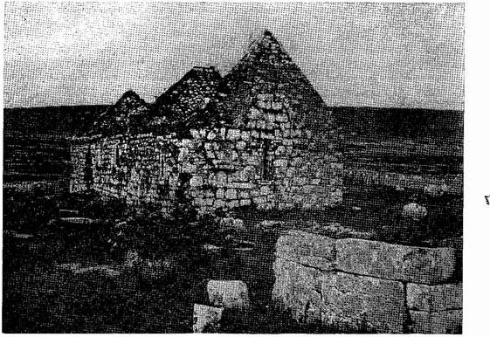

KILLEANY CHURCH AND ALTAR, COUNTY CLARE.

Kilcredaun Church, Co Clare

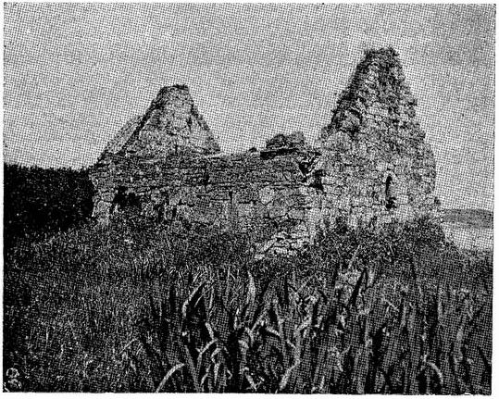

49

The nave is 34 ½ feet; the chancel 19 feet 2 inches, being square the church being that width inside the separation being marked by the arch alone, (8)

In the graveyard to the S.E. is a rude and curious altar of large limestone blocks, measuring 9 ½ - by 10 ½ feet. On it lie 28 of the shale nodules usually called “cursing stones.” The only interesting tombstones are those of Honora Neylan, 1725, and Father Moriargh Flanagan, the priest of the parish, 1712.

Southward from Lisdoonvarna there are few remains of general

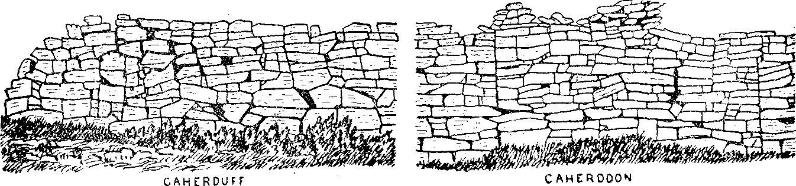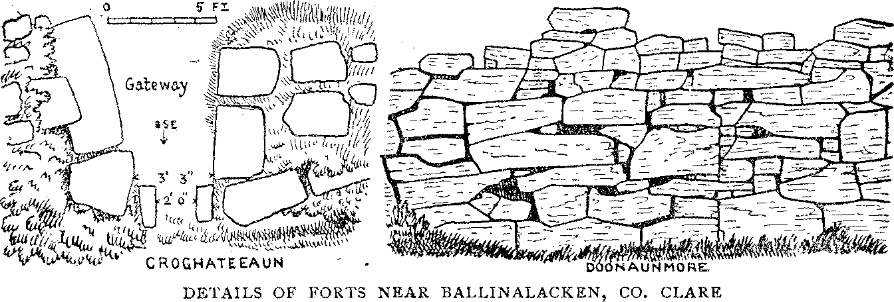

interest. The much damaged fort of Caherkinallia or Caherreagh stands at the end of a long promontory running out into the bogs near Lough Goller, and can be seen from the road to Ennistymon. Little else but raths of the ordinary type are to be seen in that direction till we approach the sea.

OUGHTDARRA (O.S. 8.) Taking the road to one of the most perfect castles in the county (and probably the best known of the Clare

(8) The church has been described and illustrated in Proc. Royal Irish Academy Series III, Vol. vi, p. 132, and by Canon O’Hanlon “ Lives of the Irish Saints” III, p. 915, and in R.S.A.I. Vol. xxx, p. 305.

50

peel towers) beside the pretty villa of the O’Brien’s, on the steep rock of Ballinalacken, we come to the sharp turn of the road from Lisdoon- varna, we see the earthworks called Lislard and the Mote. Both have a rounded central mound, and a ring and ditch round it, and both are probably burial places. Westward is a very fine view of the deep green valley and the little ruined house and plantation under a sheltering cliff at Cregg Lodge. Beyond “the great endless deep” from the Cliffs of Moher out past Aran. The three holy isles, fort-crowned and church-crowded, the white houses of Kilronan and Killeany, and the sandhills near them, and at Inishere, shining in the sunlight. Then we turn the hill and come in full view of a most interesting scene. Behind are the great cliffs and terraced limestone hills so characteristic of the Burren. Up on the highest plateau rises a little wall against the sky. It is the fine ring fort of Caheradoon, Below the tall cliffs with their sheets of ivy are green glens, mossy crags and hawthorns. Beautiful it is to see the white masses of blossom in May, and to wander through those crags brightened with primrose, blue gentian and wild violet, into the low valleys where the streams break

forth from under the hills.

“Oh ! that I too were   
By deep wells and water flood,

Streams of ancient hills, and where   
All the wan, grey places bear   
Blossoms, cleaving to the sod.”

Days may he spent enjoyably in this wild place, but few ever go off the beaten track to see itsbeauties. In the deepest valley, among the few cottages and beside the great craggy bluff of the ‘Cnockauns ’ —Cnockaungall, with its white rocks, near the houses, Gnockaunatinnagh, the haunt of foxes, and for that matter, badgers, to the north, and Cnockaunadacloich, a long stony ridge—lies the ruined oratory of Oughtdarra. Fragments of the walls of a late church 18 ½ by 36 ½ feet, with the cut stones of its pointed south door and narrow east window,, and a holy water basin, may be found. There is no carving or notable tombstone, for the cemetery is only, I believe, used for children dying under seven years of age.

It is dedicated to the famous Saint Sionach Mac Dara,— famous locally, where even angry people fear to curse in his name, and venerated all round Galway Bay, but making very little figure in the

5I

records. He is supposed to have lived in the sixth century, and his chief hermitage is represented by the interesting stone-roofed oratory and carved stones on the Island of Cruach Mac Dara. So obscure is his life that the idea that he is a mythical fox-hero (his name being “Fox, son of oak tree,” by interpretation) has been suggested. His interesting and massive church near Dun Aenghus, in Aran, is well known. (9).

The remarkable fairy hill, Croghateeaun, haunted by the “Dan- nans,” rises —regular as an artificial mote—-on the plateau to the west of the Cnockauns. On the summit are the foundations of a once strong hill fort, its gateway facing the S.S.E. Behind these remains are a giant wall of rock, ending in a bold headland to the S. W. It is called Doonaunmore, and is a really fine promontory fort of the type of Caherconree. A great rampart, over 300 feet long, crosses the neck of the headland, and is a strong wall nearly 9 feet thick and over 10 feet high; inside are the remains of several houses. Legend tells of a Giant occupant who was attacked, lost his magic wand, or “Druid staff,” and was slain. A rock-pillar called Farbreaga stands at the foot of the southern end, and through the plateau at its foot runs southward a remarkable valley with two huge rocks strongly like negroes’ heads, at one side, and mushroom-like pillars on the plateau near its mouth.

In the opposite direction in the highest cliffs, where the townlands of Crumlin, Ballynahown and Oughtdarra meet, we see a cave, Labhanaheanbo. When the great final battle is fought in Ireland the General of the native army will be wanting till he is found hidden in that cave and comes out to lead his forces to victory; he is to be an Ulsterman. As to the “one cow,” I was unable to get any information from my most kind guides, Messrs. Hilary and Kelleher, of Oughtdarra, who took me over the lower plateau on one of the three days I devoted to the study of the townlands. Another cow, the famous “Glas,” so famed on Glasgeivnagh Hill, near Corofin, sojourned in the green valleys behind Doonaunmore, but nothing further is told though her hoof-prints are shown.

(9) See Journal Royal Society Antiquarians, Ireland, xxv., for his church in Aran, xxvi. for Cruach Mac Dara, and xxxv. for the Oughtdarra district

52

Following the cliffs westward, we find a series of picturesque escarpments and gullies with fine outlooks. One cliff is Doonaunbeg, but no trace of a fort is to be seen. Then a bolder knoll has a cave in its face called Ooanaleeshagh, from the Lysaght family who once dwelt at Oughtdarra. Beside it, a long natural cranny has been roofed artificially. It runs up to a gap called Barnagoskaigh, which in its turn leads to a little amphitheatre surrounded by an ancient horse-shoe wall. In the arena, an enclosure and row of large blocks is called Tuamangoskaigh, beside the blocks was laid the giant hero with his great sword, and the “cave” was said to continue up to and under the “Tuam.” The foundations of a small fort or large house are visible on the crags to the south, and another at the foot of the cliff. We are now nearly in line with the Cnockauns, and find one of the most picturesque passes in the Burren, a long, green ascent flanked by cliffs 50 to 80 feet high, sheeted with ivy and climbing plants, and forming natural towers, curtain walls and bastions. On the plateau to the east of the pass lie several greatly broken forts, and the strong and remarkable little Caher, Cahernagrian, on a bold, hazel-clad knoll at the foot of the great cliffs. Along the latter in a bold recess to the east, if one ascends the great talus of broken rocks, one finds accessible, but 15 or 20 feet up the cliff, a fairly large and remarkable cave, but it exhibits no sign of human residence and is floored by the bare rock. There is a most beautiful view from its mouth. To the west of Cahernagrian, a ladderlike pass up the cliff leads to the plateau on which stands the fairly perfect and well built ring wall of Caherdoon. It has a terraced rampart, hut sites, a souterrain 19 feet long and 5 feet wide, with a small side chamber and, in the field to the east, the fallen slabs of a reputed cromlech. On the other and northern edge of the plateau and a few fields away, is another fine but much injured fort named Caherduff, probably from its shady position to the north, in contrast to the sunny and sheltered site of Cahernagrian on the south.  
At the foot of the slope below Caherduff, is the venerable little oratory of Crumlin, once a parish named Cromglaon, in 1302. It is dedicated to St. Columba. Tradition says that when the great “Apostle of the Hebrides” left Aran—that change he so pathetically laments if the poem to Aran be really his own—he built this little

53

church whence he could see the loved and holy isles across the bay. Only the east gable and portions of the sides remain. The east and south windows are of a very early type with round heads cut out of single blocks outside and rudely arched inside. It is much to be wished that so early a building, with its recollection of so great a man and saint, were vested and preserved from further injury.

The interesting forts through the valley with the old round castle of Faunaroosca and the church at Killonaghan, lie so far outside the Lisdoonvarna District that we need not deal with them in this paper.

Before returning to Ballinalacken Castle we may notice the charming little bays and low cliffs in line with Oughtdarra. The break of the sea into these, throwing up sheaves of dazzling foam, the rocks sheeted with samphire and sea-loving plants, and the beautiful flowers and ferns of the slopes beyond the break of the waves—for in gales the spray blows far inland—make it a spot to “linger out a dreamy summer day,” as charming as it is healthy and cheering.

**(to be continued).**

*,* I may here give corrigenda to the paper on the “Ancient Remains near Miltown Malbay,” in this Journal. Vol. ii, p. 47, and vol. iii, p. I.

Vol. iii, p. 4, line 28, for “I will not surrender, &c.” read “ I will not take the quarter of Belliaw and Sruell,” p. 9, correct “Telegraph,” and 10, delete ubt”in middle sentence; p. 11. correct to “ Iniscathaigh,” and in line 10 read “some papers of the original partition are among.”

143

ANCIENT REMAINS NEAR LISDOONVARNA.

(Continued from vol. iii, p. 52.)

By THOMAS JOHNSON WESTROPP, M.A., M.R.I.A.

Nothing can be more discouraging to an antiquary or more disappointing to his readers than the few dry facts yielded by many years of general research for the history of places of local interest. In the case of castles the popular idea seems to be that they are “big historic places, with plenty to tell about them, if anyone took the trouble to make it out.” The idea sprang from a confusion between the great mediaeval fortresses, round which early warfare concentrated itself in other lands, and where families taking a leading part in church or state resided, with the little private houses of the smaller gentry, in places which rarely were affected by even a cattle raid or petty local combat. In these far western spots too, the local gentry were very “local,” and they took no leading part in public affairs, so their houses were seldom, if ever, attacked. Instead of the grim fortress, with its tales of fierce assault and dogged siege—its dungeons filled with noble, even with royal, captives; great kings, banquetting in its halls; tales of love, fortunate or star-crossed, of fair ladies; tales of the great statesmen, warriors, and churchmen, who consulted there anxiously on great national questions; tales of pathos and terror of the tortured wretches in its dungeons—we would find a tale of simple family life, simple hospitality, vast monotony, endless hunting, occasional visits of equally unremarkable persons, all like the “squire- life” of later days— “ennui, varied by hunting and occasional races” and gatherings. Probably few of the occupants could write, and family “papers” were, doubtless, very rare. How unreasonable then are those who cling to the idea that a sort of “Harrison Ainsworth story” should be told of a place like Ballinalackan. Consideration of the obvious facts

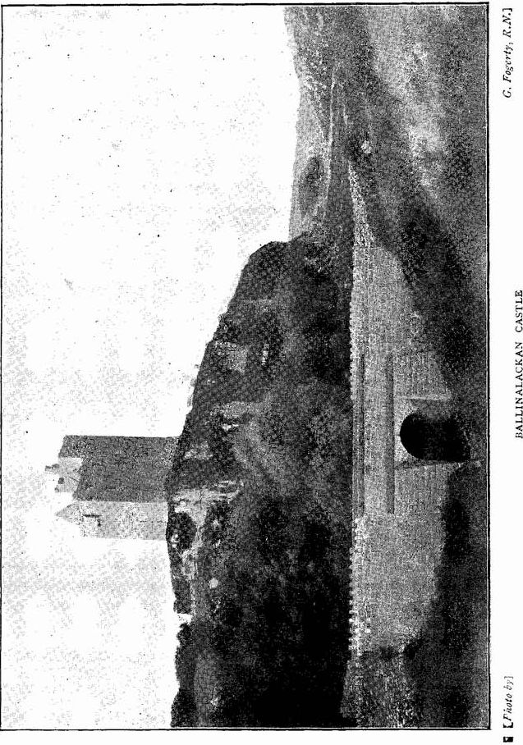

144

that such little towers could play little or no part in battles and great sieges, that the infinitely little “wars” of the remotest west gave little opportunity for the “making of history,” would prevent much silly and misleading talk and expectations foredoomed to the utmost disappointment.

BALLINALACKAN. We purposely passed by the ruin best known to the indwellers of Lisdoonvarna, the peel tower or “Castle” of Ballinalackan. One of the spurs of the high brown, Knockauns Mountain runs like a headland into the limestone valleys. The southern side has a small gulley fenced by abrupt cliffs—that to the north so square- edged and perpendicular as to seem artificial. Lower crags mark out a flat-topped oblong platform on its summit, and there, at the abrupt southwest angle of the precipice, rises the perfect little tower, sitting on its outpost watching the glens of Oughtdarra, the ridges towards Moher and the sea, and the Isles of Arran, beyond.

“The spirit of the mountains looks on thee,

Over an hundred hills quaint shadows flee,

Across the marbled mirror brooding lie   
Storm mists of infant cloud,

With a sight-baffling shroud,

Mantling the grey-blue islands in the Western sky.”

The tower is a very characteristic example of the gentleman’s residence as built during the 15th or early 16th century. The beautifully, neat, and solid stone work, the plain, but well-designed and chisel- dressed, doors and windows, the plan and general arrangements, so rarely differing in Ireland, Scotland, and Northern England—all are here, and, from their excellent preservation, can be studied to the best advantage. We will accordingly describe it in some detail.

First, we may consider some points in its history and in the general studies of the towers. It is not certain how they came into such general use in Ireland. They possibly had been built from the 13th century as in Scotland, but in Clare it is precarious to date any as much earlier than the 15th century. They differ strongly from the Norman castles, such as Trim, Maynooth, and (in Western Ireland,) Adare, Limerick and Quin. All such buildings of the Normans were essentially fortresses. The peels were merely houses, only stronger than our safer state of society requires. We have been formerly criticised for using the term “peel,” it being alleged that it applies only to towers (like Peel Castle in the Isle of Man)standing on a bay or creek (pyle). This is absolutely incorrect, as the word is generally applied to towers far from the sea and on uplands. It is akin to “pile,” and is used very frequently, “castellum seu pilum,” in Tudor documents relating to the lesser castles of Munster, (1) The name however, does not appear to have been used by the Irish speakers who use “cashlaun” equally for certain early forts, the great strongholds, and the little peel towers.

As for the particular case of County Clare, it is noteworthy that the rentals of O’Brien and MacNamara, the latter (dating in the time of Maccon, grandson of that Lochlain MacNamara, who was put to death by his enemies, the Hymbloid, near Lough Colmeen, in 1313, i.e., about 1380-90), no single castle is mentioned on lands where dozens are still standing. In fact, while the Irish maintained the strict tribal system of redistribution, it would have been most unlikely that any man would build an elaborate residence on land which might be passed over to another (without compensation for the tenant’s “improvements”) in a few years—even in the lifetime of the reigning chief. Had we a true copy of the ‘‘Castle Founders’ List”(2) we might speak with less hesitation. As it is, none of the best copies of this document seem to give us any Clare castle earlier than Rossroe, i.e., about 1380. Some copies give Enagh, Maumtalloon, and Trough, as built by Sioda, son of Mahon MacNamara, after 1380, but others attribute them to his son, Flan. One copy only gives the date of Ennistymon Castle as 1306. Certainly about that time King Turlough had completed towers at Clonroad and Inchiquin, and some other unnamed towers,(3) but the evidence as against the contradiction of more probable statements is slight, for Ennistymon was probably of the 16th century.

Roughly speaking, and we follow the less doubtful entries, we may put between 1380 and 1402 (contemporaneously with the main building of Quin Abbey), Dangan, near Quin, Rossroe, and Neadanura, or Newtown, near Clonlara, the details of which are, however, much later. (4) The

1. For example in the great “Desmond Survey” of 1583.
2. Catalogue Irish MSS. in the British Museum (Standish Hayes O’Grady), p. 72, &c., and MSS. R.I.A.
3. Cathreim Thoirdhealbhaigh.
4. This, however, may favour the early date by implying the need of an extensive restoration about 1500.

146

period from 1430 to 1480 seems to have been the golden age of “castle” building in Clare. The list assigns to it Ballymarkahan, Fortanne (Rosslara), Ballymulcashel (Mountcashel), Drumline, Garruragh, Knap- poge, and others. Their architecture tallies well with the statement. Little, if at all, inferior is the next group, 1480 to 1520: Ballintlea, Ballyhannon or Castlefergus ; Bealnafirverna, or O’Brien’s Castle, near Crusheen; Danganbrack, Moghane, Ralahine, and Miltown, or Bally- mullen, near Tulla. The still later “castles” are, as a rule, poor enough. We would assign Ballinalackan to the period between 1480 and the first years of the 16th century; earlier than the time of Henry VIII.

The obscurity of the O’Conor genealogy(5) leaves us very much in the dark as to the date of the Castle Founders, whose houses lie in this district. The list gives Ennistymon and “Dough in the Sand hills,” as founder either by Donogh MacDonall in 1306, or by Donogh MacCon, “Lachticonor and Moherruane,”(6) by Cathal of the Red Hand; “Doonagore,” by Teige MacTurlough MacCon, and “Ballinalacken and Muing,” by Lochlan MacCon. Of these men we have been unable to fix any date.(7)

The O’Brien rental, supposed of 1380 or ’90, does not help us much. Dues were claimed off Tuath Glae (or Tooclae) at Ballyna Huamadh, O’Clery’s quarter, the short quarter Cragicorrain, Glaishe, Bailie I. Coileim, Duma I. Uanna, I. Buadad, and Baile Na Lecan.(8)

The sum of the cess of O’Brien from Glae, over and above the Galloglasses, royalties, sportsmen, and Gilladuff, viz.:—10 pence and 5 ounces and 12 marks, and the immunities of the family of Clan Flanchadha (O Clanchy.)(9) The immunities of Sil Flanchadha, and half a mark of the rent of O’Brien are on Craig I. Corradain, so that there are 5 pence and 5 ounces on each of those 14 quarters. The amount of O’Brien’s lordship under the stewardship of MacCon also included cattle and swine dues.

1. For this clan see Mr. James Frost’s “History and Topography of the County of Clare,” p. 93.
2. I find no other mention or remains of these castles. There was an ancient promontory fort with a dry stone wall at Moher.
3. Castle Founders’ List, pp 69-74.
4. Trans. R. I. Acad. 1826, vol. xv., p. 42.
5. For this family see Frost’s “History,” pp. 95-98,

147

The district was held by the O’Conors from prehistoric times down to 1582. Then, probably feeling that in the unsettled and dangerous days that they had fallen on, it was better to subordinate their semi-independence to a family in high favour with the “Red Queen” they granted their lands by deed to Turlough O’Brien, of Ennistymon, Jan. 2nd, 1582; Donell O’Conor, of Fantii; Conor McOwen O’Conor, of Ballyhea; Conor MacConor O’Conor, of Innisdyman; Bryan Mohoone O’Conor, of Liskannor; Brian MacCahill O’Conor, of Down-na-goarr, gent; Donell MacTeige, of Glan (Glen Castle, Ennistymon), and others, granting Dough, Dunnagoar, Liscannor, &c.(10) The deed was witnessed by Boetius Clancy and others.

Two years later “Ballanelacken Castle” was held by Teig Mac- Murough O’Brien; Innisdyman and Glan, by Sir Donell O’Brien; Dinnegoir, by Sir D. O’Brien; Dunnycphelim, by Teigh O’Brien; Tuomullen, by Conor MacClancy; Duagh and Liscannor, by Sir Donel O’Brien.(11) In the following year, August 17th, 1585, Sir John Perrot, on behalf of the Queen, made a settlement of the estates of the Clare gentry, among whom Sir Turlough O’Brien, Knight, is named as holding 14 quarters, including Douoghyconnogher, Innyshtiman, and Ballinelackyne, and excluding the lands of the Bishop and Dean of Kilfenora and Boetius Clanchy of Knockfyne Castle.

The place was held at the outbreak of the civil war in 1641-2, by Donough or Daniel O’Brien of Dough. He also held part of Ballynahown, with Carrownaderry, and lands of greater extent in Kilmacreehy parish. We hope at some future time to tell in connection with that castle of his humanity to the English settlers, and his intervention at the siege of Tromroe Castle, and other events of the period.

When once again the English cause had triumphed by the iron troops of the dreaded Cromwell, we find Daniel petitioning Col. Stubber and the “Commissioners for overthrowing and demolishing castles in Connaught and Clare.” He had evidently not confined himself to protecting the English settlers, for be claims to have cut off the ears of many plunderers and executed others. After two years he was taken and imprisoned by the “predominant power.” Then, since the taking of

1. Diocese of Killaloe, p. 555.
2. Castle List, T.C. D.

148

Limerick, he paid a heavy monthly contribution—sometimes up to £100 for a month—till his substance and livelihood were exhausted. Despite the orders of the governor of the Precinct of Limerick and Clare, five of his castles were “razed down,” and he petitioned to be allowed to build a house in Dough, which is no place of strength, and a little castle, which is already demolished by the Irish, by name Ballenelacken, which hath no bawn or barbican that stands as yet, and not in the lists of the masons, “he was afeard that the said masons out of malice or gain will fall doune the said stearcase of Dough or the ruinous castle of Ballinalacken” to his great prejudice; and he was even willing to save charges by “putting down” at his own expense the “steappes” and to dismantle the ruinous castle of Ballinalacken. Stubber, by an order at Loughrea, 13th September, 1654, ordered the masons to spare the “strand hasse of Dough” and Ballinalacken till further orders(12), and from the remains the castles were evidently preserved. The “Book of Distribution and Survey,”(13) 1655, calls it Ballynalackan alias Carrowreagh alias Clonadowne, arable and rough pasture, of Donnell O’Brien, to Moore Butler alias Bryen.

The Act of Settlement, November 12th, 1667, seems to assign “Ballynaleakin” in Corcomroe to Captain W. Hamilton, but it was at any rate held by the O’Brien family for many generations, and is still in possession of another branch, the O’Briens of Elmvale, Corofin.(14)

It is shown in the “1675,” Survey now at Edenvale, as held by Sir D. O’Brien, on the margin is rough but recognisable sketch, showing the castle from the west. The battlemented tower, with its high gable, the bawn, with its large gateway, and a building to the north side are well shown.

1. Diocese of Killaloe, p. 218.
2. Vol. I., p. 248.
3. In a copy of the 1694 pedigree of the O’Briens, the Dough branch is derived from Daniel, second son of Conor, the King of Thomond, and brother of Donough, the second Earl. His son, Sir Therlough, married Eileen Lynch of Galway; from their two sons sprang the houses of Dough and Newtown. Daniel of Dough had a son, Teige, whose son, Donough, by his wife, Honora (daughter of Conor O’Brien of Lemeneagh), had a son, Christopher, living 1694. The present owners claim descent from Torlough O’Brien and his wife, Elizabeth, daughter of Henry O’Brien of Bealacorick, whose great grandson, John O’Brien, of Elmvale and Ballinalackin, was High Sheriff of Clare, 1836, and M.P. for Limerick, 1841-52, father of the present Lord O’Brien of Kilfenora.

149

Let us now describe the building itself(15). Having ascended the steep path up the hill, we enter the courtyard by a large, round-headed gateway. Over it are the four corbels of a small gallery, the large slab pierced with holes lies before the gate, but once enabled the defenders to pour scalding water on any assailants. The gateway is 5 feet 8 inches wide, and is further defended by a projecting bastion to the north, pierced with 7 loop holes. The plateau was walled, but little, save a few upturned slabs, remains along the southern cliff. The corbelled pier of a postern gate remains at the north-east corner. The bawn is about 350 feet long east and west, and its enclosure does not seem older than the earlier 17th century.

The peel tower stands at the south-west angle of the platform. It is over 60 feet high, and measures 42 feet east and west and 28 feet 9 inches north and south. It is not (as so often) in two divisions, but continuous, so as to form a simple oblong. The main wing is 27 feet 9 inches long. The staircase or eastern wing 14 feet 10 inches long. The walls are slightly sloped or battered, and embody some upraised slabs. The door has been nearly destroyed; its jambs were rebuilt, closing a shot hole in the north jamb. It leads into a vaulted passage 13 feet 3 inches long, with no trace of the usual “murder hole” in the roof. The porter’s lodge is to the south; the staircase to the north; the former is vaulted, and has a pointed door and an oblong slit to the east. The staircase is, as usual, spiral, of 75 steps, to the topmost floor, and some 10 more to the roof. It has a round-headed door, with a raised threshold, and is lighted by oblong slits. A newel, or roll moulding, forming the “hand rail,” extends upwards from the 10th step. The doors leading to the rooms in the main wing occur at the 19th, 36th and 53rd steps; the 68th leads to the battlements. The doors to the rooms in the side wing are at the 17th, 34th, 51st, and 75th step. The doors to the battlements and upper room are very properly closed with iron gratings to save the stream of tourists from flowing over the battlements by their habitual recklessness.

The side wing, over the porter’s lodge, has three stories under one vault, and one other room overhead. The rooms have ogee-headed lights, one single and one double (the latter with a round arched splay),

(15) A short account appears in Journal R.S.A.I., vol. xxx, p. 286.

150

to the east. Those to the south have—the lower a flat splay; the second both light and splay round-headed; the top round, with lintelled splay. There are skew doors to the stairs, and the middle room has also got one to the main wing. The topmost room has a curious flat ogee arch to the stairs, and small windows to the south and east. It once had a light to the west, which was closed by the ledge of a later roof of the main wing. The windows have ogee heads and round splays, and there is a corbelled cornice.

The rooms of the main wing were four; the lower is entered by a pointed door, once secured by two bars. There are two stories under the vault, each with a double ogee light to the west; ambreys in the north and south walls; oblong and ogee slits in the north side, and rows of corbels supporting the floors and ceilings. A narrow passage runs over a round arch to a garderobe or closet in the south wall of the second room. Over the vault are two more stories. The lower has a defaced fire-place, with windows to either side in the south, and a double and single ogee window to the north. In the upper room are a finely- moulded fire-place, with the date 1641, to the east, and a door from the stairs; two oblong windows, with one and two shafts to the south; the north side has a window, with two shafts and a cross bar, now broken; and a doorway into a bartizan, “flanker,” or corbelled gallery; a corbelled door in the middle of the west wall leads to a second bartizan. These “flankers” each rest on three corbels of two steps each; they have round shot holes; two to the outer face and one to each side. All the window shafts are gone. The outer walls are 5 ½ feet thick; the sides 4 ½ feet.

THE GLASHA RIDGE. Save to a person specially interested in stone ring forts, the remains along the Glasha ridge, between the road and the sea, from the barrack of Ballyreen to Bealaghaline, would have little attraction. They are described in the journal of the Royal Society of Antiquaries(16). We need only note that Cahermaccrusheen commands an ancient road or pass leading to the sea, and was of large and beautiful masonry. To the south lies the only cromlech of this district. It was a great box of four slabs, tapering eastward, with a cover nearly 10 feet by 8 feet. They lie as they fell, and are said to

(16) Vol. XXV., 1905, p. 353.

have been “overturned by a thunder bolt.” More probably the removal of the cairn in which they were embedded left them unsupported, and they fell like a house of cards. On the summit of the ridge, Caherma- clanchy, the remains of another fine stone fort, commands a very beautiful view into the Ballyreen and Oughtdarra valleys, and and southward to the cliffs of Moher. These noble rocky ramparts, rising nearly 600 feet above the waves, breast the force of the Atlantic not far to the south, with their dark and perpendicular walls of sandstone.

Several of the forts along the ridge have souterrains or “caves,” long passages, with walls of small masonry and great slab covers. They sometimes have side cells, and in one case (Cahermaclanchy) lead to a pit full of water. This is now closed, and the complex passage at Caherglasha, about 64 feet long, was wrecked, in an attempt to evict a family of badgers. There are in all remains of over 65 forts. The great rock of Leagwee is a conspicuous natural monument; the largest fort, Caheradoon, near Doolin, was demolished for road metal. It may have been the Caher Galline, held by Hugh MacClanchy in 1579(17), as it near Bellaghaline.

Passing Tooclae Chapel, a large and well-built church, we recall that we are at Knockfin cross roads, the only relic of the name of the manor established for the ferocious Boetius MacClanchy, sheriff of Clare in 1588, whose merciless executions of the survivors of the wrecked ships of the Spanish Armada have never been forgotten in local tradition. Tooclae also preserves the ancient name of the district, “Glae” or “Tuath Glae,” as it is named in the O’Briens’ rental about 1380. There are records of a castle at Knockfin, and another at Tomolyn (Toomullin) in 1579 and 1588, but the site of neither can be fixed. Possibly the former was at Aran View House, as the later residences were frequently at or near the sites of castles. This is borne out by the statements that Ballyvoe was at the castle of Knockfin—“Ballyvoe iherogh juxta castr. predict,” according to the 1588 Inquisition—and the confirmation to cornet, John Gore of “the castle, town and lands of Ballyvoye alias Knockfin” under the Act of Settlement.

KILLILAGH. Till February, 1903, when the “great gale” swept across Ireland, leaving destruction in its wake, from the churches on the

(17) Inq. Ch. Remem. No. 9 of Elizabeth, and T.C.D. Castle List, 1588.

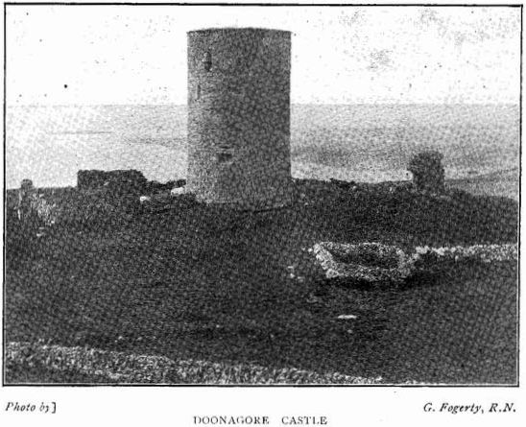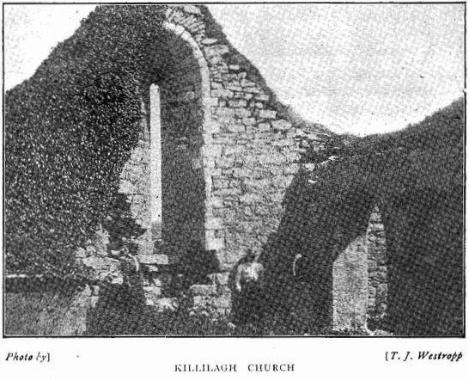

152

Atlantic coast and the larch woods of Clare, to the great elms of the Phoenix Park and the roofs of Dublin—a very perfect church stood near Roadford. It was named Killilagh, and seems to have been founded by a certain Lonan—perhaps that unknown bishop (not Flannan, as so often stated), that gave his name to the church of Killaspuglonane. His well is still venerated at Killilagh by the name of Toberlonan. It was a parish church in 1302, and appears as Killadlack (cil eidlach), along with Wafferig or Oughtdarra, in the Papal taxation. As usual it has little record and no history. In 1411 Dermitius O’Hacharni was priest of Killadmyr (18), and in the same year Thomas Machmachuna was appointed to the living of Killagloich on the resignation of, I presume, his relation, Donat Mechmachunna. Thomas O’Cormacan was also priest of Killadmyr in 1411, so that its spiritual affairs must have got somewhat unsettled by these numerous changes. In 1419 we get more information, which shows us a new element of confusion. John Okathel, cleric of the diocese of Killaloe, was now to be collated to the perpetual vicarage of Kylleileagh, not exceeding seven marks, so long void by the death of of Cornelius Ohare that it had lapsed to the Holy See under the Lateran Statutes. But the end was not reached, for in the following February new orders were issued to assign Killacgleach in Kilfenora, worth five marks, which had become void by the death at the Apostolic See of Thomas Machmachuna, to one of the Clanchys, Maurice Maclanchaga, a priest. The living had been reserved to Pope John XXIII., who had not disposed of it at the time of his deposition by the Council of Constance. Maclanchaga was of noble birth, and had studied Canon Law, but he had it for a year without getting ordained priest, and the Pope had to rehabilitate him. The parish churches were wont to be governed by one rector, and were Rallergleach (Killagleach) and Vettorach (Uchforach or Uchtdaragh) forming the Rectory of Glae. It had certainly lapsed to the Apostolic See, either for one of the above reasons, or because Donatus Maclandchaga when holding it had obtained the perpetual Vicarage of Killanasuleach in the diocese of Killaloe.

Visitors will remember its heavily-ivied west gable—a pleasant object in this usually bare district, and how, by the overhang of the ivy, it seemed to lean out eastward. Unfortunately there may have been some

(18) Cal. Papal Letters, VI., p.p. 263-4; VII., p. 104 ; p. 107-8.

153

truth in appearances, for in some way the “great gale” caught it, and levelled it and its tall early window. It is strange how often this must have occurred in the county. The same gale blew down the east end of Clooney Church, while the east gables of Kilcorney, Kilmurry Ibrickan (19), the oratory and Templeairdnanangel at Scattery; Kil- fieragh, Templenanaeve, at Ross; Kilmihill, Templemochulla, Clonlea, Croaghaun, Dromline, Kilconry, Feenagh and Kilmaleery, have all fallen.

Killilagh Church does not show remains of any very early work. It is probably on an early site, as its graveyard is cut into the base of a rath, on whose summit one usually sees a crowd of cattle enjoying the summer breeze. (20) The building is of neat, thin flagstone masonry, with well- cut coign stones and window dressings. The main wing measures 57 ½ feet by 19 feet; the north wall, as usual, is blank. The west end has a small oblong slit, and is crowned by a single bell-chamber covered by a flagstone. It is very unusual to find in the churches of this storm-swept coast any large window, and very rarely even a door, in the west end. The east window (of which we give a view, taken about two years before its fall) was lofty, plain, and round-headed—the oldest feature in the church. It is splayed deeply from 8 feet at the light to 5 inside. The south door has a holy water stoup in the left jamb ; it was pointed, but the blocks had been torn out of the arch. Only the right block of the head is in place. This door lies 14 feet from the west, and 13 feet farther east is an oblong window. Projecting from the south wall is a late chapel of about the same age as that at Kilmoon, and the church of Kilbract, near Cahermacnaughten, It measures 57 ½ feet by 19 feet inside, and is entered by a very neat round-headed arch (21), with

1. When writing on Kilmurry Ibrickan in these pages (96 supra)y I had conjectured it to be the Collebonoum or Collebououm of the 1302 Taxation. I have since found in the local name, “Ox Mount,” just beside the church, the “ Colle- bovum 55 of the epithet. It would be formally “ Ecclesia S. Marie de Colle-bovum.” This shows the importance of preserving even apparently uninteresting local names, whether Irish or English. The case of the supposed late names, Bropark, &c., near Newgrange, Co. Meath, which we have traced back to monastic times, and which probably represent the venerable “Brugh” of the Boyne, is another case in point.
2. The granting of a chief’s rath to the church is a common feature in the history of our early saints. Rathborney, Templenaraha, Glencolumbcille in County Clare, and Clonagh in Limerick, give material evidence of the custom. See “Ancient Forts of Ireland.” Section 42.
3. Not “pointed” as stated in the Ordnance Survey Letters MSS. R.I.A. The ogee windows are also therein described as “pointed.”

154

beautifully-executed late chisel drafting on the blocks. There are single ogee-headed lights in the middle of the side walls, and double lights under an angular hood ledge in the south wall. There are few monuments of any but personal interest. The large vault of the MacNamaras of Doolin, 1852, lies to the south of the graveyard. A table tomb in the north-east angle of the church has slabs with foilage, and a lion passant, but of no great age. A tomb put up by Bryan Kilmartin, in memory of Honora Haverty, December, 1794, lies outside near the corner of the church. Another bears the epitaph: “Pray for the soul of Lott Queely, who died at Towmullin, the 16th of January, 1779, aged 84 years, and for his wife Mary Davoren, who died the 11th of March, 1784, aged 78 years.” Yet another at the south-west corner commemorates Fanny Queely, alias Burke, who died April, 1799, aged 53.

TOOMULLIN. The church of St. Brecan at Toomullin lies inland, not far from the east, and near a pretty little waterfall on the Aille River. From the dedication of its well and the connection of the district with Saints Enda and Brecan of Aran, we may regard its foundadation as attributed to Brecan, son of King Eochy Bailldearg, the first Christian King of North Munster in the 5th century. As already stated Brecan, was reputed to be the first evangeliser of Thomond. Christianity probably existed among its inhabitants, especially if we accept the statement in the “Tripartite Life of St. Patrick,” that the men of Thomond crossed the Shannon in crowds to meet the Apostle of Ireland. Brecan founded three churches, not far to the east of Ennis; Kilbrecan, or Carntemple, whose massive but nearly levelled and overgrown walls lie near the well of Toberdooran, not far from Kilbrecan Chapel; Doora, or Durinierekin, a venerable chuich, mainly of the 10th or 11th century, near Ennis station, and Clooney Church, where he was venerated as St. Rikin.

He eventually established a monastery in the western part of Aranmore, where his church Templebrecan, his tomb enclosure, “Labba Brecain,” with the fragments of an elaborately-decorated cross, and an earlier slab, figured by Petrie, inscribed with plain encircled cross, and the words “Sci (“Sancti” not “Capiti”) Brecani,” confirm the early legends. Legends told of Brecan’s kindness and conciliatory actions towards St. Enda, with whom he enjoyed perfect friendship ; how he sat at

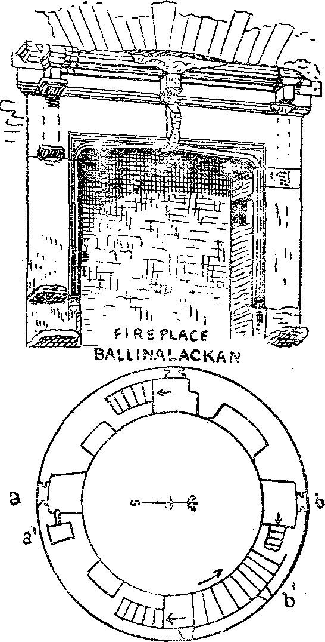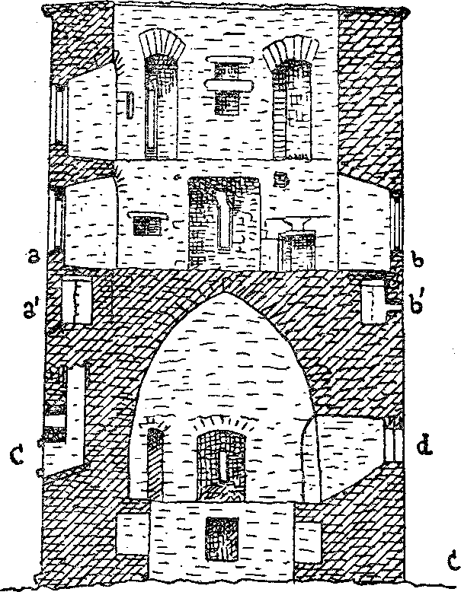

doonagore

Sketch-plans-  
aacl section

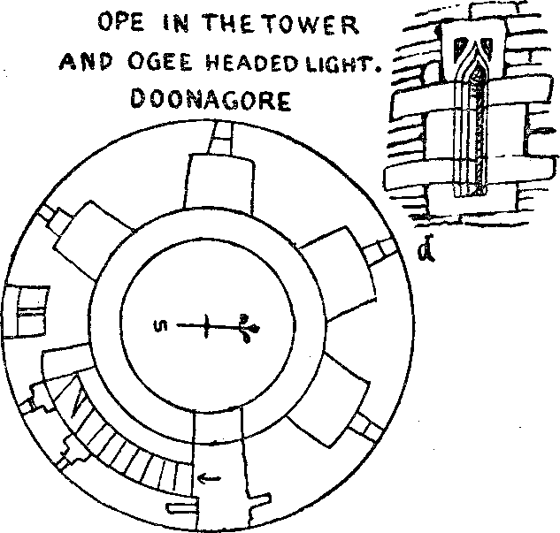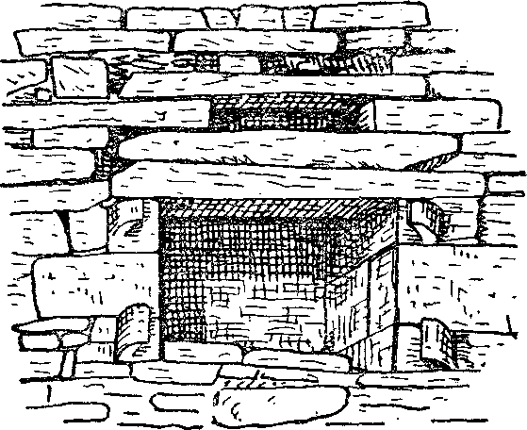Plans and Sections of Ballinalackan and Doonagore Castles,

his feet with Enda’s other followers to prevent his own disciples boasting of him against his brother saint. How he refused to join Enda in cursing a Pagan chief and won the heathen prince to loyal love for himself and his religion, and of his joyous old age ever growing in “the three dogmas of the Lord—hope, righteousness and love.” None save that of the friendly division of Aranmore between Enda and Brecan seems of any great age, but even the shadow shows that a very fair light of a loving useful life is cast down the ages.

The church was parochial, and appears in 1302 in the Papal Taxation under the name “Thuomlynny.” It is hardly again named till Stuart times, but may be the otherwise unknown parish of Killmony. “Tomalin, other part of the two sesses; this is part of the parish of Killmony.” Pasture, Boetius Clanchy held it in 1641; John Sarsfield, 1655, “Tomaliny, parish of Gleabland.” So it stands recorded in the “Book of Distribution and Survey.” (22)

The existing building seems even later than the main part of Killilagh. It is a simple oblong; the eastern part forms the church, and is 33 feet by 17 feet. The western formed the priest’s room, and is 10 feet long. It was added outside the original west end, which has a pointed door and a broken bell chamber on the gable. A door in each wall of the church; a south window five feet from the east end, and a narrow trefoil light in the east end, with a simple angular hood ledge and triquetra knots in the spandrels of the head on its outer face still remain. There are no traces of burials, and the well of St. Brecan remains not far away.

On the bold bastion of the hill north end of the cliffs of Moher is the conspicuous earthen fort of Knocknastoolery, a mound partly artificial, with a ditch and other ring. In the centre stands a pillar stone six feet high, with obscure scores supposed to be an ogmic inscription, but so far as I can judge merely weather scoring. The fort rises 12 or 14 feet above the fosse, and has no ramparts on top. The outer line is four to six feet long. It is probably a burial mound. From its summit is a broad view over the field covered by this paper up to Caheradoon fort and back over Lisdoonvarna to the inner ridges of Burren.

(22) P. Rec. Off. Ir. Vol. I., p. 248. Downanhir is also given as in Killmoney parish.

157

DOONAGORE. In order to complete the notes on the ruins near Lisdoonvarna, I must risk wearying my readers by a description of the very curious round castle of Doonagore. The popular idea that it was named from its owners, the Gores, is absolutely unfounded. The Gores were Cromwellian settlers, who first appear in Clare about 1652 (23), whereas “Downenaghyr” was held by Hugh Clanchy at his death in 1589 (24). By his son Boetius, who died 1580, and the latter’s nephew, Boetius, the sheriff. As usual it has no history, merely appearing in the Surveys of 1655, and the Edenvale Survey of 1673, as held by John Sarsfield. John Gore at that time held Ballyvoe, Cragcurridane, Killilagh, Ballycahane, East Glasha, Ballymaclancy, Cahermacreshine, and a few other townlands below the hills. So much for the popular etymology.

There are only three round castles known to me in County Clare. Newtown near Ballyvaughan, Faunaroosca in Killonaghan and Doonagore (25). This last is a well-built turret of flagstones. It is about 46 feet high, and has four stories, being 29 feet in external diameter, and 12 feet inside on the ground level; the walls are thick. The door is quite defaced, though it was perfect when I first visited the castle in May, 1878. It faced eastward, and was recessed and chamfered. We find traces of bar holes and three recesses partly built up, one being a window. A staircase from the south jamb of the door rises through the thickness of the wall. The lower steps are covered and built over to keep cattle from climbing up. The 19th step of these leads into a curious garderobe. The stair there turns abruptly, becomes a barrel stair of 2 feet 10 inches radius, and at the 29th step reaches the third floor, which rests on a beehive-like vault, the second floor under this vault having several windows. The third and fourth stories are of greater interest. The stair ran for nine steps up to the fourth floor level, at which a passage ran to the upper garderobe southwards. The drains of this and the lower compartment run down the wall to a large oblong door with stone

1. See “Diocese of Killaloe,” Rev. Canon O’Dwyer, p. 302.
2. Inq. Ch. Rem. No. 9 of Eliz. Journal Roy. Soc. Antiqq., Irelan., XXXV., P- 353.
3. See Proc., R.I.A., series 3, vol. V, p. 355, with illustration of Newtown. “Dublin University Magazine,” vol. XXI, p. 89. Journal Roy. Soc. Antiqq. Ireland, vol. XXX. p. 287.

158

brackets or loops to hold a cover and a long ventilating slit over the double lintel. The north window, like its companions on these floors, has an ogee head; from its right jamb a narrow passage with seven steps leads down to a little cell under the top steps of the main stairs. This cell is three feet wide, the passage being only 26 inches wide.

The west window has in its left jamb a similar flight and small chamber, with an ambrey and small unglazed ope. Its ceiling has a slit in the floor of the recess of the south window. There are several recesses and ambreys in both the upper rooms. Their southern windows are one above the other, but the eastern, western and northern windows are not so regularly placed; the only fire place is on the third floor. The upper wall is much split and decayed, and the battlements are entirely removed. The south window of the third floor has a little stone sink into the shaft of the drain.

The tower had a bawn, a strong walled enclosure to the north; much was standing in 1878, but now only a fragment of the south-eastern bastion rises to anything like its full height. It has two recesses. It is much to be desired that the people of Lisdoonvarna should get these notable castles preserved. The people of Tuam and their Council have set an excellent example of enlightened interest in such matters. How is it that the County Council of “historic Clare” did not lead the way, or at least, follow in so creditable and patriotic a movement? (26)

The Bay of Bealaghaline, just below Doonagore, is a charming spot. Its golden sands, facing the dark, cave-fretted cliffs of Moher; its great sand hills, which have yielded evidences of a human settlement of the stone age, probably preceding the building of the forts by more centuries than some of the latter preceded that of the castles; the old shattered peel tower of Doonmacfelin, with its under vault and lofty end wall, form scenes full of interest and beauty. The bay, indeed, catching the full sweep of the Atlantic, rarely fails to add the untold grandeur of rolling waves and the feathery silver of the spray, climbing the cliffs at times for over 60 feet, and falling like waterfalls from the rocks. Strange marine creatures, such as the purple-clad “Portuguese man-of-war,” swarms of

1. I have to thank the Royal Society of Antiquaries for the loan of the line blocks in Part I. of this paper, and the Royal Irish Academy for those facing p. 48. Kilcredaun got inserted in error. I must also thank Dr. George Fogerty for the photographs of the two castles and much other kind help.

159

opalescent jelly fish, and, if tales be true, unexpected objects, cocoa nuts, American timber, and even a turtle—have been washed up on its strand. Similar finds there must have been, announcing to all thinking men in the past that the great ocean of the sunset was not without its limits; for the Irish and Norse alone, held through the ages, the belief in lands of wonder beyond the waves, waiting till the time foretold by Seneca, when—

“In later years shall come a time,

When oceans shall relax their chains,

And a vast continent appear—

A new Tiphys shall find new worlds,

And Thule shall no longer form Earth’s bounds.” (27)

The tendency of ordinary tourists to keep to the roads, and let their drivers tell them what to look at and what to visit, shuts off many from some of the most pleasant nooks and the objects of the greatest interest in the district. We write to diminish if possible the number of those unhappy people who, having exhausted the stock “sights,” have nothing left on six days a week, but weary “amusements” and “constitutional walks.” The naturalist and antiquary, with any degree of fine weather, cannot know ennui on the Atlantic coast.

To those who wander over the grey crags and grassy ridges, when the wild thyme, cranesbills and bedstraw cover the forts, there is joy in every field. Down in the hawthorn glens of Oughtdarra, through the flowering marshy plains and the deep runnels of the shale land; among the nearly bare crags of the shore near the sprays—where the samphire branches out of every few inches of soil, and the hartstongue and maiden hair, the hermits of the crannies, make their nests in the rock—or on the yellow sandhills, and the smooth sweeps of strand facing the cliffs of Moher, are pleasures and the “companionship of loneliness,” such as can never be found in the fashionable watering place or pleasure resort. We have only written for the antiquary, but the naturalist will find even a richer banquet, and whatever may come to pass in the future, long must be the period before discovery can cease, and even then who can say that the beauty and richness of the neighbourhood shall be found to have been exhausted? Since “for the fresh heart God new creates the universe every day and every night.”

(27) Seneca, “Medea”—Columbus was the “Tiphys” piloting a new “Argo ” to greater riches than the Golden Fleece.