Journal of Limerick Field Club 1908 vol 3  
ANCIENT REMAINS NEAR LEHINCH,  
CO- CLARE.  
By THOMAS JOHNSON WESTROPP, M.A., M.R.I.A

1. Introduction The Spanish Armada  
   2. Lehinch and Doonmeeve  
   3. Kilstuiffin  
   4. Moy  
   5. Dough  
   6. Kilmacreehy  
   7. St MacCreehy

ANCIENT REMAINS NEAR LEHINCH,  
CO- CLARE.

By THOMAS JOHNSON WESTROPP, M.A., M.R.I.A.

We have in this Journal for several years endeavoured to point out the antiquities which add an interest to the various health resorts along the Clare coast. Having (so far as we were able) dealt with the remains accessible from Miltown Malbay and Lisdoonvarna, we naturally turn to the district between them, round Lehinch. The individuality of this place is very marked. The irregular breakers of Miltown and Kilkee are replaced by the beautifully regular crescents of waves marching up the long shallow bay of Liscannor with well marked cross waves deflected from each shore, travelling towards each other without deranging the curved ridges on their way shoreward. The high walls of cliffs at Kilkee and the low reefs of Miltown have here no equivalent. Low shale cliffs occur and high sand dunes, behind which a winding creek with low marshy fields runs down from Kilshanny, past where Cairn Con- naughtagh hides its secret among the swamps, to the tall, grey ghost of Dough Castle. The creek, here a mass of rippled silver, is often full of opalescent jelly fish, shining with gold and purple in the sun. It, with the bay, helps to form the peninsula Leath innsi, or Lehinsi, which gave the village and angle its correct name. This was at first anglicised as “Lehinch.” At present, even this less barbarous form is getting swallowed up by the abominable “Lahinch” (the yet more horrible “Lahenzey,” used by Archdeacon Kenny, is fortunately, extinct). The other, promulgated by Lewis—father of fearful spellings—should be, in these days of Irish revival, opposed by all, though the ever increasing ranks of the golfer and the lovers of the Atlantic coast (unversed in name lore) are rapidly stereotyping it in its worst form.

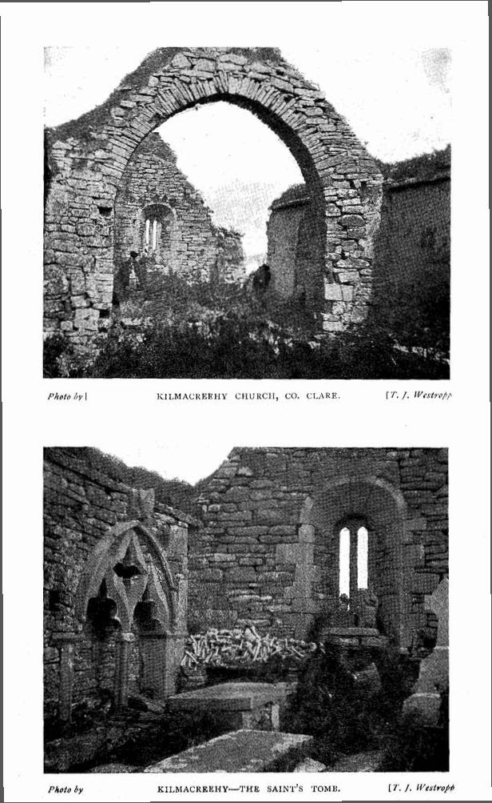

194

More accessible than most of the sea-side villages, it is already dear to the pleasure seeker and the naturalist; may we show it also as a “happy hunting ground” for the antiquary and collector of legends and folk-lore?

We are still (as at Lisdoonvarna) in the Corcomroe territory, with its recollections of the dispossessed Firbolgs, the tribe of Dael, and the descendants of Fergus, son of Roigh, and of Maeve, the great Queen of the Cattle Foray of Cuailgne. Round its valleys holy men—Mainchin, MacCreiche, Lonan, Seanach, and Fachtna—laboured in the cause of religion in the sixth century and onwards. When territorial Bishopricks were established, the monastery of Fachtnan, at Kilfenora, became the cathedral of the Corca Modruad, that tribe split into the O’Conors and O’Loughlins; and the former were lords paramount of the place till Tudor times, when, for policy, the once proud tribe yielded their castles to the O’Briens, as over-lords. There, across the bay, on its low cliffs, we see Liscannor Castle, where (a few years after the O’Conors’ deed) in 1588, Sir Turlough O’Brien mustered all the force of the baronies against those Spaniards, with whom both for religion and politics, close sympathy was rather to be expected. The Irish camped in the fields round the peel tower, (1)

It was a wild and stormy day (2) in September, and the light was dying out westward over the great rollers of the Atlantic, when the watchers on the towering Cliffs of Moher saw two sails beyond Aran, and in the dim twilight, fancied they saw others farther out to sea. They brought the news to Liscannor in the gathering dusk to the Sheriff, Boetius Clanchy. We can imagine the excitement and speculation that buzzed round the numerous watch fires that flickered on the bare walls of Sir Turlough’s castle, as the dark, long night passed slowly away. Another grey day of cloud and storm and roaring of the waves had

1. The following is taken almost exclusively from the original letters in the Calendar of Irish State Papers of the year 1588, from Boetius Clanchy (Sheriff) to Sir Richard Bingham, Governor of Connaught, Sep. 6, p. 29. Bingham to Lord Deputy, Sep. 10. Nicholas Cahane (Coroner) to Mayor of Limerick, Sep. 12th, p. 38. See also introduction, p. xxvii, p. xxxi. See also Carew MSS. Calendar.
2. Sep. 5th, 1588.

195

dawned, and there, in Coolrone—the seals’ creek—(3) the bay to the west of the castle, lay a strange vessel. We can picture to ourselves that hapless waif, the Zuniga, one of the mightiest of the ships of that mightiest of fleets, with her lofty wooden castles, gilt, painted and carved, rising high above the middle deck to stern and bow, her tall, tapering, masts (it may be still flying the wind-beaten flag of Castile and Leon), and the cross yards—armed with sharp reaping hooks to cut the cordage of the English ships, with which the Spaniards were too slow to grapple or even meet. (4) The lonely bay, harbour of gulls and seals, sheltered from the north-west gale a princely guest that morning. A cock boat, bigger than those of English vessels, drifted away from the ship; a red anchor was painted conspicuously on its side; it was seen attempting to land, but, even in the bay, the surf ran high, no one got to shore, and only some wreckage and an oil jar landed on the strand inside Liscannor.

Later on in the day two apparent merchants came ashore and were met and questioned; they were the patron and the purser of the ship, and implored to be allowed to buy water. Whether (as they did at Kilrush) they offered a cask of wine for every one of water, we are not told; but there, they were so maddened by thirst, that they offered a great ship with all its ordnance and furniture to be allowed to take a supply of water. Evil was their destiny, as that of the doomed ship of the Ancient Mariner in the snake-seething waters of the great calm.

Clanchy’s emissary having got the Spaniards into his power, now showed his fangs and sprang on them. The patron barely escaped in the boat to the galeass, which still lay dangerously near the sands, “out against Dogh i Conor.” The purser was brought to the camp,—he was one Pedro Baptista, of Naples, and on examination told that the galliass was the Sumiga, and that death was busy on board, the master and four men having died since they anchored on the coast. His fate

1. Archdeacon Kenny, in 1814, mentions that “These creeks are remarkable for being safe receptacles for Seals.” Mason’s “ Parochial Survey.” Vol. 1, p. 481.
2. The English consulted as to whether they should adopt this innovation, and wisely decided that it would endanger their own rigging more than that of the enemy. This was well brought out and illustrated in a lecture in the Royal Dublin Society, by the Rev. Mr. Green.

196

is not recorded, but the history and local tradition show that in the hands of Clanchy and in the jaws of the sea and the pestilence, equal mercy was to be found. The crew of the Zuniga made no other attempt. Held up by the wind and guessing their doom if they stranded, they lay before the greedy eyes of the human wolves till the 9th of September, and then, taking advantage of some flaw of wind, went out into the storm and the great deep to come to harbour in Spain, where the few survivors could at least die among friends and get Christian burial. Two other ships drifted down the coast, the one to be wrecked on the reef between Mutton Island and Tromra, the second at the mouth of Dunbeg creek, opposite Dunmore. The English prayer was indeed, answered: “Make Thou their way dark and slippery, and follow them up ever with Thy storm.” (5)

LEHINCH. The little village, though of no ancient date itself,(6) is on a site of some antiquity. In 1471, the chief of the district, O’Conor, of Corcomroe, was slain at Leithinnsi, by his nephew, Donchadh.(7) Like most of the neighbourhood, it passed to the O’Briens; these seem to have been in possession at least for five years or more before the oft quoted deed of January 22nd, 1582-3 was executed, Teige O’Conor, of Killeylagh, Cahil, of Cahirmenanbeg, Donell, of Fanta, Conor, of Ballyhea, Conor and Brian, of Inishdyman, Bryan Mohoon, of Liskannor, Brian, of Down na goarr, Donall, of Glan, Edmond, of Ballygrical, the leaders of the ancient house of O’Conor, yielded up their rights to Therrelay O’Brien, of Innishdyman. The latter still held it in 1625, Daniel, or Donough O’Brien, succeeded and held Lehinch at the outbreak of the Civil War in 1641; he and Lord Ikerrin owned it in 1655, and Ikerrin is given as holding Leagh Inchey in 1675.(8) It became a bathing place of some note, and by 1835, had nearly two hundred houses and over one thousand inhabitants. It

1. For other Notes, see Journal Royal Society of Antiquaries, Ireland. Vol. xix., p. 131, and vol. xxx., p. 92. Relics of the Spanish Armada in Clare.
2. The Rev. James Kenny, Archdeacon of Kilfenora, in his report on the Union of Kilmanaheen, mentions “Lahensey,” as lately a few miserable cabins, now (1814) about sixty houses. W. Shaw Mason’s Parochial Survey I., p. 486.
3. Annals of Four Masters.
4. Edenvale Survey, p. 36.

197

suffered in later days from inroads of the sea, but recently the railway, golf links and fine new hotel, have done much to revive its prosperity.

The only antiquities near the village are three forts. Two are neat and characteristic ring forts, with fosses, slightly raised central garths and outer rings. The third is much defaced but of greater note. It is called Doonmeeve on the maps, but Doonmihil and Dooneeva, locally. There are two segments of curved fosses coming out at a slope near the shore; they are cut through drift, and when a block of shale was met with it was neatly cut to the slope of the bank. The inner is dry, but a water runnel courses down the outer one. They are 6' to 10' deep and wide at the bottom in parts, the inner 28', and the outer 20' wide at the top. The bank between these is 22' wide at the top. It probably enclosed a space on the cliffs, and could hardly be a promontory fort whose promontory was washed away by the unresting sea. Bronze implements have been found on the shore at the foot of the cliff which bounds its enclosure. A very curious tradition was told us in the neighbourhood. A certain man, in no very remote past years, began to dig up the space inside its trenches, before he had been long at work he fell down and lay to all appearance dead. News was brought at once to his wife a reputed “wise woman,” who was evidently equal to the emergency. She rushed to the nearest fairy spot, did magic, and ran to Dooneva to her apparently lifeless husband. She then addressed herself to the unseen inhabitants of the fort and imperiously ordered them to bring back her husband at once, Rapidly as the deceased brother of the unvirtuous de Birchington, of Ingoldsby, the insensible man sat up and recovered complete strength, while a stick was carried off in his stead. After all the story in its facts, apart from their deductions, may very well have happened, and even the charms may have been done in as good faith as many others worked to our personal knowledge.

KILSTUIFFIN. Before turning to mere fact we may give here the legends of what is probably more real than many realities to the natives of this coast—the lost Island of Kilstuiffin, or Kilstapheen. In its older form we cannot be very sure of its integrity. Michael Comyn, one of the group accused of the forgery of the passage in “the Battle of Gabhra,” relating to the Mount Callan ogham, wrote about the year

198

1750 a romance, the “Adventures of the sons of Thorailbh mac Stairin.” People in those days, and even later, even when collecting traditions for traditions sake, never hesitated to “improve” on them so in an avowed romance doubt is natural as to the preservation of the “true lie” as has been said. Let Comyn speak for himself, as O’Curry seems to accept his version in the Ordnance Survey Letters.

Three brothers, Crochaun, Dahlin, and Saul, from the forts bearing their names on Loop Head, found one day that their cattle had been “driven” by three other brothers, chiefs in Corcomroe. These were Ruadhan, of Moher, ui ruadhin, Ceanuir, of Liscannor, and Stuithin, of Kilstuithin, an enchanted fort under the sea in Liscannor Bay. Encumbered by the spoil of Corcavaskin, the plunderers had only reached its northern border near Lehinch before the irate owners overtook them. The Corcomroe men turned at the river Eidneach, and had barely time to place the cattle on Creachoilean (now the sand bar of Creachalan, whence its name Island of Plunder), before O’Brien’s Bridge at Dough, before they were fiercely assailed. The Corcavaskin army prevailed, slaying the three chiefs and the majority of their soldiers and destroyed the forts of Moher and Liscannor, but they found the Island of Kilstuithin surrounded by a wall of water and were obliged to leave it unravaged. They returned in triumph to Loop Head to find their sister, on whose celibacy their lives depended, eloped with Dermot O’Duine, and fearing a more horrible fate if they waited the stroke of doom, sprang over the cliff and were drowned.(9)

The present legend, so far as we could gather it, tells how a Dunbeg man took the cattle of Stapheen, who lived in an island at the mouth of the bay. The latter pursued and overtook them at Bohercrohaun,(10) near Moy, both sides fought fiercely, but in the struggle Stapheen lost the golden key of his island, which at once sank under

1. Ordnance Survey Letters, R.I. Acad., 14 B 23 (Oct. 1839), pp. 300-303; and 14 B 24, p. 74 and 99.
2. Note occurrence of the name “Crochaun,” supporting Comyn’s legend as (at least) based on genuine folk tales. It is curious that at Downpatrick in Mayo the separation of Dun Brista from the shore is attributed to an earthquake that split Slieve Crochan in Achill. Some older and notable legend must lie behind the three tales.

199

the waves. The key was said in 1838, to lie under the ogham scribed slab of Conan, on Mount Callan. The Island is now only seen—raising its golden domes and towers proudly above the waves, or gleaming under the clear waters—once in seven years; woe to the beholders in such a case, for ere it be seen again they shall have long been dead.

The Island is alluded to in the “Monks of Kilcrea ”—

“ . . . how high the billows roll

Above lost Kilsafeen,

Its palaces and towers of pride   
All buried in the rushing tide   
And deep— sea waters green.”

Long ago, in 1878, I heard a pretty tale, how boatmen at times smelt the wild thyme of its flowery fields as they rowed over the shallow, as one smells it off the coast of Mutton Island further south. This seems to have a British equivalent near the sunken land of “Lyonesse ”—

“There is a wind in Cornwall that I know   
From any other wind, because it smells   
Of the warm, honey-breath of heather bells   
And of the sea salt; and these meet and flow   
Till the astonished sense in ecstasy   
Tastes the ripe earth and the unvintaged sea.”

Kilstapheen is, actually, a dangerous reef at the mouth of Liscannor Bay, marked on the charts. In 1839, it was called Kilstuiffeen, and said to have been an Island-monastery overwhelmed by an earthquake. All our Annals record between 799 and 802, how Inis Fitae, on the coast of Corcavaskin, was split into three by the sea and there was a storm of thunder and lightning on the day before St. Patrick’s Day; over a thousand persons perished, while heaps of sand and rocks were thrown up on the coast. Is it too daring to conjecture that the Island and Church of Kilstapheen perished in that great catastrophe, and that its legend, like that of Mutton Island, rests on a firm historic basis?

The whole coast gives many traces of submergence during untold ages. The old beds of the Shannon and Erne are traceable far out under the sea; submerged bogs, with tree trunks and roots, in Liscannor and off Mayo and Kerry tell the same tale. Our legends are full of

200

it, Monaster Letteragh,(11) Kilstapheen,(12) and the sunken church in Ballyheige Bay, with its picturesque story (so well told by Crofton Croker in “Cantillon’s Funeral,”) show how the ravages of the sea impressed the coast dwellers; while the story of Teite’s grave in the “Agallamh,” the submerged cairn of Eothall Trawohelly in the Irish “Nennius,”(13) the submerged cromlech at Rostellan(14) and the bed of St. MacCreiche near Liscannor, now far out on the strand, show the slow sinking of the land and recall the man-hater’s grave in that most bitter of plays—

“. . . his everlasting mansion

Upon the beached verge of the salt flood Entombed upon the very hem of the sea.”

O’Curry speculates as to the name Kilstuitheen, which he suggests may be Kilscoithin, from St. Scoithin, of Slieve Margy, whose church was certainly in the sea, but off the coast of Louth. It is evidently from an imperfect version of this note that Canon Dwyer mentions “St. Scioth” and “ this church under the waves”(15) (only to “omit” them) in his little guide; it is a pity that he, with such local advantages and the power of pleasant story telling, almost invariably mentions a legend to state that he passes it by.

MOY. The antiquities between Lehinch and Milltown are of comparatively little interest. Passing the pretty wooded glen of Moy, winding by complicated old roads, up river valleys and through low, green hills, we find an almost destroyed dolmen at Calluragh and the old church and castle of Moy. The first calls for little note, the covers and end having been removed.(16) The castle is, structurally, of no

1. See R.S.A.I. Antiquarian Handbook. No. vi., p. 24.
2. There are two “Kilstapheens;” the second is in the Shannon estuary near Loop Head. (S. C. Hall’s “Ireland”). Vol. ii., p. 436.
3. “Agallamh” (Silva Gadelica, S. H. O’Grady, Vol. ii., p. 201), for Eothall Trawohelly, see W. Borlase “Dolmen’s of Ireland.” Vol. i, p. 179, and “Irish Nennius,” p. III.
4. See The Irish Naturalist, 1907.
5. A “Hand Book to Lisdoonvarna ” (1876), p. 64. In calling attention to such errors, we in no sense depreciate what is practically the first handbook to these most interesting baronies—the work of a kind and genial clergyman of witty speech— now passed from among us, and a personal friend of our own.
6. There is a view and a note in Journal R.S. A. Ireland. Vol. xxxi., p. 437. It was first noted by Miss Parkinson.

201

importance, the nearly featureless side wall, with the trace of several vaulted rooms, remains standing beside a modern house on a rocky knoll. Magh, in Ui breacain, is spoken of as so strong a castle in the reign of Elizabeth, that we can well sympathise with the disappointment of the authors of the Ordnance Survey Letters at so poor a ruin. The 1675 survey shows it as a broad, low, side tower, with high gables and (apparently) a courtyard with a pointed roofed turret,(17) It was held by Lord Ibrickan, son of the Earl of Thomond, in 1584, a mill was built there by the Bishop of Killaloe, in 1619, and the place was granted in fee farm by Henry, Earl of Thomond, to Augustine Fitzgerald, in 1719, with Freagh castle and other lands, for nearly all the parishes of Kilfarboy and Kilmurry Ibrickan belonged to the Earls. The castle lies in Moybeg; at some distance up the valley in Moymore we find the church. It seems to have been named Inisdia, and, like its holy well, dedicated to St. Findclu Inghean Baoith, the patroness of Kilnaboy, who lived about 540.(18) It is a plain building of flagstones, measuring 40' by 19 ½'. The south door is defaced; the east and south windows had ogee lights (the first double, the shaft being gone) with neat semicircular splay arches. The east light is set in a recess slightly marked inside, but not appearing on the outer wall, which has a slight batter below the level of the sill. There are two plain ambreys in the south east corner, and the gable though much broken, shows trace of a stepped cornice or battlement.

DOUGH. Returning to Lehinch northward, we pass on through the sandhills at its opposite side. These natural fortifications yield, like those of Fanore and Bealaghaline traces of early settlement. They were the reputed residence of “Donn of the Sandhills” a puissant fairy prince, not to be confused with his still more doughty brother, “Donn. Firinne” of Knockfierna, Co. limerick. A poem(19) by Andrew MacCurtin, about 1740, is addressed to Donn Dubdach (or Dumhach) complaining of the neglect of the local gentry, and asking for a situation

(17) Edenvale Surveys p. 34.

(r8) See note by Dr. George U. Macnamara, Royal Society Antiquarians, Ireland. Vol. xxxvii., p. 406.

(19) R.I.A, MSS. 23 M 47.

202

in the fairy court. MacCurtin at that time resided at Maghglas, near Dough or Dumhach. We reach the two bridges over the mouth of the Dael river, noting that Poulinver, the pool below them, retains the last trace of the name which O’Huidhrin, about 1420, gave to Ibrickan “the land of the two Inbhers” (Dough and Dunbeg). Near it is the sandhill “Crughaneer,” supposed to be specially haunted. O’Brien’s Bridge bears an inscription partly defaced, owing to the badness of the stone. It runs thus—... “In compliment to Cornelius O’Brien, Esq., M.P., of Birchfield, who suggested and promoted the work, has been erected at the expense of the County and the Commissioners of Public Works. Commenced in 18 . . . and completed in 1836.” Mrs. Knott(20) mentions the Bridge as in progress, but had to use the ford in 1835. The ford of Beal an chip, of which we shall have more to say with regard to the O’Brien’s battle in 1573 is supposed to have been near this spot

In the field beside the bridge to the east of the river is the lofty tower of Dough (Doogh as pronounced), deriving its name from the sand hills (Dumhach) on which it stands. It is a gaunt tower five stories high, with a window facing N., S. and W. in each story, and no trace of vaulting or staircase. The east wall has fallen en masse on to the strand, a natural result to “a house built upon the sand.” The windows are rude, oblong. opes, with flat arches and slab lintels, probably superseding older slit windows. The wall had fallen before 1839, and a considerable mass, with (I think) a chimney, fell (I was told, in 1883) after 1878 when I first saw, but unfortunately did not sketch the ruin. It is much as when sketched in 1885.

The castle existed in 1422, when Rory, son of Conor O’Conor, Lord of Corcomroe, was slain by his relative, the son of Felim O’Connor, “in his own town of Caislean Dumhcha.”(21) The Castle List says that it was built by Donchadh, son of Domnall O’Conor (or Donagh Mac Conn), but gives no date. The castle seems to have been owned by the O’Briens in 1564, long before its formal transfer by the O’Conors in 1583. Sir Donall O’Brien held the castle of Duagh in

1. Two Months at Kilkee, p. 149.
2. Annals of Four Masters.

203

Tuathmór Yconor at that time. It is called “Castle Doe” on the Hardiman Maps, 1590. Terence O’Brien held Dowgh (“w” was then pronounced literally u u) Icnogher down to his death in 1625. However, we incidentally find Douagh Iconagh held by Brien Mac Morrogh O’Conor at his death in March, 1593, as named in an Inquisition of 1612, at Killinebui. In 1621, Daniel O’Brien, of Douogh Iconogher, son and heir of Sir Tirelagh, was confirmed by Letters Patent of James I. in his Corcomroe estates.(22) Daniel (Domnall) O’Brien, as we have told when writing on Ballinalackin, held the “strand hasse” of Dough, in 1642, and petitioned in 1652 that it might not be dismantled, fearing lest the “masons out of malice or gain will fall down the stearcase” in 1652. At that time Joseph Molony, however, held it under Lord Ikerrin and Pierce Butler in 1659. Dough is stated to be the property of Lord Ikerrin in 1675, which shows it was a tall, battlemented tower with several windows and a door; a large dwelling-house two stones [stories?] high and with four windows is attached to one side. In 1778, John Lloyd in his “Impartial Tour,” describes “the noted sandhills of Liscannor Bay called O’Connor’s Dough from that chief’s residence on the inside sandy plain; the walls of this court and castle are still upon the river Ainey.” Hely Dutton includes it in his list of castles in 1808, but does not give it as then inhabited. O’Brien, of Dough, was one of the few gentry that obtained a certificate of “constant good affection,” and saved much of his estates. He well deserved it for his confessed humanity and liberality in 1642, doing all he could to save the lives and entertain the harassed English settlers until they could find means of removal to England. Captain George Norton, of Mooh or Moy Castle in Ibrickan, in 1642, besides witnessing these deeds, records Daniel’s kindness and charity to several shipwrecked sailors. We have already told of his partly unsuccessful attempt to rescue the Wards of Tromra when O’Flaherty took that castle, nevertheless he is alleged to have eagerly seized that place when O’Flaherty retired to Aran.

1. The pedigree of H.B. at Dromoland, made when Henry, the eighth Earl of Thomond was “a child of six year old,” about 1694, gives the descent from Conor, Prince of Thomond, 1536, and his second wife Elizabeth, daughter of the Earl of Desmond, viz. — 1, Daniel More, 2, Sir Therlogh, 3, Daniel of Dooh, m Ellen, daughter of the Knight of Glin, 4, Teig, 6, Donagh of Dough, 7, Christopher, now living. Sir Therlogh’s second son, Donogh of Newtown, was grandfather of Therlogh of Newtown.

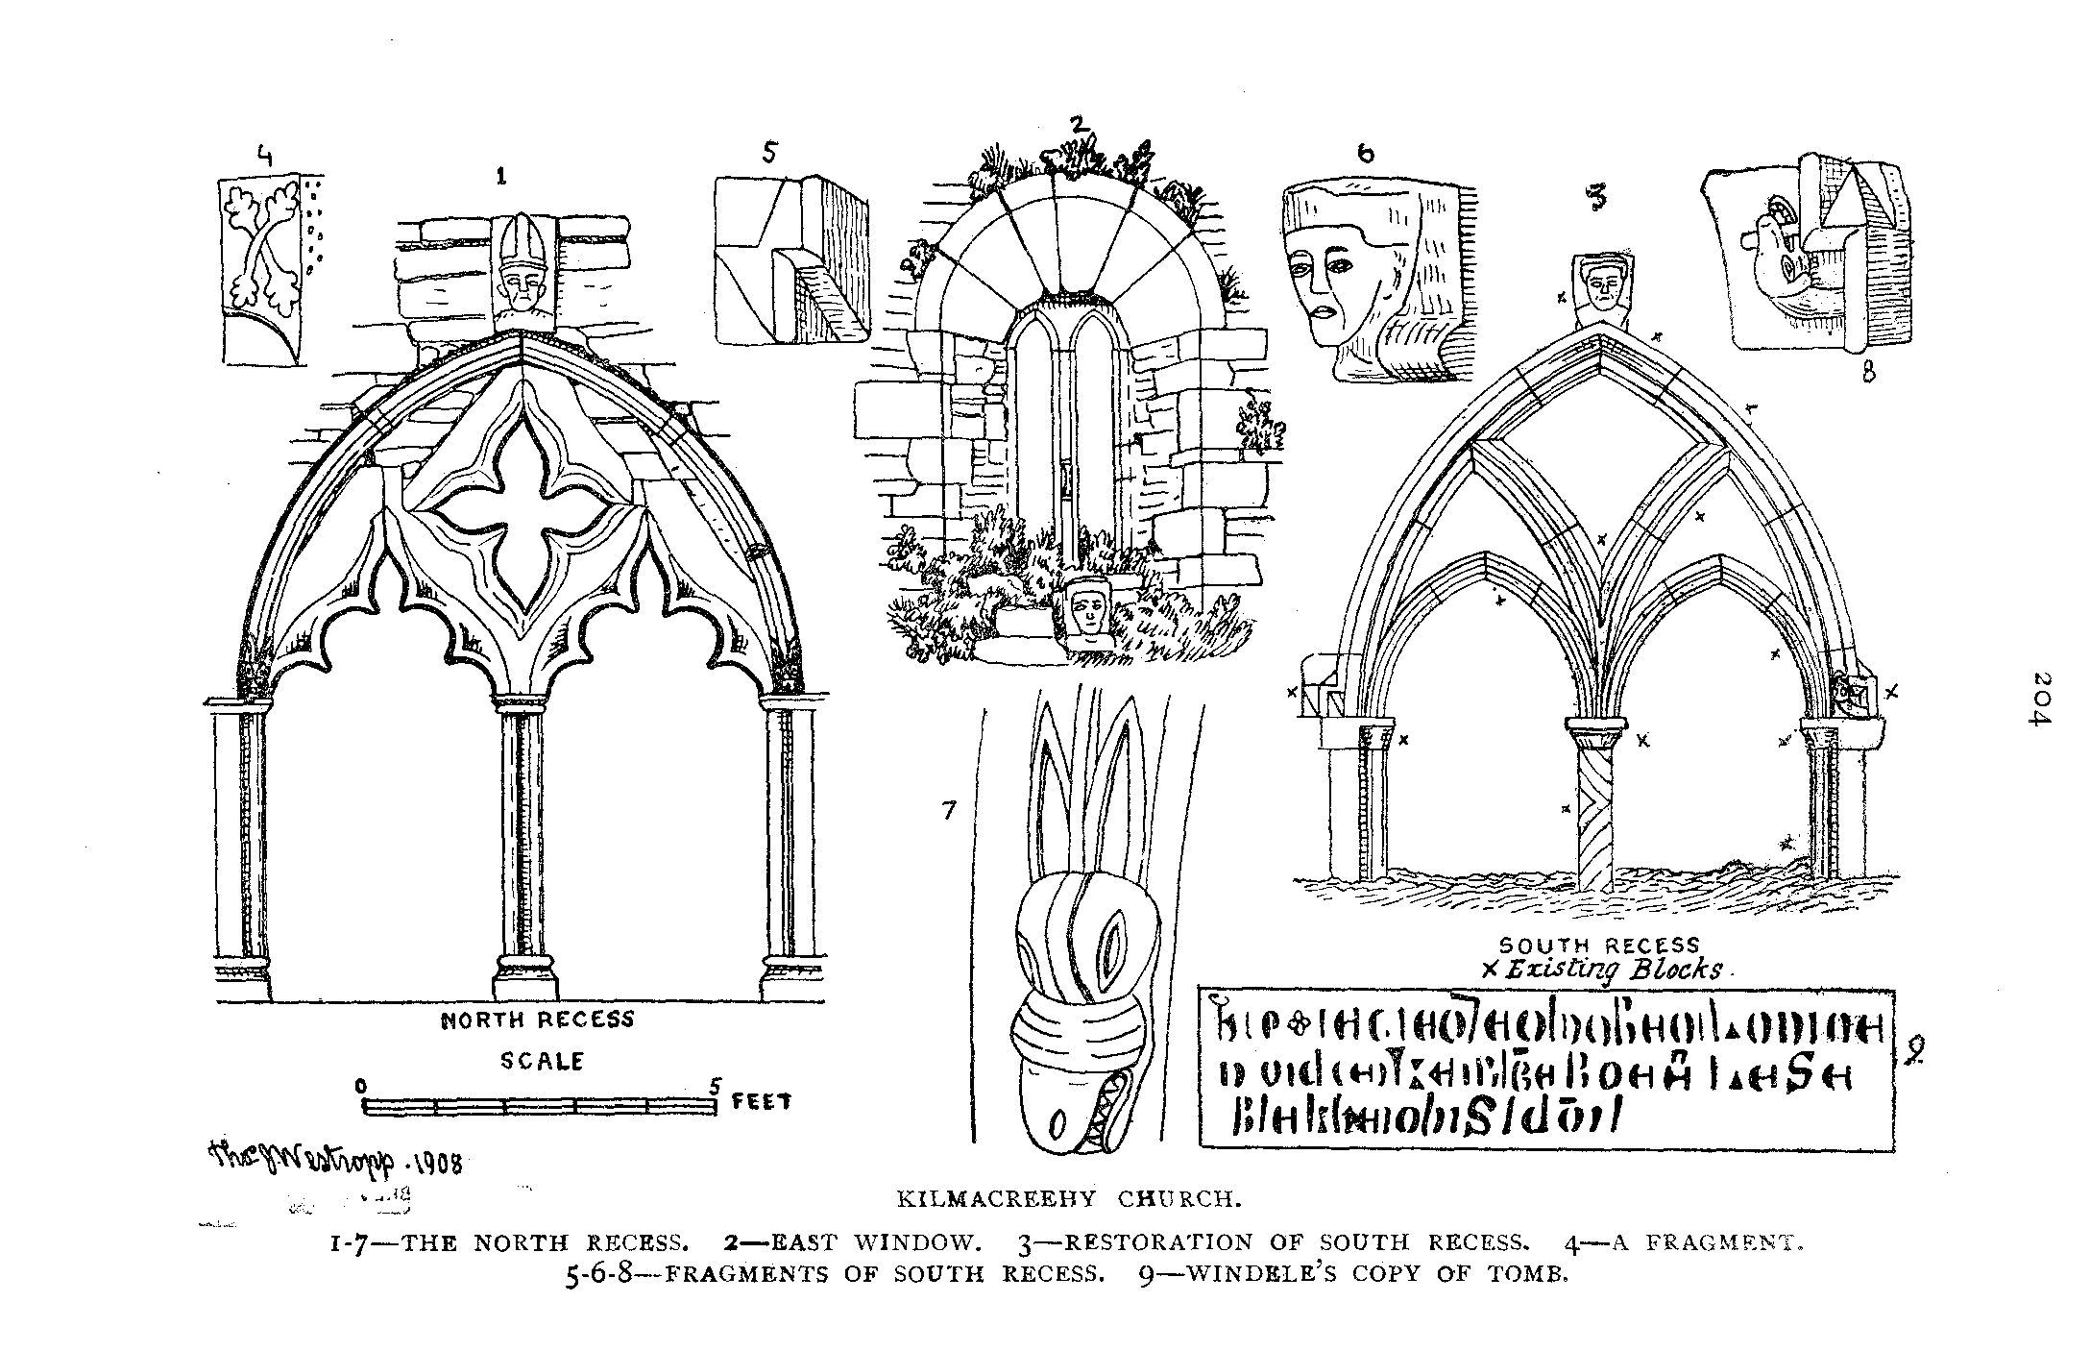

205

KILMACREEHY.(23) Passing westward, we soon reach the lonely looking ruin of a church which we see from Lehinch across the bay. It forms with the overhanging castle-crowned cliff and the clustered houses of Liscannor in the background, a sufficiently picturesque object, and is of some architectural interest. On entering the laneway and approaching its weather-beaten walls we see the large, old masonry in its basement, sole relic of an earlier church of considerable antiquity, the bulk of the building being of thin flagstones, and of the late fifteenth, or in parts, perhaps, even of the early sixteenth century. The little weed-grown graveyard, with its flagstone monuments, rippled and tracked by the waters and sea creatures of an unreckoned past, with the ever haunting sound of the waves in their ceaseless procession up the bay, and the whistle of the wind in the gables of the dark storm- beaten ruin—makes a fascinating subject for saddened thought and memory. Storm worn, indeed, is the ruin, tottering to its fall, and it is most regrettable that no public spirit exists here to follow the bright example of the people of Tuam—too long without imitators. “Men of historic Clare” have, indeed, little cause for pride in the wreckage wrought in the priceless collection of early forts and cromlechs, the neglect and collapse (or, worse still, demolition for sordid public motives or mere selfish ends) of the churches and castles in the last twenty years. Years of Irish revival should have raised local interest, but Clooney, Killilagh, Fenloe, Ballysheen, and Kiimacreehy, with many another church, have fallen, and the breaking down of the stairs in Ballyportrea, the south wall of Kiltola, the whole of the early caher-girt oratory of Templenaraha, and the carved gateway of Lemeneagh, all in the last few years, fill us with apprehension for the fate of our unvested ruins. As for the stone forts the destruction wrought even in the last 12 years is appalling, and a deep disgrace to all concerned therein.

A flag-topped vault beside the church porch has this quaint inscription—

Here resteth Nick whose fame no age can blot The chief MacDonough of old Heber’s lot

Who while on earth revived the ancient fame   
Of his own line and yt of all his name   
His fixed religion was his actions guide   
And, as he lived beloved, lamented died.”

Erected in the year of our Lord, 1745.

(23) Archdeacon Kenny calls it Kiimacreehy known by the name of “Quoranna,” probably Tuoghranna, as Tooclae is printed Quoclae in same letter. Parochial Survey I., p. 479. He says, p. 489, that MacCreehy was traditionally a bishop.

206

Let us now examine the church. We pass in through a neat but late round doorway and a small porch projecting from the south wall and measuring 11 ½ by 8 ½‘. There is an ogee window to the east, a pointed door leads into the nave. The church consists of a nave and chancel, respectively measuring in feet 32 to 34 by 17 and 39 by 22 ½, They are divided by a high, slightly pointed arch in great decay, the mortar being washed deeply out of all the joints by centuries of storm, for the church seems to have remained unused since Elizabeth’s reign.24) It is 13' high by 9' wide, and built of thin flagstones.

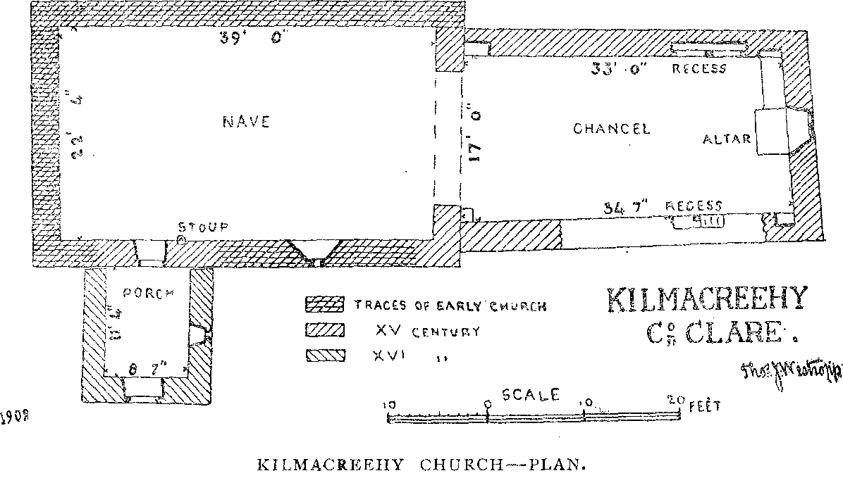

The Nave has, otherwise, few features of interest, it has a narrow south window, with splay head of three stones, the ivied base of a fallen bell chamber rises on its western gable, and a plain holy-water stoup projects from its south wall. The Chancel has a neat window, like those at Moy, save that the lights are slightly pointed, it has the round arched splay and the external angular, dropped hood. The lights were unglazed, and there was a projection with a slot on the central shaft to catch the shutter bolts. In each wall was a curious monument, the church, probably, from its exposed position, being unusually poor in windows.

(24) The porch, however, has been patched with brick work at some uncertain age.

The monument in the north wall was (evidently, in 1854, and at least down to 1878) reputed to be the tomb of the patron St. Mac- Creehy. It is a curious very late gothic screen, probably suggested by the monument or sedile in the corresponding position in Kilfenora Cathedral. It has a large quatrefoil ope overhead, and two cinque foil arches below the top, covered by a bold hood forming a pointed arch, and with a mitred head on the keystone, curious, eared serpent heads of early type decorate the ends of the hood, similar to those in Scattery cathedral; the sill and corner adjoining it are heaped deeply with skulls, bones, and coffin planks.

The corresponding monument to the south has been destroyed by the fall of the wall since 1839; even in that year the heads of its arches were gone. I have been able from its numerous fragments to give a restoration, for there is only a diagram in the Ordnance Survey Letters. It had two pointed arches, the shaft between them further branching up into the covering pointed arch of the hood. The latter had a head(25) with a flat cap on the keystone, and ended in serpents of a different type from those opposite and holding short bars in their mouths. These two structures are of very great interest from their late date and the curious survivals of early art. Though Irish Gothic Art is at present little esteemed outside this country, it would afford a most valuable subject if a skilled architect undertook a monograph on its evolution, adaptations, and late survival.

The Monuments we omit for want of space, the oldest seems a very curious inscription, which a correspondent sent to John Windele, and which O’Curry partly unearthed in 1839, we utterly failed to find it, and (in the sketch) cannot decypher it any more than our predecessors. Another has, in raised capitals, “ T. HEO. CLO ” (clerico) and dates 1642.

The Saint’s Well lies to the N.W. of the church. It has been long neglected, but at one time was believed to do good to sore eyes. St. MacCreiche’s Day was kept on Garland Sunday, (Domhnach chrom

(25) Archdeacon Kenny mentions the tradition that mitred head represented St. McCreehy and the flat-capped one represented St. Manaheen which, in face of the MacCreiche legend, is very probable. Parochial Survey I., p. 489.

208

dubh) but appears to have been actually the fixed date of August 11th ; his pattern was held at Lehinch. (26)

ST, MACCREEHY. The Saint is but little remembered, save by name, among the peasantry. We have to depend almost entirely on the curious late mediaeval “Vita Maccrecii,” a work demonstrably inaccurate in its chronology, and not free from the fabulous.(27) From it we learn that Maccreiche was a native of the district and a member of the Corcamodruad tribe, he was attracted by the holiness and learning of the great St. Ailbe of Emly, or Imleach lubhair, and studied as one of his disciples, excelling in virtue; there he abode for many years. At last duty called him home. The King of Connaught, Aed, son of Eochy, invaded the Corcomroes and carried off cattle spoil to Rathcroghan. Here is a difficulty in the story, for St. Ailbe died in 541, and Aed, son of Eochaidh Tirmcharna, in 574. Perhaps, as so often in the lives, the coarb of Ailbe, should be read for the saint himself at the time of the raid. The “Lives” were usually sermons for edification, not careful histories, but, being based on such, they have a great (though in details somewhat doubtful) value when not used dogmatically, and as tradition and folk lore of the eleventh or twelfth century they are invaluable.

The plundered Corcamodruad recalled their pious countryman, and sending to Emly, asked MacCreiche to meet them at Carn mic tail, where the tribe was wont to assemble, a place probably at the great cairn of the Connaughtmen, not very far from the church afterwards founded by the Saint. MacCreiche, with his friends Mainchin and an unnamed monk at once set out for Corcomroe, They reached the Abbey of “the clear lake,” Tomfinlough, on a Saturday, and asked shelter and counsel from St. Luchtighern Mac Ui Trata. The Abbot heard their story, and "confirmed MacCreiche in his opinion that it was a call of duty, entertained them till the Tuesday (urgent travelling in those days seems very leisurely to us) when they again set out and reached Carn mic Tail— the place was called from the burial cairn of MacTail, son of Broc,

1. O. S. Letters 14 B 23, p. 291, the saint is (from the date Aug. 11th, alone) suggested to be Mochta of Louth.
2. An abstract is given in the new edition of Archdall’s Monasticon.

209

eleventh in descent from the tribal ancestor, Modruad. The “parliament” of the tribe received him joyously, and after a long discussion (in the manner of the district to this day) determined to demand back the spoils, and appointed MacCreiche their ambassador, a post too unsafe for a layman to undertake. The story is told with a convincing sincerity and even probability, and is, we can hardly doubt at this point at least, quite authentic.

MacCreiche set out escorted by Mainchin, bearing his bachall, or pastoral staff and the bell, called “Cuiteach Fuait,” which had been brought from the Altar of St. Peter’s, at Rome. . At last they reached the place where the plundered cattle were grazing, undisturbed by their change of masters. The two clerics carried the relics round the herds, claiming them in the name of the ecclesiastical heads of the Corca- Modruad. They then crossed Magh Aoi, and arrived at the king’s palace at Rathcroghan. The king was prejudiced against the saints by the malignant advice and language of his Druids (the “leaders of the opposition” in all these legends), and refused to see the mediators, spurning the advice and intercession of “a miserable old cleric,” for MacCreiche had come to full four score years. The rough, discourteous message repelled the saint who returned hungry, weary and thirsty to his lodging on Magh Aoi. As he sat down he said wearily, “if it pleases God, great as my thirst is now, may the king’s thirst be greater before the morning, though abundant drinks be in his house.”

The king probably soothed his ruffled temper with these liquors, and aided by his passion got feverish, excited and sleepless, a burning thirst naturally seized him during the night, and all his fears aroused in the darkness away from the support of his Druids and flatterers. Thoroughly terrified he got up and was brought by his followers to MacCreiche. Humbling himself before the venerable man, he promised that neither he nor any subsequent King of Connaught should plunder the Corcamodruad for respect of the saint and his successors. MacCreiche, like another Moses (adds the legend) struck the earth, a well gushed forth, which, long after, still bore his name, and the king drank and was healed, while the cleric returned back to his tribe amidst the lowing, hustling herds he had recovered for them.

2 10

The Corcamodruad received him with the greatest enthusiasm, they gave him tribute, appointed him and his successors their spiritual chiefs. Baoth Bronach, King of the Corca-modruad, gave him his dun in the field beside the stream below Ennistymon (Inis Diomain) where, and at Kilmacreehy, the saint at the request of his tribe built two churches, but the latter was named Kilmanaheen, after his friend Mainchin, whom he named his successor for, being “come to fourscore years, his strength was but labour and sorrow,” quoniam supervenit mansuetudo. He is said to have founded two more churches, both near Inagh : Teampull na glas Aighne, of which small fragments stood in 1839, and Cill Seanbotha, which lay near it to the west. He probably died soon afterwards at an advanced age, and Mainchin carried the bachall and bell with him everywhere while he lived though neither is known to exist; nor is there so far as I am aware, any mention of them subsequent to the compilation of the “ Life of St. Maccrecius.”

The legends of Rathblamaic Church told how MacCreiche triumphed over a “demon badger,” perhaps a belated bear, which is not improbable, in face of the superabundance of the bones of the latter beast in Clare caves and the silence of our records as to its extinction, which may have been as late as in Great Britain, i,e about the middle of the eleventh century. The name “Mathgamhain,” or Mahon (“bear”) witnessing to its “popularity” in the human period.(28) The monster infested a cavern called Poulnabruckee, on the flank of the hill of Scamhal, or Scool. It ravaged all the country, slaying and devouring cattle and even men; and the prayers of the local clergy (as in the case of the notorious Bete de Gevaudan in France, in the eighteenth century) (29) seemed only to make it more destructive. At last MacCreiche was sent for, and, after prayer, captured and bound the brute, flinging it—

“ deep in that forgotten mere,

Among the tumhled fragments of the hills.”

1. However, none of the Irish heroes or saints to our knowledge, fight with the bear, and the history of King David would surely have suggested the incident had the animal been extant when the “Lives” were written.
2. “Deserts of Southern France.” (Rev. S Baring Gould)—Vol. I, p. 114.

2 I I

Kiimacreehy Church has, as usual, little history; it does not figure in the Annals or in the Rental of 1390. It is called Kilmaccrik in the Papal Taxation of 1302. In the Calendars of Papal Registers we find in 1420, Donat MacMachunna, priest of Hyllneichriche-na-traga—(30) Kiimacreehy of the Strand, a most excellent description—in the diocese of Kilfenora. In 1571, its rectory is held by the Archdeacon, as “Kil- micrihy” along with Killasboi-L.unane and Kilmunihane, the adjoining parishes.(31) It is Kiimacreehy in the Castle list of 1584.(32) In 1615, the Treasurer of Kilfenora, Mr. Evan Jones, minister and preacher, held the vicarages of Kilmakrie and Killaspoclanan, worth £3, church and chauncell ruinated; the rectories of Killaspoclonan, Kilmakrie and Killmanahyn belonged to the Archdeacon, Mr. Hugh Powell, Kilmanahin church and chancell was also ruinated; indeed, it seems as if the Cathedral alone was in repair and used for worship by the Protestants at that time. Killaylagh was then in an equal state of ruin. In 1633, Kilmacree, worth £6, belonged to the Archdeacon, (its vicar being Owen Nelane). Killmanyheene, worth 50 shillings, to same (vicar, Rev. Hugh Powell), Eugenius Nealand had been ordained deacon in April, and priest in October, 1617, by the Bishop of Killaloe, in re literaria studiosus, presented by Charles I. (Letters Patent 8 Aug. Anno. V.) to Carne and Killincrihy, united, propier tenuitatem, to Killeilagh and Kilmoon; he was instituted by Pat Gilliesaghta (Lysaght), chancellor, 17th Sep. 1629, and inducted by Daniel Gilliesaghta, rector of Killeillaght two days later.(33) One more entry in the Edenvale Survey, 1675, will suffice (p. 37) Killmacrihy parish, with Castles of Tullamore and Dough O’Conor; Lords Thomond, Ikerrin, and Inchiquin, Daniel O’Brien, James Hamilton, and Brigadier Francis Gore owned the lands in this parish.

Now, we must note that every one of these forms confirms the “MacCrecius” of the “Life” so the saint’s name must be spelled with a second “c” for correctness, not the “t” as in the unwarranted “ MacCrithe ” of the Ordnance Survey Map and Letters which, un-

1. Cal. Papal Registers. Vol. vii., p. 148.
2. Visitation of Cashel, 1571. P.R.O.I.
3. MSS. T.C.D.
4. See Canon Dwyer’s “ Diocese of Killaloe,” pp. 98, 177, 179.

213

fortunately, has been adapted by certain local people as the Irish form of the name. No one is justified in treating the Ordnance Survey Letters as if they were inspired and infallible. All must acknowledge their high value and the learning and weight of the great Irish scholars and antiquaries, O’Donovan and O'Curry, but these authors had little minute acquaintance with records, (other than the Annals, which never name the saint or his church) and, unless we recognise such limitations, and do not shut our eyes to the ever increasing mass of material (all unpublished in 1839), sound and critical advance can never be made to put Irish archaeology and nomenclature on the sound basis attained by other nations.

(to be continued).